JSCIAR, India,

24th November 2023

**Ebook in the making:**

**Title:** Leaders with the imitation of Christ

Shri D K Shiva Kumar

Deputy CM\_ Karnataka

**DK Shivakumar reacts to Karnataka cabinet's decision on CBI probe against him**

Story by Written by Pathi Venkata Thadhagath

[[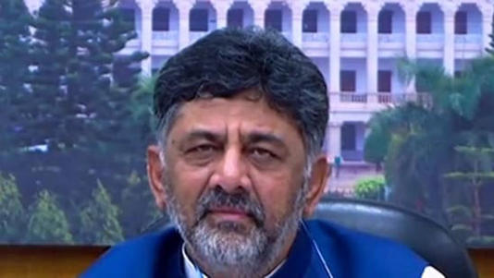](https://www.msn.com/en-in/news/India/dk-shivakumar-reacts-to-karnataka-cabinet-s-decision-on-cbi-probe-against-him/ar-AA1ks5FV?ocid=msedgntp&cvid=38f0c7acab294714be3c4a5296d5e477&ei=71&fullscreen=true#image=2)](https://www.msn.com/en-in/news/India/dk-shivakumar-reacts-to-karnataka-cabinet-s-decision-on-cbi-probe-against-him/ar-AA1ks5FV?ocid=msedgntp&cvid=38f0c7acab294714be3c4a5296d5e477&ei=71&fullscreen=true" \l "image=2" \t "_self)

DK Shivakumar© Provided by Hindustan Times

In an initial response to the Karnataka cabinet pulling out the consent given to the Central Bureau of Investigation (CBI) to probe the disproportionate case against him, deputy chief minister DK Shivakumar said that he was not aware of the development. Shivakumar said he only saw news reports this morning and learned about the decision.

Speaking to reporters on Friday, DK Shivakumar said, “I did not know about the decision until I read newspapers this morning. I did not attend the cabinet meeting on Thursday as I was busy with the assembly elections in Telangana. For the next two days, I will be in Telangana for the election campaign.”

The BJP has slammed the Congress party for the decision and called it a blatant misuse of power in the state. BJP MLA Ashwath Narayan said, “CBI is investigating a disproportionate assets case. This is a serious case, and it is in its final stages in the court as well. At such a time, misusing the power, they are planning to take the case away from the CBI. We condemn it. They (Congress leaders) behave like they are clean, so why are they opposing this investigation? If you are clean, face the CBI probe.”

LoadedOn Thursday, Karnataka law minister HK Patil announced the decision to withdraw the consent given to CBI to probe DK Shivakumar. He said, “Before handing over the case to CBI, the BJP government did not get permission from the speaker as per the procedure. This is in violation of the rules that require the Speaker’s permission before giving the sanction to the CBI. The previous Advocate General’s and the current Advocate General’s opinions were considered. Keeping in view of the Advocate General’s opinion the cabinet has held that this is not in accordance with the law.”

Recently, DK Shivakumar had filed a petition in the high court seeking quashing of the disproportionate assets case. However, the court dismissed Shivakumar’s plea in October and directed the CBI to conclude its investigation within three months. The court said that it won’t interfere in the matter as the CBI is almost complete with its investigation.

# https://www.msn.com/en-in/news/India/massive-political-fight-breaks-out-over-karnataka-government-decision-to-withdraw-the-cbi-probe-against-dk-shivakumar/ar-AA1ks7XO?ocid=msedgntp&cvid=93260ca5f7b84c3e95a077c3f323d782&ei=29

# Massive political fight breaks out over Karnataka government decision to withdraw the CBI probe against DK Shivakumar

[[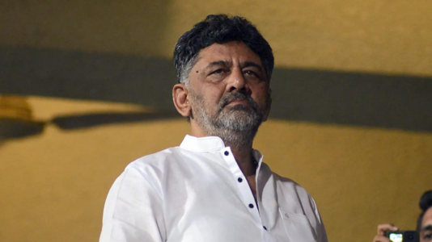](https://www.msn.com/en-in/news/India/massive-political-fight-breaks-out-over-karnataka-government-decision-to-withdraw-the-cbi-probe-against-dk-shivakumar/ar-AA1ks7XO?ocid=msedgntp&cvid=93260ca5f7b84c3e95a077c3f323d782&ei=29&fullscreen=true#image=2)](https://www.msn.com/en-in/news/India/massive-political-fight-breaks-out-over-karnataka-government-decision-to-withdraw-the-cbi-probe-against-dk-shivakumar/ar-AA1ks7XO?ocid=msedgntp&cvid=93260ca5f7b84c3e95a077c3f323d782&ei=29&fullscreen=true" \l "image=2" \t "_self)

Massive political fight breaks out over Karnataka government decision to withdraw the CBI probe against DK Shivakumar© Provided by The Times of India

BENGALURU: A political fight has broken out in Karnataka after the Congress-ruled state government approved a proposal to withdraw the CBI probe against Karnataka deputy chief minister DK Shivakumar in the alleged disproportionate assets case.

Criticising the state cabinet's decision to withdraw a CBI case investigating deputy chief minister DK Shivakumar's alleged disproportionate assets, Karnataka BJP chief BY Vijayendra on Friday called the decision "totally illegal" under the Constitution. Vijayendra urged Shivakumar to trust the legal process and not support such cabinet decisions. He also demanded that the chief minister revoke this decision.

"The decision taken by the state cabinet pertaining to DK Shivakumar's disproportionate assets case The decision of the cabinet is totally illegal under the Constitution. I request our deputy CM, DK Shivakumar, that if you have faith in the legal process and legal remedy, then please don't entertain such decisions taken by the cabinet... I demand CM take back this decision. Crores of money have been seized in Karnataka and other states. When the ED is investigating the entire issue, then the decision of the cabinet is completely illegal," Karnataka BJP chief BY Vijayendra said.

Meanwhile, JDS leader and former chief minister HD Kumaraswamy targeted the Congress-led Karnataka government over its approval of a proposal to withdraw a CBI case investigating the alleged disproportionate assets of Deputy chief minister DK Shivakumar, saying "This government is in power to safeguard the dacoits".

"This government is in power to safeguard the dacoits. When an issue is in court, I don't want to speak more about it. People who have some shame respect the court; those who don't have shame will not care. They have such an arrogant attitude that they can buy anything," JDS leader and former Chief Minister HD Kumaraswamy said.

Responding to the charges Karnataka Deputy CM DK Shivakumar claimed he wasnt' aware of the cabinet decision.

"I have seen it in the newspapers. I could not attend the cabinet meeting yesterday. I am going to Telangana for election campaigning for two days" DK Shivakumar said.

The Congress government however has defended its decision claiming the case against DK Shivakumar was politically motivated.

"BJP can only threaten. They tried it through social media and agencies. Since yesterday they have been doing the same thing in the disproportionate case of DK Shivakumar. BJP is just spreading misinformation on this issue. The case against DK Shivakumar was politically motivated and it was filed to control Congress and Siddaramaiah, DK Shivakumar because they (BJP) were losing the elections" Karnatak Minister Priyank Kharge said

Karnataka Home Minister G Parameshwara said the decision taken by the cabinet was well within the law.

"We have made a decision within the framework of the law, within our limits... We will inform the court about the cabinet's decision. What the CBI will do next and what the court will do is up to them... The BJP-JDS interpretation is up to them. We have done what we have to do within the framework of the law" G Parameshwara said.

Meanwhile, the Karnataka high court has adjourned the hearing of the appeal filed by D K Shivakumar against the sanction accorded by the previous government to the CBI to prosecute him in the disproportionate assets case, to November 29.

JSCIAR, India,

27th November 2023.

https://www.msn.com/en-in/news/India/dks-disproportionate-assets-case-govt-oppn-set-for-a-pitched-battle/ar-AA1kwX4o?ocid=msedgntp&cvid=0d052ad1d4204b9388e80852ed721941&ei=9

# DKS’ disproportionate assets case: Govt-Oppn set for a pitched battle

In 2019, the then BJP government headed by BS Yediyurappa gave consent for the CBI probe, and Shivakumar challenged it in the court.

The Siddaramaiah government’s efforts to extricate Deputy Chief Minister DK Shivakumar from the Central Bureau of Investigation (CBI) probe in the disproportionate assets case has kicked up a political storm. It is likely to engulf the winter session of the state legislature and keep the political atmosphere charged ahead of the Lok Sabha polls early next year.

The state government’s contention that the then BJP regime had not taken the Assembly Speaker’s consent before permitting the Central agency to probe the case, will be subjected to legal scrutiny as the issue is already before the courts. But, on the political front, both sides are preparing for a long and sustained fight. It will be one of the key issues around which the political discourse in the state will be centered in the run-up to the LS polls.

The entire cabinet, including the Chief Minister, rallied behind the DyCM who is also the president of the state unit of the Congress party, while the opposition BJP is going all guns blazing as it sniffs a potent issue to put the Siddaramaiah government on the mat over corruption and probity in public life. The Siddaramaiah government will also be accused of setting a bad precedent by attempting to stall the probe with retrospective effect.

The Income Tax Department conducted raids on Shivakumar’s premises in 2017. Based on that, the Enforcement Directorate (ED) started its investigation. Following the ED investigation, the CBI had sought sanction from the state government to register an FIR against Shivakumar under the Prevention of Corruption Act. In 2019, the then BJP government headed by BS Yediyurappa gave consent for the CBI probe, and Shivakumar challenged it in the court. Now, the government has decided to withdraw the sanction accorded to the Central agency.

Given the sensitivity of the issue, the Congress leaders are showing swiftness and aggression in defending the government’s stand. The party came to power on the promise of providing a clean and transparent administration. It cannot take the BJP’s allegations of trying to subvert the system to protect a leader facing serious charges lightly.

In his first stint as the CM, from 2013-18, Siddaramaiah was accused of attempting to weaken the Lokayukta. His government had defanged the anti-corruption ombudsman institution headed by a retired judge by establishing an Anti-Corruption Bureau (ACB) headed by a police officer. Only after the court’s intervention, the ACB had to be disbanded and Lokayukta’s powers were restored. It was one of the issues in the 2018 assembly polls.

In Shivakumar’s case, legal nuances aside, Congress will be more concerned about the BJP’s attempts to build a narrative against the state government on the issue of corruption. If the state Congress leaders fail to handle the issue deftly, it can pose a threat to the party’s larger plans of taking the “Karnataka Model” of governance to other states, and could even undo the gains accrued by implementing the guarantee schemes.

For now, the Congress leaders seem to be adopting a combative strategy to thwart the BJP’s attempts to gain control of the narrative.

On its part, the BJP, under the leadership of newly appointed state president BY Vijayendra and Leader of Opposition R Ashoka, is showing similar aggression. Their efforts will be supplemented by former Chief Minister and JDS leader HD Kumaraswamy who is going ballistic with his attack on the CM and DyCM, almost on a daily basis.

It will be the first big test for Vijayendra and Ashoka to take everyone in the party along in their fight against the Congress, both within the assembly and outside. Their challenge is to make it a national issue to target the Congress’ central leadership and keep up the momentum till the Lok Sabha polls.

The issue could even lead to an uproar in the winter session of the state legislature starting from December 4 in Belagavi. Unfortunately, the session might end up being a platform for expressing growing animosity between the ruling and the opposition parties, instead of debating issues concerning the people of the state.

Long after the May 10 assembly polls, the political atmosphere in the state continues to be fully charged up. It will further intensify once the focus shifts to the Lok Sabha polls after the assembly elections in Telangana, Rajasthan, Madhya Pradesh, Chhattisgarh and Mizoram.

[[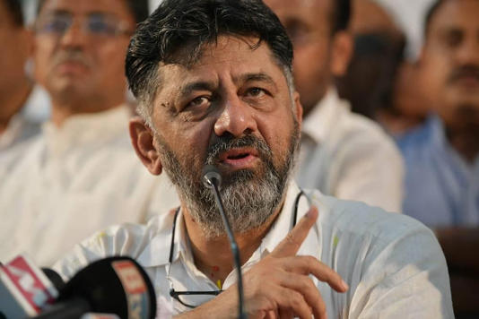](https://www.msn.com/en-in/news/India/dks-disproportionate-assets-case-govt-oppn-set-for-a-pitched-battle/ar-AA1kwX4o?ocid=msedgntp&cvid=0d052ad1d4204b9388e80852ed721941&ei=9&fullscreen=true#image=2)](https://www.msn.com/en-in/news/India/dks-disproportionate-assets-case-govt-oppn-set-for-a-pitched-battle/ar-AA1kwX4o?ocid=msedgntp&cvid=0d052ad1d4204b9388e80852ed721941&ei=9&fullscreen=true" \l "image=2" \t "_self)

DKS’ disproportionate assets case: Govt-Oppn set for a pitched battle © Provided by The New Indian Express

JSCIAR, India,

27th November 2023.

**Secular values of Shri DKS**

https://www.msn.com/en-in/news/India/just-because-you-haven-t-heard-owaisi-to-dk-shivakumar-on-it-park-for-muslims/ar-AA1kAYXi?ocid=msedgntp&cvid=72955578f0a54c1899ac4a107872f1a6&ei=23

[[India Today](https://www.indiatoday.in/)](https://www.indiatoday.in/" \o "India Today" \t "_blank)

**[India Today](https://www.indiatoday.in/" \o "India Today" \t "_blank)**

Follow

# 'Just because you haven't heard...': Owaisi to DK Shivakumar on IT Park for Muslims

[[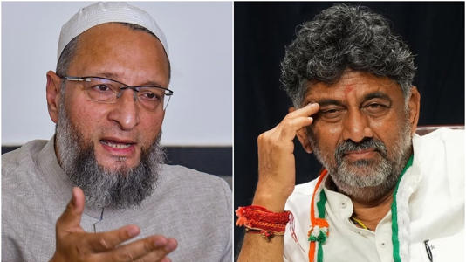](https://www.msn.com/en-in/news/India/just-because-you-haven-t-heard-owaisi-to-dk-shivakumar-on-it-park-for-muslims/ar-AA1kAYXi?ocid=msedgntp&cvid=72955578f0a54c1899ac4a107872f1a6&ei=23&fullscreen=true#image=2)](https://www.msn.com/en-in/news/India/just-because-you-haven-t-heard-owaisi-to-dk-shivakumar-on-it-park-for-muslims/ar-AA1kAYXi?ocid=msedgntp&cvid=72955578f0a54c1899ac4a107872f1a6&ei=23&fullscreen=true" \l "image=2" \t "_self)

'Just because you haven't heard...': Owaisi to DK Shivakumar on IT Park for Muslims© Provided by India Today

All India Majlis-e-Ittehadul Muslimeen (AIMIM) chief Asaduddin Owaisi on Monday slammed Congress leader and Karnataka Deputy Chief Minister DK Shivkumar for questioning Telangana CM K Chandrasekhar Rao's announcement of [**setting up a special Information Technology (IT) Park in Hyderabad**](https://www.indiatoday.in/elections/telangana-assembly-polls-2023/story/will-set-up-special-it-park-for-young-muslim-if-brs-wins-kcr-at-poll-rally-2467071-2023-11-24) for Muslim community.

Earlier in the day, Shivakumar reacted to KCR's IT Park announcement, expressing skepticism about creating a park exclusively for one community.

"How can they make an IT park just for a community? I have never heard any such thing. This shows that KCR has weakened himself. You can promote the minority community, women, and children, but cannot make an IT park just for one community," Shivakumar had said.

However, Owaisi expressed his disapproval of Shivakumar's comments, stating that the Congress leader may not have heard about several things, but that doesn't mean they cannot exisit.

"Dear DK Shivakumar, you have not heard of many things, doesn't mean that they are impossible. If youth, children, and women don't have any caste, why is your leader promising caste census? The truth is that Muslims, BCs, SCs & STs face disadvantages that dominant castes don't," Owaisi tweeted.

* [[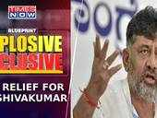](https://www.msn.com/en-in/video/news/big-relief-for-dk-shivakumar-karnataka-cover-to-expose-congress-in-telangana-blueprint-explosive/vi-AA1ktccQ?ocid=msedgntp)](https://www.msn.com/en-in/video/news/big-relief-for-dk-shivakumar-karnataka-cover-to-expose-congress-in-telangana-blueprint-explosive/vi-AA1ktccQ?ocid=msedgntp" \t "_blank)

[Ti](https://www.msn.com/en-in/video/news/big-relief-for-dk-shivakumar-karnataka-cover-to-expose-congress-in-telangana-blueprint-explosive/vi-AA1ktccQ?ocid=msedgntp" \t "_blank)

[[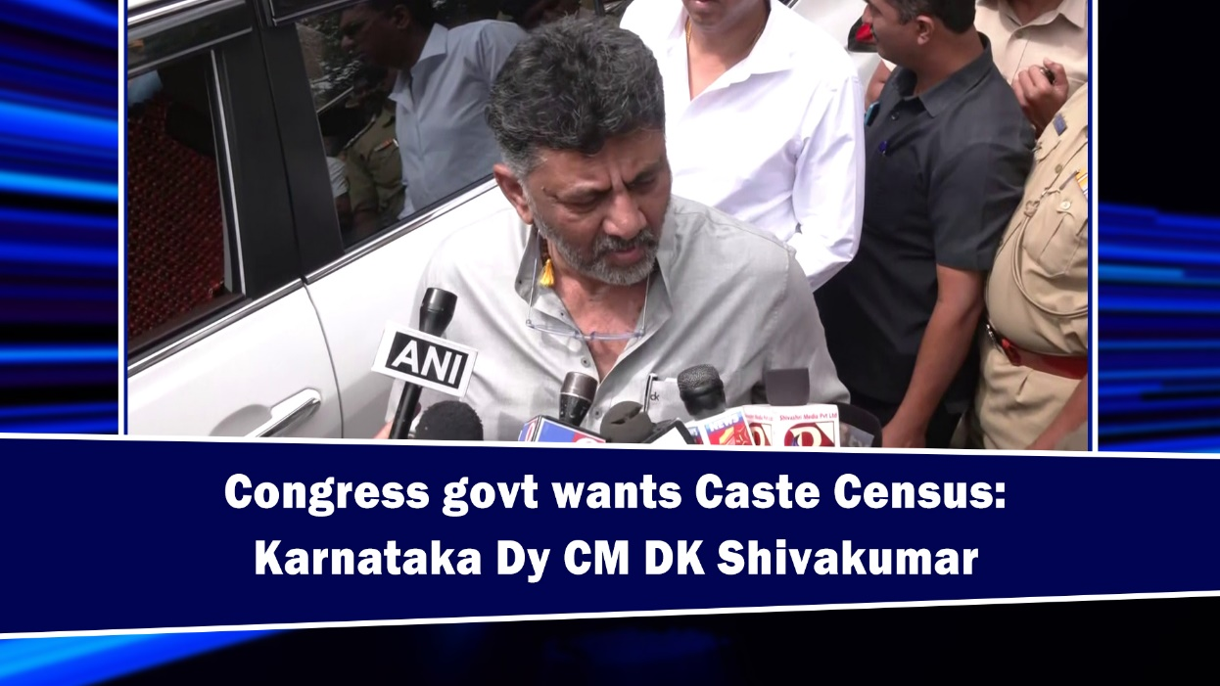](https://www.msn.com/en-in/video/news/congress-govt-wants-caste-census-karnataka-dy-cm-dk-shivakumar/vi-AA1klMB1?ocid=msedgntp)](https://www.msn.com/en-in/video/news/congress-govt-wants-caste-census-karnataka-dy-cm-dk-shivakumar/vi-AA1klMB1?ocid=msedgntp" \t "_blank)

[ANI Video](https://www.msn.com/en-in/video/news/congress-govt-wants-caste-census-karnataka-dy-cm-dk-shivakumar/vi-AA1klMB1?ocid=msedgntp" \t "_blank)**[Congress govt wants Caste Census: Karnataka Dy CM DK Shivakumar](https://www.msn.com/en-in/video/news/congress-govt-wants-caste-census-karnataka-dy-cm-dk-shivakumar/vi-AA1klMB1?ocid=msedgntp" \t "_blank)**

[[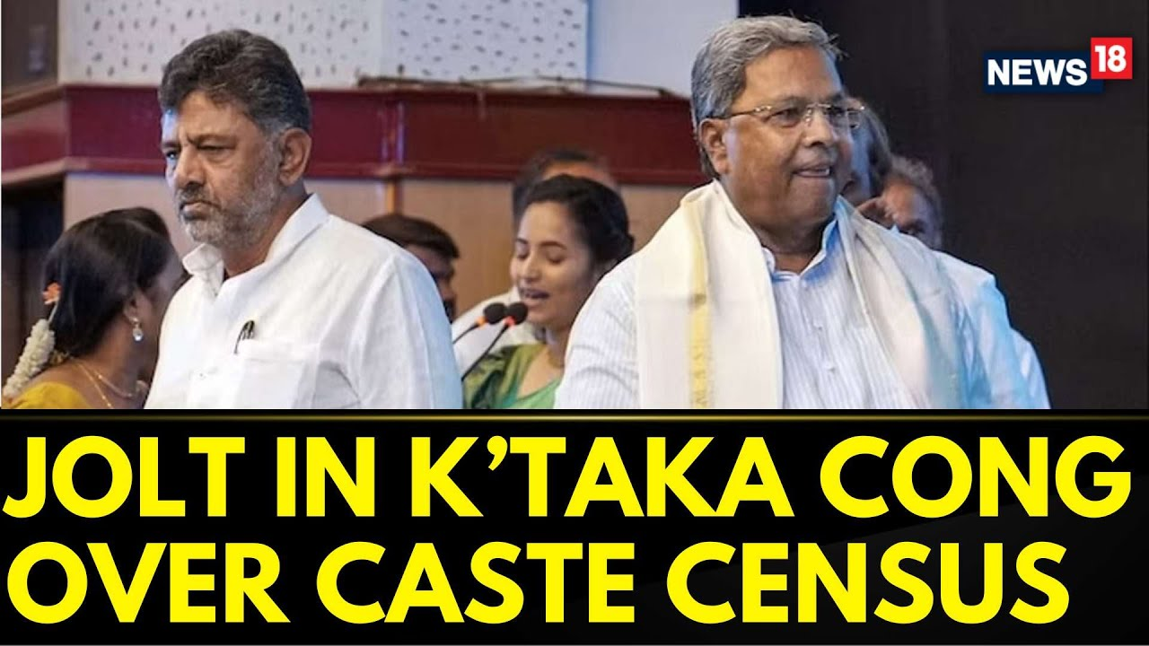](https://www.msn.com/en-in/video/news/karnataka-news-caste-census-karnataka-dk-shivakumar-signs-petition-against-caste-census-news18/vi-AA1kogNR?ocid=msedgntp)](https://www.msn.com/en-in/video/news/karnataka-news-caste-census-karnataka-dk-shivakumar-signs-petition-against-caste-census-news18/vi-AA1kogNR?ocid=msedgntp" \t "_blank)

[News18/News18](https://www.msn.com/en-in/video/news/karnataka-news-caste-census-karnataka-dk-shivakumar-signs-petition-against-caste-census-news18/vi-AA1kogNR?ocid=msedgntp" \t "_blank)**[Karnataka News | Caste Census Karnataka | DK Shivakumar Signs Petition Against Caste Census | News18](https://www.msn.com/en-in/video/news/karnataka-news-caste-census-karnataka-dk-shivakumar-signs-petition-against-caste-census-news18/vi-AA1kogNR?ocid=msedgntp" \t "_blank)**

Owaisi also emphasised that in Telangana, Muslim minorities are not just voters but full-fledged citizens who deserve a fair share in the state's progress. The AIMIM chief said that providing support to Muslim entrepreneurs is essential to help transform them into job creators from mere job seekers.

While addressing concerns raised by Shivakumar about the creation of an exclusive IT park for Muslims, Owaisi clarified, "It doesn't mean an EXCLUSIVE IT Park where ONLY Muslims work, but it definitely means that special support is provided to them so that they can overcome the discrimination that they face."

Owaisi further criticised Shivakumar for what he termed "showing your real anti-Muslim face" and posed a question regarding the quota for backward Muslims in Karnataka, asking whether it will be reinstated or abandoned.

In a bid to woo minority voters in November 30 Telangana Assembly elections, BRS president and incumbent Chief Minister K Chandrasekhar Rao recently told a poll rally that if his party was back to power, his government would set up a special IT park for Muslim youths.

"Today, we are giving pensions which Muslims are also getting. We have opened residential schools in which Muslim students also study. We take everyone along with us. Today, we are thinking about Muslim youths and setting up a special IT park for them near Hyderabad. The IT park will come up near Pahadi Shareef," he said.

KCR's announcement was also criticised by the Bhartiya Janata Party (BJP), which labelled the construction of IT park for one particular community as "appeasement politics". "One IT park for a particular religion in Hyderabad is appeasement by KCR. We need to keep this in mind," BJP national president JP Nadda said.

JSCIAR, India,

28th November, 2023.

https://www.msn.com/en-in/news/India/dks-in-delhi-to-discuss-cbi-da-case/ar-AA1kDL8S?ocid=msedgntp&cvid=32df5696af54429cb64e230ba9ab2158&ei=23#image=2

[[The New Indian Express](https://www.newindianexpress.com/)](https://www.newindianexpress.com/" \o "The New Indian Express" \t "_blank)

**[The New Indian Express](https://www.newindianexpress.com/" \o "The New Indian Express" \t "_blank)**

Follow

# DKS in Delhi to discuss CBI DA case

His visit is significant as the appeal he has filed before the Karnatka High Court to quash the CBI case against him is coming up for hearing on November 29.

BENGALURU: Deputy Chief Minister and KPCC president DK Shivakumar, who got the backing of the cabinet by withdrawing permission given by the previous BJP government to the CBI to probe the disproportionate assets case against him, visited New Delhi on Monday to meet the party high command leaders and to discuss the fallout of the recent developments with his counsel.

His visit is significant as the appeal he has filed before the Karnatka High Court to quash the CBI case against him is coming up for hearing on November 29.

[[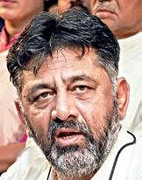](https://www.msn.com/en-in/news/India/dks-in-delhi-to-discuss-cbi-da-case/ar-AA1kDL8S?ocid=msedgntp&cvid=32df5696af54429cb64e230ba9ab2158&ei=23&fullscreen=true#image=2)](https://www.msn.com/en-in/news/India/dks-in-delhi-to-discuss-cbi-da-case/ar-AA1kDL8S?ocid=msedgntp&cvid=32df5696af54429cb64e230ba9ab2158&ei=23&fullscreen=true" \l "image=2" \t "_self)

DKS in Delhi to discuss CBI DA case© Provided by The New Indian Express

Asked about his visit to Delhi, he said, “There is a wedding ceremony at the residence of Siddhartha, who was my lawyer, and I will  return after attending it.”

He said the cabinet decision helped him understand who his friends and foes are. “I am not going to talk now about withdrawal of permission given to the CBI for investigation against me. I will certainly talk about it later and answer everything,” the Deputy Chief Minister said.

Shivakumar, who is in charge of the Telangana Assembly election and has campaigned in the neighbouring state, said there is a Congress wave in that state, but cannot predict how many seats the party will win.  “The Congress government will be formed in Telangana and at the very first cabinet meeting on December 9, approval will be given to implement all the six guarantees,” he added.

“Like in Karnataka, we have promised six guarantees in Telangana. The K Chandrashekar Rao government has not fulfilled its promises, including making a Dalit a chief minister, in the last 10 years. Sonia Gandhi was responsible for the creation of Telangana and people feel indebted to her and want a change this time,” he said.

On Leader of Opposition R Ashoka terming Chief Minister Siddaramaiah’s day-long ‘Janata Darshan’ bogus and alleging that the government has woken up late, Shivakumar said, “He is the new Leader of the Opposition. Like a new dhobi, he too is washing clothes loudly now. We know everyone’s mood.”

[[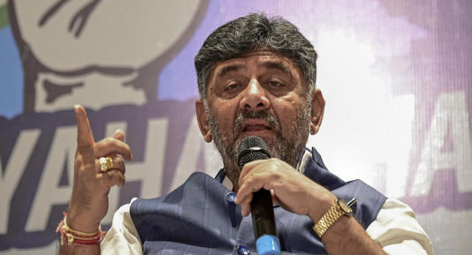](https://www.msn.com/en-in/news/India/dks-in-delhi-to-discuss-cbi-da-case/ar-AA1kDL8S?ocid=msedgntp&cvid=32df5696af54429cb64e230ba9ab2158&ei=23&fullscreen=true#image=2)](https://www.msn.com/en-in/news/India/dks-in-delhi-to-discuss-cbi-da-case/ar-AA1kDL8S?ocid=msedgntp&cvid=32df5696af54429cb64e230ba9ab2158&ei=23&fullscreen=true" \l "image=2" \t "_self)

DKS in Delhi to discuss CBI DA case© Provided by The New Indian Express

**“Reformers of Indian politics – Towards corruption and poverty ridden India”**

**1. Shri D K Shiva Kumar**

**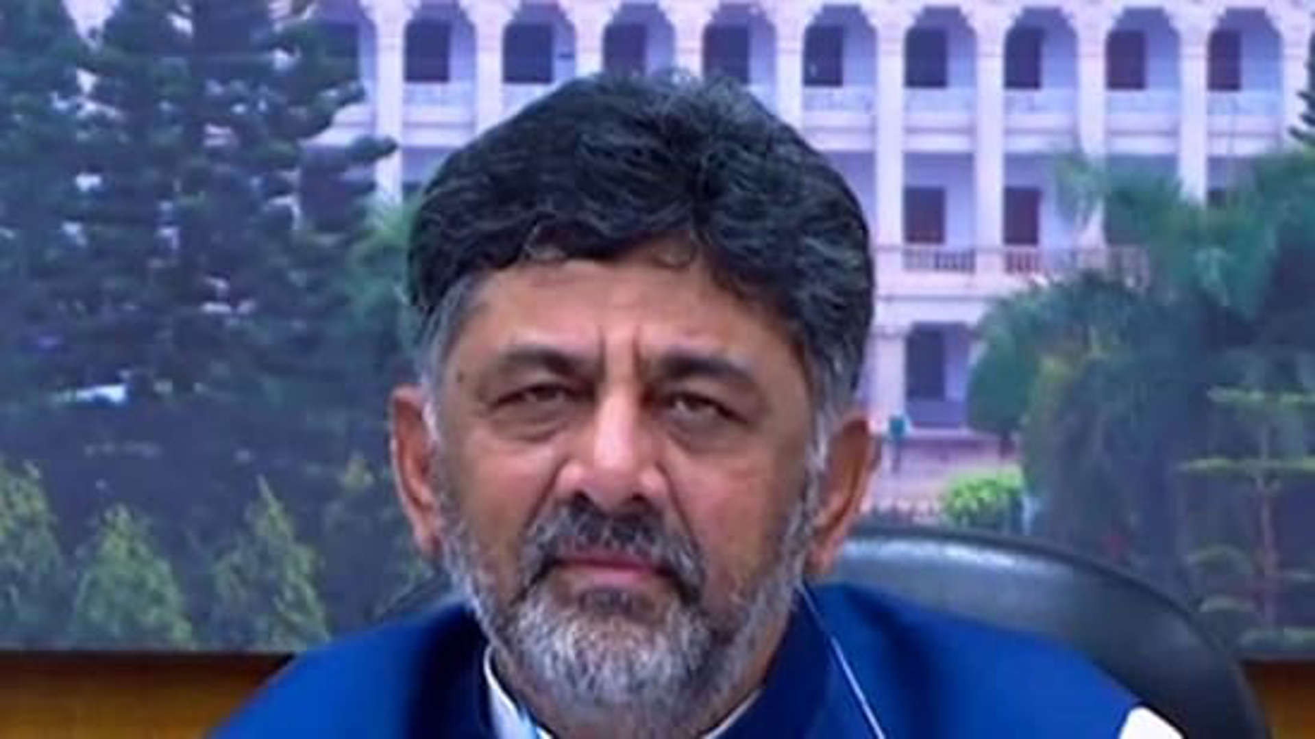**

**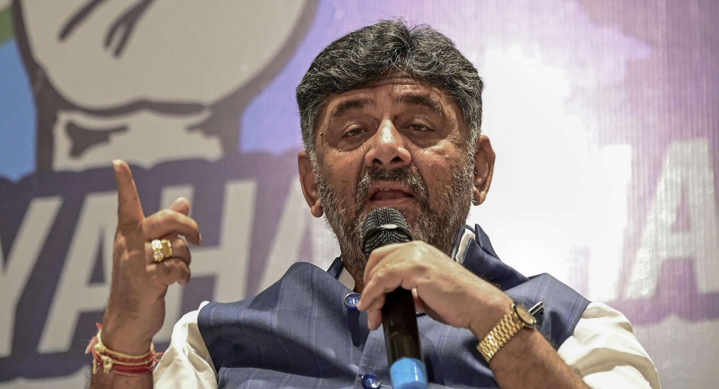**

**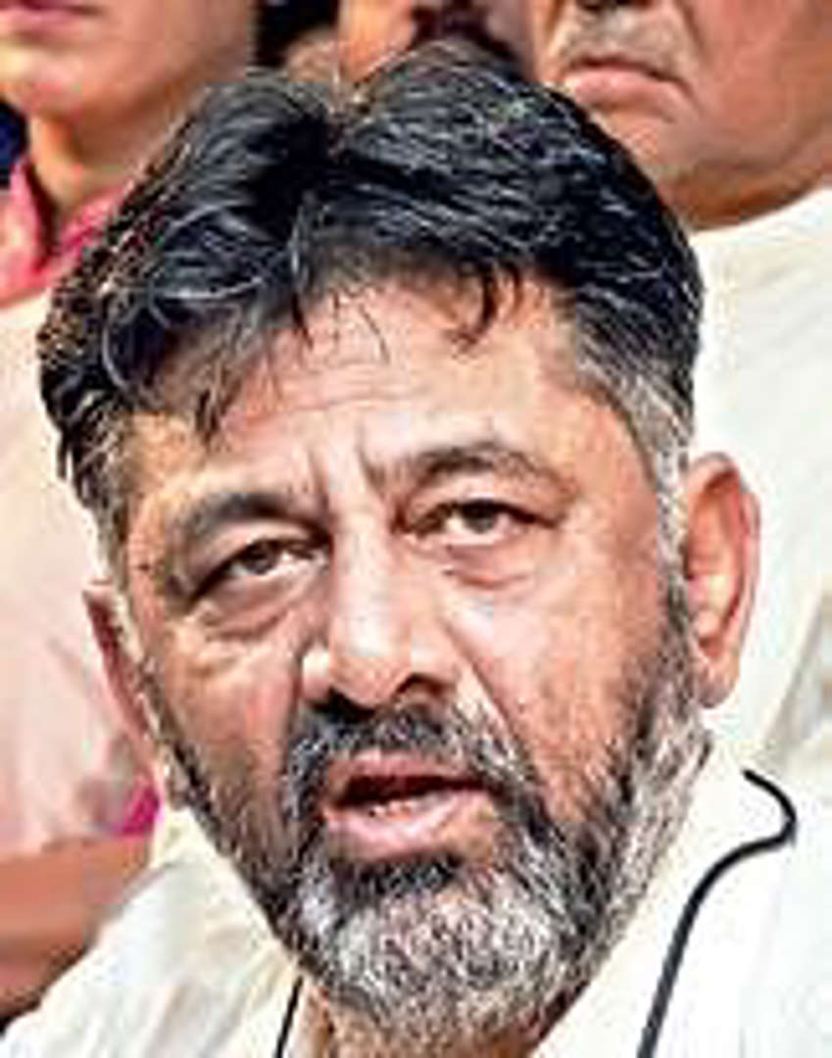**

**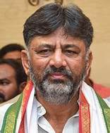**

**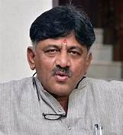**

**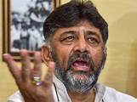**

**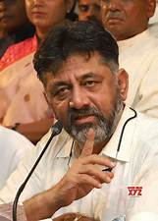**

**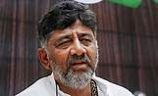**

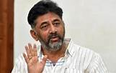

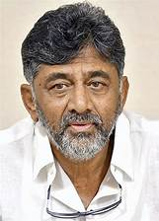

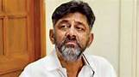

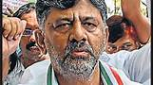

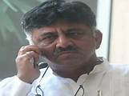

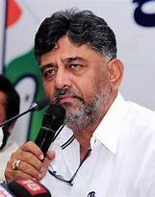

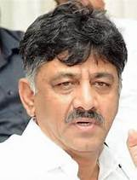

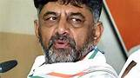

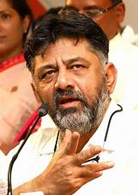

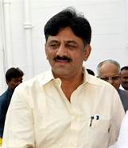

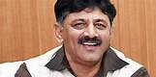

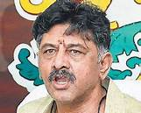

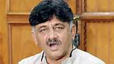

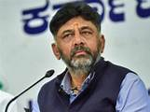

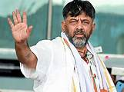

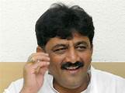

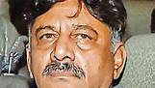

<https://www.msn.com/en-in/news/India/k-taka-hc-permits-dk-shivakumar-to-withdraw-appeal-as-cong-govt-takes-back-consent-for-cbi-probe-in-da-case/ar-AA1kIBDL?ocid=msedgntp&cvid=c1752514f9d64ad38adba88c3ef05bdb&ei=7>

[[The New Indian Express](https://www.newindianexpress.com/)](https://www.newindianexpress.com/" \o "The New Indian Express" \t "_blank)

**[The New Indian Express](https://www.newindianexpress.com/" \o "The New Indian Express" \t "_blank)**

Follow

# K'taka HC permits DK Shivakumar to withdraw appeal as cong -govt takes back consent for CBI probe in DA case

6h

The November 28, 2023 notification issued by the state government withdrawing the sanction dated September 25, 2019, was placed before the court.

BENGALURU: The Karnataka High Court on Wednesday permitted Deputy Chief Minister D K Shivakumar to withdraw his petition as well as the appeal filed by him questioning the sanction given by the previous BJP government to the [**Central Bureau of Investigation**](https://www.newindianexpress.com/states/karnataka/2023/nov/24/nod-for-cbi-investigation-against-shivakumar-not-in-accordance-with-law-karnataka-cabinet-2635711.html) (CBI) to prosecute him for allegedly possessing assets disproportionate to his known source of income under the Prevention of Corruption Act, as the very sanction itself has been withdrawn by the Chief Minister Siddaramaiah led Congress government now.

A division bench of Chief Justice Prasanna B Varale and Justice Krishna S Dixit passed the order permitting Shivakumar to withdraw the petition and appeal after the senior advocate Kapil Sibal and Advocate General Shashikiran Shetty placed before the court a notification dated November 28, 2023, issued by the state government withdrawing the sanction dated September 25, 2019, given by the previous BJP government, subsequent to the decision taken in the cabinet to withdraw the sanction.

After placing the notification, the senior advocates Abhishek Singhvi and Uday Holla, representing D K Shivakumar, submitted before the court that both the writ petition and writ appeal filed by Shivakumar questioning sanction are infructuous, as the very sanction itself has been withdrawn by the present state government.

Meanwhile, advocate P Prasanna Kumar, representing the CBI, submitted that there is no hurdle for the investigating agency to proceed further as withdrawing the sanction will be effective prospectively and hence he has no objection to the withdrawal of the appeal but he is against withdrawing the petition in which the single judge had upheld the sanction given to prosecute Shivakumar and an investigation was launched after registration of the First Information Report (FIR) based on the sanction.

Even the advocate Venkatesh P Dalwai, representing senior BJP MLA Basanagouda R Patil Yatnal, who filed an intervening application to hear him on the issue of withdrawal of sanction, opposed the state government's decision, saying that the government ought not to have withdrawn the consent as same is against the law laid down by the apex court.

The court, however, permitted Shivakumar to withdraw his petition and appeal, saying that there was no challenge to the notification issued by the state government to withdraw the sanction given to prosecute the petitioner.

[[](https://www.msn.com/en-in/news/India/k-taka-hc-permits-dk-shivakumar-to-withdraw-appeal-as-cong-govt-takes-back-consent-for-cbi-probe-in-da-case/ar-AA1kIBDL?ocid=msedgntp&cvid=c1752514f9d64ad38adba88c3ef05bdb&ei=7&fullscreen=true#image=2)](https://www.msn.com/en-in/news/India/k-taka-hc-permits-dk-shivakumar-to-withdraw-appeal-as-cong-govt-takes-back-consent-for-cbi-probe-in-da-case/ar-AA1kIBDL?ocid=msedgntp&cvid=c1752514f9d64ad38adba88c3ef05bdb&ei=7&fullscreen=true" \l "image=2" \t "_self)

K'taka HC permits DK Shivakumar to withdraw appeal as cong -govt takes back consent for CBI probe in DA case© Provided by The New Indian Express

JSCIAR, India,

29th November 2023.

The leader with clear conscience:

<https://www.msn.com/en-in/money/news/have-done-no-wrong-only-worked-for-cong-says-dks/ar-AA1kLB4M>

[[The New Indian Express](https://www.newindianexpress.com/)](https://www.newindianexpress.com/" \o "The New Indian Express" \t "_blank)

**[The New Indian Express](https://www.newindianexpress.com/" \o "The New Indian Express" \t "_blank)**

Follow

# Have done no wrong, only worked for cong, says DKS

tressing on his DA case, Shivakumar said that he has not committed any mistake.

BENGALURU: KPCC president and DyCM DK Shivakumar said that he has done no wrong and has only worked for the party for which he has faced many problems. Stressing on his DA case, Shivakumar said that he has not committed any mistake.

“You (media) and people have seen that. I have only worked for the party and for this I have faced many problems. I believe that God is there to protect me even in the future. People know what is wrong and those who gave me trouble are now facing it,” the DyCM told reporters.

Shivakumar was reacting on the High Court granting him permission to withdraw his petition and file an appeal questioning sanction given by the previous government to the CBI to prosecute him in the DA case. The Congress government recently decided to withdraw permission given to the CBI to probe the case.

Shivakumar said that he does not know the details of the judgment and cannot speak about it without getting details from the lawyers.

When asked about BJP leader and MLA Basanagouda Patil Yatnal filing an appeal in the High Court against him, he said, “I am watching his behaviour and actions. I will respond to all of it at an appropriate time.”

[[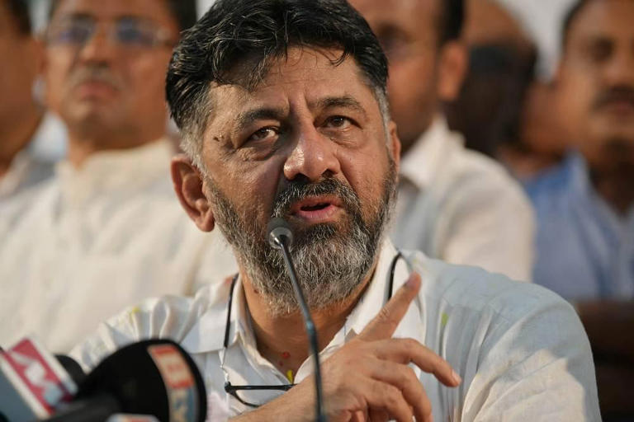](https://www.msn.com/en-in/money/news/have-done-no-wrong-only-worked-for-cong-says-dks/ar-AA1kLB4M?fullscreen=true#image=2)](https://www.msn.com/en-in/money/news/have-done-no-wrong-only-worked-for-cong-says-dks/ar-AA1kLB4M?fullscreen=true" \l "image=2" \t "_self)

Have done no wrong, only worked for cong, says DKS  © Provided by The New Indian Express

JSCIAR, India,

30th November 2023.

**Leader with courage to face challenges**

[**https://www.msn.com/en-in/news/India/karnataka-dycm-dk-shivakumar-evades-cbi-probe-for-now-but-challenges-await-ahead/ar-AA1kLdHy**](https://www.msn.com/en-in/news/India/karnataka-dycm-dk-shivakumar-evades-cbi-probe-for-now-but-challenges-await-ahead/ar-AA1kLdHy)

# Karnataka: DyCM DK Shivakumar evades CBI probe for now, but challenges await ahead

5h

[[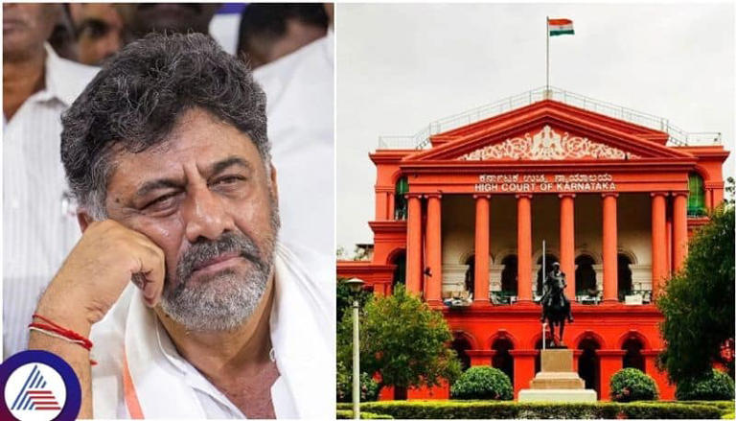](https://www.msn.com/en-in/news/India/karnataka-dycm-dk-shivakumar-evades-cbi-probe-for-now-but-challenges-await-ahead/ar-AA1kLdHy?fullscreen=true#image=2)](https://www.msn.com/en-in/news/India/karnataka-dycm-dk-shivakumar-evades-cbi-probe-for-now-but-challenges-await-ahead/ar-AA1kLdHy?fullscreen=true" \l "image=2" \t "_self)

Karnataka: DyCM DK Shivakumar evades CBI probe for now, but challenges await ahead© Provided by Newsable Asianet News

Arecent development in the High Court has temporarily relieved Deputy Chief Minister DK Shivakumar from the CBI investigation initiated by the previous BJP government regarding alleged wealth gain beyond income. The court permitted Shivakumar to withdraw the petition and appeal related to the dispute, effectively settling the case.

However, this respite might be short-lived, as potential challenges loom. If the government's decision to retract permission for the CBI probe is questioned and brought back to court, legal battles could reignite. However, ongoing criminal proceedings by the Enforcement Directorate (ED) in a money laundering case are pending in Delhi's Special Court.

**What happened at the High Court?**

In the courtroom, the state government officially withdrew the approval granted by the previous administration for the CBI investigation on November 24, followed by a notification on November 28. Subsequently, DK Shivakumar's counsel submitted a memo seeking the withdrawal of the contentious application and appeal, which the High Court approved.

The court's order emphasized that, as of now, no challenges have arisen against the government's decision to revoke CBI investigation approval. The bench acknowledged the appellant's plea to withdraw their application and appeal, citing the government's policy shift as the basis for invalidating the dispute.

During the proceedings, senior advocates representing Shivakumar highlighted the withdrawal of the state government's approval to the CBI, rendering the dispute petition irrelevant. The High Court granted the request for withdrawal in light of this significant policy change.

**Background of the case**

This legal episode stemmed from the BJP government's authorization on September 25, 2022, for a CBI investigation into the alleged wealth gain. Earlier, Shivakumar's petition seeking cancellation of the order was dismissed by a single-member bench of the High Court on April 20, 2023. Challenging this decision, Shivakumar appealed to the Division Bench, which temporarily halted the CBI probe. Subsequently, the current state government moved to retract the permission granted for the CBI investigation.

However, the question of the FIR registered by the CBI remains in contention. The CBI asserted that the investigation had commenced but remained partial. With the government's withdrawal of permission, the CBI argued against the Supreme Court's judgment, stating that only the court, not the government, can dismiss an FIR. The High Court refrained from making an immediate decision on this matter. This recent legal development marks a momentary relief for Shivakumar from the CBI inquiry, yet potential challenges and legal complexities persist on the horizon.

"I have faced all this trouble for simply doing party work. I haven't done anything wrong. All I've done is work for the party and endure a lot because of it. Both God and the people of the state stand by me. I'm not yet sure what's happening in the court."

- DK Shivakumar, Deputy Chief Minister

JSCIAR, India,

4th December 2023.

**“Timely hard work in election campaign by Shri DKS lead to party’s victory in Telangana:**

**Faithfulness and dedicated services of Shri DKS for the party’s success”**

[[The Times of India](https://timesofindia.indiatimes.com/)](https://timesofindia.indiatimes.com/" \t "_blank)

**[The Times of India](https://timesofindia.indiatimes.com/" \t "_blank)**

Follow

# 'People of Telangana have given an answer to KCR, KTR': Karnataka Deputy CM DK Shivakumar

1d

[[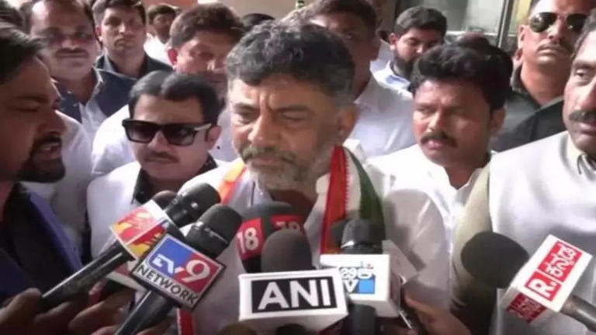](https://www.msn.com/en-in/news/India/people-of-telangana-have-given-an-answer-to-kcr-ktr-karnataka-deputy-cm-dk-shivakumar/ar-AA1kUKBq?fullscreen=true#image=2)](https://www.msn.com/en-in/news/India/people-of-telangana-have-given-an-answer-to-kcr-ktr-karnataka-deputy-cm-dk-shivakumar/ar-AA1kUKBq?fullscreen=true" \l "image=2" \t "_self)

'People of Telangana have given an answer to KCR, KTR': Karnataka Deputy CM DK Shivakumar© Provided by The Times of India

HYDERABAD: Karnataka Deputy Chief Minister DK Shivakumar on Sunday hit out at Telangana CM K. Chandrashekar Rao and BRS leader K. T. Rama Rao and said that the people of Telangana have given them an answer as the grand old party has comfortably reached the majority mark as per the latest trends of the Election Commission of India.

He also thanked the people of Telangana for giving a majority mark to the Congress party as per the latest trends of ECI.

"I thank the voters of Telangana for showing confidence on us. The people of Telangana have decided that there must be change, there must be change for progress and development," Shivakumar said.

When asked about the Chief Minister's face in the youngest state, the Congress leader said that the party would take the decision.

"He (Revanth Reddy) is the PCC president. He is the team leader. Our party will take the decision (on the CM's face). The election was fought on collective leadership. I do not want to comment on K. Chandrashekar Rao or K. T. Rama Rao, the people of Telangana have given them an answer," the Congress leader said.

The Congress is leading on 61 seats while the BRS on 36 and the BJP leading on 10, as per ECI.

Revanth Reddy is MP in the Lok Sabha from INC representing Malkajgiri Constituency. Earlier, He was a two-time MLA in the Andhra Pradesh Assembly from TDP in 2009 and 2014 and in the Telangana Assembly between 2014 and 2018 representing Kodangal Constituency.

He left TDP and joined Congress in 2017.

In June 2021, he was appointed as president of the Telangana Pradesh Congress Committee replacing N. Uttam Kumar Reddy.

Revanth Reddy is leading in both the seats he is contesting Kamareddy where he stood against incumbent CM K Chandrashekar Rao and Kodangal.

Telangana CM KCR is leading from the Gajwel seat. Since the formation of the State in the year 2014, BRS has been holding power with KCR as its chief minister.

Kalvakuntla Taraka Rama Rao (KTR) is leading from Sircilla, which is considered one of the most important seats. KTR fought from the same seat in the 2018 elections and won.

Payal Shanker from BJP is leading on the Adilabad seat while Dhanpal Suryanarayana leading from Nizamabad (Urban). Former Indian Cricketer Mohammed Azharuddin who is contesting on a Congress ticket is trailing in Jubilee Hills. Jaffar Hussain from AIMIM is leading on the Yakutpura seat.

Celebrations were seen outside the Congress office in Hyderabad over the party crossing the halfway mark comfortably. The party cadre chanted "Bye bye KCR".

The Telangana election results will be important for the Congress as it heads into the 2024 Lok Sabha elections. A win in Karnataka and Telangana would further concrete its presence in the South.

The Congress party, which is now in reckoning, was completely written off just six months ago. Several factors could have contributed to the Congress's upturn: Perceived anti-incumbency at the constituency level against BRS MLAs; energy infused by the Karnataka victory in the party leaders and cadres; the BJP's decline following the removal of Bandi Sanjay as the Telangana unit chief; and the perception that the BRS and AIMIM are in cahoots with the BJP.

The fate of 2,290 candidates from 109 parties including the national and regional parties will be revealed as the counting proceeds. The contestants include 221 women and one transgender. A total of 103 legislators are re-contesting this time, most of them from the ruling BRS.

Telangana went to vote on November 30. In 2018, BRS (then Telangana Rashtra Samithi) won 88 of the 119 seats and had a 47.4 per cent vote share. The Congress came a distant second with 19 seats.

**Hard work in election campaign by Shri DKS lead to victory of the party in Telangana**

**Prevention is better than cure**

**Foresightedness of Dr DKS in keeping the winning MLAs together to ensure the formation of Telangana government**

**https://www.msn.com/en-in/money/topstories/all-is-not-over-yet-in-telangana-congress-dk-shivakumar-takes-charge-gets-buses-ready-to-take-mlas-to-karnataka/ar-AA1kUQq2?ocid=msedgntp&cvid=99aca12e54c248cfaf9dfd4b1d21ee3b&ei=17**

[[Business Today](https://www.businesstoday.in/)](https://www.businesstoday.in/" \t "_blank)

**[Business Today](https://www.businesstoday.in/" \t "_blank)**

# All is not over yet in Telangana? Congress' DK Shivakumar takes charge, gets buses ready to take MLAs to Karnataka

Story by Saurabh Sharma • 1d

[[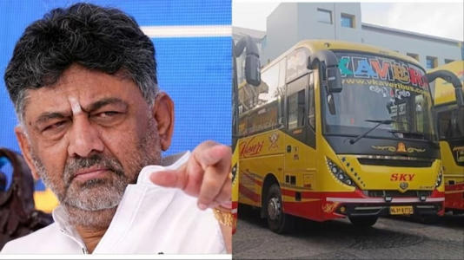](https://www.msn.com/en-in/money/topstories/all-is-not-over-yet-in-telangana-congress-dk-shivakumar-takes-charge-gets-buses-ready-to-take-mlas-to-karnataka/ar-AA1kUQq2?ocid=msedgntp&cvid=99aca12e54c248cfaf9dfd4b1d21ee3b&ei=17&fullscreen=true#image=2)](https://www.msn.com/en-in/money/topstories/all-is-not-over-yet-in-telangana-congress-dk-shivakumar-takes-charge-gets-buses-ready-to-take-mlas-to-karnataka/ar-AA1kUQq2?ocid=msedgntp&cvid=99aca12e54c248cfaf9dfd4b1d21ee3b&ei=17&fullscreen=true" \l "image=2" \t "_self)

All is not over yet in Telangana? Congress' DK Shivakumar takes charge, gets buses ready to take MLAs to Karnataka© Provided by Business Today

The Congress, which has crossed the majority mark in Telangana, is not taking any chances and is ready to transport its MLAs to Karnataka if the winning margin narrows in the last rounds of counting, which is currently underway. The Congress needs 60 seats to form the government in Telangana, which has a 119-member House.

As of now, the grand old party, under the leadership of Revanth Reddy, is doing fairly well and is leading on 64 seats. The Bharat Rashtra Samithi (BRS), which ruled the state for 10 years, is leading on 40 seats. Besides these two, the Bharatiya Janata Party (BJP) is ahead on 7 while Asaduddin Owaisi's AIMIM is leading on six seats.

Both BRS and AIMIM have opposed the Congress and can come together in case the latter slips below the majority mark. But they would still need support from the BJP, which is likely to win 7 seats.

Sensing danger and poaching attempts by the ruling BRS, the Congress has deployed its trouble-shooter in the southern region, DK Shivakumar, to keep the flock together. The Congress has also got buses ready at Hyderabad's Taj Krishna to transport the winning MLAs to neghbouring Karnataka.

Speaking on buses stationed in Hyderabad, Telangana Pradesh Congress Committee Vice President, Kiran Kumar Chamala, said the party had taken some measures to ward off the poaching attempt by Chief Minister KCR. "You all know KCR's style of functioning, poaching is his main agenda. So we have taken some measurements, but after seeing the result today, the trends and everything. Such activity is not needed because at least we will have 80 plus seats...Everything is fine. We are very happy today," he said while speaking to ANI.

Krishnamurthy, a journalist, also shared a video, showing four buses ready in Hyderabad to take winning MLAs in case Congress falls below 60 seats - the number required to form government in Telangana. "Congress not taking any chances. 4 buses are ready in Taj Krishna in #Hyderabad where Karnataka Deputy CM DK Shivakumar is overseeing operations. In case the party does not have a definitive number, Congress MLAs will be transported to #Karnataka," he wrote on X.

Congress leader and Karnataka minister Rahim Khan was also asked whether Telangana MLAs will be shifted to Bengaluru. "If that situation comes, then party high command will decide," he said while speaking to reporters.

The counting of votes is still underway.

JSCIAR, India,

13th December, 2023.

Shri DKS – A leader with a vision for social economic justice to all sections of the society

[[The Times of India](https://timesofindia.indiatimes.com/)](https://timesofindia.indiatimes.com/" \o "The Times of India" \t "_blank)

**[The Times of India](https://timesofindia.indiatimes.com/" \o "The Times of India" \t "_blank)**

Follow

# DKS roots for scientific survey after Kharge expresses anger over delay

5h

[[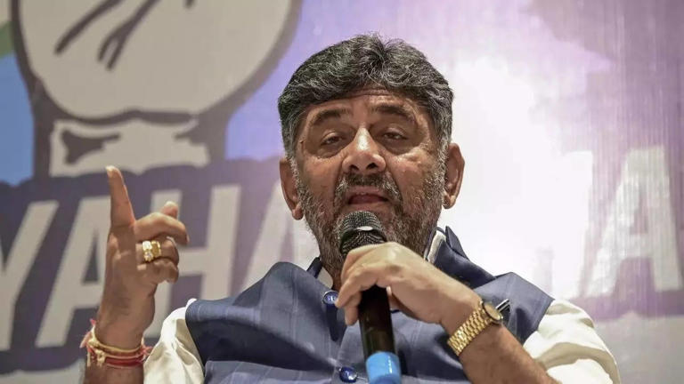](https://www.msn.com/en-in/news/other/dks-roots-for-scientific-survey-after-kharge-expresses-anger-over-delay/ar-AA1lpneD?fullscreen=true#image=2)](https://www.msn.com/en-in/news/other/dks-roots-for-scientific-survey-after-kharge-expresses-anger-over-delay/ar-AA1lpneD?fullscreen=true" \l "image=2" \t "_self)

DKS roots for scientific survey after Kharge expresses anger over delay© Provided by The Times of India

BELAGABI/BENGALURU: In response to reported admonishment from AICC president Mallikarjuna Kharge, deputy chief minister DK Shivakumar clarified on Tuesday that he does "not oppose" the caste census, but is in favour of a scientific socio-economic survey to assess community conditions.

Kharge, in the Rajya Sabha Monday, had expressed displeasure over delay in releasing the caste census report, leading Shivakumar to emphasize the importance of a methodical approach.

Shivakumar said, "Every community, including minorities and SC/STs, claims rights and seeks grants proportionate to their population. We've full faith in the socio-economic survey, and I remain committed to the Congress stand on social justice. As Karnataka state Congress president and OBC leader, I must consider the interests of all communities."

  Continue reading

**DKS highlights technical issues in caste census report**

Responding to comments from Union parliamentary affairs minister Pralhad Joshi about Congress facing resistance in the Rajya Sabha, Kharge highlighted opposition from both Shivakumar and BJP. He claimed, "All upper castes, including Shivakumar, are united on this," after BJP members questioned Congress's challenges in making the report public.

Justifying his stance, Shivakumar said Karnataka was the first state in the country to take up caste census and acknowledged objections from his party MLAs regarding the survey's methodology. He insisted on benefits for every community based on population numbers, seeking clarity on the scientific rationale behind the census.

Shivakumar asserted his OBC status under the central government's reclassification, emphasizing his duty as the Congress state president to treat all communities equally.

"I firmly stand with the concept of social justice, the backbone of Congress, and I believe in the Gandhi family," he added.

Highlighting the technical issues, Shivakumar mentioned the absence of the member-secretary's signature on the report hindered its public release.

He recalled that the survey commissioned by Siddaramaiah in his first term as CM from 2013 to 2018 cost the state Rs 170 crore.

Under pressure from AICC leader Rahul Gandhi, CM Siddaramaiah had, in November, reportedly planned to accept the report and make it public ahead of the Lok Sabha polls.

Due to the opposition from within the party, he beat a hasty retreat and extended the Backward Classes Commission's tenure.

Signatories to a petition against the report's release include those of Shivakumar, agriculture minister N Cheluvarayaswamy and several Congress MLAs.

JSCIAR, India

15th December, 2023.

https://www.msn.com/en-in/news/other/more-bengaluru-roads-to-be-white-topped-announces-karnataka-dy-cm-d-k-shivakumar/ar-AA1lvAUg

Shri DKC – Vision for national infrastructure

[[The Indian Express](http://indianexpress.com/)](http://indianexpress.com/" \t "_blank)

**[The Indian Express](http://indianexpress.com/" \t "_blank)**

Follow

# More Bengaluru roads to be white-topped, announces Karnataka Dy CM D K Shivakumar

Story by Express News Service • 13h

[[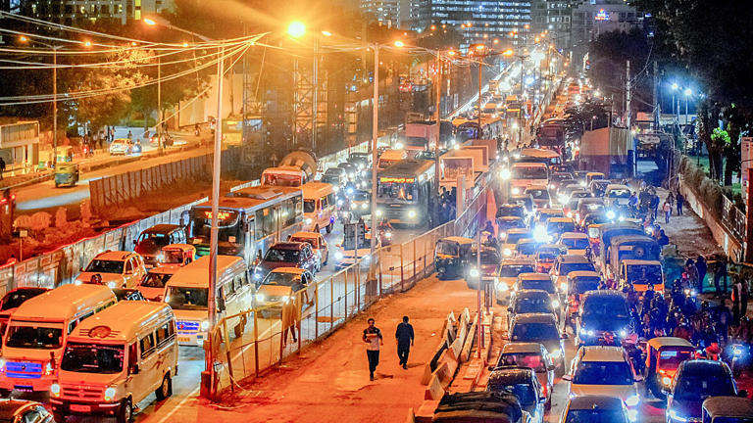](https://www.msn.com/en-in/news/other/more-bengaluru-roads-to-be-white-topped-announces-karnataka-dy-cm-d-k-shivakumar/ar-AA1lvAUg?fullscreen=true#image=2)](https://www.msn.com/en-in/news/other/more-bengaluru-roads-to-be-white-topped-announces-karnataka-dy-cm-d-k-shivakumar/ar-AA1lvAUg?fullscreen=true" \l "image=2" \t "_self)

More Bengaluru roads to be white-topped, announces Karnataka Dy CM D K Shivakumar© Provided by The Indian Express

Karnataka Deputy CM and Bengaluru Development Minister D K Shivakumar Thursday said white-topping will be employed to develop more roads in Bengaluru. A meeting with all city legislators will be held soon over the issue, he added.

For the white-topping project, Rs 1,000 crore was available with the state government, he said, noting a demand to extend such roads across the city. “This will be done in phases,” he told the Legislative Council, in response to a question by MLC H S Gopinath.

“Roads are being dug indiscriminately in the city for installing cables and other works. So, white-topping should be taken up in a planned manner. The government was prioritising white-topping as such roads have a lifespan of 25 to 40 years,” he said.

Commenting on potholes in the city, Shivakumar said that roads were taking a hit due to the rapid increase in vehicle numbers in Bengaluru. “Every day, 1,300 two-wheelers and 490 cars are registered on average in the city. Due to this, roads take a hit. Filling potholes itself is a major challenge,” he said.

Separate arrangements are being made in Bengaluru to fill potholes at the ward level, Shivakumar added.

People’s leader Shri KC:

[[Hindustan Times](https://www.hindustantimes.com/)](https://www.hindustantimes.com/" \o "Hindustan Times" \t "_blank)

**[Hindustan Times](https://www.hindustantimes.com/" \o "Hindustan Times" \t "_blank)**

Follow

# Damaged Bengaluru roads will be white topped in phased manner: Karnataka Dy CM DK Shivakumar

Story by HT News Desk  • 1d

https://www.msn.com/en-in/news/India/damaged-bengaluru-roads-will-be-white-topped-in-phased-manner-karnataka-dy-cm-dk-shivakumar/ar-AA1lClyp?ocid=msedgntp&cvid=bda3461ddd6041ba93982ec605bc9628&ei=39

[[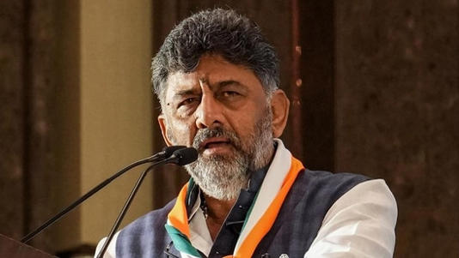](https://www.msn.com/en-in/news/India/damaged-bengaluru-roads-will-be-white-topped-in-phased-manner-karnataka-dy-cm-dk-shivakumar/ar-AA1lClyp?ocid=msedgntp&cvid=bda3461ddd6041ba93982ec605bc9628&ei=39&fullscreen=true#image=2)](https://www.msn.com/en-in/news/India/damaged-bengaluru-roads-will-be-white-topped-in-phased-manner-karnataka-dy-cm-dk-shivakumar/ar-AA1lClyp?ocid=msedgntp&cvid=bda3461ddd6041ba93982ec605bc9628&ei=39&fullscreen=true" \l "image=2" \t "_self)

Damaged Bengaluru roads will be white topped in phased manner: Karnataka Dy CM© Provided by Hindustan Times

Karnataka deputy CM DK Shivakumar said that the government is planning to rapidly implement the white topping process on damaged roads in Bengaluru. He said that the potholes issue will be solved soon and giving better roads is the priority of government.

Speaking in the legislative council, Karnataka deputy CM said, “In Bengaluru, various departments have been digging roads for installations and that is leading to the damage of roads. The government is identifying such roads and planning to fix them with white topping in a phased manner. A meeting will be called with all legislators from Bengaluru soon.”

Shivakumar also said that rapid urbanisation is also one of the main reasons for numerous potholes in the city. “On average, close to 2,000 new vehicles are getting registered in Bengaluru. These many vehicles plying on the roads damage them naturally. Fixing the roads with white topping will give the endurance of 30 to 40 years to these roads,” he added.

He also stressed that the arrangements have been made to fill potholes in all wards of Bengaluru.

White topping is a process where the bituminous road or black-top roads are given a Portland Cement Concrete (PCC) overlay. The rapid road method involves pre-cast large cement blocks that are 20 feet long and 5 feet wide, placed together on a stretch.

Earlier, the Karnataka government introduced ‘rapid road word’ technology to fix the damaged roads in Bengaluru. According to BBMP, the lifespan of white topping is 30 years whereas the rapid roads will last for about 100 years.

Read more news like this on [HindustanTimes.com](https://www.hindustantimes.com/?utm_source=microsoft_homepagelink)

JSCIAR, India,

18th December 2023.

Shri DKS – Charismatic leader with decision making ability:

[[ABP Live](https://news.abplive.com/)](https://news.abplive.com/" \o "ABP Live" \t "_blank)

**[ABP Live](https://news.abplive.com/" \o "ABP Live" \t "_blank)**

Follow

# Karnataka Congress To Finalise Key Appointments In State-Run Boards, Corporations

Story by PTI  • 7h

**Bengaluru:** Ruling Congress in Karnataka appears set to finalise the list of party legislators and workers to be appointed to key positions in various state-run boards and corporations, during the visit of Chief Minister Siddaramaiah and Deputy Chief Minister D K Shivakumar to New Delhi from Monday.

Shivakumar, who is also the state Congress President, said a list has already been sent to Congress high command for its approval.

"We will definitely finalise it and come, we have already sent the list and proposal, as there were elections (in five states) and as there was Assembly (session) there was a delay. Both the Chief Minister and I are going, we will finalise and come," he told reporters here ahead of leaving for the national capital.

Responding to a question on the Chief Minister reportedly getting an appointment to meet the Prime Minister Narendra Modi, he merely said, "okay, we will meet." According to the Chief Minister's tour plan shared with the media, he will be travelling to Delhi this evening and meeting Union Ministers there on Tuesday, while his return journey has been kept open. There is no official word on his meeting with the Prime Minister yet.

In case Siddaramaiah meets the PM, he is likely to take up several key issues concerning the state including delay in release of drought relief by the Centre, party sources said.

The Deputy Chief Minister, who is travelling to Delhi ahead of the Chief Minister, will be meeting some Union Minister this evening and also on Tuesday. His return journey too has been kept open.

Congress in Karnataka had prepared a list of party legislators and workers to be appointed to key positions in various state-run boards and corporations last month, in the presence of party General Secretary in-charge of Karnataka Randeep Singh Surjewala, even as there seems to be some differences among leaders over the process, with Home Minister G Parameshwara openly saying he was not consulted on the exercise.

There has been some disgruntlement and growing impatience within a section of the Congress party, with legislators, who could not make it to the Ministry and were keenly aspiring for the key posts in boards and corporations, unhappy about the delay in appointments.

Also many party men are upset over the delay in rewarding loyal workers, noting that the Congress has been in power for more than six months now.

Shivakumar had recently said that both Congress legislators and party workers would be appointed to these positions, and indicated that about 15 to 20 party MLAs and MLCs would be accommodated, and the rest would be distributed among loyal party workers.

Appointments to boards and corporations are said to be among the issues on which Siddaramaiah and Shivakumar had certain differences of opinion, according to party sources.

***(This report has been published as part of an auto-generated syndicated wire feed. Except for the headline, the content has not been modified or edited by ABP LIVE.)***

**JSCIAR, India,**

**18th December 2023.**

**Shri DKS – Leader with passion for social justice and defender of womens rights**

https://www.msn.com/en-in/entertainment/other/bjp-is-doing-politics-on-belagavi-incident-karnataka-dy-cm-dk-shivakumar/ar-AA1lCgz9?ocid=msedgntp&cvid=9052acf46492452facf0352df6aedb8b&ei=36

[[Mid-Day](http://www.mid-day.com/)](http://www.mid-day.com/" \o "Mid-Day" \t "_blank)

**[Mid-Day](http://www.mid-day.com/" \o "Mid-Day" \t "_blank)**

Follow

# BJP is doing politics on Belagavi incident: Karnataka Dy CM DK Shivakumar

Story by Mid-day  • 1d

[[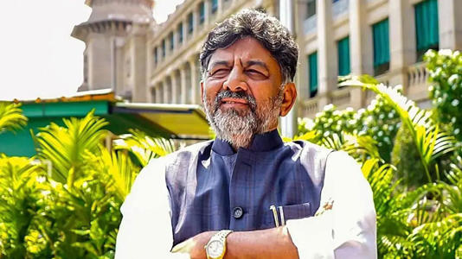](https://www.msn.com/en-in/entertainment/other/bjp-is-doing-politics-on-belagavi-incident-karnataka-dy-cm-dk-shivakumar/ar-AA1lCgz9?ocid=msedgntp&cvid=9052acf46492452facf0352df6aedb8b&ei=36&fullscreen=true#image=2)](https://www.msn.com/en-in/entertainment/other/bjp-is-doing-politics-on-belagavi-incident-karnataka-dy-cm-dk-shivakumar/ar-AA1lCgz9?ocid=msedgntp&cvid=9052acf46492452facf0352df6aedb8b&ei=36&fullscreen=true" \l "image=2" \t "_self)

BJP is doing politics on Belagavi incident: Karnataka Dy CM DK Shivakumar© Provided by Mid-Day

Karnataka [**Deputy Chief Minister DK Shivakumar**](https://www.mid-day.com/search/bengaluru-articles) lashed out at the Bharatiya Janata Party (BJP) for politicising the Belagavi incident despite the State government taking action against the culprits.

"The Home Minister, Women and Child Welfare Minister, and district in-charge minister have taken necessary action regarding this incident and yet the BJP is trying to exploit it politically. Our government is committed to protecting women in the state; strict legal action will be initiated against the culprits." Shivakumar said on Saturday while responding to a question asked by a reporter.

A 42-year-old woman was stripped naked, paraded, and assaulted after being tied to an electric pole early on Monday in [**Karnataka`s Belagavi district**](https://www.mid-day.com/search/karnataka-articles) after her son eloped with a woman. Seven people have been arrested in connection with the incident.

Speaking at the valedictory function of EXCON 2023, South Asia`s biggest construction equipment expo, Shivakumar said, "Confederation of Indian Industries has been organising EXCON for the construction equipment industry for the last 23 years. This expo introduces new technologies in the construction sector. One of the new things that I saw this year was the introduction of electric equipment for the construction sector. Many of the equipment in this expo is manufactured in Karnataka and is even exported."

The Deputy Chief Minister urged the organisers to allow engineering students to attend the expo next year so that they are exposed to new technologies. "Karnataka is known for high-quality education and it would help students explore the latest technology if they attended expos like this," he said. Shivakumar said that he saw several new-age technologies at EXCON 2023 that save time, enhance safety and protect the environment.

"I saw many technologies in the expo that save time, enhance safety and protect the environment. A hydrogen-run earth mover was the highlight of the expo. New technologies help save time in the construction sector. These advanced equipment have made it possible to complete a bridge in two years which would otherwise have taken five years."

The Deputy Chief Minister said that he could not be present for the inauguration of Excon 2023 as he had to attend the [**Karnataka winter session**](https://www.mid-day.com/news/india-news/article/karnataka-woman-assaulted-paraded-naked-after-son-elopes-with-girl-7-held-23324486) in Belagavi and so he came for the valedictory ceremony. "I was supposed to be at the expo for the inauguration but could not due to the session in Belagavi. I came for the valedictory ceremony to encourage the industry," he said.

This story has been sourced from a third party syndicated feed, agencies. Mid-day accepts no responsibility or liability for its dependability, trustworthiness, reliability and data of the text. Mid-day management/mid-day.com reserves the sole right to alter, delete or remove (without notice) the content in its absolute discretion for any reason whatsoever.

JSCIAR, India

19th December, 2023

Shri DKS – Bright views on Agriculture and irrigation

[[The New Indian Express](https://www.newindianexpress.com/)](https://www.newindianexpress.com/" \o "The New Indian Express" \t "_blank)

**[The New Indian Express](https://www.newindianexpress.com/" \o "The New Indian Express" \t "_blank)**

Follow

# DK Shivakumar may get nod for appointments to boards, corporations

9h

Shivakumar said he has sought a meeting with Prime Minister Narendra Modi to discuss irrigation projects and Bengaluru City development.

BENGALURU:  Deputy Chief Minister DK Shivakumar who is in the national capital on a two-day visit is likely to get approval from the Congress high command to the first list of appointments to boards and corporations.

“A meeting is scheduled with the high command, but I cannot discuss the agenda of the meeting in public. MLAs will be appointed to boards and corporations in the first phase. We will try to include some of the party workers also in the first phase if possible, as the appointments will happen in three phases,” he told reporters in New Delhi.

Shivakumar said he has sought a meeting with Prime Minister Narendra Modi to discuss irrigation projects and Bengaluru City development. “I have asked for time with the prime minister to discuss fund allocation for irrigation projects in the state, including the Upper Bhadra project, and Bengaluru City development. I am waiting for the confirmation.”, he told reporters.

“The PM has given time for the Chief Minister’s meeting. The CM will be discussing many key issues including drought relief, and an increase in MGNREGA man days. My meeting with the PM is yet to be confirmed, and hence, I have asked for time from the Union ministers in the meantime,” he clarified.

According to sources, the PM is unlikely to give an appointment to Shivakumar this time, following which the latter has sought appointments with certain Union ministers, including Jal Shakti Minister Gajendra Singh Shekhawat. “There is no protocol for the DCM to accompany the CM. The CM is taking the revenue minister along with him, as they will be discussing the drought issue,” a source said.

[[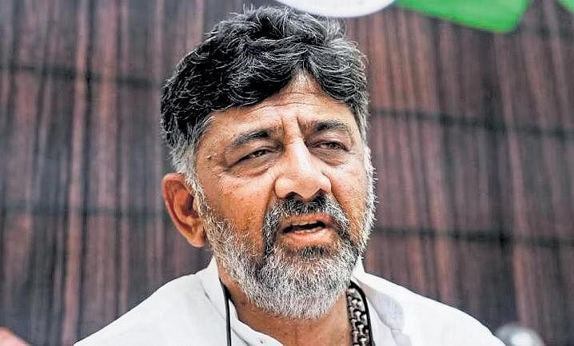](https://www.msn.com/en-in/news/India/dk-shivakumar-may-get-nod-for-appointments-to-boards-corporations/ar-AA1lHDlj?fullscreen=true#image=2)](https://www.msn.com/en-in/news/India/dk-shivakumar-may-get-nod-for-appointments-to-boards-corporations/ar-AA1lHDlj?fullscreen=true" \l "image=2" \t "_self)

DK Shivakumar may get nod for appointments to boards, corporations© Provided by The New Indian ExpressANI Video

**Shri Doddalahalli Kempegowda Shivakumar – Leader with financial planning and with ability to overcome the inter-party barriers**

https://www.msn.com/en-in/news/India/dk-shivakumar-draws-flak-for-seeking-central-grant-for-bengaluru-tunnel-road-project/ar-AA1lOLoz?ocid=msedgntp&cvid=1638564eadbd4dd7a822551747072084&ei=5

[[The New Indian Express](https://www.newindianexpress.com/)](https://www.newindianexpress.com/" \o "The New Indian Express" \t "_blank)

**[The New Indian Express](https://www.newindianexpress.com/" \o "The New Indian Express" \t "_blank)**

Follow

# DK Shivakumar draws flak for seeking Central grant for Bengaluru tunnel road project

3h

He urged the union finance minister to earmark funds in the budget for the project. Shivakumar stated that the project has been estimated at Rs 30,000 crore.

BENGALURU: Deputy Chief Minister DK Shivakumar has drawn flak for seeking funds for his ambitious Rs 30,000-crore 60-km tunnel road in Bengaluru even before getting approval for it.

Many in the government have taken exception to his move of taking it up with Union Finance Minister Nirmala Sitharaman.In a letter to Nirmala Sitharaman, Shivakumar stated that Bengaluru has become one of the most congested cities in the world. This tunnel project will help ease traffic in the city. The project will also help create an East-West and North-South corridor within the city and connect major arterial roads.

Shivakumar stated that the project has been estimated at Rs 30,000 crore. The project can be implemented jointly by the State government and the National Highways Authority of India as it connects some national highways. He urged the union finance minister to earmark funds in the budget for the project.

**Tunnel project not before fin department yet**

Meanwhile, sources in the state government said that the project proposal has not been placed before the finance department and has not even been approved by the cabinet.

A senior official said, “We should either approach the Union Government or go for the public-private partnership model. If we go for the PPP model, people have to pay toll charges. Why should people pay to use roads within the city?”

Prof MN Sreehari, the traffic expert, said any mega project needs technical and financial feasibility studies. Experts’ opinion should be taken. “Here, it looks like the government is eager to take up the project without even studying its pros and cons,” he added.

[[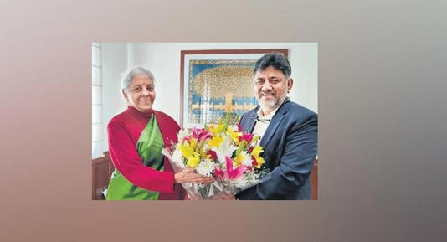](https://www.msn.com/en-in/news/India/dk-shivakumar-draws-flak-for-seeking-central-grant-for-bengaluru-tunnel-road-project/ar-AA1lOLoz?ocid=msedgntp&cvid=1638564eadbd4dd7a822551747072084&ei=5&fullscreen=true#image=2)](https://www.msn.com/en-in/news/India/dk-shivakumar-draws-flak-for-seeking-central-grant-for-bengaluru-tunnel-road-project/ar-AA1lOLoz?ocid=msedgntp&cvid=1638564eadbd4dd7a822551747072084&ei=5&fullscreen=true" \l "image=2" \t "_self)

DK Shivakumar draws flak for seeking Central grant for Bengaluru tunnel road project© Provided by The New Indian Express

JSCIAR, India,

21st December, 2023.

**Shri Doddalahalli Kempegowda Shivakumar – Leader with concern for citizens and their needs:**

https://www.msn.com/en-in/news/other/karnataka-deputy-cm-shivakumar-meets-minister-nirmala-sitharaman-seeks-funds-for-tunnel-road-bengaluru-metro-projects/ar-AA1lPp5n?ocid=msedgntp&cvid=3e98d480e8594124b25cc12f7f3994ef&ei=39

[[The Indian Express](http://indianexpress.com/)](http://indianexpress.com/" \o "The Indian Express" \t "_blank)

**[The Indian Express](http://indianexpress.com/" \o "The Indian Express" \t "_blank)**

Follow

# Karnataka Deputy CM Shivakumar meets Minister Nirmala Sitharaman, seeks funds for tunnel road, Bengaluru metro projects

Story by Express News Service  • 5h

[[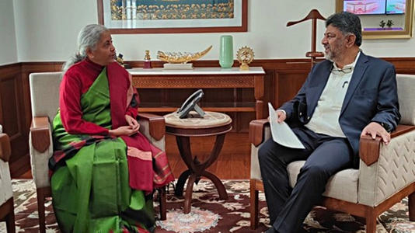](https://www.msn.com/en-in/news/other/karnataka-deputy-cm-shivakumar-meets-minister-nirmala-sitharaman-seeks-funds-for-tunnel-road-bengaluru-metro-projects/ar-AA1lPp5n?ocid=msedgntp&cvid=3e98d480e8594124b25cc12f7f3994ef&ei=39&fullscreen=true#image=2)](https://www.msn.com/en-in/news/other/karnataka-deputy-cm-shivakumar-meets-minister-nirmala-sitharaman-seeks-funds-for-tunnel-road-bengaluru-metro-projects/ar-AA1lPp5n?ocid=msedgntp&cvid=3e98d480e8594124b25cc12f7f3994ef&ei=39&fullscreen=true" \l "image=2" \t "_self)

Karnataka Deputy CM Shivakumar meets Minister Nirmala Sitharaman, seeks funds for tunnel road, Bengaluru metro projects© Provided by The Indian Express

Karnataka Deputy Chief Minister D K Shivakumar, who is in New Delhi, met Finance Minister Nirmala Sitharaman Wednesday and sought financial assistance for his ambitious tunnel road project for Bengaluru.

In a letter addressed to the minister, Shivakumar requested to allocate central funds for the state and the National Highways Authority of India (NHAI) in the next budget for the tunnel project connecting National Highways 7 and 4.

“Bengaluru city is facing severe traffic congestion and hence a 60-km tunnel project is being planned to ease traffic flow in the North-South corridor and East-West Corridor. At Rs 500 crore per km, the total cost of the tunnel project is estimated to be Rs 30,000 crore,” he stated in the letter.

The project, however, has not been welcomed by mobility experts and experts from the Indian Institute of Science, Bengaluru, who feel that construction of tunnel roads will only encourage people to use more private vehicles leading to a further increase in traffic volume.

Meanwhile, Shivakumar has called Expression of Interest (EoI) from various road engineering and construction firms to submit their proposals on the project. “Bengaluru roads can no longer be expanded because of buildings and other infrastructure works in progress. We also cannot stop people from buying private cars. Hence, the solution to decongest roads in the city is by constructing a tunnel road that can enable seamless travel,” Shivakumar had said.

With the state government giving approval for the Metro project connecting Hebbal and Sarjapur and plans of extending the Metro service to Bidadi, Shivakumar sought the approval of the Central government for the same as per the extension plan prepared by Bengaluru Metro Rail Corporation Limited (BMRCL).

Further, the letter also sought the Finance Ministry’s approval and assistance for a proposal the state government has submitted to the World Bank seeking a financial aid of Rs 3,000 crore to develop flood mitigation infrastructure in Bengaluru city.

## **Seeks nod for Mekedatu detailed project report**

The letter also sought Nirmala Sitharaman’s intervention in obtaining the approval of the Water Resources Ministry for the detailed project report on the Mekedatu project.

Mekedatu project envisages building a 67 TMC dam across river Cauvery with the objective of having a buffer stock, producing electricity and providing drinking water to Bengaluru city. The feasibility report of the project has received the nod from the Central Water Commission. The detailed project report was submitted in 2019 but is yet to get approved by the Water Resources Ministry.

Shivakumar also requested for an intervention in getting a Gazette notification for the third phase of Upper Krishna project, a lifeline for the North Karnataka region. The Krishna Water Tribunal 2 had passed an order in 2010 allowing Karnataka to use 173 TMC from the Krishna basin.

The third phase of the Upper Krishna project provides for usage of 130 TMC of water. This project is estimated to irrigate 5.94 lakh hectares in Vijayapura, Bagalkote, Kalaburgi, Raichur, Yadgir and Koppal districts. Though the Rs 16,900-crore project was cleared by the Krishna Water Tribunal a decade ago, it is yet to be notified in the Gazette, leading to water accessibility crisis in the region.

The letter also stressed on the immediate release of Rs 5,300 crore of Central funds for the Upper Bhadra project as announced in the previous Union Budget. The central government had declared the Upper Bhadra project a national project and allocated Rs 5,300 crore in the 2023-24 budget. The letter stated that the delay in release of funds is hampering the progress of the project that is estimated to irrigate 2.25 lakh hectares in Chikmagalur, Chitradurga, Tumkur and Davanagere districts.

The letter urged minister Sitharaman to help get environmental clearance from the Centre for the Kalasa Bhanduri project.

The Mahadayi Water Disputes Tribunal had, in its 2018 order, allocated 1.72 TMC for Kalasa and 2.18 TMC for Bhanduri drinking water projects. The detailed project report was accepted by the Central Water Commission.

In addition, the letter also sought Central funds to the tune of Rs 9,177.32 crore for the Yettinahole project to meet drinking water needs of Kolar, Chikkaballapura and Tumakuru districts. The total cost of the project is Rs 23,251 crore, of which the state government has already spent Rs 14,698 crore.

**Shri DKS – Leader with right assessment of the strength and weekness of Governement**

https://www.msn.com/en-in/news/India/files-piling-up-staff-overstretched-karnataka-govt-depts-at-half-capacity-as-posts-lie-vacant/ar-AA1lQ7gN?ocid=msedgntp&cvid=805f884ed1ab40c28c70176cc5789dd1&ei=37

[[ThePrint](https://theprint.in/)](https://theprint.in/" \o "ThePrint" \t "_blank)

**[ThePrint](https://theprint.in/" \o "ThePrint" \t "_blank)**

Follow

# Files piling up, staff overstretched — Karnataka govt depts at half capacity as posts lie vacant

Story by Sharan Poovanna  • 1h

[[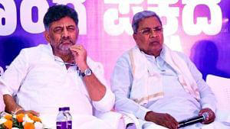](https://www.msn.com/en-in/news/India/files-piling-up-staff-overstretched-karnataka-govt-depts-at-half-capacity-as-posts-lie-vacant/ar-AA1lQ7gN?ocid=msedgntp&cvid=805f884ed1ab40c28c70176cc5789dd1&ei=37&fullscreen=true#image=2)](https://www.msn.com/en-in/news/India/files-piling-up-staff-overstretched-karnataka-govt-depts-at-half-capacity-as-posts-lie-vacant/ar-AA1lQ7gN?ocid=msedgntp&cvid=805f884ed1ab40c28c70176cc5789dd1&ei=37&fullscreen=true" \l "image=2" \t "_self)

Files piling up, staff overstretched — Karnataka govt depts at half capacity as posts lie vacant© Provided by ThePrint

**Bengaluru:** Several government departments in Karnataka are working with just over half its actual capacity as the Congress-ruled state seemingly attempts to keep salaries and other expenses in check to deliver high-cost poll guarantees to the people.

The large number of vacant posts has been piling pressure on already stretched and limited resources, and thereby impacting efficiency, clearing files and turnaround time, government officials say.

This comes at a time when the Siddaramaiah government prepares to roll out its fifth guarantee, the Yuva Nidhi programme, for providing financial assistance to the unemployed. While unemployed degree and diploma holders can register for the scheme from 26 December, the government is gearing up for its launch from 1 January, 2024.

“There is a severe shortage of officials and since elections (the Lok Sabha) are fast approaching, there will be more diverting of resources,” a government official from Mysuru told ThePrint.

On 6 December, the excise department [withdrew permission](https://theprint.in/india/ahead-of-new-year-karnataka-govt-denies-breweries-in-mysuru-permission-to-run-3rd-shift/1880272/) for a third shift of operations to at least four beer manufacturers in the region citing a shortage of officials.

Excise is one of the biggest revenue generators for the government. On Monday, the department restored permission to the breweries to operate from 10 p.m. to 6 a.m. following a backlash.

“Each distillery requires two officers. So for four, we need eight (officers) but we do not have that kind of strength. Almost all departments (of the government) are running at 55-60 percent. There is a shortage in all of them,” the official cited above said.

### Poll promises to electorate

In May, the Congress party stormed to power with the promise of delivering on its five guarantees of 200 units of free electricity, free travel for women in public buses, financial assistance to women head of the household and for unemployed youngsters as well as expanding its flagship ‘Anna Bhagya’ to 10 kg per person per month. These schemes are [estimated](https://theprint.in/politics/5-pre-poll-promises-siddaramaiah-govt-vows-to-fulfil-in-fiscal-yr-how-much-itll-cost-exchequer/1608822/) to cost around Rs 50,000 crore per year.

In its election manifesto, the Congress party assured to start recruitment to various government departments soon after it comes to power. According to latest government estimates, there are over 2.55 lakh vacancies in Group A-D as well as other categories in the state and districts.

Of the total 3,73,640 sanctioned posts in the state, there are 1,36,493 vacancies, according to data, from the finance department. Similarly, out of the total 3,98,385 sanctioned posts in the districts, 1,19,427 are lying vacant.

In total, there are over 7.72 lakh sanctioned posts, of which only 5,16,105 are currently filled. There are around 5,20,000 employees in its 72 departments across all grades.

“My department is not so bad. (The shortage) depends on the cadre… Some are 10 percent (vacant), some 20 percent. but we are doing some recruitment,” Revenue Minister Krishna Byre Gowda told ThePrint.

On Wednesday, Bharat Rashtra Samithi (BRS) leader K.T.Rama Rao took a dig at the Congress party for not living up to its promise of filling up government vacancies.

Hi Priyank Ji

Glad you too decided to join the issue.

Are these statements from your leader Rahul Gandhi about employment to 2lakh Karnataka youth and from Deputy CM on empty treasury also Fake?

Buddy, we defeated all the BJP bigwigs in Telangana including all three of their… <https://t.co/jFC2nF0TgU> [pic.twitter.com/pkIstc5Yg5](https://t.co/pkIstc5Yg5)

— KTR (@KTRBRS) [December 20, 2023](https://twitter.com/KTRBRS/status/1737299099425362197?ref_src=twsrc%5Etfw)

The former Telangana minister was referring to the March 20 statement by former Congress president Rahul Gandhi who [promised](https://theprint.in/india/rahul-gandhi-promises-unemployment-aid-filling-up-2-5-lakh-govt-job-vacancies-in-poll-bound-karnataka/1458447/) filling up of government vacancies if the party returned to power in Karnataka.

In December, the Congress wins 64 seats in the Telangana elections, ending the 10-year rule of the BRS party.

### ‘Bloating revenue expenditure’

 The acute shortage of officials is not limited to the Grade A-D and can also be seen among the IAS cadre as well, people aware of the developments say.

There are also several senior IAS officers like L.K.Ateeq, Jawaid Akthar, and Priyanka Mary Francis who hold concurrent portfolios.

Ateeq, additional chief secretary (finance), holds concurrent charge as ACS to the chief minister. Akthar, the ACS (forest & ecology), is also the ACS of the government. On Saturday, Priyanka, the commissioner for Panchayat Raj Commissionerate, was given the additional responsibility of the panchayat raj department.

“There is a huge shortage in secretary and above scale…between 1990 and 2000 batches, Karnataka was getting only 3-4 officers ..so those are the batches who are secretary, principal secretary and additional chief secretary level. There was a huge sudden shortage and people are forced to have concurrent charges,” a senior official said.

Several retirements have opened vacancies but there are not enough people to replace since many are not up for promotions, the official added.

But the shortage in senior administrative ranks is not as stark compared to those of other grades. And a large reason it remains so is because of consistent government policies that have not proactively gone into recruitment and the attempt to keep revenue expenditure down, officials say.

“Revenue expenditure bloating is definitely one of the considerations,” according to the senior government official cited above.

Revenue expenditure — short-term expenses used in the current period or typically within one year — for 2023-24 was estimated at Rs 2,50,933 crore, an increase of 15 percent over the revised estimate of 2022-23.

Many of the officials ThePrint spoke to say there is an attempt to correct this anomaly but it all depends on the government. There have been some attempts to recruit more people but the shortage is far too many, they add.

“Generally there are 40-45 percent vacancies (in govt. departments). Those vacancies can be filled up and this can be corrected. But those vacancies exist because governments over the years have not permitted recruitment,” the senior official cited above said.

(Edited by Tony Rai)

JSCIAR, India,

22nd December 2023.

**[Shri Doddalahalli Kempegowda Shivakumar – Leader with concern for citizens health and providing timely counselling](https://newsable.asianetnews.com/" \o "Newsable Asianet News" \t "_blank)**

**[Newsable Asianet News](https://newsable.asianetnews.com/" \o "Newsable Asianet News" \t "_blank)**

FolloKarnataka announces relaxed COVID guidelines for Christmas and New Year celebrations

[[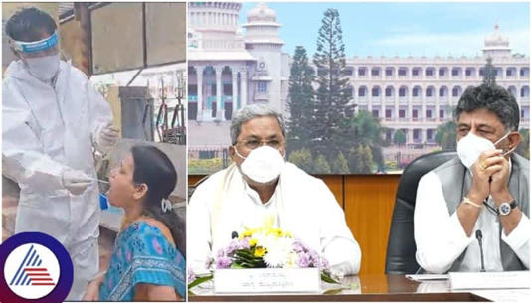](https://www.msn.com/en-in/news/India/karnataka-announces-relaxed-covid-guidelines-for-christmas-and-new-year-celebrations/ar-AA1lQdNL?ocid=msedgntp&cvid=8800aebad88a44a1a76ea80c288cd085&ei=28&fullscreen=true#image=2)](https://www.msn.com/en-in/news/India/karnataka-announces-relaxed-covid-guidelines-for-christmas-and-new-year-celebrations/ar-AA1lQdNL?ocid=msedgntp&cvid=8800aebad88a44a1a76ea80c288cd085&ei=28&fullscreen=true" \l "image=2" \t "_self)

Karnataka announces relaxed COVID guidelines for Christmas and New Year celebrations© Provided by Newsable Asianet News

However, the Siddaramaiah emphasised the importance of continued vigilance and adherence to safety protocols, especially for those over 60 years of age. He highlighted the importance of striking a balance between freedom and caution by making mask-wearing compulsory for individuals aged 60 and above, while not extending the mandate to the general population. This targeted approach aims to protect the more vulnerable age group while allowing others the flexibility to enjoy the holiday season without unnecessary restrictions.

Siddaramaiah assured the public that the state is well-prepared to handle any potential surge in COVID cases. He emphasised that all necessary arrangements, including oxygen supply, beds, ventilators, and medicines, have been put in place across dedicated COVID hospitals in various districts. The Chief Minister also urged citizens to proactively get vaccinated, emphasising preparedness ahead of any potential challenges. Addressing concerns about the Omicron variant, Siddaramaiah clarified that the current subspecies JN.1 is not considered highly dangerous.

While acknowledging the presence of 92 cases in the state, with the majority in Bengaluru, the Chief Minister reassured the public that only a small fraction required hospitalization. He urged media outlets to avoid creating unnecessary panic and underscored the importance of responsible reporting. The Chief Minister also announced the formation of a cabinet sub-committee that will enhance infection control measures through continuous collaboration with the advisory committee and regular monitoring of the situation. The government will ramp up testing in border districts to ensure a comprehensive approach to monitoring and managing the spread of the virus.

JSCIAR, India,

27th December, 2023.

**Shri Doddalahalli Kempegowda Shivakumar – A loyal Dy Chief minister**

https://www.msn.com/en-in/news/India/is-pm-modi-economist-asks-siddaramaiah-at-launch-of-registration-of-poll-guarantee-yuva-nidhi/ar-AA1m2NDl?ocid=msedgntp&cvid=e3fc4f45b7934dbab619f00a546dfad1&ei=10

Follow

# Is PM Modi economist, asks Siddaramaiah at launch of registration of poll guarantee 'Yuva Nidhi'

Story by PTI  • 17h

[[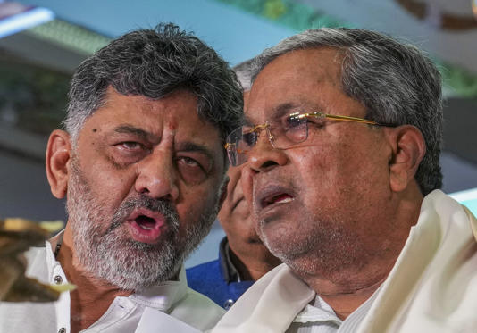](https://www.msn.com/en-in/news/India/is-pm-modi-economist-asks-siddaramaiah-at-launch-of-registration-of-poll-guarantee-yuva-nidhi/ar-AA1m2NDl?ocid=msedgntp&cvid=e3fc4f45b7934dbab619f00a546dfad1&ei=10&fullscreen=true#image=2)](https://www.msn.com/en-in/news/India/is-pm-modi-economist-asks-siddaramaiah-at-launch-of-registration-of-poll-guarantee-yuva-nidhi/ar-AA1m2NDl?ocid=msedgntp&cvid=e3fc4f45b7934dbab619f00a546dfad1&ei=10&fullscreen=true" \l "image=2" \t "_self)

Is PM Modi economist, asks Siddaramaiah at launch of registration of poll guarantee 'Yuva Nidhi'© PTI

**Bengaluru, Dec 26 (PTI)** Karnataka Chief Minister Siddaramaiah on Tuesday hit out at Prime Minister Narendra Modi for criticising the five guarantees of the Congress government and wondered whether he was an economist.

[[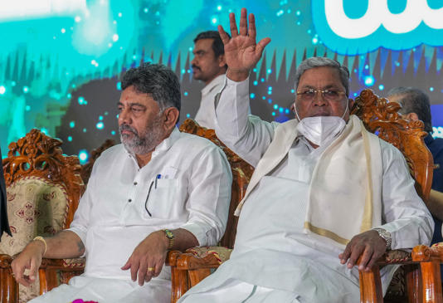](https://www.msn.com/en-in/news/India/is-pm-modi-economist-asks-siddaramaiah-at-launch-of-registration-of-poll-guarantee-yuva-nidhi/ar-AA1m2NDl?ocid=msedgntp&cvid=e3fc4f45b7934dbab619f00a546dfad1&ei=10&fullscreen=true#image=2)](https://www.msn.com/en-in/news/India/is-pm-modi-economist-asks-siddaramaiah-at-launch-of-registration-of-poll-guarantee-yuva-nidhi/ar-AA1m2NDl?ocid=msedgntp&cvid=e3fc4f45b7934dbab619f00a546dfad1&ei=10&fullscreen=true" \l "image=2" \t "_self)

Is PM Modi economist, asks Siddaramaiah at launch of registration of poll guarantee 'Yuva Nidhi'© PTI

He also took a dig at the prime minister for failing to offer two crore jobs a year as promised 10 years ago.

"Mr Prime Minister, our Congress government has implemented all the five guarantees in Karnataka. Your statement that the state will go bankrupt has proved wrong," he said.

Siddaramaiah was speaking at the launch of the registration of Congress party’s fifth and final poll guarantee ‘Yuva Nidhi’ offering unemployment assistance of Rs 3,000 to graduates and Rs 1,500 to diploma holders who passed in the academic year 2022-23.

[[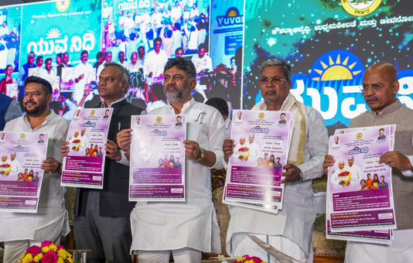](https://www.msn.com/en-in/news/India/is-pm-modi-economist-asks-siddaramaiah-at-launch-of-registration-of-poll-guarantee-yuva-nidhi/ar-AA1m2NDl?ocid=msedgntp&cvid=e3fc4f45b7934dbab619f00a546dfad1&ei=10&fullscreen=true#image=2)](https://www.msn.com/en-in/news/India/is-pm-modi-economist-asks-siddaramaiah-at-launch-of-registration-of-poll-guarantee-yuva-nidhi/ar-AA1m2NDl?ocid=msedgntp&cvid=e3fc4f45b7934dbab619f00a546dfad1&ei=10&fullscreen=true" \l "image=2" \t "_self)

Is PM Modi economist, asks Siddaramaiah at launch of registration of poll guarantee 'Yuva Nidhi'© PTI

"Is Modi an economist? He had said that Karnataka will go bankrupt if the five guarantees are implemented. The reality is that the state has grown financially strong now with the implementation of five guarantees," the chief minister claimed.

"Have you (PM Modi) created two crore jobs a year as promised by you? You should have created 20 crore jobs in 10 years. Did you create so many jobs? You failed to keep up your word," Siddaramaiah charged.

The chief minister explained that the state government will offer free training to youth besides giving them Yuva Nidhi assistance.

He also told the gathering that the disbursement of the benefit will start from Vivekananda Jayanti on January 12, 2024. The money will be directly deposited into the bank accounts of the beneficiaries.

Siddaramaiah also said that the government will take steps to fill the vacant jobs in the state.

Deputy Chief Minister D K Shivakumar, Skill Development and Entrepreneurship Minister Sharanaprakash Patil and Transport Minister Ramalinga Reddy, were among those who were present on the occasion.

According to officials, financial assistance would be given to those who do not get a job even after completion of 180 days from the date of passing the degree/diploma. The candidates are required to prove domicile of Karnataka for a minimum of six years, they said.

The unemployment allowance would be given for a period of two years from the date of announcement of the result or till he/she becomes employed/self-employed whichever is earlier.

Candidates who are self-employed and continuing higher education are excluded from the scheme.

According to Skill Development and Entrepreneurship Minister Sharanaprakash Patil, this year Rs 250 crore has been allocated to the scheme. Next year an expenditure of Rs 1,250 crore is anticipated and the year after that the state may incur a spending of approximately Rs 2,500 crore.

Those who wish to avail the benefit can apply by logging on to 'Seva Sindhu portal', or through 'Karnataka One', 'Bengaluru One', 'Grama One' and 'Bapuji Seva Kendra'. The enrollment will be free of cost, he added.

JSCIAR, India,

27th December, 2023.

<https://www.oneindia.com/politicians/d-k-shivakumar-6041.html>

D K Shivakumar DK Shivakumar is the current Deputy Chief Minister of Karnataka in Siddaramaiah's cabinet since 20th May 2023. He also holds the portfolios of Major & Medium Irrigation, Bengaluru City Development as Minister in the government of Karnataka. D. K Shivakumar, the current President of the Karnataka Pradesh Congress Committee (KPCC). He is also a long-term MLA of the Indian National Congress political party. He recently won the 2023 state assembly elections representing the Kanakapura constituency.  
  
Read more at: <https://www.oneindia.com/politicians/d-k-shivakumar-6041.html>

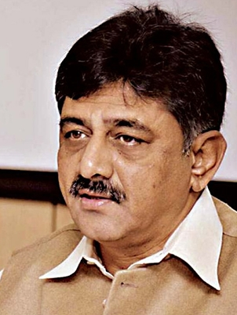

Home»Politicians»D K Shivakumar D K Shivakumar DK Shivakumar is the current Deputy Chief Minister of Karnataka in Siddaramaiah's cabinet since 20th May 2023. He also holds the portfolios of Major & Medium Irrigation, Bengaluru City Development as Minister in the government of Karnataka. D. K Shivakumar, the current President of the Karnataka Pradesh Congress Committee (KPCC). He is also a long-term MLA of the Indian National Congress political party. He recently won the 2023 state assembly elections representing the Kanakapura constituency. Quick Links D K Shivakumar BiographyD K Shivakumar Personal LifeEducation Qualification of D K ShivakumarPolitical Timeline of D K ShivakumarD K Shivakumar AchievementsInteresting Facts about D K ShivakumarD K Shivakumar Early LifeD K Shivakumar Net WorthElection history of D K ShivakumarFAQ on D K ShivakumarD K Shivakumar Latest News & Updates Select Your State  D K Shivakumar Biography Doddalahalli Kempegowda Shivakumar, briefly known as DK Shivakumar is eight times elected MLA since 1989. DK Shivakumar is known for his dynamism and is a powerhouse of the Congress party, who has been elected as a minister several times. In the 2023 assembly elections, Shivakumar won by securing 75.03 percent of votes from the constituency of Kanakapura. Before that, he also held portfolios of energy, urban development, home, etc., in the government of Karnataka. D K Shivakumar Personal Life Full Name D K Shivakumar Date of Birth 15 May 1962 (Age 61) Place of Birth Doddalahalli Kempegowda Party name Indian National Congress Education Post Graduate Profession Agriculturist, Businessmen, Educationist and Social Worker Father's Name Kempegowda Mother's Name Gouramma Spouse's Name Usha Shivakumar Spouse's Profession Businesswomen and Educationist Children 1 Son(s) 2 Daughter(s) Religion Hindu Caste Vokkaliga Permanent address 127, Doddaalahalli Kanakpura Taluk, Ramanagara District, Karnataka562126 Present address 127, Doddaalahalli Kanakpura Taluk, Ramanagara District, Karnataka562126 Contact number 9845156524 Email dkshivakumar1@gmail.com Website https://www.dkshivakumar.com/ Social Handles https://www.facebook.com/DKShivakumar.official/ https://twitter.com/dkshivakumar Education Qualification of D K Shivakumar DK Shivakumar holds a master's degree in Political Science, pursued from Karnataka State Open University, Mysore. Interesting Facts about D K Shivakumar 1. Shivakumar is among the richest politicians in Karnataka. While filing his nomination for election in 2023, he declared total assets of ₹1413 crore, whereas, he declared assets of ₹840 crore+ during the 2018 assembly election. This is an increase of more than ₹573 crore+ in the last five years. 2. His parents did not have kids for 3 years. So they went to Shivaldhappa Temple and prayed Lord Shiva for his blessing for a child. After which they had a boy child and named the child after God’s name as “Shivakumar” 3. He was elected a Secretary of Student Union in his College days. He remained an active sports person with unbeatable flair for extra curricular activities, represented school in sports and developed team leadership at a very young age. Political Timeline of D K Shivakumar 2023 - Incumbent He was sworn in as the Deputy Chief Minister of Karnataka on May 20, 2023. He also holds the portfolios of Major & Medium Irrigation, Bengaluru City Development as Minister in the government of Karnataka. 2023 - Incumbent Won the 2023 assembly election from Kanakapura constituency as an INC candidate. 2018 He got elected from Kanakapura and held the position of Minister of Irrigation and Medical Education. 2013 From 2013 to 2018, he was re-elected as an MLA from Sathanur and then was assigned the role of Ministry of Energy under Sri Siddaramaiah’s government. 2004 He merged a winner from Sathanur again in the Assembly elections. 2002 Again in 2002, I was put in charge of the Urban Development Ministry and also became the Chairman of the Karnataka State Town Planning Board. 1999 He played a huge role in convincing S M Krishna to contest for the Rajya Sabha seat and extended his full sport, and helped him emerge as an unbeatable winner with over 139 seats in Assembly elections. 1991 When Sri Veerendra Patil was to step down as Chief Minister due to his ill health he played a prominent role in getting Sri S Bangarappa elected as a successor and supported him. He was then selected as Minister berth (Minister of State for Prisons, Home Guards) from 1991-1992. 1989 He was elected as a member of Bangalore Rural Zilla Panchayat, and later he withstood a political conspiracy hatched by political rivals within Congress Party and was denied a congress ticket in 1989. 1987 He contested as an Independent candidate from the Sathanur assembly constituency and was elected as MLA at the age of 27. 1985 He was chosen as a party candidate in legislative elections by Congress in the Sathanur constituency against the political giant of the Janata Party, Sri H D Deve Gowda, and he lost by a small margin. D K Shivakumar Early Life Early 80's Completed Bachelor of Arts from Sri Jagadguru Renkacharya College, Bengaluru Completed Master of Arts in Political science From Karnataka State Open University, Mysuru Early 70's Completed SSLC from Vidyavardhaka, Bengaluru Completed PUC from Hyderabad Karnataka Education Society, Bengaluru Lok Sabha Security Breach: Lok Sabha MPs overpower intruders; 4 detained | Oneindia D K Shivakumar Achievements He became a minister at a very young age of 30 in the Government under the leadership of late CM Shri Bangarappa. He served as Minister of State for Home taking care of Departments of Home Guards and Prisons. As the Chairman of the Cabinet subcommittee, he played a prominent role in formulating and initiating Rajiv Gandhi Yuva Shakthi Sanghatan, being active in rallies, and empowering the youths to take up rural development and social work. He played a major role in planning the underpasses and flyovers for Karnataka including the construction of the K. R. Market flyover. From 2013-2018 he handled the Ministry of Energy in Karnataka which was in a doldrum for a long. DKS has also initiated building India’s Largest Solar Power Plant in Pavagada, Tumkur. His involvement and strategy in bringing victory in several crucial by-polls like Bellary and Bihar elections are much valued. D K Shivakumar Net Worth Net Worth ₹910.73 CRORE ASSETS ₹1413.8 CRORE Liabilities ₹503.07 CRORE Disclaimer: The information relating to the candidate is an archive based on the self-declared affidavit filed at the time of elections. The current status may be different. For the latest on the candidate kindly refer to the affidavit filed by the candidate with the Election Commission of India in the recent election. Election Results of D K Shivakumar Year Election Type Constituency Result 2023 Karnataka Assembly election MLA Kanakapura WON 2018 Karnataka Assembly election MLA Kanakapura WON 2013 Karnataka Assembly election MLA Kanakapura WON 2008 Karnataka Assembly election MLA Kanakapura WON 2004 Karnataka Assembly election MLA Sathanur WON 1999 Karnataka Assembly election MLA Sathanur WON 1994 Karnataka Assembly election MLA Sathanur WON 1989 Karnataka Assembly election MLA Sathanur WON 1985 Karnataka Assembly election MLA Sathanur LOST Frequently Asked Questions (FAQs on D K Shivakumar) Is D K Shivakumar going to be the next Deputy Chief Minister of Karnatka? Yes, D K Shivakuamar is set to be sworn-in as the next Deputy Chief Minister of Karnataka on 20th May, 2023. What is DK Shivakumar's current Networth? As per the 2023 affidavit, D K Shivakumar has a net worth of ₹910.73 Crore. Which candidate holds the 2nd position with highest liabilities in the 2023 Karnataka assembly election? According to the 2023 affidavit, Congress MLA D.K. Shivakumar holds the 2nd position with the highest liabilities in the fray of the 2023 Karnataka assembly election. He has total liabilities of ₹265 Crore+. Who is the 3rd candidate with highest number of assets in the 2023 Karnataka assembly election? As per the 2023 affidavit, KPCC president D K Shivakumar holds the 3rd position with the highest number of assets in the Karnataka assembly election. He has assets of ₹1413 Crore+. What is the assets update of D K Shivakumar? As per the 2023 report, D K Shivakumar has total assets of 1413 crore+. What is the date of birth of DK Shivakumar? D K Shivakumar's date of birth is 15th May 1962. How old is D K Shivakumar? D K Shivakumar is 61 years old (As of 2023). Is D K Shivakumar married? Yes, D K Shivakumar is married to Usha Shivakumar. Does D K Shivakumar have criminal cases? D K Shivakumar has 19 criminal cases (As per 2023 affidavit). What is the qualification of D K Shivakumar? D K Shivakumar holds a master's degree in Political Science. From which party does D K Shivakumar belong to? D K Shivakumar belongs to the Indian National Congress political party. What is the full name of D K Shivakumar? D K Shivakumar's full name is Doddalahalli Kempegowda Shivakumar. Who is D K Shivakumar? D K Shivakumar is the current President of the Karnataka Pradesh Congress Committee.  
  
Read more at: <https://www.oneindia.com/politicians/d-k-shivakumar-6041.html#biography>

JSCIAR, India,

28th December, 2023.

**Shri Doddalahalli Kempegowda Shivakumar – A leader with the fervour of nationality beyond regional and language barriers**

[[Press Trust of India](https://www.ptinews.com/)](https://www.ptinews.com/" \o "Press Trust of India" \t "_blank)

**[Press Trust of India](https://www.ptinews.com/" \o "Press Trust of India" \t "_blank)**

https://www.msn.com/en-in/news/India/won-t-allow-anyone-to-go-on-rampage-in-karnataka-dy-cm-shivakumar/ar-AA1m8tZR?ocid=msedgntp&cvid=ed7b5150aefb44a38537c7693b407acc&ei=2

Follow

# Won't allow anyone to go on rampage in Karnataka: Dy CM Shivakumar

Story by PTI  • now

[[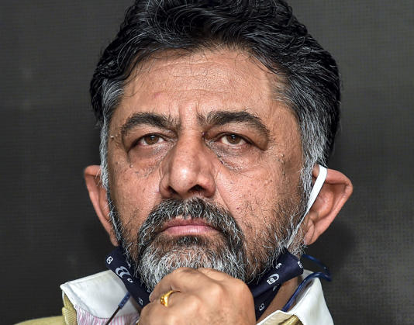](https://www.msn.com/en-in/news/India/won-t-allow-anyone-to-go-on-rampage-in-karnataka-dy-cm-shivakumar/ar-AA1m8tZR?ocid=msedgntp&cvid=ed7b5150aefb44a38537c7693b407acc&ei=2&fullscreen=true#image=2)](https://www.msn.com/en-in/news/India/won-t-allow-anyone-to-go-on-rampage-in-karnataka-dy-cm-shivakumar/ar-AA1m8tZR?ocid=msedgntp&cvid=ed7b5150aefb44a38537c7693b407acc&ei=2&fullscreen=true" \l "image=2" \t "_self)

Won't allow anyone to go on rampage in Karnataka: Dy CM Shivakumar© PTI

**Bengaluru, Dec 28 (PTI)** Karnataka Deputy Chief Minister D K Shivakumar on Thursday said the government will not allow anyone to take law into their own hands in the state in the name of fighting for the Kannada language.

He was reacting to the large-scale vandalism in Bengaluru by the activists of Karnataka Rakshana Vedike (Narayana Gowda faction) targeting shops and business establishments which did not have Kannada signboards, advertisements and name plates.

"We are not against the pro-Kannada activists but they should not take law into their hands. We are not ready to accept damage caused to the properties in Bengaluru," Shivakumar told reporters here.

"We have to save Kannada and we respect those who fight for saving Kannada but that should not mean that the government will shut it's eyes to vandalism," he added.

The Deputy CM said the government directions are clear that signboards, advertisements and name plates should have 60 per cent Kannada and there is a way to implement it such as issuing notices to those violating this norm.

The protesters can stage protests and raise slogans but damaging property is not acceptable, he said.

"We are committed to save Kannada. Even the CM has directed us to have all the communications and our official business in Kannada. He had said that the government is committed to save Kannada," Shivakumar told reporters.

To a question that T A Narayana Gowda, KRV convener, has given a warning to the government that it will face the music during the Lok Sabha elections if it did not respect the sentiments of Kannadigas, Shivakumar said let them do whatever they want in a democratic manner but vandalism is not accepted.

"Investors have come here from different parts of the world. People are living here to make their livelihood. They should not be threatened," he added.

Meanwhile, a Magistrate Court in Bengaluru has sent over 29 Kannada activists including Karnataka Rakshana Vedike president TA Narayana Gowda, to 14 days judicial custody till January 10.

They were arrested by the police on Wednesday after their protests demanding that 60 per cent of nameboards in commercial establishments to be in Kannada turned violent with destruction of boards that were in English.

Police had detained nearly 500 activists of the KRV who went on the rampage across Bengaluru and other parts of Karnataka.

Gowda was arrested along with some of his aides in Yelahanka. On Thursday at around 5 AM, he was produced before a Magistrate at his residence in Devanahalli who ordered the judicial custody of the arrested persons.

The police have registered three separate FIRs at the Chikkajala Police Station against Gowda and 28 others under Sections 188, 283, 341, 353 and 427 of the Indian Penal Code.

The allegations include assault or criminal force to deter public servant from discharge of his duty, wrongful restraint, mischief, cause danger, obstruction or injury to any person and disobedience to order duly promulgated by public servant.

After their detention on Wednesday evening, Gowda and others were kept at the Police Driving and Maintainance School in Yelahanka before being taken for medical examination and produced before the Magistrate.

Sources said they will be shifted to the Central Jail at Parappana Agrahara in the city.

**JSCIAR,**

**2nd January 2023.**

**Shri Doddalahalli Kempegowda Shivakumar – Honest leader declaring his vast assests truly – being haunted for speaking truth**

**Yet, thus saith the word of the LORD: “Many are the afflictions of the righteous; but the LORD will deliver them from all.”**

[[The New Indian Express](https://www.newindianexpress.com/)](https://www.newindianexpress.com/" \o "The New Indian Express" \t "_blank)

**[The New Indian Express](https://www.newindianexpress.com/" \o "The New Indian Express" \t "_blank)**

Follow

# Big conspiracy going on to finish me politically, says Karnataka Deputy CM Shivakumar

15h

https://www.msn.com/en-in/news/India/big-conspiracy-going-on-to-finish-me-politically-says-karnataka-deputy-cm-shivakumar/ar-AA1miPau

CBI had issued a notice to Jaihind Communications on Sunday seeking details of the investments made in the channel by Shivakumar in connection with a disproportionate assets case.

BENGALURU: With the Central Bureau of Investigation serving notice to Kerala-based Jaihind Communications Pvt Ltd channel headed by him, Karnataka Deputy Chief Minister D K Shivakumar on Monday alleged that a big conspiracy is going on to finish him politically.

The central agency issued a notice to the firm on Sunday seeking details of the investments made in the channel by Shivakumar in connection with a disproportionate assets case against the Congress leader.

The Bengaluru unit of the agency, which is probing the case against Shivakumar, had asked the managing director of Jaihind Communications Pvt. Ltd. to appear before it on January 11, 2024, along with all the requisite documents sought by the investigation officer.

Reacting to the latest development, the Deputy CM said if the CBI wants to arrest him, then let them do so as he is prepared for it.

Shivakumar, who is also the Karnataka Congress unit president, wondered how the CBI was issuing notices against his firm though it had all the documents with it.

"I don't know how they are issuing notices. They have all the documents with them. It's not because they don't have any documents. There are big people to harass me. I know it all. It's not that I am unaware of it. Let them do whatever they want to finish me politically," Shivakumar, who is an MLA from Kanakapura, told reporters here.

"There is a big conspiracy going on. Some BJP leaders had said earlier that they would send me to jail. They have conveyed their message to the department concerned. I have asked those who have spoken about me to come for discussion. There is a big plot being hatched," he said.

Stating that he has not done anything wrong, and he will get justice, Shivakumar said let the CBI conduct any inquiry against him.

To a question whether he had got the notice, he said his firm had got it.

"My partnership firm of which I am the chief, has been served notice. They are asking my children, my wife and relatives. The CBI is asking our family members and those from our village who are directors of the society," Shivakumar explained.

When asked whether he got individual notice, he said the CBI will first finish their investigation at the firm level and then come after him.

Shivakumar said the state government had handed over the matter to Lokayukta though he did not request or insist on it.

The government has withdrawn the permission granted to the CBI to prosecute cases against him and handed over the case to the Lokayukta.

He said that he would answer the Lokayukta whenever it asks for it.

"Earlier the case was given to the CBI. The investigation has not been completed yet. They wanted cross-examination, which they haven't done. Now, based on their notice, (it seems) they did not do even 10 per cent of the investigation, but they told the court that 90 per cent of the inquiry is over. I don't know the basis behind their claim," Shivakumar pointed out.

To a question about whether he would challenge the notice, he said the CBI is summoning him but there is "no occasion" for him to go there.

"They are asking me to challenge their notice. If they want to see me behind bars, then let them do it. I have no problem. I am ready for it," he said.

Shivakumar who is accused in a money laundering case, had spent 51 days in Tihar Jail in 2019.

Recently, the Karnataka government withdrew the permission granted to the CBI to probe cases against Shivakumar, saying that it was 'not in accordance with law'.

[[](https://www.msn.com/en-in/news/India/big-conspiracy-going-on-to-finish-me-politically-says-karnataka-deputy-cm-shivakumar/ar-AA1miPau?fullscreen=true#image=2)](https://www.msn.com/en-in/news/India/big-conspiracy-going-on-to-finish-me-politically-says-karnataka-deputy-cm-shivakumar/ar-AA1miPau?fullscreen=true" \l "image=2" \t "_self)

Big conspiracy going on to finish me politically, says Karnataka Deputy CM Shivakumar © Provided by The New Indian Express

JSCIAR,

2nd January 2023

**Shri Doddalahalli Kempegowda Shivakumar – Person of the year 2023 awardee for the exceptional organizational skills**

[[The New Indian Express](https://www.newindianexpress.com/)](https://www.newindianexpress.com/" \o "The New Indian Express" \t "_blank)

**[The New Indian Express](https://www.newindianexpress.com/" \o "The New Indian Express" \t "_blank)**

Follow

# CM Siddaramaiah says his deputy a better organiser than him

1d

I have full faith in the judiciary... it will provide me justice,” Shivakumar, who has been facing a CBI probe in a Disproportionate Asset case, said.

BENGALURU:  Chief Minister Siddaramaiah on Sunday praised his deputy DK Shivakumar for his organisation skills as Karnataka Pradesh Congress Committee (KPCC) president and even termed the latter as a better organiser than him.

Speaking at the Press Club of Bengaluru annual award ceremony here, the CM said, “I may be senior to DK Shivakumar in politics, but he is an astute organiser and way ahead of me in it. I, too, was JDS president in the past... but JDS did not come to power.” On the occasion, Shivakumar was conferred the ‘Person of the Year’ award.

Earlier, when Shivakumar was hesitant to speak, Siddaramaiah convinced him to address the gathering.

Recalling the events that led to him becoming the KPCC chief, Shivakumar said, “Sonia Gandhiji came to Tihar jail and told me to handle the responsibility of KPCC. Siddaramaiah and I built the party together and brought it back to power even as a few predicted a fractured mandate.” Calling media trials a threat to democracy, Shivakumar said, “There is no need to be afraid when one hasn’t committed any mistake. Criticise us when we make mistakes. I believe who criticise me rather than those who shower praises on me. I have full faith in the judiciary... it will provide me justice,” Shivakumar, who has been facing a CBI probe in a Disproportionate Asset case, said.

He suggested that Press Club of Bengaluru organise a workshop for 300 new generation journalists to provide them with an exposure on how politicians get moulded. “Myself or Siddaramaiah have not emerged as leaders overnight, but have put in a lot of effort. But the media can spoil our repute all of a sudden by discounting our efforts we put in to become leaders,” he said.

“When ED started its probe, many advised me to obtain anticipatory bail... but I refused. Where was the need for an anticipatory bail when I haven’t made any mistake? I worked for my party. When I was in jail, I only thought of what my kids would think... but I never lost my self-confidence. I had the belief that I would achieve something in Karnataka. I had that faith then, now and I will have the same in the future too,” the DyCM said.

Former minister Shamanur Shivashankarappa, Labour Minister Santosh Lad and CM’s Political Secretary K Govindaraju were honoured with the special awards. As many as 29 senior journalists were conferred with the annual awards. Conferring the awards, former Supreme Court Judge Justice Shivaraj Patil said that for  judges and elected representatives taking oath itself is a religion. “ For judges their path is religion and conscience is their watchman”, he remarked. The media should also have a conscience and focus on social issues, including child marriages and child labour, to be deserved as the fourth estate.

Meanwhile, Siddaramaiah had advice for the journalists present. “I did not quit JDS but was expelled. Then I joined Congress and became a two-time CM with the blessings of the people. Therefore, it is not right to write that I quit JDS,” he said.

[[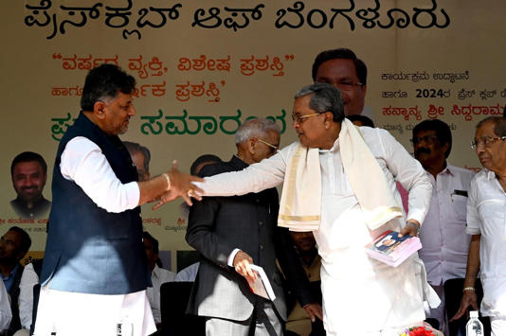](https://www.msn.com/en-in/news/India/cm-siddaramaiah-says-his-deputy-a-better-organiser-than-him/ar-AA1midqd?ocid=msedgntp&cvid=6d49b01b39eb49b0b054ef710d8c27a8&ei=1&fullscreen=true#image=2)](https://www.msn.com/en-in/news/India/cm-siddaramaiah-says-his-deputy-a-better-organiser-than-him/ar-AA1midqd?ocid=msedgntp&cvid=6d49b01b39eb49b0b054ef710d8c27a8&ei=1&fullscreen=true" \l "image=2" \t "_self)

CM Siddaramaiah says his deputy a better organiser than him © Provided by The New Indian Express

JSCIAR,

3rd January, 2024.

Shri Doddalahalli Kempegowda Shivakumar – Making the impossible possible at a National scale in converting BJP

[[Newsable Asianet News](https://newsable.asianetnews.com/)](https://newsable.asianetnews.com/" \o "Newsable Asianet News" \t "_blank)

**[Newsable Asianet News](https://newsable.asianetnews.com/" \o "Newsable Asianet News" \t "_blank)**

https://www.msn.com/en-in/news/India/strategic-meetings-of-karnataka-bjp-mla-s-t-somashekhar-spark-speculation-amidst-lok-sabha-elections/ar-AA1mllkK?ocid=msedgntp&cvid=2d5fbcd763a842809996b7c73a91e3d6&ei=20

Follow

# Strategic meetings of Karnataka BJP MLA S.T Somashekhar spark speculation amidst Lok Sabha elections

1d

[[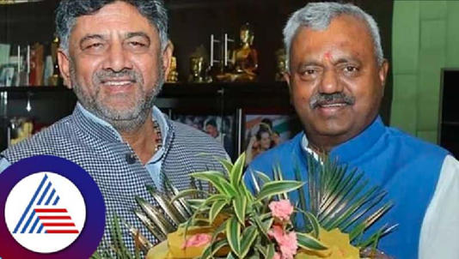](https://www.msn.com/en-in/news/India/strategic-meetings-of-karnataka-bjp-mla-s-t-somashekhar-spark-speculation-amidst-lok-sabha-elections/ar-AA1mllkK?ocid=msedgntp&cvid=2d5fbcd763a842809996b7c73a91e3d6&ei=20&fullscreen=true#image=2)](https://www.msn.com/en-in/news/India/strategic-meetings-of-karnataka-bjp-mla-s-t-somashekhar-spark-speculation-amidst-lok-sabha-elections/ar-AA1mllkK?ocid=msedgntp&cvid=2d5fbcd763a842809996b7c73a91e3d6&ei=20&fullscreen=true" \l "image=2" \t "_self)

Strategic meetings of Karnataka BJP MLA S.T Somashekhar spark speculation amidst Lok Sabha elections© Provided by Newsable Asianet News

The recent meeting between S.T. Somashekhar and D.K. Shivakumar has set the political circles abuzz with rumours and conjectures. The speculation is rife that Somashekhar might extend his support to the Congress in the forthcoming elections.

Despite the announcement of former Union minister DV Sadanand Gowda's retirement from electoral politics, ST Somashekhar has been persistent in advocating for Gowda's candidature as the BJP representative from the Bengaluru North constituency. However, sources suggest that if the BJP fields another candidate, former national general secretary CT Ravi, the likelihood of Somashekhar supporting the Congress candidate increases.

It has been reported that ST Somashekhar is actively lobbying for his son, Nishant, to be chosen as the candidate for the upcoming elections. If his son fails to secure the BJP ticket, Somashekhar has allegedly decided to throw his support behind the Congress candidate.

Also Read: [Karnataka: DK Shivakumar alleges political conspiracy by BJP leaders despite CBI probe withdrawal](https://newsable.asianetnews.com/karnataka-news/karnataka-dk-shivakumar-alleges-political-conspiracy-by-bjp-leaders-despite-cbi-probe-withdrawal-s6m9ap)

Sources reveal that Somashekhar has already dispatched his supporters to work in favour of the Congress in the Yeshwantpur assembly constituency, which falls under the Bengaluru North Lok Sabha constituency.

When questioned about his frequent visits to Congress leaders, Somashekhar downplayed the significance of his meetings. He explained that some BJP leaders conduct night-time meetings with Shivakumar for specific constituency-related matters. While he acknowledged his visits, he emphasised that he does not operate in the shadows and highlighted the unnoticed visits of other BJP leaders.

Somashekhar's meetings with Congress leaders, including the dinner party with MLC H Vishwanath after the Congress Legislature Party meeting in Belgavi, have sparked controversy within the BJP. State President B.S. Vijayendra has deemed the matter serious and called for an explanation from Somashekhar and former minister Shivaram Hebbar.

JSCIAR,

3rd January, 2024.

Shri Doddalahalli Kempegowda Shivakumar – A leader with planning

[[The New Indian Express](https://www.newindianexpress.com/)](https://www.newindianexpress.com/" \o "The New Indian Express" \t "_blank)

**[The New Indian Express](https://www.newindianexpress.com/" \o "The New Indian Express" \t "_blank)**

DK Shivakumar convenes meet to discuss Congress preparations for LS polls on Jan 10

8h

The leaders will also brainstorm on senior party leader Rahul Gandhi’s Bharat Jodo Yatra 2.0, sources said.

BENGALURU: Congress seems to have realised that its run for the Lok Sabha elections in the state will not be as easy as it thought when it came to power with a thumping majority in the Assembly polls in May.

Congress state president DK Shivakumar has now called a meeting of district ministers, observers, working presidents, AICC secretaries, PCC vice-presidents, Assembly and Council members on January 10 to discuss preparation for the elections. The polls are crucial for the Grand Old Party, which won just one seat in the 2019 elections.

Shivakumar told TNIE, “We will get reports and feedback from observers. We will discuss in detail as to how to take this important campaign forward. We will also work towards getting prepared for our campaign. We are planning to release our list of candidates by January-end.’’

Working president Saleem Ahmed said, “The meeting will discuss preparations for the polls in detail. We will take the success of guarantee schemes to all districts and constituencies across the state.’’

CM Siddaramaiah and state party leaders are headed to Delhi on Wednesday and poll preparation is expected to come up for discussion on Thursday. Appointments to boards and corporations are likely to be discussed. The leaders will also brainstorm on senior party leader Rahul Gandhi’s Bharat Jodo Yatra 2.0, sources said.

Many experts have pointed to the lack of winnable candidates in Congress. Saleem Ahmed, however, said the party will field candidates in all the 28 constituencies and the party will do well.

“We will make people realise the failures of the Union government over the last ten years. The saffron party’s inability to provide jobs to 2 crore youth, will be the focus of the meetings,” he added.

[[](https://www.msn.com/en-in/news/India/dk-shivakumar-convenes-meet-to-discuss-congress-preparations-for-ls-polls-on-jan-10/ar-AA1mnJ9A?ocid=msedgntp&cvid=4686005d237d44c38a34bc87d59b9a34&ei=65&fullscreen=true#image=2)](https://www.msn.com/en-in/news/India/dk-shivakumar-convenes-meet-to-discuss-congress-preparations-for-ls-polls-on-jan-10/ar-AA1mnJ9A?ocid=msedgntp&cvid=4686005d237d44c38a34bc87d59b9a34&ei=65&fullscreen=true" \l "image=2" \t "_self)

DK Shivakumar convenes meet to discuss Congress preparations for LS polls on Jan 10© Provided by The New Indian Express

JSCIAR,

4th January, 2024.

**Be strong and courageous. Joshua 1:9**

**Shri Doddalahalli Kempegowda Shivakumar – A leader strong in the face of acquisitions**

[[The Indian Express](http://indianexpress.com/)](http://indianexpress.com/" \o "The Indian Express" \t "_blank)

**[The Indian Express](http://indianexpress.com/" \o "The Indian Express" \t "_blank)**

Follow

# Karnataka refers Dy CM’s DA case to state Lokayukta

Story by Express News Service  • 7h

https://www.msn.com/en-in/news/other/karnataka-refers-dy-cm-s-da-case-to-state-lokayukta/ar-AA1mqjLv?ocid=msedgntp&cvid=5516d8b96c46401b94c8685b573bc07e&ei=11

[[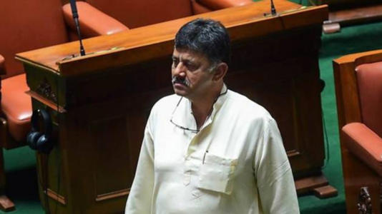](https://www.msn.com/en-in/news/other/karnataka-refers-dy-cm-s-da-case-to-state-lokayukta/ar-AA1mqjLv?ocid=msedgntp&cvid=5516d8b96c46401b94c8685b573bc07e&ei=11&fullscreen=true#image=2)](https://www.msn.com/en-in/news/other/karnataka-refers-dy-cm-s-da-case-to-state-lokayukta/ar-AA1mqjLv?ocid=msedgntp&cvid=5516d8b96c46401b94c8685b573bc07e&ei=11&fullscreen=true" \l "image=2" \t "_self)

Karnataka refers Dy CM’s DA case to state Lokayukta© Provided by The Indian Express

The Karnataka government, which had withdrawn CBI sanction given by the previous BJP government to investigate a corruption charges against deputy Chief Minister D K Shivakumar, has now referred the case to the Karnataka Lokayukta.

The Congress government has written to the Karnataka Lokayukta to probe into allegations of accumulation of disproportionate assets against Shivakumar following I-T and ED cases from 2016-2019, government sources said.

JSCIAR,

5th January, 2024

**Shri Doddalahalli Kempegowda Shivakumar – A prolific organizer of meetings but with a man of few words**

[[The New Indian Express](https://www.newindianexpress.com/)](https://www.newindianexpress.com/" \o "The New Indian Express" \t "_blank)

**[The New Indian Express](https://www.newindianexpress.com/" \o "The New Indian Express" \t "_blank)**

# Karnataka CM, DyCM to meet Congress brass, discuss winnability of ministers, kin in polls

1d

Muniyappa, who is eyeing Kolar, might shift to Chitradurga or push his son M Narasimharaju, an IRS officer who is on study leave for two years, a Congress leader said.

TUMAKURU: With CM Siddaramaiah and DyCM DK Shivakumar attending the meeting called by Congress high command in New Delhi the key issue of fielding ministers and their family members in the state is likely to be discussed at length.

The Congress top brass has called for a meeting to discuss the party’s strategy for the Lok Sabha elections and preparations for the Bharat Nyay Yatra.

The Congress aims to win not less than 20 Lok Sabha seats of the 28 in Karnataka. But political pundits opine that the party may focus on 10-12 seats in the state and is in search of winnable candidates.

The ministers appointed as observers for the LS constituencies have shortlisted 3-4 names in each constituency and submitted a report to Shivakumar. The names of ministers KH Muniyappa for Kolar, B Nagendra for Ballari, Dr H C Mahadevappa for Chamarajanagar, and Eshwar Khandre for Bidar have been shortlisted, according to sources.

Muniyappa, who is eyeing Kolar, might shift to Chitradurga or push his son M Narasimharaju, a IRS officer who is on study leave for two years, a Congress leader said.

Interestingly, since AICC president M Mallikarjuna Kharge, RS member is unlikely to contest from Kalaburagi LS seat, the party is likely to field his son-in-law Radhakrishna, an informed source told TNIE.

Apart from Kalaburagi, there is a huge demand for the Chitradurga LS seat from SC community leaders as CM Siddaramaiah is holding an AHINDA rally there on January 28.

Since BJP-JDS alliance is a strong force in the Vokkaliga bastion of the Old Mysuru region, the Congress top brass would consider fielding Vokkaliga leaders and Shivakumar has already chalked out a plan, a Congress leader said.

Former minister and Yeshwantpur BJP MLA ST Somashekar’s name has been suggested for either Bengaluru North or Mysuru LS seat and this is also likely to be discussed in the meeting.

The name of Siddaramaiah’s son and former MLA Dr Yathindra has surfaced as a probable candidate from Mysuru-Kodagu.

Apart from the discussion on LS polls, the high command is also likely to discuss the nomination to the boards and corporations. The CM and DyCM will also meet union ministers.

[[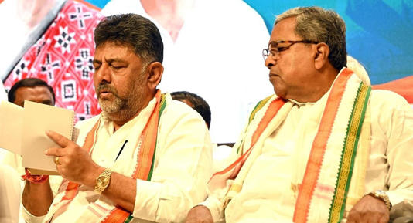](https://www.msn.com/en-in/news/India/karnataka-cm-dycm-to-meet-congress-brass-discuss-winnability-of-ministers-kin-in-polls/ar-AA1mqThW?ocid=msedgntp&cvid=9a833fb722a54d47a5d8acbf7018a4c8&ei=73&fullscreen=true#image=2)](https://www.msn.com/en-in/news/India/karnataka-cm-dycm-to-meet-congress-brass-discuss-winnability-of-ministers-kin-in-polls/ar-AA1mqThW?ocid=msedgntp&cvid=9a833fb722a54d47a5d8acbf7018a4c8&ei=73&fullscreen=true" \l "image=2" \t "_self)

Karnataka CM, DyCM to meet Congress brass, discuss winnability of ministers, kin in polls© Provided by The New Indian Express

**Jesus calms the storms [Matthew 8: 23-27; Mark 4:35-41; Luke 8:22-25]**

**Shri Doddalahalli Kempegowda Shivakumar – Maintaining calm demeanor amidst storms in political and personal life**

https://www.msn.com/en-in/autos/photos/karnataka-cbi-moves-hc-against-state-s-decision-to-drop-assets-case-against-deputy-cm-shivakumar/ar-AA1mvrPF?ocid=msedgntp&cvid=6c98679ac00546529a037e63eb696d25&ei=48

**[ABP Live](https://news.abplive.com/" \o "ABP Live" \t "_blank)**

# Karnataka: CBI Moves HC Against State's Decision To Drop Assets Case Against Deputy CM Shivakumar

Story by ABP News Bureau  • 22h

The Central Bureau of Investigation (CBI) moved Karnataka High Court challenging the government's decision to withdraw sanction to the probe agency to investigate the disproportionate assets (DA) case against Shivakumar, and handing it over to the Lokayukta. Two months ago, Karnataka government approved a proposal to withdraw CBI probe against DK Shivakumar in an alleged DA case. The state government decided in a cabinet meeting under the leadership of CM Siddaramaiah at Vidhansoudha in November 2023.

According to ANI, CBI moved Karnataka High Court after the State Government dropped the CBI case against Deputy CM DK Shivakumar case. The High Court is hearing the plea filed by BJP MLA Basangouda Patil Yatnal challenging the withdrawal of consent for CBI probe into corruption allegations against Deputy CM DK Shivakumar.

Reacting to the decision, Karnataka Deputy CM said, "I know that they want to harass me. The (Karnataka) government has taken a stand because it (referring to CBI probe in the disproportionate assets case) is politically motivated, and they have referred the matter to the Lokayukta. After withdrawing also, they are issuing notices to my friends, relatives, family members - all who have been associated with me for the last 30-40 years."

In 2018, the CBI filed an FIR against DK Shivakumar. In 2019, then Chief Minister BS Yediyurappa agreed to transfer the case to the central probe agency. The CBI was investigating Shivakumar for allegedly having assets disproportionate to his known sources of income. Prior to this, the Income Tax department had conducted a search against him.

**JSCIAR,**

**7th January, 2023.**

**It is not you they have rejected, but they have rejected me as their king. I Samuel 8:7**

**Shri Doddalahalli Kempegowda Shivakumar – Leader with strength and capacity to accept rejection**

[[Press Trust of India](https://www.ptinews.com/)](https://www.ptinews.com/" \o "Press Trust of India" \t "_blank)

**[Press Trust of India](https://www.ptinews.com/" \o "Press Trust of India" \t "_blank)**

Party high command to decide on demand for three Deputy CMs in Karnataka: D K Shivakumar

Story by PTI  • 9h

https://www.msn.com/en-in/news/India/party-high-command-to-decide-on-demand-for-three-deputy-cms-in-karnataka-d-k-shivakumar/ar-AA1mykUw?ocid=msedgntp&cvid=b5db307892da4ad58e697146361b8c10&ei=9

[[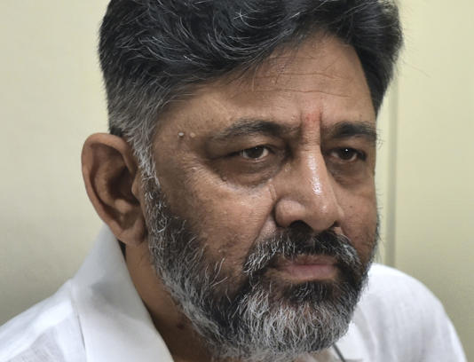](https://www.msn.com/en-in/news/India/party-high-command-to-decide-on-demand-for-three-deputy-cms-in-karnataka-d-k-shivakumar/ar-AA1mykUw?ocid=msedgntp&cvid=b5db307892da4ad58e697146361b8c10&ei=9&fullscreen=true#image=2)](https://www.msn.com/en-in/news/India/party-high-command-to-decide-on-demand-for-three-deputy-cms-in-karnataka-d-k-shivakumar/ar-AA1mykUw?ocid=msedgntp&cvid=b5db307892da4ad58e697146361b8c10&ei=9&fullscreen=true" \l "image=2" \t "_self)

Party high command to decide on demand for three Deputy CMs in Karnataka: D K Shivakumar© PTI

**Bengaluru, Jan 6 (PTI)** With Karnataka Cooperation Minister K N Rajanna batting for having three deputy chief ministers in the state, state Deputy Chief Minister D K Shivakumar said only the party high command can take a call on it.

Rajanna, who has been insisting on having three deputy chief ministers in Karnataka instead of just one, reiterated on Saturday that his demand is not something which has been fed to him by someone else.

"I said this keeping in mind that making three DCMs will help in the Lok Sabha elections. It's not so that it (creation of three DCMs) will happen soon after my statement. I have only made a request to the party high command and brought it to their notice. They are the ones who take the final decision," Rajanna told reporters.

Pointing out that there are more than one deputy chief ministers in Madhya Pradesh, Chhattisgarh and Rajasthan where the BJP came to power in the recent Assembly elections, Rajanna said it will be appropriate if there are three DCMs in Karnataka too.

Reacting to Rajanna's 'suggestion," the lone DCM of the state Shivakumar said, "Only the high command can answer such questions. I cannot answer it. That is not the issue to be discussed. Everyone has to work together to win the parliamentary election. That’s it.”

Karnataka Home Minister Dr G Parameshwara too said it was only Rajanna’s personal view and not of the party.

"People express their personal views. Having three DCMs in the state could be good from Rajanna's point of view but we don't know what the High Command thinks," the Home Minister said.

Rajanna got a supporter in Social Welfare Minister H C Mahadevappa, who found nothing wrong in the demand.

"Rajanna is a senior leader. From political view point, he must have found merits in having multiple DCMs. It is left to the party high command whether to take his views into consideration," Mahadevappa said.

**JSCIAR,**

**8th January, 2024.**

**He that waters will himself be watered. Proverbs 11:25**

**Shri Doddallahalli Kempegowda Sivakumar – As irrigation minister facing the drought with wisdom to save the lives of poor farmers**

[[Times Now](https://www.timesnownews.com/)](https://www.timesnownews.com/" \o "Times Now" \t "_blank)

**[Times Now](https://www.timesnownews.com/" \o "Times Now" \t "_blank)**

Follow

# Karnataka Government Releases Water to Save Chili Crops Amid Farmer Protests

Story by Times Now Digital  • 1h

[[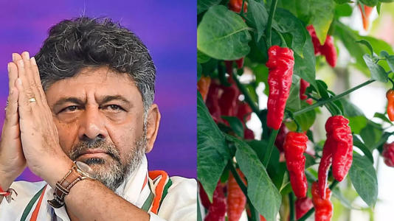](https://www.msn.com/en-in/news/India/karnataka-government-releases-water-to-save-chili-crops-amid-farmer-protests/ar-AA1mBZiR?ocid=msedgntp&cvid=2d0f525ee2384397992b8b15566d8d69&ei=16&fullscreen=true#image=2)](https://www.msn.com/en-in/news/India/karnataka-government-releases-water-to-save-chili-crops-amid-farmer-protests/ar-AA1mBZiR?ocid=msedgntp&cvid=2d0f525ee2384397992b8b15566d8d69&ei=16&fullscreen=true" \l "image=2" \t "_self)

karnataka government releases water to save chili crops amid farmer protests© Provided by Times Now

**Bengaluru:**After two days of farmer protests, the Karnataka government, on Saturday night, decided to release 2.75 tmcft of water from two Krishna reservoirs to protect chili crops in four North Karnataka districts. The decision to release water from the storage of 48 tmcft available in Almatti and Narayanapur dams across the Krishna river was made at the residences of deputy chief minister DK Shivakumar and brother-MP DK Suresh in Sadashivanagar, Bengaluru, late at night.

Farmers in Yadgir, Raichur, Bagalkot, Kalaburagi, and surrounding areas had been protesting in front of the Krishna Bhagya Jala Nigam Ltd (KBJNL) office at Bheemarayangudi in Yadgir over the past 48 hours. The sit-in included protests with farmers digging large graves outside the office and protesting by sitting inside them.

District ministers and local legislators from various parties urged Shivakumar to release water for the standing crops. On Sunday morning, Shivakumar briefed the media about the decision under enormous pressure from legislators and farmers' associations.

Deputy CM Shivakumar stated, "Despite our decision not to release water, except for drinking water purposes and other mandatory requirements, the government has decided to release 2.75 tmcft of water for the chili crop. We're releasing water that may reach the last destination point in the next four days."

Shivakumar mentioned that the government had retained water in the two dams to serve the region until the onset of the monsoon rain in mid-June this year, as per TOI reports.

"Almatti and Narayanapura dams have a combined capacity of 47 tmcft of water. With 38 tmcft required for drinking purposes and accounting for evaporation, 3 tmcft for mandatory other requirements, and 1.5 tmcft loss during the flow between the dams, the release of 2.75 tmcft of water means we will be cutting it very fine," said Shivakumar. "We cannot deploy police personnel to protect the flow of water to chili growers."

JSCIAR,

9th January, 2024.

You crown the year with your goodness. Psalms 65:11

**[The New Indian Express](https://www.newindianexpress.com/" \o "The New Indian Express" \t "_blank)**

# 2.75 tmcft to be released to Upper Krishna for chilli crops: DK Shivakumar

5h

While 37 tmcft is needed for drinking water purposes, and 3 tmcft for other purposes, 1.5 tmcft is lost during outflow, he said.

BENGALURU:  Karnataka Deputy Chief Minister DK Shivakumar on Sunday said 2.75 tmcft of

water will be released from Almatti and Narayanpura reservoirs to save the chilli crop in the Upper Krishna basin.

“Water will be released immediately and will reach the basin in two or three days,” Shivakumar, also the water resources minister, told reporters. He held a meeting of district in-charge ministers of Kalaburagi, Raichur, Bagalkot and Yadgiri, MLAs of all parties and farmer leaders late on Saturday evening. If the chilli crop is destroyed, the estimated loss will be around Rs 2,000 crore, he said.

“To  protect our farmers, last night we decided to release 2.75 tmcft of water for the last time. Protesting farmers and legislators should ensure that the water is used only for chilli crops,” he said. Almatti and Narayanpur dams together have stored 47 tmcft of water. While 37 tmcft is needed for drinking water purposes, and 3 tmcft for other purposes, 1.5 tmcft is lost during outflow, he said.

Asked how he will monitor the use of water, he said, “The police cannot be deployed to monitor water usage. I have given this responsibility to the people’s representatives and farmer organisations. You have to be the police and make good use of this water. We have also instructed our officials, but they cannot fight with farmers. The media should also create awareness about the responsibilities of farmers,” Shivakumar said.

On the river-linking proposal, Shivakumar said a team of  31 parliamentarians will visit the state to inspect the Cauvery catchment area. “River linking is a large central government project and we should not deviate from the issue we are facing now. Our irrigation problems will also be discussed with the team,” he said. Sources said the team is likely to visit the state in a couple of days and hold deliberations with water resources department officials.

[[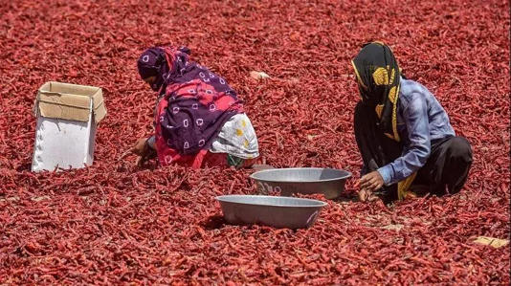](https://www.msn.com/en-in/news/India/2-75-tmcft-to-be-released-to-upper-krishna-for-chilli-crops-dk-shivakumar/ar-AA1mBs43?ocid=msedgntp&cvid=224747aa2ecd4b2ba7cd1aef61ed9620&ei=107&fullscreen=true#image=2)](https://www.msn.com/en-in/news/India/2-75-tmcft-to-be-released-to-upper-krishna-for-chilli-crops-dk-shivakumar/ar-AA1mBs43?ocid=msedgntp&cvid=224747aa2ecd4b2ba7cd1aef61ed9620&ei=107&fullscreen=true" \l "image=2" \t "_self)

2.75 tmcft to be released to Upper Krishna for chilli crops: DK Shivakumar© Provided by The New Indian Express

JSCIAR,

9th January, 2024.

**Pure and undefiled religion before God and the Father is this: to visit orphans and widows in their trouble, and to keep oneself unspotted from the world. James 1:27**

**Shri Doddalahalli Kempegowda Shivakumar – religious and observant hindu and outspoken about his faith**

[[Times Now](https://www.timesnownews.com/)](https://www.timesnownews.com/" \o "Times Now" \t "_blank)

**[Times Now](https://www.timesnownews.com/" \o "Times Now" \t "_blank)**

['We Are Hindus...': Karnataka Deputy CM DK Shivakumar Defends Temple Pujas On January 22 (msn.com)](https://www.msn.com/en-in/news/India/we-are-hindus-karnataka-deputy-cm-dk-shivakumar-defends-temple-pujas-on-january-22/ar-AA1mG7Iz?ocid=msedgntp&cvid=454a835d59ee473d8138823727c50a3c&ei=8)

Follow

# 'We Are Hindus...': Karnataka Deputy CM DK Shivakumar Defends Temple Pujas On January 22

Story by Times Now Digital  • 2h

[[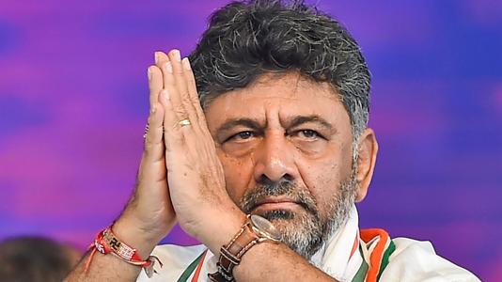](https://www.msn.com/en-in/news/India/we-are-hindus-karnataka-deputy-cm-dk-shivakumar-defends-temple-pujas-on-january-22/ar-AA1mG7Iz?ocid=msedgntp&cvid=454a835d59ee473d8138823727c50a3c&ei=8&fullscreen=true#image=2)](https://www.msn.com/en-in/news/India/we-are-hindus-karnataka-deputy-cm-dk-shivakumar-defends-temple-pujas-on-january-22/ar-AA1mG7Iz?ocid=msedgntp&cvid=454a835d59ee473d8138823727c50a3c&ei=8&fullscreen=true" \l "image=2" \t "_self)

'we are hindus...': karnataka deputy cm dk shivakumar defends temple pujas on january 22© Provided by Times Now

**Bengaluru:** Deputy Chief Minister DK Shivakumar defended the Congress government's decision to organize special pujas in 34,000 state-owned temples in Karnataka to mark the 'Pran Pratishtapan' ceremony of the Ram temple in Ayodhya on January 22. He stated that being Hindus, there's nothing wrong in attending the consecration ceremony, emphasizing that no religion or symbol belongs to any one individual.

"Ultimately, we are Hindus and no religion or symbol belongs to any one individual," Shivakumar said.

The state government issued a circular asking temples administered by the muzrai department to conduct special pujas for the 'Pran Pratishtapan' of the Ram idol in Ayodhya. Responding to queries about Congress's stand on attending the event, Shivakumar mentioned that the party would soon arrive at a decision.

He criticised the Union government for selectively deciding on the invitee list, emphasising that the ceremony is not private property but public property. Meanwhile, Union Minister Prahlad Joshi commented that "wisdom" has finally dawned on the Congress.

BJP leaders, including MLA CN Ashwathnarayan and party leader CT Ravi, appreciated the Karnataka government's decision. The BJP's Karnataka state unit posted on social media, noting the irony of Congress, traditionally skeptical about Lord Ram, now participating in Ram Japa. The post drew parallels with the past, suggesting that Lord Ram followers have overcome challenges, reflecting on the present political landscape.

The Congress has yet to make a final decision on attending the consecration ceremony, and the political discourse continues over the government's move to organize special pujas in state-owned temples.

JSCIAR,

12th January, 2024

**God was with Joseph and Joseph was successful. Genesis 39:2**

[[The New Indian Express](https://www.newindianexpress.com/)](https://www.newindianexpress.com/" \o "The New Indian Express" \t "_blank)

**[The New Indian Express](https://www.newindianexpress.com/" \o "The New Indian Express" \t "_blank)**

Follow https://www.msn.com/en-in/news/India/on-deputy-cm-s-orders-bengaluru-south-to-get-cauvery-water/ar-AA1mPYyK?ocid=msedgntp&cvid=f56ebc4eb4614fa782080fc4bee31b63&ei=15

# On deputy CM’s orders, Bengaluru South to get Cauvery water

25m

Shivakumar added that people approach the government when they don’t get a solution to their problems. “Instead of you coming to our doorstep, I have brought the government to your doorstep."

BENGALURU:  Deputy Chief Minister D K Shivakumar on Thursday instructed the Bangalore Water Supply and Sewerage Board (BWSSB) and Bangalore Development Authority (BDA) to supply Cauvery water to residents of Bengaluru South and parts of Anekal in the next three-four months.

Speaking the ‘Government at Your Doorstep’ programme near Yelachenahalli, he said, “MP D K Suresh has raised the issue of drinking water and traffic congestion in the area. I will instruct the officials of BWSSB and BDA to prioritise Cauvery water for the area in the next three-four months.”

Shivakumar added that people approach the government when they don’t get a solution to their problems. “Instead of you coming to our doorstep, I have brought the government to your doorstep. We will redress people’s issues in all the assembly constituencies of Bengaluru,” he said.

The DCM said around 500 officials attended to public grievances at the spot on Thursday. There is a need to provide an alternative route for the 18-km stretch in Bengaluru South assembly constituency, he said, adding that efforts are on to revive an old BDA proposal to provide connectivity between Kanakapura and Electronic City.

[[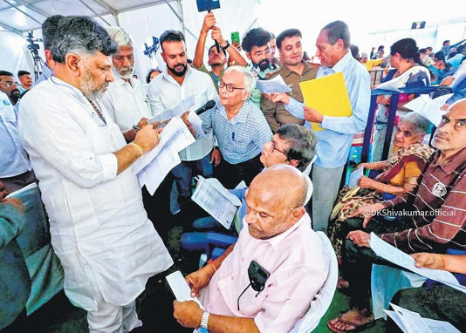](https://www.msn.com/en-in/news/India/on-deputy-cm-s-orders-bengaluru-south-to-get-cauvery-water/ar-AA1mPYyK?ocid=msedgntp&cvid=f56ebc4eb4614fa782080fc4bee31b63&ei=15&fullscreen=true#image=2)](https://www.msn.com/en-in/news/India/on-deputy-cm-s-orders-bengaluru-south-to-get-cauvery-water/ar-AA1mPYyK?ocid=msedgntp&cvid=f56ebc4eb4614fa782080fc4bee31b63&ei=15&fullscreen=true" \l "image=2" \t "_self)

On deputy CM’s orders, Bengaluru South to get Cauvery water© Provided by The New Indian Express

JSCIAR,

15th January, 2024.

**Those that wait upon the LORD shall renew their strength. Isaiah 40:31**

**Shri Doddalahalli Kempegowda Shivakumar – Tireless travallere advocating the strategies for improved governance with emphasis on irrigation and agriculture**

[[The New Indian Express](https://www.newindianexpress.com/)](https://www.newindianexpress.com/" \o "The New Indian Express" \t "_blank)

**[The New Indian Express](https://www.newindianexpress.com/" \o "The New Indian Express" \t "_blank)**

llowSiddaramaiah, DK Shivakumar, join Rahul, Kharge in Imphal

6h

[[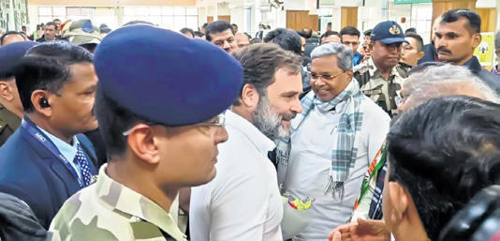](https://www.msn.com/en-in/news/India/siddaramaiah-dk-shivakumar-join-rahul-kharge-in-imphal/ar-AA1mYPXq?ocid=msedgntp&pc=U531&cvid=ee23905501cb4aff830ed42a486cf6b0&ei=7&fullscreen=true#image=2)](https://www.msn.com/en-in/news/India/siddaramaiah-dk-shivakumar-join-rahul-kharge-in-imphal/ar-AA1mYPXq?ocid=msedgntp&pc=U531&cvid=ee23905501cb4aff830ed42a486cf6b0&ei=7&fullscreen=true" \l "image=2" \t "_self)

Chief Minister Siddaramaiah greets Congress leader Rahul Gandhi during the launch of the Bharat Jodo Nyay Yatra in Imphal on Sunday© Provided by The New Indian Express

BENGALURU: Top congress leaders from Karnataka, including Chief Minister Siddaramaiah, Deputy CM DK Shivakumar and Home Minister Dr G Parameshwara, joined party leader Rahul Gandhi and AICC president Mallikarjun Kharge during the launch of Bharat Jodo Nyay Yatra in Imphal on Sunday.

The state leaders were visibly upbeat on their arrival in Manipur and they were given a warm welcome by the Manipur Congress functionaries. Siddaramaiah personally greeted Rahul Gandhi and also shared the dais along with national leaders.

Karnataka, which is the home turf of AICC president Mallikarjun Kharge, is a key state for the Grand Old Party. Participation of Congress leaders from the south Indian states, including former Andhra Pradesh chief minister Y S Rajashekara Reddy’s daughter Y S Sharmila, could be a shot in the arm for Kharge, who was recently appointed as I.N.D.I.A block chief, especially as the party is looking to win more seats in this cluster of states in the LS polls.

The first leg of Rahul Gandhi’s Bharat Jodo Yatra, which traversed across Karnataka, had worked as a unifying force between leaders in the Congress, especially Siddaramaiah and Shivakumar, and contributed to the party’s win in the assembly polls with 135 seats.

Though Siddaramaiah and Shivakumar showed up together at Imphal Airport, they arrived by separate special flights. Siddaramaiah was accompanied by Parameshwara and his political secretary Govindaraju.

JSCIAR,

16th January, 2024.

**Call unto me in the day of trouble. I will answer you. Psalm 50:15**

**Shri Doddalahalli Kempegowda Shivakumar – Advocating the divine modes of communicaiton, the wireless**

https://www.msn.com/en-in/news/India/use-of-wireless-connectivity-for-smooth-ambulance-movement-karnataka-dycm-dk-shivakumar/ar-AA1n2hGs?ocid=msedgdhp&pc=U531&cvid=d25d8d7d19984b378f57edf3951ef4fa&ei=35

[[Newsable Asianet News](https://newsable.asianetnews.com/)](https://newsable.asianetnews.com/" \o "Newsable Asianet News" \t "_blank)

**[Newsable Asianet News](https://newsable.asianetnews.com/" \o "Newsable Asianet News" \t "_blank)**

Follow

# Use of wireless connectivity for smooth ambulance movement: Karnataka DyCM DK Shivakumar

26m

[[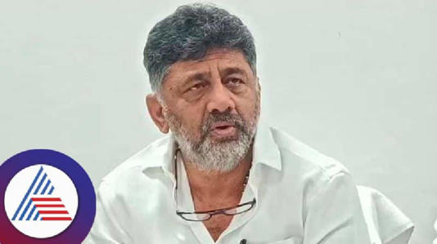](https://www.msn.com/en-in/news/India/use-of-wireless-connectivity-for-smooth-ambulance-movement-karnataka-dycm-dk-shivakumar/ar-AA1n2hGs?ocid=msedgdhp&pc=U531&cvid=d25d8d7d19984b378f57edf3951ef4fa&ei=35&fullscreen=true#image=2)](https://www.msn.com/en-in/news/India/use-of-wireless-connectivity-for-smooth-ambulance-movement-karnataka-dycm-dk-shivakumar/ar-AA1n2hGs?ocid=msedgdhp&pc=U531&cvid=d25d8d7d19984b378f57edf3951ef4fa&ei=35&fullscreen=true" \l "image=2" \t "_self)

Use of wireless connectivity for smooth ambulance movement: Karnataka DyCM DK Shivakumar© Provided by Newsable Asianet News

Karnataka Deputy Chief Minister DK Shivakumar has announced the intent to implement the most impactful suggestions from the Ideathon competition. These proposals, which include wireless connectivity with traffic signals, installation of pink booths in public places, and efficient disposal of flowers and food waste, aim to enhance the seamless movement of ambulances in the city.

Shivakumar distributed prizes to the winners of the Youth Leadership Conference and Ideathon competition held in the city. Recognizing the potential for innovative ideas from school children, he highlighted the significance of their thinking and leadership qualities for the overall development of the country. Encouraging leadership qualities beyond the realm of politics, Shivakumar expressed his commitment to advising the BBMP commissioner to organize similar competitions at the school level.

Sudha Murthy, the co-founder of Infosys Foundation, emphasized the importance of providing a platform for children to express their new ideas. Murthy commended the confidence exhibited by the participating children in sharing their thoughts during the competition. Acknowledging the challenge of judging suggestions from the younger generation, she noted, "I can learn some things from the younger generation."

The concept of Ideathon, introduced and implemented by Aishwarya D.K.S., received recognition during the event. The competition was conducted as part of the Brand Bengaluru project.

JSCIAR,

19th January, 2024.

**Well done good and faithful servant. Matthew 25:23**

https://www.msn.com/en-in/news/other/75-mlas-workers-to-be-appointed-to-karnataka-boards-shivakumar/ar-AA1ncVTW

[[Hindustan Times](https://www.hindustantimes.com/)](https://www.hindustantimes.com/" \o "Hindustan Times" \t "_blank)

**[Hindustan Times](https://www.hindustantimes.com/" \o "Hindustan Times" \t "_blank)**

Follow

# 75 MLAs, workers to be appointed to Karnataka boards: Shivakumar

Story by HT Correspondent  • 11h

[[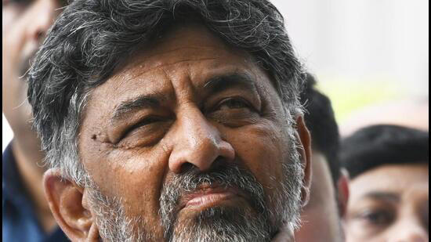](https://www.msn.com/en-in/news/other/75-mlas-workers-to-be-appointed-to-karnataka-boards-shivakumar/ar-AA1ncVTW?fullscreen=true#image=2)](https://www.msn.com/en-in/news/other/75-mlas-workers-to-be-appointed-to-karnataka-boards-shivakumar/ar-AA1ncVTW?fullscreen=true" \l "image=2" \t "_self)

A total of 7,000 positions need to be filled, including appointments in districts and taluks.© Provided by Hindustan Times

Bengaluru: Karnataka deputy chief minister DK Shivakumar said on Thursday that a total of 36 legislators and 39 party workers will soon be appointed to various government-owned boards and corporations. The official list of these 75 appointments is expected to be released imminently.

“The leaders and workers have brought the party to power in the state, and so they have been rewarded suitably,” Shivakumar said while addressing the media in Bengaluru.

A total of 7,000 positions need to be filled, including appointments in districts and taluks. Approximately 600 chairperson and director positions are highly sought after. Since both Shivakumar and chief minister Siddaramaiah have their preferred candidates, the task becomes significantly more challenging.

During the media interaction, Shivakumar also announced that the Lok Sabha election committee meeting is scheduled for Friday at Indira Gandhi Bhavan.

“Earlier, we planned to hold the meeting in the afternoon, but postponed it to evening, given the Prime Minister’s visit to the city,” stated Shivakumar, who is also the president of Karnataka Congress unit.

Expressing confidence in the party’s performance in the upcoming LS elections, Shivakumar said the party aims to secure at least 25 seats out of the total 28 in Karnataka. When questioned about the JD(S) contemplating joining the BJP-led National Democratic Alliance, Shivakumar remarked, “It is their wish.” “The last time we joined hands with JD(S), we were hopeful of winning a lot of seats, but ended up with one seat each. Let’s wait and see. This time, we are confident of winning at least 25 seats,” he added.

In the 2019 Lok Sabha elections, the Bharatiya Janata Party (BJP) won 25 seats while Congress and JD(S) won one each. An independent backed by the BJP also emerged victorious. Asked if the list of candidates will be finalised on January 19, Shivakumar said, “We will have the first round of meeting tomorrow. Jagadish Shettar and Laxman Savadi have also been invited to the meeting. Ministers in charge of districts have collected opinions from all the constituencies which will be discussed in tomorrow’s meeting.”

When asked about some ministers showing reluctance to contest the upcoming general elections, he said, “If the party wants, everyone has to contest, whether it is me or anyone else.”

JSCIAR,

23rd January, 2024.

**True religion in the sight of God is to care for the widows and orphans. James 1:27**

Shri Doddalahalli Kempegowda Shivakumar – With clear views on religion and politics

[[Newsable Asianet News](https://newsable.asianetnews.com/)](https://newsable.asianetnews.com/" \o "Newsable Asianet News" \t "_blank)

**[Newsable Asianet News](https://newsable.asianetnews.com/" \o "Newsable Asianet News" \t "_blank)**

Follow

# There’s Shiva in my name, Ram in CM’s name: Karnataka DyCM DK Shivakumar

1d

[[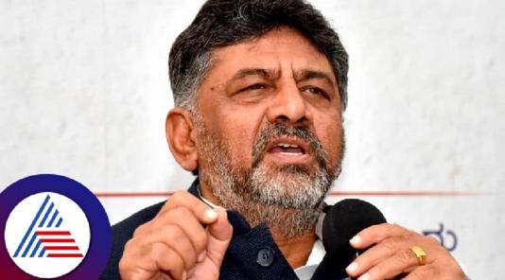](https://www.msn.com/en-in/news/India/there-s-shiva-in-my-name-ram-in-cm-s-name-karnataka-dycm-dk-shivakumar/ar-BB1h2ZMj?ocid=msedgntp&pc=U531&cvid=d220ec4697f24228acc0c0d33d55ce8f&ei=8&fullscreen=true#image=2)](https://www.msn.com/en-in/news/India/there-s-shiva-in-my-name-ram-in-cm-s-name-karnataka-dycm-dk-shivakumar/ar-BB1h2ZMj?ocid=msedgntp&pc=U531&cvid=d220ec4697f24228acc0c0d33d55ce8f&ei=8&fullscreen=true" \l "image=2" \t "_self)

There’s Shiva in my name, Ram in CM’s name: Karnataka DyCM DK Shivakumar© Provided by Newsable Asianet News

Karnataka Deputy Chief Minister D.K. Shivakumar underlined the state government's commitment to cultural and religious practices, asserting that no external pressure or influence would dictate their approach. He revealed that the government had already issued instructions for special pujas to be conducted in all temples under the Mujarai department on Monday, coinciding with the inauguration of Ayodhya's Ram Mandir.

Shivakumar addressed the Bharatiya Janata Party's (BJP) suggestion to declare schools and colleges holidays on the day of the Ayodhya Ram Mandir inauguration. Dismissing any need for external influence on matters of religion and culture, he stated, "We have been worshipping, doing penance, and preserving our culture," highlighting the government's dedication to maintaining cultural practices.

Expressing the belief that prayers yield results, Shivakumar affirmed that all necessary rituals and prayers in temples would be conducted without external interference. He emphasized the government's commitment to duty and criticized the BJP's stance on the intersection of religion and politics. "There should be religion in politics, and politics should not be done in religion," he remarked in response to BJP leaders' comments.

Taking a swipe at BJP MP Ananthkumar Hegde, who made remarks about Chief Minister Siddaramaiah's mental stability, Shivakumar urged Hegde to focus on his mental health. He dismissed Hegde's comments, stating, "Mentally stable people do not talk like this." Shivakumar acknowledged that leaders should understand the impact of their words and called Hegde's remarks a "good development."

JSCIAR,

25th January, 2024.

**You shall teach them diligently to your children. Deuteronomy 6:7**

**Shri Doddallahalli Kempegowda Shivakumar – A leader with the knowledge of history of Indian National Congress and the Freedom Struggle**

[[Press Trust of India](https://www.ptinews.com/)](https://www.ptinews.com/" \t "_blank)

**[Press Trust of India](https://www.ptinews.com/" \t "_blank)**

Follow

# Strengthen Congress to regain past glory in coastal districts: D K Shivakumar

Story by PTI • now

[[](https://www.msn.com/en-in/news/India/strengthen-congress-to-regain-past-glory-in-coastal-districts-d-k-shivakumar/ar-BB1hdXsr?ocid=msedgntp&pc=U531&cvid=255659e68ab7444c94658eb9043b52b6&ei=9&fullscreen=true#image=2)](https://www.msn.com/en-in/news/India/strengthen-congress-to-regain-past-glory-in-coastal-districts-d-k-shivakumar/ar-BB1hdXsr?ocid=msedgntp&pc=U531&cvid=255659e68ab7444c94658eb9043b52b6&ei=9&fullscreen=true" \l "image=2" \t "_self)

Strengthen Congress to regain past glory in coastal districts: D K Shivakumar© PTI

**Mangaluru, Jan 25 (PTI)** Karnataka Deputy Chief Minister and state PCC president D K Shivakumar has urged party workers in the coastal districts to strengthen the Congress to regain its past glory in the region.

Addressing a workers' meeting at the district Congress committee office Wednesday evening, he said the state-level convention of the party will be held in Mangaluru next month to prepare ground for the coming Lok Sabha elections.

AICC president Mallikarjun Kharge and other national leaders are expected to attend the convention, to be jointly organised by the district units of Dakshina Kannada and Udupi.

He said the party should be activated at the booth-level by involving more youth and the people should be made aware of the benefits of the guarantees implemented by the Congress government in the state.

Shivakumar said the party needs more activists at the booth-level than leaders. The differences in the party in Sullia block of DK district should be sorted out among leaders.

He said the party workers should not get disappointed over the results of the last Assembly elections in the two districts where it could only win two seats. Attempts should be made to turn the Congress into a cadre-based party with the active involvement of result-oriented workers.

Later taking part in the annual conference of Karnataka state Sunni Yuvajana Sangha (SYS), Shivakumar said the Siddramaiah-led government is committed to protecting the rights of the minorities.

Without commenting on the contentious issues raised at the conference including hijab, he said the future of the country rests in the hands of the youth.

Earlier, talking to reporters, Shivakumar said the hijab issue and related religious matters are before court and should be addressed within the framework of law and the Constitution, ensuring protection of the rights of all religions.

JSCIAR,

25th January, 2024.

Rebuke the satan and it will flee away from you. James 4:7

**Shri Dodallahalli Kempegowda Shivakumar – Rebuking the unloyal to bring discipline in the govrnenance**

[[Hindustan Times](https://www.hindustantimes.com/)](https://www.hindustantimes.com/" \t "_blank)

**[Hindustan Times](https://www.hindustantimes.com/" \t "_blank)**

Follow

# He backstabbed Congress: Karnataka DCM DK Shivakumar on Jagadish Shetter joining BJP

Story by Pathi Venkata Thadhagath • 1h

[[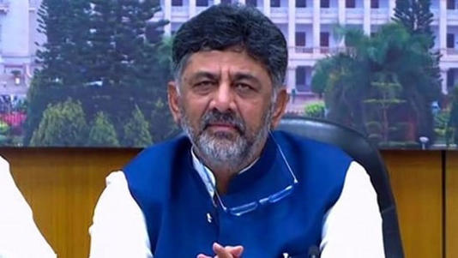](https://www.msn.com/en-in/news/India/he-backstabbed-congress-karnataka-dcm-dk-shivakumar-on-jagadish-shetter-joining-bjp/ar-BB1hey3q?ocid=msedgntp&pc=U531&cvid=d54a5cc40c54453eb2eace3ed019bcea&ei=5&fullscreen=true#image=2)](https://www.msn.com/en-in/news/India/he-backstabbed-congress-karnataka-dcm-dk-shivakumar-on-jagadish-shetter-joining-bjp/ar-BB1hey3q?ocid=msedgntp&pc=U531&cvid=d54a5cc40c54453eb2eace3ed019bcea&ei=5&fullscreen=true" \l "image=2" \t "_self)

He backstabbed Congress: Karnataka DCM DK Shivakumar on Shetter joining BJP© Provided by Hindustan Times

After former Karnataka CM Jagadish Shetter rejoined BJP from the Congress on Thursday, DK Shivakumar slammed the senior leader and said he backstabbed the party. He also alleged that Shetter was against the BJP’s ideology till yesterday.

Speaking to reporters on Thursday, DK Shivakumar said, “It is shocking for me. He told me yesterday that the Congress has reshaped his political career in Karnataka after BJP disowned him. He even said that the BJP is doing politics with Ram mandir in Ayodhya. Suddenly, he met them and fell for their promises.”

DK Shivakumar also claimed that the Congress party treated him with utmost respect. “We treated him with all the respect he deserved. He had other intentions and I do not know what Amit Shah offered him. Let him find his way as people watch everything,” DK Shivakumar added.

On Thursday afternoon, Jagadish Shetter reached the BJP headquarters where he was welcomed back to the party in the presence of former CM BS Yediyurappa and state BJP President BY Vijayendra.

Jagadish Shetter said, “The party gave me a lot of responsibilities in the past. Because of some issues, I went to the Congress party. In the last 8-9 months, there were a lot of discussions in the BJP. Karnataka BJP leaders and workers asked me to come back to the BJP. Yediyurappa ji and Vijayendra ji also wanted me to return to the BJP. I am rejoining the party believing that Narendra Modi ji has to become the PM again.”

After serving as an MLA for close to three decades and in multiple key positions, Jagadish Shettar submitted his resignation to the BJP and joined the Congress in April last year. He contested from Hubballi-Dharwad central constituency in the assembly elections and lost to the BJP.

However, the Congress offered him an MLC position after the assembly elections. Reports claim that Shetter was aiming for a Lok Sabha seat from the Congress, and he was denied a ticket by the grand old party. The senior BJP leaders approached him and made an offer to rejoin the BJP.

JSCIAR,

26th January, 2024.

**The good shepherd lays down His life for the sheep. John 10:11**

**Shri Doddalahalli Kempegowda Shivakumar – Guarding the party workers like good shepherd from temptations**

[[Press Trust of India](https://www.ptinews.com/)](https://www.ptinews.com/" \o "Press Trust of India" \t "_blank)

[Press Trust of India](https://www.ptinews.com/" \o "Press Trust of India" \t "_blank)

Follow

# BJP trying to lure our leaders and legislators: Karnataka Cong chief Shivakumar

Story by PTI  • now

[[](https://www.msn.com/en-in/news/India/bjp-trying-to-lure-our-leaders-and-legislators-karnataka-cong-chief-shivakumar/ar-BB1hiuNC?ocid=msedgntp&pc=U531&cvid=2a18a899802d4956ad23313bc061b50e&ei=2&fullscreen=true#image=2)](https://www.msn.com/en-in/news/India/bjp-trying-to-lure-our-leaders-and-legislators-karnataka-cong-chief-shivakumar/ar-BB1hiuNC?ocid=msedgntp&pc=U531&cvid=2a18a899802d4956ad23313bc061b50e&ei=2&fullscreen=true" \l "image=2" \t "_self)

BJP trying to lure our leaders and legislators: Karnataka Cong chief Shivakumar© PTI

**Bengaluru, Jan 26 (PTI)** Accusing the BJP of trying to lure his party's leaders and legislators, state Congress President and Deputy Chief Minister D K Shivakumar on Friday indicated that he too was not silent and that many leaders from the saffron party are in touch with him.

His comments came a day after former Karnataka Chief Minister Jagadish Shettar rejoined the BJP quitting Congress. He had joined Congress, ahead of Assembly polls last year, after being denied ticket by the BJP to contest the elections.

"I'm in talks with several (BJP) leaders, many are looking at us, I don't want to reveal names," Shivakumar told reporters here as he accused BJP of making all efforts to lure Congress leaders into the party.

"Whom have they left? They are trying every one, I don't want to take names. But we too know the job, I'm not speaking now that's all, if not (their) houses would have become empty by now, but we are remaining silent that's all," he added.

On some BJP leaders claiming to be in touch with several Congress leaders and legislators, Shivakumar said, "Don't they know that I'm too in touch with them. Have they left me? Should I read the list...let's not do it now."

Noting that Shettar had joined Congress unconditionally after quitting BJP accusing it of insulting and ill treating him, Shivakumar said, considering his stature being a senior leader, Congress gave him ticket to contest Assembly polls and despite him losing the polls by a margin of about 35,000 votes, the party made him an MLC.

"Denying a loyal party worker the ticket, we gave him a ticket and treated him with respect.....we were aware about BJP leaders contacting him from the last two-three months, and he kept saying he will not go. Day before yesterday I had spoken to him, but all of a sudden, he announced quitting the party," he said.

Shettar may have quit the party, but Congress is like an ocean, the Karnataka Pradesh Congress Committee chief said hundreds of people may come to the party, and hundreds may quit, but no one can do anything to Congress.

"We have won 136 seats on our strength in assembly polls. Because of our own mistakes we might have lost seven to eight seats, or else our calculation was over 141 seats."

He further said, Shettar quitting the Congress may cause "just one day's embarrassment to the party before the media, but the party workers are happy about him going out, as it will help them in organising Congress much better."

"Congress will give the seat vacated by Shettar to a loyal Congress worker and fight it out.....Congress is like an ocean, we are least bothered (about Shettar joining BJP)," he added.

Shivakumar also said that Congress MLA Laxman Savadi, who too had joined the party quitting BJP ahead of Assembly polls, has assured that he will remain in the Congress and work for the party.

"He (Savadi) is a leader of the party and will be an asset to the party," he added.

Shivakumar, hitting out at JD(S) and its leader H D Kumaraswamy for allying with BJP which had brought down the Congress-JD(S) coalition government led by him with the help of "operation Kamala", said: JD(S) and Kumaraswamy have become spokesperson for BJP.

"They (JDS) are hugging and having a relationship with the party that removed them from power," he added.

Responding to a question on Minister K N Rajanna's alleged comments violating the party discipline that has embarrassed the party, Shivakumar said, he (Rajanna) is cabinet minister and the Chief Minister Siddaramaiah will respond to it; also high command and national president of Congress are watching.

**JSCIAR,**

**2nd February, 2024.**

**The hand of the diligent will rule. Proverbs 12:24**

**Shri Doddalahalli Kempegowda Shivakumar – A diligent ruler seeking people’s welfare.**

[[The New Indian Express](https://www.newindianexpress.com/)](https://www.newindianexpress.com/" \o "The New Indian Express" \t "_blank)

**[The New Indian Express](https://www.newindianexpress.com/" \o "The New Indian Express" \t "_blank)**

Raw deal for Karnataka: CM Siddaramaiah, DK Shivakumar

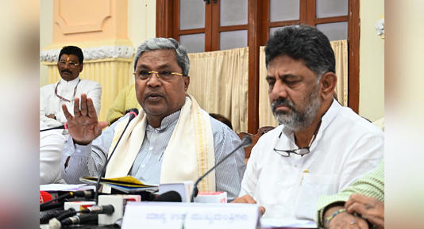

Karnataka CM Siddaramaiah and Deputy CM DK Shivakumar.© Provided by The New Indian Express

BENGALURU: Chief Minister Siddaramaiah and Deputy Chief Minister DK Shivakumar termed the Union budget presented on Thursday as “disappointing” with Karnataka not getting any new projects. “The budget has not addressed the real problems of people like price rise, unemployment, farmers issues and problems faced by poor people,” Siddaramaiah told reporters here.

The CM said the budget will not take the country on the path of development as claimed by the BJP, but will lead the country on the path of destruction.

During the UPA government, the average increase in the budget size used to be around 13.79 per cent, but in the current NDA government, it is around 9.6 per cent, he said and added that this clearly shows that the per capita income has not increased.

Siddaramaiah accused the Centre of doing a great injustice to Karnataka in the devolution of taxes. Though Karnataka is the second state in the country after Maharashtra in tax collection, it is the 10th state in the devolution of funds, he said and added that the major share of funds go to Bihar, Uttar Pradesh and Madhya Pradesh.

Responding to Congress MP DK Suresh’s demand for a separate country for the southern states, the CM said, “The nation should remain united, the state should remain united. “

[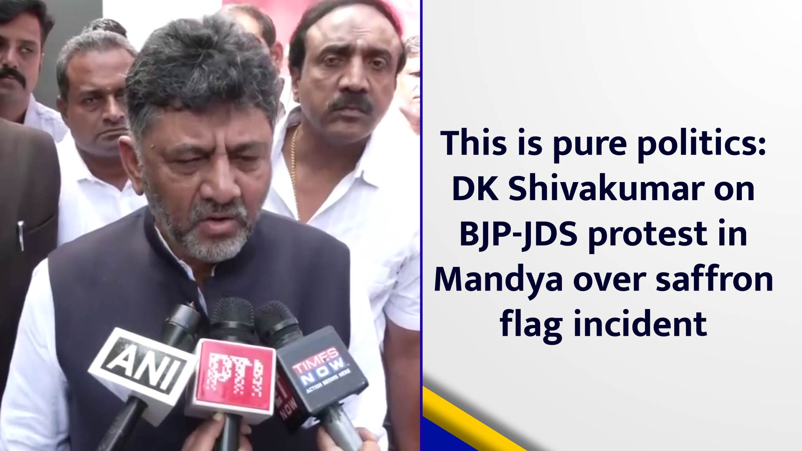](https://www.msn.com/en-in/video/news/this-is-pure-politics-dk-shivakumar-on-bjp-jds-protest-in-mandya-over-saffron-flag-incident/vi-BB1hqoUC?ocid=msedgntp)

He said in the federal system, they can make demands for devolution of taxes. Shivakumar termed the budget as “the worst I have ever seen”. “I had appealed for allocation of funds for various projects in Karnataka, but nothing has been allocated.

Many irrigation projects are suffering due to paucity of funds and several new projects in Bengaluru needs funds. She (Finance Minister Nirmala Sitaraman) was elected from Karnataka, but the got a raw deal in the budget. It is a very disappointing budget,” the DCM said.

Shivakumar said he had sought time from the Prime Minister to discuss development works in Bengaluru, but did not get it. An allocation of Rs 5,000 crore announced for the Upper Bhadra project in the last budget has not been released yet.

JSCIAR,

6th March 2024.

**The horse is prepared for the battle, but deliverance is from the LORD. Proverbs 21:31**

[[The Indian Express](https://www.msn.com/en-in/channel/source/The%20Indian%20Express/sr-vid-0n3ryst3jb54cd25pi87scxp7ijpqfajrbb8imcgceh66hiffv3s?ocid=msedgntp&pc=U531&cvid=3bb52db8d3964848a223f36ced610103&ei=30)](https://www.msn.com/en-in/channel/source/The%20Indian%20Express/sr-vid-0n3ryst3jb54cd25pi87scxp7ijpqfajrbb8imcgceh66hiffv3s?ocid=msedgntp&pc=U531&cvid=3bb52db8d3964848a223f36ced610103&ei=30" \o "View profile" \t "_blank)

**[The Indian Express](https://www.msn.com/en-in/channel/source/The%20Indian%20Express/sr-vid-0n3ryst3jb54cd25pi87scxp7ijpqfajrbb8imcgceh66hiffv3s?ocid=msedgntp&pc=U531&cvid=3bb52db8d3964848a223f36ced610103&ei=30" \o "View profile" \t "_blank)**

llow

**258.6K Followers**

# SC quashes 2018 money laundering case against Karnataka Deputy CM DK Shivakumar

Story by Express Web Desk

 • 18h

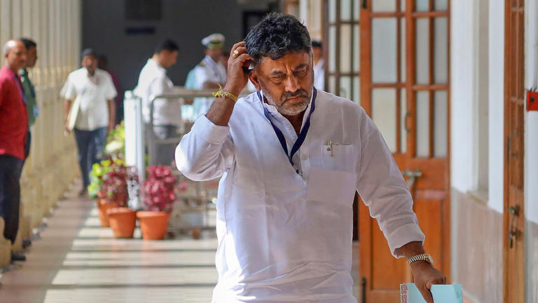

SC quashes 2018 money laundering case against Karnataka Deputy CM DK Shivakumar© Provided by The Indian Express

In a major relief for Karnataka Deputy Chief Minister D K Shivakumar, the Supreme Court Tuesday quashed proceedings initiated against him in a 2018 money laundering case.

The Karnataka Deputy CM and four others — Sachin Narayan, Sunil Sharma, Anjaneya Hanumanthaiah, and Rajendra N — were investigated by the ED following a preliminary complaint filed in 2018 on the basis of a 2017 I-T department investigation into the income and assets of Shivakumar. In 2022, the ED filed a prosecution complaint against Shivakumar alleging that as a Congress minister in Karnataka, he generated a huge amount of illegal wealth that was hidden away through a “criminal conspiracy” with associates.

JSCIAR,

14th March 2024.

For thus says the LORD: “You shall not see wind, nor shall you see rain; yet that valley shall be filled with water, so that you, your cattle, and your animals may drink.” 2 Kings 3:17

https://www.msn.com/en-in/news/India/there-s-no-water-crisis-as-far-as-bengaluru-is-concerned-karnataka-deputy-cm-shivakumar/ar-BB1jS315?ocid=msedgntp&pc=U531&cvid=53467c058f60410a9b3d16068f3c4077&ei=17

# 'There's No Water Crisis As Far As Bengaluru Is Concerned': Karnataka Deputy CM Shivakumar

Story by ABP News Bureau

 • 3h • 2 min read

Karnataka Deputy Chief Minister DK Shivakumar on Thursday declared that Bengaluru is not facing a water crisis and the state has made alternate arrangements to provide water. Further, Shivakumar reached out to the Prime Minister and BJP MPs urging them to secure the necessary permissions for the construction of the Mekedatu Dam.

On the water crisis issue, Karnataka Deputy CM DK Shivakumar says, "As far as Bengaluru is concerned, there is no water crisis. We have made alternative arrangements. BJP is saying that we are releasing water to Tamil Nadu. This is absolutely false. I appeal to the PM and BJP MPs that we get permission for the Mekadatu dam."

DK Shivakumar's statement follows accusations by Leader of Opposition R Ashoka, who criticised the Karnataka government for allegedly releasing Cauvery water to Tamil Nadu. Ashoka demanded an immediate halt to the water release and urged the government to address the water needs of Bengaluru residents.

Earlier, even CM Siddaramaiah clarified, "All that is lie. Who will let the water flow, that too in this situation? We will not give even a drop of water to Tamil Nadu without retaining water for our consumption."

He stated that Tamil Nadu did not request it nor did anyone instruct Karnataka to release water to the neighboring state.

Meanwhile, the water crisis in India's Silicon Valley has become an important topic of discussion in political circles just ahead of Lok Sabha elections scheduled to take place in April-May 2023.