JSCIAR,

16th January, 2024.

**Humanity is reading the last chronicles of the plant earth:**

**Bible prophesies being fulfilled at a rapid phase**

**The fall of the Babylon the great**

**The formation of the Palestine state**

**The Israel Palestine peace deal**

**One world government with one single currency 666**

**The building of the temple of the God of heaven and earth in Jerusalem**

**All those that believe in Jesus Christ will be saved. This is the judgement.**

**Qatar proposing the formation of the state of Palestine- Iteration of what Mr Xi Jinping has stated very recently**

[[Hindustan Times](https://www.hindustantimes.com/)](https://www.hindustantimes.com/" \o "Hindustan Times" \t "_blank)

**[Hindustan Times](https://www.hindustantimes.com/" \o "Hindustan Times" \t "_blank)**

Follow

**Qatar PM's stinging message for Israel: 'Gaza is not there anymore'**

Story by Mallika Soni  • 1h

https://www.msn.com/en-in/news/world/qatar-pm-s-stinging-message-for-israel-gaza-is-not-there-anymore/ar-AA1n3wCU?ocid=msedgntp&pc=U531&cvid=c0132f6bf8bd4825b0b3c35322c9e7a3&ei=10

Israel-Hamas War: Qatar's PM Sheikh Mohammed bin Abdulrahman Al Thani looks on.© Provided by Hindustan Times

Qatar’s prime minister warned of the massive destruction inflicted by Israel as he criticised Israeli defense minister’s rejection of a cease-fire in Gaza. The war which was sparked by Hamas' October 7 attack on Israel that triggered a humanitarian catastrophe in the enclave, displacing most of Gaza's 2.3 million population, as per United Nations. The was has continued for more than 100 days as the death toll in Gaza crossed 24,000 while in Israel around 1,200 people have been killed.

Qatar’s prime minister criticised Israel and the international community over the ongoing Israeli war on Hamas. Sheikh Mohammed bin Abdulrahman Al Thani, who also serves as Qatar’s foreign minister, said a two-state solution was required to end the conflict . The Israeli response showed the region could not go back to the way it was before, he said at the World Economic Forum in Davos.

“Gaza is not there anymore. I mean, there is nothing over there,” he said, adding, "It’s carpet bombing everywhere.”

Talking about ongoing tensions in the West Bank, he urged for an end to Palestinian divisions, saying, “We cannot have a two-state solution without having a government and politicians in Israel who believe in coexisting together side by side peacefully and we cannot have all this ongoing without ending this war.”

[[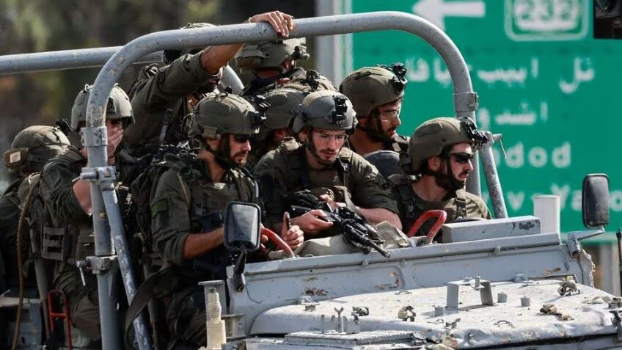](https://www.msn.com/en-in/video/news/hamas-ruined-us-gaza-civilians-tell-israeli-army-officers-in-audio-recording/vi-AA1mYeRI?ocid=msedgntp)](https://www.msn.com/en-in/video/news/hamas-ruined-us-gaza-civilians-tell-israeli-army-officers-in-audio-recording/vi-AA1mYeRI?ocid=msedgntp" \t "_blank)

[India Today](https://www.msn.com/en-in/video/news/hamas-ruined-us-gaza-civilians-tell-israeli-army-officers-in-audio-recording/vi-AA1mYeRI?ocid=msedgntp" \t "_blank)**[Hamas ruined us: Gaza civilians tell Israeli army officers in audio recording](https://www.msn.com/en-in/video/news/hamas-ruined-us-gaza-civilians-tell-israeli-army-officers-in-audio-recording/vi-AA1mYeRI?ocid=msedgntp" \t "_blank)**

[[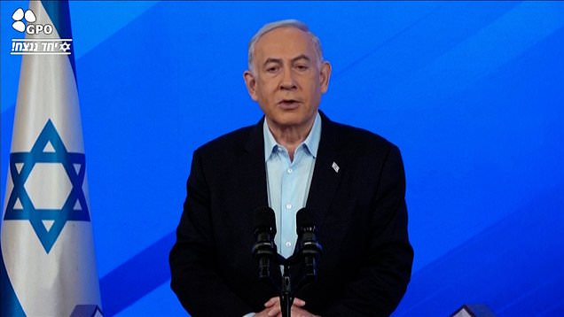](https://www.msn.com/en-in/video/news/netanyahu-says-icj-wont-stop-israel-fighting-until-victory-in-gaza/vi-AA1mVn2W?ocid=msedgntp)](https://www.msn.com/en-in/video/news/netanyahu-says-icj-wont-stop-israel-fighting-until-victory-in-gaza/vi-AA1mVn2W?ocid=msedgntp" \t "_blank)

[Dail](https://www.msn.com/en-in/video/news/netanyahu-says-icj-wont-stop-israel-fighting-until-victory-in-gaza/vi-AA1mVn2W?ocid=msedgntp" \t "_blank)

Warning that a military confrontation in the Mideast waterways “will not contain” the attacks by Yemen's Houthi rebels, he said, “What we have right now in the region is a recipe of escalation everywhere."

This comes as UN secretary-general Antonio Guterres said that Gaza faces “the long shadow of starvation” and the risk of disease. He said he was “deeply troubled by the clear violation of international humanitarian law that we are witnessing" but the UN and its partners “cannot effectively deliver humanitarian aid while Gaza is under such heavy, widespread and unrelenting bombardment.”

JSCIAR,

20th January, 2024.

**Heaven and earth will pass away, but my words will never pass away. Matthew 24:35**

**World heading towards fulfilling the end time prophecies – Mr Joe Biden reiterating what the Arab World and Mr Xi Jinping wanted – The formation of the Palestine state**

[[The Times of India](https://timesofindia.indiatimes.com/)](https://timesofindia.indiatimes.com/" \o "The Times of India" \t "_blank)

**[The Times of India](https://timesofindia.indiatimes.com/" \o "The Times of India" \t "_blank)**

https://www.msn.com/en-in/news/other/joe-biden-netanyahu-not-opposed-to-all-two-state-solutions-for-palestinians/ar-BB1gYnB5?ocid=msedgntp&pc=U531&cvid=69802e4f2dcb42b591e6f76de177ba2d&ei=18

Joe Biden: Netanyahu not opposed to all two-state solutions for Palestinians

Story by TOI World Desk  • 3h

[[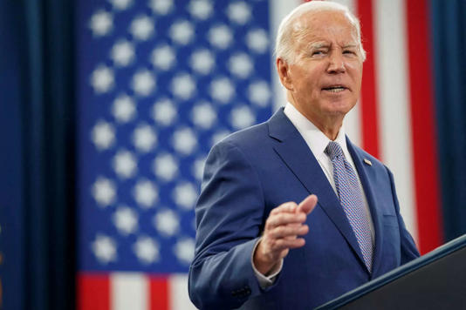](https://www.msn.com/en-in/news/other/joe-biden-netanyahu-not-opposed-to-all-two-state-solutions-for-palestinians/ar-BB1gYnB5?ocid=msedgntp&pc=U531&cvid=69802e4f2dcb42b591e6f76de177ba2d&ei=18&fullscreen=true#image=2)](https://www.msn.com/en-in/news/other/joe-biden-netanyahu-not-opposed-to-all-two-state-solutions-for-palestinians/ar-BB1gYnB5?ocid=msedgntp&pc=U531&cvid=69802e4f2dcb42b591e6f76de177ba2d&ei=18&fullscreen=true" \l "image=2" \t "_self)

Joe Biden: Netanyahu not opposed to all two-state solutions for Palestinians© Provided by The Times of India

In a significant diplomatic development, US President Joe Biden and Israeli Prime Minister Benjamin Netanyahu finally held discussions on Friday, marking their first direct communication in nearly a month. The White House revealed that the talks centered around Israel's ongoing military actions in Gaza and potential pathways to establishing an independent Palestinian state. Biden, addressing reporters after a meeting with US mayors, emphasized that Netanyahu is not entirely opposed to a two-state solution, suggesting the possibility of a non-militarized Palestinian government among various types of solutions.

“As we’re talking about post-conflict Gaza ... you can’t do that without also talking about the aspirations of the Palestinian people and what that needs to look like for them,” National Security Council spokesman John Kirby said.

Despite the apparent alignment on certain aspects, stark differences remain between the two leaders, particularly concerning the conditions for Palestinian statehood. Netanyahu has firmly stated his opposition to any form of Palestinian state that compromises Israel's security, insisting on Israel's control over the entire territory west of the Jordan River. This stance has led to a noticeable strain in the relationship between the US and Israel, especially as Biden continues to advocate for a two-state solution as a means to achieve long-term peace in the region.

The discussions also touched on efforts to secure the release of hostages held by Hamas and Israel's shift towards more targeted operations in Gaza to facilitate the entry of humanitarian aid. However, the recent escalation in violence, marked by a significant death toll and accusations against Israel of firing on a hospital in Khan Younis, has intensified the urgency for a diplomatic resolution.

As the conflict persists, the international community, including countries like Mexico and Chile, has called for investigations into potential war crimes in Gaza, a move that the US is cautiously approaching. The death of a 17-year-old Palestinian-American teenager by Israeli security forces has further complicated the situation, drawing serious concern from the White House.

The Biden-Netanyahu dialogue, while a step towards addressing the ongoing crisis, underscores the complex dynamics and deep-seated political considerations influencing the relationship between the US and Israel.

**Political crossroads:** As Biden gears up for the upcoming presidential election, and Netanyahu navigates internal challenges, their partnership teeters on a delicate balance, shaping future US and Israeli policies in the region.

In a landscape marked by political discord and humanitarian crises, the Biden-Netanyahu dialogue encapsulates the complexities of Middle Eastern diplomacy, reflecting a tumultuous path towards peace and stability.

JSCIAR,

22nd January, 2024.

**The stone that the builders have rejected has become the corner stone. Psalm 118:22**

[[Dagens.com India (Eng)](https://www.dagens.com/)](https://www.dagens.com/" \o "Dagens.com India (Eng)" \t "_blank)

**[Dagens.com India (Eng)](https://www.dagens.com/" \o "Dagens.com India (Eng)" \t "_blank)**

North Korea Emerges as Russia's Largest Arms Supplier, Says Ukrainian Intelligence Chief

Story by Henrik Rothen  • 11h

[[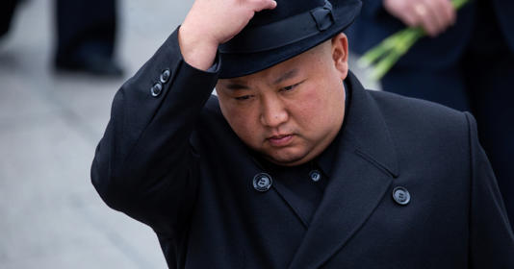](https://www.msn.com/en-in/news/world/north-korea-emerges-as-russia-s-largest-arms-supplier-says-ukrainian-intelligence-chief/ar-BB1h2lGI?ocid=msedgntp&pc=U531&cvid=facf7c1ebf7b4521adc47880a4a9653a&ei=24&fullscreen=true#image=2)](https://www.msn.com/en-in/news/world/north-korea-emerges-as-russia-s-largest-arms-supplier-says-ukrainian-intelligence-chief/ar-BB1h2lGI?ocid=msedgntp&pc=U531&cvid=facf7c1ebf7b4521adc47880a4a9653a&ei=24&fullscreen=true" \l "image=2" \t "_self)

Photo: Shutterstock.com© Provided by Dagens.com India (Eng)

In a revelation to the [Financial Times](https://www.ft.com/content/98c005cd-7def-44b5-a938-5243c77520a9), Kyrylo Budanov, the head of Ukrainian military intelligence (HUR), stated that North Korea is currently serving as Russia's largest arms supplier.

According to Budanov's interview published on today (January 21), North Korea has provided a considerable amount of artillery ammunition to Russia.

"This has allowed Russia to breathe a little," Budanov remarked, indicating the critical role of these supplies in sustaining Russian military efforts.

"Without North Korea's help, the situation for Russia would have been catastrophic," he added.

Russia's reliance on North Korean military aid reflects its struggle to maintain weapon and munition production in line with the intense demands of the frontline. Budanov pointed out that seeking such assistance from a country like North Korea was previously deemed undignified by Moscow.

The bolstering of military ties between Moscow and Pyongyang has been particularly notable since the onset of Russia's full-scale invasion of Ukraine in February 2022.

A spokesperson for Ukraine's military intelligence had previously reported on January 15 that North Korea supplied Russia with approximately one million rounds of ammunition, primarily consisting of 122 mm and 152 mm artillery shells.

Adding to this, both Kyiv and Washington have reported that Russia deployed North Korean ballistic missiles for the first time against Ukraine, targeting Kharkiv on January 2.

In a related development, North Korea's state news agency KCNA reported on January 21 that Russian [President Vladimir Putin plans](https://www.dagens.com/news/putin-plans-visit-to-north-korea) a forthcoming visit to North Korea. This planned visit underscores the deepening military relationship between the two nations, a strategic alliance that has garnered global attention in the context of the Ukraine conflict.