JSCIAR,

16th January, 2024.

**Humanity is reading the last chronicles of the plant earth:**

**Bible prophesies being fulfilled at a rapid phase**

**The fall of the Babylon the great**

**The formation of the Palestine state**

**The Israel Palestine peace deal**

**One world government with one single currency 666**

**The building of the temple of the God of heaven and earth in Jerusalem**

**All those that believe in Jesus Christ will be saved. This is the judgement.**

**Qatar proposing the formation of the state of Palestine- Iteration of what Mr Xi Jinping has stated very recently**

[[Hindustan Times](https://www.hindustantimes.com/)](https://www.hindustantimes.com/" \o "Hindustan Times" \t "_blank)

**[Hindustan Times](https://www.hindustantimes.com/" \o "Hindustan Times" \t "_blank)**

Follow

**Qatar PM's stinging message for Israel: 'Gaza is not there anymore'**

Story by Mallika Soni  • 1h

https://www.msn.com/en-in/news/world/qatar-pm-s-stinging-message-for-israel-gaza-is-not-there-anymore/ar-AA1n3wCU?ocid=msedgntp&pc=U531&cvid=c0132f6bf8bd4825b0b3c35322c9e7a3&ei=10

Israel-Hamas War: Qatar's PM Sheikh Mohammed bin Abdulrahman Al Thani looks on.© Provided by Hindustan Times

Qatar’s prime minister warned of the massive destruction inflicted by Israel as he criticised Israeli defense minister’s rejection of a cease-fire in Gaza. The war which was sparked by Hamas' October 7 attack on Israel that triggered a humanitarian catastrophe in the enclave, displacing most of Gaza's 2.3 million population, as per United Nations. The was has continued for more than 100 days as the death toll in Gaza crossed 24,000 while in Israel around 1,200 people have been killed.

Qatar’s prime minister criticised Israel and the international community over the ongoing Israeli war on Hamas. Sheikh Mohammed bin Abdulrahman Al Thani, who also serves as Qatar’s foreign minister, said a two-state solution was required to end the conflict . The Israeli response showed the region could not go back to the way it was before, he said at the World Economic Forum in Davos.

“Gaza is not there anymore. I mean, there is nothing over there,” he said, adding, "It’s carpet bombing everywhere.”

Talking about ongoing tensions in the West Bank, he urged for an end to Palestinian divisions, saying, “We cannot have a two-state solution without having a government and politicians in Israel who believe in coexisting together side by side peacefully and we cannot have all this ongoing without ending this war.”

[[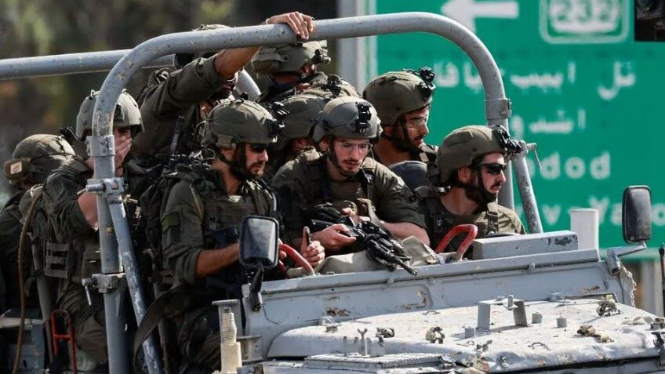](https://www.msn.com/en-in/video/news/hamas-ruined-us-gaza-civilians-tell-israeli-army-officers-in-audio-recording/vi-AA1mYeRI?ocid=msedgntp)](https://www.msn.com/en-in/video/news/hamas-ruined-us-gaza-civilians-tell-israeli-army-officers-in-audio-recording/vi-AA1mYeRI?ocid=msedgntp" \t "_blank)

[India Today](https://www.msn.com/en-in/video/news/hamas-ruined-us-gaza-civilians-tell-israeli-army-officers-in-audio-recording/vi-AA1mYeRI?ocid=msedgntp" \t "_blank)**[Hamas ruined us: Gaza civilians tell Israeli army officers in audio recording](https://www.msn.com/en-in/video/news/hamas-ruined-us-gaza-civilians-tell-israeli-army-officers-in-audio-recording/vi-AA1mYeRI?ocid=msedgntp" \t "_blank)**

[[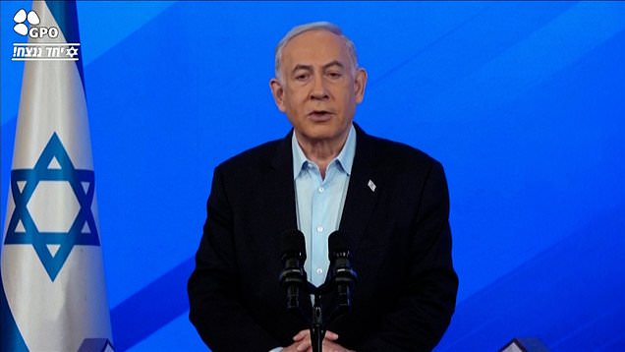](https://www.msn.com/en-in/video/news/netanyahu-says-icj-wont-stop-israel-fighting-until-victory-in-gaza/vi-AA1mVn2W?ocid=msedgntp)](https://www.msn.com/en-in/video/news/netanyahu-says-icj-wont-stop-israel-fighting-until-victory-in-gaza/vi-AA1mVn2W?ocid=msedgntp" \t "_blank)

[Dail](https://www.msn.com/en-in/video/news/netanyahu-says-icj-wont-stop-israel-fighting-until-victory-in-gaza/vi-AA1mVn2W?ocid=msedgntp" \t "_blank)

Warning that a military confrontation in the Mideast waterways “will not contain” the attacks by Yemen's Houthi rebels, he said, “What we have right now in the region is a recipe of escalation everywhere."

This comes as UN secretary-general Antonio Guterres said that Gaza faces “the long shadow of starvation” and the risk of disease. He said he was “deeply troubled by the clear violation of international humanitarian law that we are witnessing" but the UN and its partners “cannot effectively deliver humanitarian aid while Gaza is under such heavy, widespread and unrelenting bombardment.”