JSCIAR, India,

28th November, 2023.

**Shree Udayanidhi learning from his father and aunt and in the making of a national leader:**

https://www.msn.com/en-in/news/other/mk-stalin-akhilesh-yadav-honour-vp-singh-congress-skips-event/ar-AA1kCv6N?ocid=msedgntp&cvid=07a8f11f5bfa49b08bdb3433acc1d564&ei=22

[[The Times of India](https://timesofindia.indiatimes.com/)](https://timesofindia.indiatimes.com/" \o "The Times of India" \t "_blank)

**[The Times of India](https://timesofindia.indiatimes.com/" \o "The Times of India" \t "_blank)**

**MK Stalin & Akhilesh Yadav honour VP Singh, Congress skips event**

[[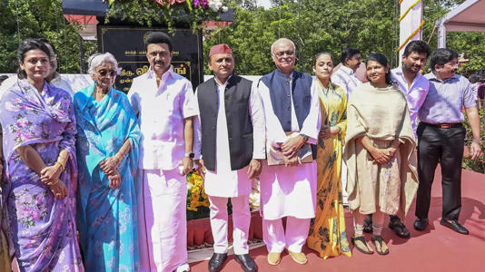](https://www.msn.com/en-in/news/other/mk-stalin-akhilesh-yadav-honour-vp-singh-congress-skips-event/ar-AA1kCv6N?ocid=msedgntp&cvid=49b4be370e0c4df6b5d1d85f97a6eaea&ei=4&fullscreen=true#image=2)](https://www.msn.com/en-in/news/other/mk-stalin-akhilesh-yadav-honour-vp-singh-congress-skips-event/ar-AA1kCv6N?ocid=msedgntp&cvid=49b4be370e0c4df6b5d1d85f97a6eaea&ei=4&fullscreen=true#image=2)

MK Stalin & Akhilesh Yadav honour VP Singh, Congress skips event© Provided by The Times of India

CHENNAI: Tamil Nadu CM MK Stalin unveiled a life-size statue of former PM VP Singh in Chennai on Monday, accompanied by SP chief Akhilesh Yadav, but leaders of DMK ally Congress were conspicuous by their absence. Sources said Congress had no representation at the event ostensibly because the PCC chief was out of town.

The Congress harbours resentment against Singh for orchestrating the downfall of Rajiv Gandhi in the 1989 general elections and forming a Janata Dal-led coalition government with Leftist parties and BJP to become the seventh PM. Akhilesh's presence holds significance as his father Mulayam Singh Yadav, then the CM of UP, withdrew support to Singh in 1990, supporting Chandra Shekhar instead.

During the unveiling of the statue, which cost Rs 52 lakh and is the first of its kind outside Singh's native UP, Stalin reiterated his call for a nationwide caste census to systematically implement proportionate reservation. He proposed the formation of a monitoring body comprising MPs from all parties to ensure proper execution of caste-based quota.

105542138

Stalin asserted that conducting a caste census alongside the overdue population census would be a genuine tribute to Singh who, during his 11-month tenure as PM, implemented the Mandal Commission report for backward castes, triggering significant protests.

For his part, Akhilesh expressed gratitude to Stalin for installing the statue, underscoring that it sends a message to leaders in New Delhi that social justice should drive policies. "SP stands with DMK in its fight for social uplift... it's a long road ahead and we will fight this together," he said.

Stalin paid tribute to the former PM, describing him as the guardian of social justice and a close friend of his father M Karunanidhi. He highlighted the need for proper implementation of reservations for backward classes, SCs, STs, and minorities nationwide.

JSCIAR, India

3rd December 2023.

Shri Udayanidhi Statili – Outspoken leader

[[The New Indian Express](https://www.newindianexpress.com/)](https://www.newindianexpress.com/" \t "_blank)

**[The New Indian Express](https://www.newindianexpress.com/" \t "_blank)**

# PM handed over country to Adani, claims Udhayanidhi

Udhayanidhi was taking part in a meeting of DMK youth wing at CODISSIA grounds in the city.

COIMBATORE/NILGIRIS: DMK youth wing secretary and Minister for Youth Welfare and Sports Development Udhayanidhi Stalin on Saturday said Prime Minister Narendra Modi has handed over the country to his friend Adani.

Udhayanidhi was taking part in a meeting of DMK youth wing at CODISSIA grounds in the city. He said the CIA has given statement on a scam worth Rs 7.5 lakh crore puled off by the ruling BJP at the centre, and compared it with Tamil film ‘Ramana’.

Udhayanidhi also claimed that the central government received Rs 9.5 lakh crore as tax from Tamil Nadu and is refusing to give the state its due share.Udhayanidhi said that so far 20 students have died by suicide due to NEET.“So far, the party has received 70 lakh signature from students who are against NEET,” he said.

Udhayanidhi also said DMK’s second state youth wing conference will be held in Salem ahead of the 2024 parliamentary elections.

[[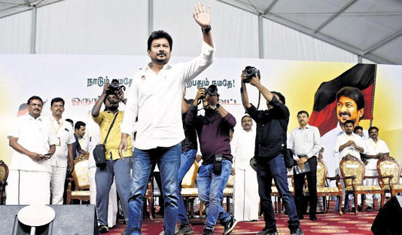](https://www.msn.com/en-in/news/India/pm-handed-over-country-to-adani-claims-udhayanidhi/ar-AA1kUj2j?ocid=msedgntp&cvid=2772141661a34448b0164348c9fd341d&ei=32&fullscreen=true#image=2)](https://www.msn.com/en-in/news/India/pm-handed-over-country-to-adani-claims-udhayanidhi/ar-AA1kUj2j?ocid=msedgntp&cvid=2772141661a34448b0164348c9fd341d&ei=32&fullscreen=true" \l "image=2" \t "_self)

PM handed over country to Adani, claims Udhayanidhi© Provided by The New Indian Express

JSCIAR, India,

3rd December 2023.

“Shri Udhayanidhi Stalin can make a difference by turning the challenges to opportunities to win trust of the people – And here is such an opportunity.”

[[The New Indian Express](https://www.newindianexpress.com/)](https://www.newindianexpress.com/" \t "_blank)

**[The New Indian Express](https://www.newindianexpress.com/" \t "_blank)**

# Flooded streets in Chennai reveal govt’s incompetence: Edappadi K Palaniswami

He further alleged that the state government is wasting public money on events like car races, which is organised at a cost of Rs 242 crore, where Rs 42 crore has been spent to create tracks.

SALEM: Rainwater stagnation in Chennai shows the administrative incompetence of the DMK government, said AIADMK general secretary Edappadi K Palaniswami in Salem on Saturday. Speaking to media persons after a consultation meeting held in Omalur, he said, “The state government had announced Rs 4000 crore for drainage works in Chennai and assured people that there will not be any water stagnation. However, Chennai has been severely affected by the recent rains as the stormwater drains are not constructed properly. This shows the administrative incompetence of the government.”

He further alleged that the state government is wasting public money on events like car races in Island Grounds (Theevu Thidal) in Chennai, which is organised at a cost of Rs 242 crore, where Rs 42 crore has been spent to create tracks. “Why should the race be conducted on Island Grounds, when we already have a race track in Irungattukottai? Many government projects like Amma canteens are floundering without funds and the government is wasting people’s money in such events. This is highly condemnable.” Palaniswami also said the race will cause inconvenience to the public as its location is near government hospitals, railway stations and ports.

When asked about the DVAC raid at ED office, he said, “A mistake is a mistake irrespective of who commits it, and the law will be doing its duty.” Talking about parliamentary elections, he said 90% of preliminary work is completed, which includes setting up booth committees in each district. “Other works will be completed in a week. After that, we will discuss the election strategies with the party’s chief functionaries and will announce the alliance as the election approaches,” he said.To the question about alleged threats to the Tamil Nadu Assembly speaker, M Appavu, Palaniswami said, “As far as AIADMK is concerned, we respect him. But we don’t value his speech as he always supports DMK in Assembly.”

[[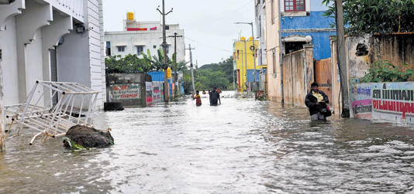](https://www.msn.com/en-in/news/India/flooded-streets-in-chennai-reveal-govt-s-incompetence-edappadi-k-palaniswami/ar-AA1kUgF5?ocid=msedgntp&cvid=9f5d939e3ad3486495a1ac72707a4945&ei=54&fullscreen=true#image=2)](https://www.msn.com/en-in/news/India/flooded-streets-in-chennai-reveal-govt-s-incompetence-edappadi-k-palaniswami/ar-AA1kUgF5?ocid=msedgntp&cvid=9f5d939e3ad3486495a1ac72707a4945&ei=54&fullscreen=true" \l "image=2" \t "_self)

Flooded streets in Chennai reveal govt’s incompetence: Edappadi K Palaniswami© Provided by The New Indian Express

JSCIAR, India,

4th December, 2023.

Challenges that Shri Udhayanidhi Stalin should quicly encash to win electoral confidence:

https://www.msn.com/en-in/entertainment/tv/10-viral-videos-of-the-chennai-floods-that-show-just-how-bad-it-is-there-right-now/ar-AA1kXtuF?ocid=msedgntp&cvid=428f2324d92f43a6bced8440ac68d1b6&ei=19

10 viral videos of the Chennai floods that show just how bad it is there right now

Story by adhyamoona • 8h [[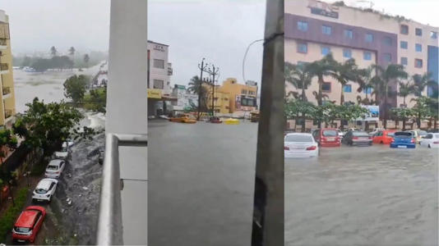](https://www.msn.com/en-in/entertainment/tv/10-viral-videos-of-the-chennai-floods-that-show-just-how-bad-it-is-there-right-now/ar-AA1kXtuF?ocid=msedgntp&cvid=428f2324d92f43a6bced8440ac68d1b6&ei=19&fullscreen=true#image=2)](https://www.msn.com/en-in/entertainment/tv/10-viral-videos-of-the-chennai-floods-that-show-just-how-bad-it-is-there-right-now/ar-AA1kXtuF?ocid=msedgntp&cvid=428f2324d92f43a6bced8440ac68d1b6&ei=19&fullscreen=true#image=2)

10 viral videos of the Chennai floods that show just how bad it is there right now© Provided by DailyO

The deep depression over the Bay of Bengal has intensified, and is expected to become a severe cyclonic storm, Michaung, today. Parts of Chennai received heavy rain with strong winds throughout today as Cyclone Michaung inched closer to the Tamil Nadu and Andhra Pradesh coast.

Here are 10 videos that show just how bad the situation is in Chennai.

## **Videos going viral on X**

**Here are the videos going viral on X (Twitter), showing just how severely the rains and cyclone have affected Chennai.**

**1. A car stuck in the massive waterlogging caused by the heavy rains**

**2. The Chennai international airport has also been affected because of the rains.**

**3. Here's another video of how people are struggling because of the rain and waterlogging in Vadapalani and Arumbakkam areas of the city.**

**4. The Chennai flood level is concerning.**

**5. The India Meteorological Department (IMD) has predicted that Chennai and it's neighbouring districts would experience heavy rain in the next 24 hours.**

**6. The unsung heroes.**

**7. Cars can be seen floating in water.**

**8. The city is being lashed by heavy winds since last night.**

**9. Cars have broken down on roads because of the rains.**

**10. This is not it, there's also a video that has been going viral on X that shows a mugger crocodile crossing the road in Chennai.**

## **What's happening**

**The situation in Chennai:**

* Chennai, Kanchipuram, Chengalpattu and Tiruvallur districts of Tamil Nadu are among the most affected areas.
* Teams of the National Disaster Response Force (NDRF) rescued around 15 people from Peerkankaranai and Perungalathur neighbourhoods in Chennai's Tambaram area, as it experienced severe waterlogging and power outages.

**What did India Meteorological Department say?**

* S Balachandran, Director, the India Meteorological Department (IMD), Chennai, said, "Cyclone 'Michaung' lies about 100 km from East-North East of Chennai. In the last 6 hours, it has moved at the speed of 10 km/hr and it's expected to move in the northwest direction, intensified to severe cyclonic storm is expected by 4 pm today."
* He added, "Further, it will move parallel to the coast of north Tamil Nadu and South Andhra Pradesh, expected to cross Nellore- Machilipatnam by tomorrow at 4 pm. Heavy rainfall and strong winds are likely to continue till this evening in Chennai, Chengalpattu, Kancheepuram and Thiruvallur districts."

## **Latest developments**

* **Section 144 imposed in Puducherry:**The Puducherry district administration has imposed Section 144 of the IPC on the coastal areas close to the sea shore of Puducherry. They have done so to prevent any loss of life or property and have also restricted the movement of people on the coastal areas near the sea shore has been prohibited from 7 pm on December 3 until 6 pm on December 5.
* **Wall collapsed:** A newly constructed wall collapsed in the Kanathur area, East Coastal Road, Chennai, this morning. Two people died and one was critically injured in this incident.
* **Trains cancelled:** 11 express trains have cancelled after water level breached the danger mark in Basin Bridge-Vyasarpadi section.
* **Chennai airport: Chennai airport will remain shut till**11.30 pm on Monday. Today, around 10 flights were cancelled and 20 flights were delayed.

JSCIAR, India

4th December, 2023.

Shri Udhayanidhi Stalin \_ The voice of the people

[[The New Indian Express](https://www.newindianexpress.com/)](https://www.newindianexpress.com/" \t "_blank)

**[The New Indian Express](https://www.newindianexpress.com/" \t "_blank)**

Follow

# PM Modi spreading false news about me: Udhayanidhi

10h

"Modi twisted the statement and said I will carry out a genocide. A case has been filed in the courts, but I refused to apologise or express regret for my comments."

TIRUPPUR: Minister for Youth Welfare and Sports Development Udhayanidhi Stalin on Sunday said Prime Minister Narendra Modi is spreading false statements about him.

[[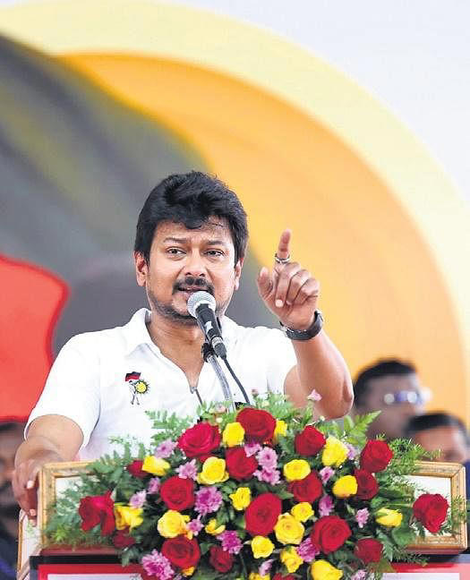](https://www.msn.com/en-in/news/India/pm-modi-spreading-false-news-about-me-udhayanidhi/ar-AA1kXo9N?ocid=msedgntp&cvid=fafcf0afd36b416dabcad8cc7ac34f55&ei=41&fullscreen=true#image=2)](https://www.msn.com/en-in/news/India/pm-modi-spreading-false-news-about-me-udhayanidhi/ar-AA1kXo9N?ocid=msedgntp&cvid=fafcf0afd36b416dabcad8cc7ac34f55&ei=41&fullscreen=true" \l "image=2" \t "_self)

Sports Minister Udhayanidhi Stalin at Kangeyam on Sunday | Express© Provided by The New Indian Express

Addressing party workers at Kangeyam, he said, “Whenever PM Narendra Modi travels to a state, he never forgets about Tamil Nadu, Chief Minister MK Stalin and me. While campaigning for Madhya Pradesh elections last week, he talked about me alone.

He said so many things which I didn’t say and spread false information and rumours. Speaking at a recent public conference in Chennai about social justice and equality among people, I said all obstacles must be removed for the welfare of society. But he twisted the statement and said I will carry out a genocide. A case has been filed in the courts, but I refused to apologise or express regret for my comments.”

Further, Udhayanidhi said, “The union government is always biased towards Tamil Nadu. For the past 9 years, Tamil Nadu contributed Rs 5 lakh crore as tax to the centre, but the union government offered just Rs 2 lakh crore. But at the same time, the union government gave around Rs 9 lakh crore to Uttar Pradesh. Such basic rights of the state were denied. We have to question the act and raising questions about them is our right.”

[[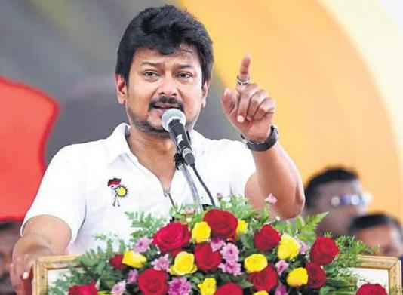](https://www.msn.com/en-in/news/India/pm-modi-spreading-false-news-about-me-udhayanidhi/ar-AA1kXo9N?ocid=msedgntp&cvid=fafcf0afd36b416dabcad8cc7ac34f55&ei=41&fullscreen=true#image=2)](https://www.msn.com/en-in/news/India/pm-modi-spreading-false-news-about-me-udhayanidhi/ar-AA1kXo9N?ocid=msedgntp&cvid=fafcf0afd36b416dabcad8cc7ac34f55&ei=41&fullscreen=true" \l "image=2" \t "_self)

PM Modi spreading false news about me: Udhayanidhi© Provided by The New Indian Express

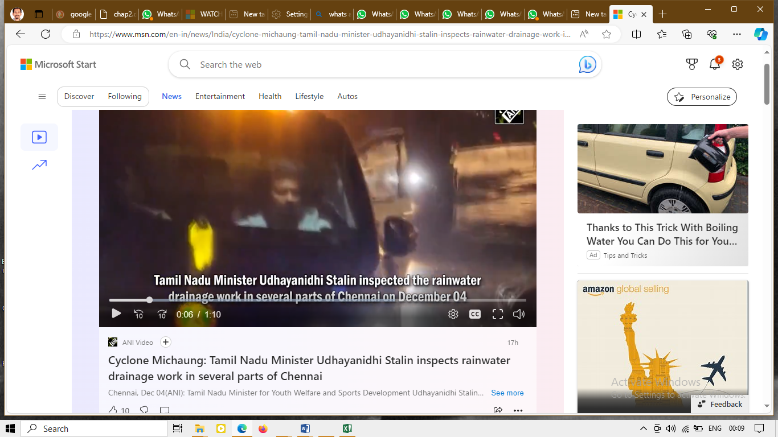

Shri Udhayanidh Stalin \_ Persistent leader in seeking good for the victims

https://www.msn.com/en-in/news/India/udhayanidhi-stalin-urges-centre-to-release-necessary-funds-for-flood-relief-in-tamil-nadu/ar-AA1m0Zwn

[[The Times of India](https://timesofindia.indiatimes.com/)](https://timesofindia.indiatimes.com/" \o "The Times of India" \t "_blank)

**[The Times of India](https://timesofindia.indiatimes.com/" \o "The Times of India" \t "_blank)**

https://www.msn.com/en-in/news/India/udhayanidhi-stalin-urges-centre-to-release-necessary-funds-for-flood-relief-in-tamil-nadu/ar-AA1m0Zwn

Follow

# Udhayanidhi Stalin urges Centre to release 'necessary' funds for flood relief in Tamil Nadu

10h

[[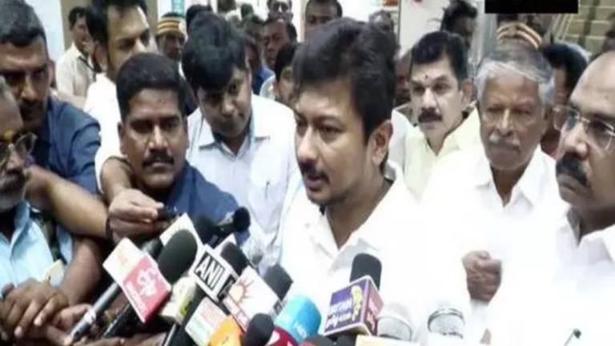](https://www.msn.com/en-in/news/India/udhayanidhi-stalin-urges-centre-to-release-necessary-funds-for-flood-relief-in-tamil-nadu/ar-AA1m0Zwn?fullscreen=true#image=2)](https://www.msn.com/en-in/news/India/udhayanidhi-stalin-urges-centre-to-release-necessary-funds-for-flood-relief-in-tamil-nadu/ar-AA1m0Zwn?fullscreen=true" \l "image=2" \t "_self)

Udhayanidhi Stalin urges Centre to release 'necessary' funds for flood relief in Tamil Nadu© Provided by The Times of India

THOOTHUKUDI: Tamil Nadu minister Udhayanidhi Stalin expressed hope on Monday that after the inspection of Union Finance Minister Nirmala Sitharaman in the flood-affected areas of the state, the Centre will allocate the required funds to the state.

"We are hopeful that after the inspection, Finance Minister Nirmala Sitharaman will allocate the required funds to the state," Udhayanidhi Stalin said here after reviewing the post-flood reconstruction and rehabilitation activities in the district.

Notably, Tamil Nadu is grappling with the aftermath of the cyclone and flooding, the state government and the Centre have jointly mobilised a massive rescue and relief operation to help the affected people.

As many as 35 deaths have been reported so far in the ongoing flooding, with Thoothukudi district accounting for 22 fatalities and Tirunelveli for 13.

"The Union Minister (Nirmala Sitharaman) said there is no big disaster. Now she is coming here tomorrow for an inspection. Prime Minister Narendra Modi has also spoken with the Tamil Nadu Chief Minister. The CM has also told the PM about the loss and has also asked for the necessary funds," he added.

Meanwhile, Tamil Nadu Bharatiya Janata Party (BJP) Chief K Annamalai on Monday hailed Prime Minister Narendra Modi for assuring support to the flood-affected state and deputing Union Finance Minister Nirmala Sitharaman to assess the flood situation, saying that the PM has always had the best interests of the people of the state in mind.

In a response to Chief Minister MK Stalin's post on X, wherein he confirmed the assistance from the union government for flood-affected regions, the BJP state chief listed earlier assistance provided to the state by the central government.

"Our Hon PM Thiru @narendramodi avl has always had the best interests of the people of TN in mind & his actions in the last 9 years exemplify that," Annamalai said.

He further said that CM Stalin should remind his party workers and his ministers, who've been "vile and exaggerative, spreading half-truths to divert people's anger for the unpreparedness of the State Government" despite receiving warnings of heavy rainfall.

Earlier on Sunday, in a post on X, Chief Minister MK Stalin expressed gratitude for the Prime Minister's prompt attention to the dire situation.

"Prime Minister @narendramodi called me to inquire about the unprecedented floods in Southern Tamil Nadu, immediately after #CycloneMichaung," CM Stalin said in the post.

The Chief Minister apprised the Prime Minister of the urgent need for financial support from the Union government to address the mounting challenges faced by the state.

"I have explained to him the massive rescue and relief efforts undertaken by the state government, despite resource constraints, and sought immediate financial support from the Union government," he added.

In response to the Chief Minister's plea, PM Modi assured full support from the Union government to help Tamil Nadu overcome these twin calamities.

Furthermore, the Prime Minister conveyed that Union Finance Minister Nirmala Sitharaman has been deputed to assess the flood situation on the ground.

"Prime Minister has assured the support of the Union government to overcome these twin calamities and conveyed that he has deputed Union Finance Minister @nsitharaman to assess the flood situation," Stalin said.

For more news like this visit [TOI](https://timesofindia.indiatimes.com/). Get all the [Latest News](https://timesofindia.indiatimes.com/), [City News](https://timesofindia.indiatimes.com/city), [India News](https://timesofindia.indiatimes.com/india), [Business News](https://timesofindia.indiatimes.com/business), and [Sports News](https://timesofindia.indiatimes.com/sports). For [Entertainment News](https://timesofindia.indiatimes.com/entertainment), [TV News](https://timesofindia.indiatimes.com/tv/hindi), and [Lifestyle Tips](https://timesofindia.indiatimes.com/life-style) visit [Etimes](https://timesofindia.indiatimes.com/etimes)

JSCIAR,

9th January, 2024.

**Humility goes before honor. Proverbs 18:12**

**Humble yourself under the mighty arms of the LORD that you will be lifted up in due time.**

**1 Peter 5:6**

**https://www.msn.com/en-in/news/India/udhayanidhi-stalin-to-become-tamil-nadu-deputy-chief-minister-he-says/ar-AA1mEm28**

[[India Today](https://www.indiatoday.in/)](https://www.indiatoday.in/" \o "India Today" \t "_blank)

**[India Today](https://www.indiatoday.in/" \o "India Today" \t "_blank)**

[Udhayanidhi Stalin to become Tamil Nadu Deputy Chief Minister? He says... (msn.com)](https://www.msn.com/en-in/news/India/udhayanidhi-stalin-to-become-tamil-nadu-deputy-chief-minister-he-says/ar-AA1mEm28)

# Udhayanidhi Stalin to become Tamil Nadu Deputy Chief Minister? He says...

Story by Pramod Madhav  • 10h

[[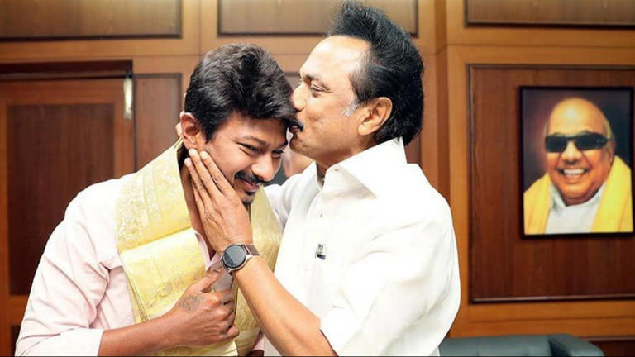](https://www.msn.com/en-in/news/India/udhayanidhi-stalin-to-become-tamil-nadu-deputy-chief-minister-he-says/ar-AA1mEm28?fullscreen=true#image=2)](https://www.msn.com/en-in/news/India/udhayanidhi-stalin-to-become-tamil-nadu-deputy-chief-minister-he-says/ar-AA1mEm28?fullscreen=true" \l "image=2" \t "_self)

Udhayanidhi Stalin to become Tamil Nadu Deputy Chief Minister? He says...© Provided by India Today

Speculations have been rife in Tamil Nadu's political circles about the possible elevation of DMK leader and Sports Minister Udhayanidhi as the Deputy Chief Minister of the state in the days to come.

Sources within the ruling Dravida Munnetra Kazhagam (DMK) told India Today that MK Stalin is expected to embark on a foreign trip in February, paving the way for Udhayanidhi Stalin to assume the role of his father's deputy.

The anticipated elevation is speculated to occur following the party's Youth Wing meeting scheduled in Salem on January 21.

While DMK Organisational Secretary TKS Elangovan expressed a lack of awareness regarding Udhayanidhi's appointment as Tamil Nadu's Deputy Chief Minister, he acknowledged Udhayanidhi's active involvement in the party.

Elangovan, however, asserted that the final decision lies with MK Stalin, adding, "There is nothing wrong with it, as he is very active. But whether he will become Deputy Chief Minister or not will be decided only by the Chief Minister and not others".

Meanwhile, Udhayanidhi, while speaking with India Today, downplayed the entire episode and called it to be a 'rumour'. "Only the Chief Minister has to take the decision. It is just a rumour", Udhayanidhi said.

Reacting to the reports, All India Anna Dravida Munnetra Kazhagam (AIADMK) stressed that Udhayanidhi becoming a Deputy Chief Minister can't be dismissed as a rumour as it is a fact.

"This is what we have been saying since last one year. From the time he (Udhayanidhi) was given a ticket to contest in Assembly elections. Then he became a minister and now Deputy Chief Minister. He will be the CM face in 2026 and this shows that DMK is the perfect example of 'parivarvad' in the name of democracy," AIADMK spokesperson Kovai Sathyan said.

"Father, son, grandson and great-grandson are the only people capable of leading the party, which shows that there is no democracy in the DMK, unlike AIADMK where even a grass-root worker can become the head of the party," Sathyan added.