JSCIAR,

15th January, 2024.

**Leader with the imitation of Christ**

**Whosoever will be great among you, let him be your minister. Matthew 20:26**

**Shri Amit Shah – Leader with loyalty responsible for stable unity government in India**

* Follow

**Home Minister Amit Shah's Elder Sister Passes Away At Mumbai Hospital**

3h

[[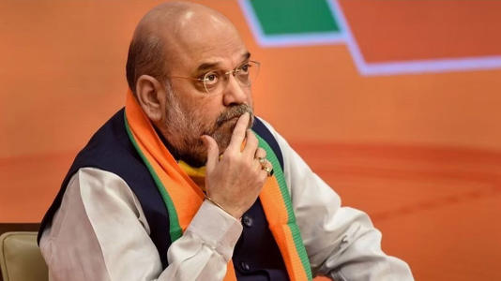](https://www.msn.com/en-in/health/health-news/home-minister-amit-shah-s-elder-sister-passes-away-at-mumbai-hospital/ar-AA1mZ6Xt?ocid=msedgntp&pc=U531&cvid=0aa4a58424674c32bbff38ecce020335&ei=14&fullscreen=true#image=2)](https://www.msn.com/en-in/health/health-news/home-minister-amit-shah-s-elder-sister-passes-away-at-mumbai-hospital/ar-AA1mZ6Xt?ocid=msedgntp&pc=U531&cvid=0aa4a58424674c32bbff38ecce020335&ei=14&fullscreen=true" \l "image=2" \t "_self)

Home Minister Amit Shah's Elder Sister Passes Away At Mumbai Hospital© Provided by Free Press Journal

Rajuben, the elder sister of Union Home Minister Amit Shah, breathed her last on Monday at a Mumbai hospital, The Indian Express reported. Rajuben had been undergoing recovery at the hospital following a lung transplant procedure conducted a few months ago.

After the unfortunate news, Shah decided to cancel two public events that were originally scheduled to take place in Gujarat. A BJP leader mentioned that, in light of his elder sister's demise, Shah opted to forgo all his public engagements.

**Shah was scheduled to attend two events**

Shah had planned to participate in two public functions in Gujarat, with one scheduled at Banas Dairy in Deodar of Banaskantha district and the other at Rashtriya Raksha University in Gandhinagar.

Shah had plans to inaugurate several projects and unveil new products for Banas Dairy, in addition to addressing a public gathering in the morning.

Ajay Patel, Chairman of the Gujarat State Cooperative Bank Limited, who attended the Banaskantha event, stated that Shah was unable to be present at the occasion due to the passing of his elder sister.

JSCIAR,

18th January, 2024.

**Humility goes before honor. Proverbs 18:12**

[[India.com](https://www.india.com/)](https://www.india.com/" \o "India.com" \t "_blank)

**[India.com](https://www.india.com/" \o "India.com" \t "_blank)**

Follow

# Lok Sabha Polls: Kumaraswamy Discusses JD(S)-BJP Seat-Sharing With Nadda, Shah

Story by support@india.com (India.com News Desk)  • 13h

https://www.msn.com/en-in/news/India/lok-sabha-polls-kumaraswamy-discusses-jd-s-bjp-seat-sharing-with-nadda-shah/ar-AA1n8Ald?ocid=msedgntp&pc=U531&cvid=859ff945f1e44ab794c5bb34fd2c5117&ei=14

[[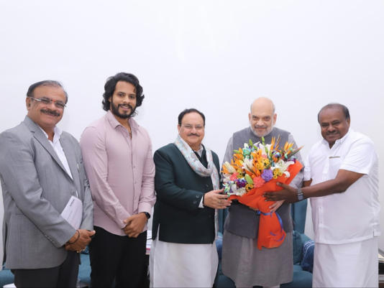](https://www.msn.com/en-in/news/India/lok-sabha-polls-kumaraswamy-discusses-jd-s-bjp-seat-sharing-with-nadda-shah/ar-AA1n8Ald?ocid=msedgntp&pc=U531&cvid=859ff945f1e44ab794c5bb34fd2c5117&ei=14&fullscreen=true#image=2)](https://www.msn.com/en-in/news/India/lok-sabha-polls-kumaraswamy-discusses-jd-s-bjp-seat-sharing-with-nadda-shah/ar-AA1n8Ald?ocid=msedgntp&pc=U531&cvid=859ff945f1e44ab794c5bb34fd2c5117&ei=14&fullscreen=true" \l "image=2" \t "_self)

Image tweeted by @hd\_kumaraswamy© Gazi Abbas Shahid

**2024 Lok Sabha Polls:** Former Karnataka chief minister and JD(S) state president H D Kumaraswamy Wednesday said he had an important meeting with Union Home Minister Amit Shah and BJP national president J P Nadda in New Delhi regarding preparations for the upcoming Lok Sabha elections.

Kumaraswamy's son and JDS youth wing state president Nikhil Kumaraswamy, and former MP Kupendra Reddy were also present in the meeting held at Shah's residence.

"The Home Minister and Nadda had a discussion with the JD(S) leaders for more than 45 minutes on state politics, seat sharing and the issue of alliance," Kumaraswamy said in a statement.

The former chief minister said Shah told him that he would discuss the process of JD(S) officially joining the BJP-led National Democratic Alliance (NDA) and seat allocation after the completion of the consecration of Rama temple in Ayodhya in the presence of Nadda.

The leaders were unanimous that the NDA should win all the 28 Lok Sabha constituencies in the state and Narendra Modi should once again become the prime minister, according to the statement.

Shah and Nadda told Kumaraswamy that BJP and JD(S) should take all the decisions to face the election on the basis of trust and faith. Stating that there is a "strong anti-incumbency wave" against the Congress government in Karnataka within a year of it coming to power, Kumaraswamy said they discussed ways to effectively bring the failures of the state government to the attention of the people.

The JD(S) joined the NDA in September last year after a meeting H D Kumaraswamy, former prime minister Deve Gowda's son, had with Home Minister Shah and BJP national president Nadda in New Delhi.

Both parties have said they would fight the coming Lok Sabha elections in Karnataka together.

In the elections to the 224-member Karnataka Assembly in May last year, the JD(S) put up a poor show, winning only 19 seats. The Congress bagged 135 and the BJP 66.

(Only the headline has been reworked by India.com staff. Copy comes from an agency feed)

JSCIAR,

17th January, 2024.

**How good and pleasant it Is when brothers live in unity. Psalm 133:1**

**Shri Amit Shah – Extending the vision and mission of Shri Sardar Vallabhai Patel for the unification of extreme regions of North West and North East India**

**Engaging the youth in the developmental activities so that they will not fall into extremism and treason**

https://www.msn.com/en-in/news/India/union-home-ministry-sets-up-tribunals-to-review-ban-on-kashmiri-groups-under-uapa/ar-AA1n4PcN

Union Home Ministry Sets Up Tribunals To Review Ban On Kashmiri Groups Under UAPA

Story by Kamal Kumar  • 5h

https://www.msn.com/en-in/news/India/union-home-ministry-sets-up-tribunals-to-review-ban-on-kashmiri-groups-under-uapa/ar-AA1n4PcN

[[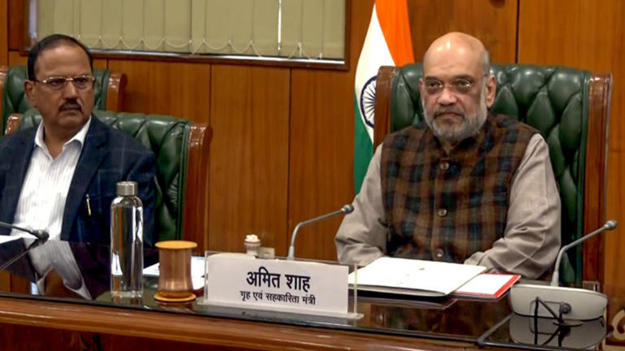](https://www.msn.com/en-in/news/India/union-home-ministry-sets-up-tribunals-to-review-ban-on-kashmiri-groups-under-uapa/ar-AA1n4PcN?fullscreen=true#image=2)](https://www.msn.com/en-in/news/India/union-home-ministry-sets-up-tribunals-to-review-ban-on-kashmiri-groups-under-uapa/ar-AA1n4PcN?fullscreen=true" \l "image=2" \t "_self)

Union Home Ministry Sets Up Tribunals To Review Ban On Kashmiri Groups Under UAPA© Provided by Jagran English

Days after the two Kashmir-based organisations were handed bans under the stringent terror law, Unlawful Activities Prevention Act (UAPA), the Union Home Ministry formed two tribunals to decide whether the ban was justified on Muslim League and Tehreek-e-Hurriyat. The ministry released a statement specifying the details about the tribunals. According to the statement, Justice Sachin Dutta of the High Court of Delhi will head the two tribunals.

On December 27 and December 31, 2023, the ministry imposed a ban under the UAPA on the Muslim League, led by Masarat Alam Bhat, and Tehreek-e-Hurriyat, established by the deceased separatist leader Syed Ali Shah Geelani. NDTV while quoting a senior official said that the tribunals will issue notices to the organisations to present their side.

The process will include documenting statements from investigating officers and experts, presenting evidence against the actions of Tehreek-e-Hurriyat and Muslim League by the home ministry, and recording arguments from the organisations.

In the previous week, two notifications were issued by the home ministry, granting authority to states and Union Territories to take action against the Muslim League and Tehreek-e-Hurriyat. These notifications authorize the Jammu and Kashmir administration to confiscate assets, freeze bank accounts, and control the finances associated with the two groups.

Tehreek-e-Hurriyat was banned on the charges of fomenting anti-India sentiments and spreading terrorism in Jammu and Kashmir in December.

"The Tehreek-e-Hurriyat, J&K (TeH) has been declared an 'Unlawful Association' under UAPA. The outfit is involved in forbidden activities to separate J&K from India and establish Islamic rule. The group is found spreading anti-India propaganda and continuing terror activities to fuel secessionism in J&K. Under PM @narendramodi Ji's zero-tolerance policy against terrorism, any individual or organization found involved in anti-India activities will be thwarted forthwith," read his post on X, formerly Twitter.

**JSCIAR,**

**18th January, 2024.**

**You have heard of the patience of Job. James 5:11**

**Shri Amit Shah – Known for patience with all**

**[[Newsable Asianet News](https://newsable.asianetnews.com/)](https://newsable.asianetnews.com/" \o "Newsable Asianet News" \t "_blank)**

**[Newsable Asianet News](https://newsable.asianetnews.com/" \o "Newsable Asianet News" \t "_blank)**

Lok Sabha Elections 2024: BJP and JD-S initiate seat sharing talks

7h

[[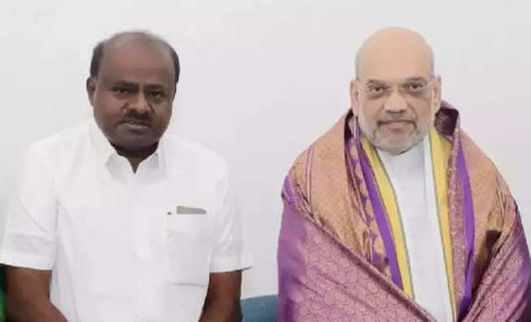](https://www.msn.com/en-in/news/India/lok-sabha-elections-2024-bjp-and-jd-s-initiate-seat-sharing-talks/ar-AA1n9S3d?ocid=msedgntp&pc=U531&cvid=61e916099f0d4ab396e155c0c88b05d1&ei=47&fullscreen=true#image=2)](https://www.msn.com/en-in/news/India/lok-sabha-elections-2024-bjp-and-jd-s-initiate-seat-sharing-talks/ar-AA1n9S3d?ocid=msedgntp&pc=U531&cvid=61e916099f0d4ab396e155c0c88b05d1&ei=47&fullscreen=true" \l "image=2" \t "_self)

Lok Sabha Elections 2024: BJP and JD-S initiate seat sharing talks© Provided by Newsable Asianet News

The discussions, held at Amit Shah's residence lasted for 45 minutes, involved detailed presentations by Kumaraswamy on the strengths and reach of both the JD-S and BJP across various regions of Karnataka. According to sources , in the forthcoming elections, Kumaraswamy proposed allocating four to five constituencies to JD-S.

Confirming the significance of the Ram Mandir Prana Pratishte as a key event shaping the political landscape, Amit Shah deferred the final decision on seat allocation and other aspects of the alliance until after the Ayodhya inauguration program.

During the meeting, both parties expressed the shared objective of the National Democratic Alliance (NDA) winning all 28 Lok Sabha seats in Karnataka, contributing to the return of Prime Minister Narendra Modi's government. The leaders emphasized the importance of collaborative efforts to address the growing anti-incumbency sentiment in the state, with a focus on highlighting the failures of the existing government.

In his statement after the meeting, Kumaraswamy highlighted JD-S's commitment to working in tandem with BJP for the success of the NDA alliance. The leaders stressed the need for decisions to be made based on trust and faith, indicating a cooperative and mutually beneficial approach towards the upcoming elections.

After attending the Ayodhya event, Kumaraswamy heads to Delhi for further discussions with BJP National President JP Nadda, and the alliance is expected to take shape, outlining seat distribution.

**JSCIAR,**

**19th January, 2024.**

**I will not reject any one that comes to me. John 6:37**

**Shri Amit Shah – A statesman approachable by all**

[[India Today](https://www.indiatoday.in/)](https://www.indiatoday.in/" \o "India Today" \t "_blank)

**[India Today](https://www.indiatoday.in/" \o "India Today" \t "_blank)**

FollowAmit Shah's cryptic remark on Nitish Kumar triggers flurry of meetings in Bihar

Story by Aditya Vaibhav  • 3h

https://www.msn.com/en-in/news/other/amit-shah-s-cryptic-remark-on-nitish-kumar-triggers-flurry-of-meetings-in-bihar/ar-BB1gWAYG?ocid=msedgntp&pc=U531&cvid=4074405237a941d496e1e8f4d52a1d41&ei=36

[[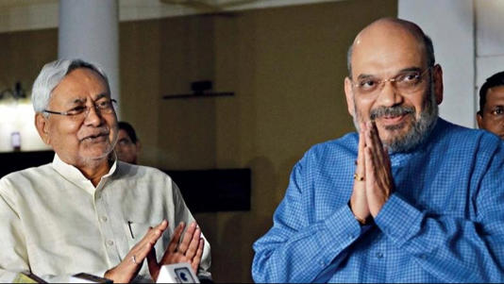](https://www.msn.com/en-in/news/other/amit-shah-s-cryptic-remark-on-nitish-kumar-triggers-flurry-of-meetings-in-bihar/ar-BB1gWAYG?ocid=msedgntp&pc=U531&cvid=4074405237a941d496e1e8f4d52a1d41&ei=36&fullscreen=true#image=2)](https://www.msn.com/en-in/news/other/amit-shah-s-cryptic-remark-on-nitish-kumar-triggers-flurry-of-meetings-in-bihar/ar-BB1gWAYG?ocid=msedgntp&pc=U531&cvid=4074405237a941d496e1e8f4d52a1d41&ei=36&fullscreen=true" \l "image=2" \t "_self)

Amit Shah's cryptic remark on Nitish Kumar triggers flurry of meetings in Bihar© Provided by India Today

Acomment made by Union Home Minister Amit Shah recently to a vernacular daily has raised questions about the coalition government in Bihar. When asked if former allies like Bihar Chief Minister and JD(U) chief Nitish Kumar would be welcomed back into the NDA fold, Shah said if anyone has a proposal about it, it would be considered.

Amit Shah's comments were interpreted as an admission of doors not being shut on Nitish Kumar, who dumped the BJP less than two years ago.

"I do not know. Maybe you people have better knowledge of what Amit Shah wanted to imply," Bihar Deputy Chief Minister Tejashwi Yadav told the media on Friday when asked about Shah's remarks, reported news agency PTI.

The Home Minister's remark also triggered a flurry of meetings both among leaders of the ruling Mahagathbandhan and the Opposition BJP. One such meeting was held at Nitish Kumar's residence and another was held at the house of Vijay Kumar Sinha, the Leader of the Opposition in the Bihar Assembly.

After the meeting, Tejashwi Yadav talked to reporters and lashed out at the BJP and accused the saffron party of spreading rumours. "The BJP has been agonised ever since Lalu (Yadav) and Nitish (Kumar) joined hands. It is under the same frustration that they're making such statements," said the RJD leader.

He claimed the BJP will be "washed off" from Bihar's political sphere and the saffron party's "frustration" at its prospect is making the leaders resort to "rumour mongering".

"We're running the state government together. We need to meet regularly to ensure swift development of the state," said Tejashwi Yadav.

He also asked the BJP how many seats they planned to field candidates for in the upcoming Lok Sabha elections. Bihar has 40 Lok Sabha seats in total.

The Bihar Deputy Chief Minister also said "all is well" within the Opposition INDIA bloc after speculation arose that Nitish Kumar was unhappy with the alliance.

[Nitish Kumar and his party snapped ties with the BJP-led NDA](https://www.indiatoday.in/india/story/nitish-kumar-resigns-as-bihar-chief-minister-snaps-ties-with-bjp-new-alliance-tejashwi-yadav-1985781-2022-08-09) in 2022 and formed the Mahagathbandhan government with the RJD.