JSCIAR, India,

28th December, 2023.

**North Korea – Prominent role in world nuclear warfare**

**North Korea should be actively included in dialogue and should not let be isolated and in poverty to avert nuclear disaster in the west**

**Aggression, oppression is not the way but persuasion and inclusion and brotherly love with mutual trust**

**https://www.msn.com/en-in/news/world/kim-jong-un-orders-military-to-prepare-for-war/ar-AA1m8yvL?ocid=msedgntp&cvid=ed7b5150aefb44a38537c7693b407acc&ei=23**

[[Dagens.com India (Eng)](https://www.dagens.com/)](https://www.dagens.com/" \o "Dagens.com India (Eng)" \t "_blank)

**[Dagens.com India (Eng)](https://www.dagens.com/" \o "Dagens.com India (Eng)" \t "_blank)**

Follow

**Kim Jong-Un Orders Military to Prepare for War**

Story by Henrik Rothen  • 2h

[[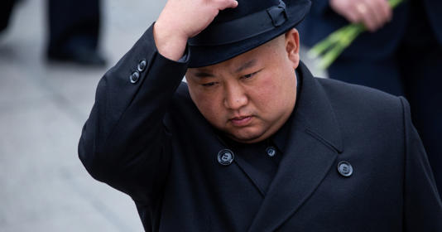](https://www.msn.com/en-in/news/world/kim-jong-un-orders-military-to-prepare-for-war/ar-AA1m8yvL?ocid=msedgntp&cvid=ed7b5150aefb44a38537c7693b407acc&ei=23&fullscreen=true#image=2)](https://www.msn.com/en-in/news/world/kim-jong-un-orders-military-to-prepare-for-war/ar-AA1m8yvL?ocid=msedgntp&cvid=ed7b5150aefb44a38537c7693b407acc&ei=23&fullscreen=true" \l "image=2" \t "_self)

Kim Jong-Un Orders Military to Prepare for War© Provided by Dagens.com India (Eng)

North Korean dictator Kim Jong-Un has issued a night-time order to his military to prepare for war, as reported by Reuters. The order also includes an acceleration of the nuclear program to counter what Kim describes as "unprecedented confrontation measures" from the United States.

This aggressive statement was made during a special meeting with the country's ruling Workers' Party. "Kim set forth the militant tasks for the people's army and the ammunition industry, nuclear weapons, and civil defense sectors to further accelerate war preparations," emphasized the state Korean news agency KCNA according to [Reuters](https://www.reuters.com/world/asia-pacific/north-koreas-kim-orders-military-accelerate-war-preparations-kcna-2023-12-27/).

The dictator also highlighted that the "military situation" on the Korean Peninsula has become "extreme" due to confrontations with the United States mentioned earlier.

**Also read**

[Drastic measures by Kim Jong Un](https://www.dagens.com/news/drastic-measures-by-kim-jong-un)

[Kim Jong Un with bold nuclear threat to the world](https://www.dagens.com/news/kim-jong-uns-bold-nuclear-threat)

South Korea and Japan, in response, have deepened their political and defense cooperation with the United States in anticipation of what is feared to be a record series of weapon tests from Pyongyang. Recently, a system was activated to share real-time data on North Korean missile launches, as reported by [Al Jazeera](https://www.aljazeera.com/news/2023/12/28/north-koreas-kim-calls-on-military-to-accelerate-war-preparations).

Earlier in December, an American nuclear-powered submarine arrived at the South Korean port city of Busan, while Washington deployed long-range bombers to train with South Korea and Japan. Meanwhile, North Korea claims to have successfully launched its first military spy satellite and tested the Hwasong-18 – the country's most advanced intercontinental ballistic missile.

Furthermore, Kim Jong-Un has enshrined in the country's constitution that North Korea will remain a nuclear power and less than a month ago warned that an invasion of South Korea is "only a matter of time."

Kim Jong-Un earlier this week defined the year 2023 as "a major turning point and change," where Pyongyang witnesses "eye-opening victories." The dictatorship has also deepened its ties with Vladimir Putin and Russia, with the latest statement from Kim indicating that cooperation will be further expanded.

**Also read**

[Sharp Warning from Vladimir Putin](https://www.dagens.com/news/sharp-warning-from-vladimir-putin)

Nuclear warfare possible - Oppression, feeling of insecurity, poverty, rejection of opportunities may lead North Korea to act in catastrophic ways disastrous to the west – the solution is building trust and hope and reconciliation by sending missionaries and gospel preachers rather than sending military

[[India Today](https://www.indiatoday.in/)](https://www.indiatoday.in/" \o "India Today" \t "_blank)

**[India Today](https://www.indiatoday.in/" \o "India Today" \t "_blank)**

https://www.msn.com/en-in/news/world/north-korea-s-kim-orders-military-to-thoroughly-annihilate-us-south-korea-if-provoked/ar-AA1mi9Qo

Follow

# North Korea's Kim orders military to ‘thoroughly annihilate' US, South Korea if provoked

Story by Associated Press • 22h

[[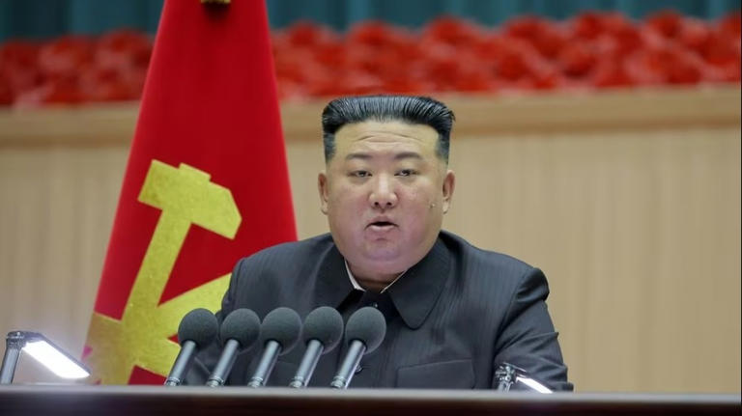](https://www.msn.com/en-in/news/world/north-korea-s-kim-orders-military-to-thoroughly-annihilate-us-south-korea-if-provoked/ar-AA1mi9Qo?fullscreen=true#image=2)](https://www.msn.com/en-in/news/world/north-korea-s-kim-orders-military-to-thoroughly-annihilate-us-south-korea-if-provoked/ar-AA1mi9Qo?fullscreen=true" \l "image=2" \t "_self)

North Korea's Kim orders military to ‘thoroughly annihilate' US, South Korea if provoked© Provided by India Today

North Korean leader Kim Jong UN ordered his military to "thoroughly annihilate" the United States and South Korea if provoked, state media reported Monday, after he vowed to boost national defence to cope with what he called an unprecedented US-led confrontation.

Kim is expected to ramp up weapons tests in 2024 ahead of the US presidential election in November. Many experts say he likely believes his expanded nuclear arsenal would allow him to wrest US concessions if former President Donald Trump is re-elected.

In a five-day major ruling party meeting last week, Kim said he will launch three more military spy satellites, produce more nuclear materials and develop attack drones this year in what observers say is an attempt to increase his leverage in future diplomacy with the US.

In a meeting on Sunday with commanding army officers, Kim said it is urgent to sharpen "the treasured sword" to safeguard national security, an apparent reference to his country's nuclear weapons program. He cited "the US and other hostile forces' military confrontation moves," according to the official Korean Central News Agency.

Kim stressed that "our army should deal a deadly blow to thoroughly annihilate them by mobilising all the toughest means and potentialities without a moment's hesitation" if they opt for military confrontation and provocations against North Korea, KCNA said.

[[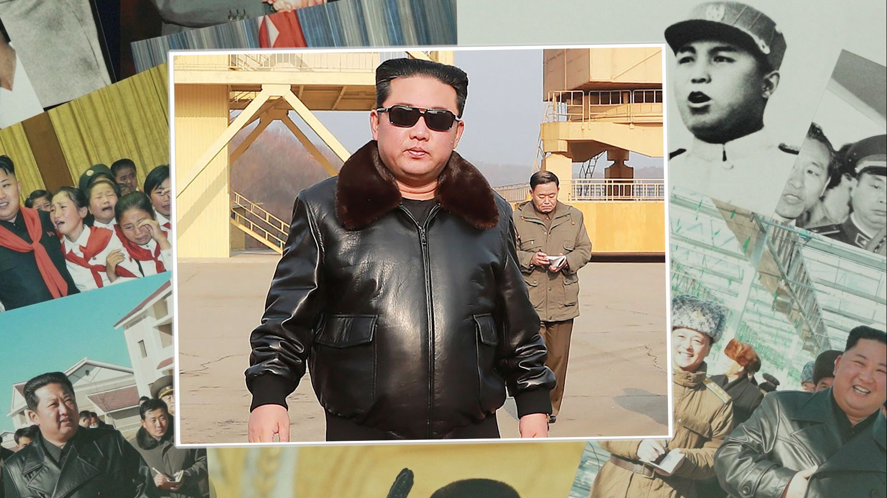](https://www.msn.com/en-in/video/news/what-kim-jong-un%E2%80%99s-changing-outfits-reveal-about-north-korea/vi-AA1mii2N)](https://www.msn.com/en-in/video/news/what-kim-jong-un%E2%80%99s-changing-outfits-reveal-about-north-korea/vi-AA1mii2N" \t "_blank)

**[6:40](https://www.msn.com/en-in/video/news/what-kim-jong-un%E2%80%99s-changing-outfits-reveal-about-north-korea/vi-AA1mii2N" \t "_blank)**

[[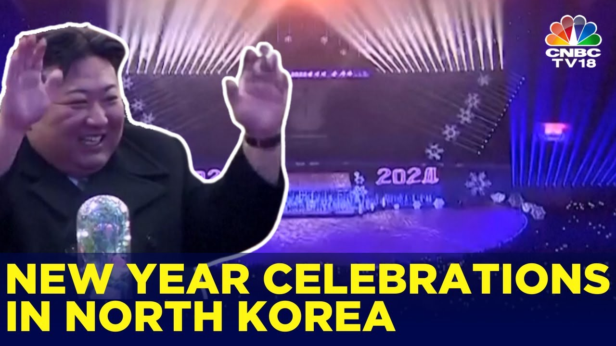](https://www.msn.com/en-in/video/news/north-korean-leader-kim-jong-un-attends-new-year-celebrations-in18v-cnbc-tv18/vi-AA1miwTs)](https://www.msn.com/en-in/video/news/north-korean-leader-kim-jong-un-attends-new-year-celebrations-in18v-cnbc-tv18/vi-AA1miwTs" \t "_blank)

In his New Year's Day address Monday, South Korean President Yoon Suk Yael said he will strengthen his military's pre-emptive strike, missile defence and retaliatory capabilities in response to the North Korean nuclear threat.

"The Republic of Korea is building genuine, lasting peace through strength, not a submissive peace that is dependent on the goodwill of the adversary," Yoon said, using South Korea's official name.

At the party meeting, Kim called South Korea "a hemiplegic malformation and colonial subordinate state" whose society is "tainted by Yankee culture." He said his military must use all available means including nuclear weapons to "suppress the whole territory of South Korea" in the event of a conflict.

South Korea's Defence Ministry warned in response that if North Korea attempts to use nuclear weapons, South Korean and WE forces will punish it overwhelmingly, resulting in the end of the Kim government.

Experts say small-scale military clashes between North and South Korea could happen this year along their heavily armed border. They say North Korea is also expected to test-launch intercontinental ballistic missiles capable of reaching the US mainland and other major new weapons.

In 2018-19, Kim met Trump in three rounds of talks on North Korea's expanding nuclear arsenal. The diplomacy fell apart after the US rejected Kim's offer to dismantle his main nuclear complex, a limited step, in exchange for extensive reductions in US-led sanctions.

Since 2022, North Korea has conducted more than 100 missile tests, prompting the US and South Korea to expand their joint military drills. North Korea has also tried to strengthen its relationships with China and Russia, which blocked efforts by the US and its partners in the UN Security Council to toughen UN sanctions on North Korea over its weapons tests.

KCNA said Kim and Chinese President Xi Jinxing exchanged New Year's Day messages on Monday on bolstering bilateral ties. North Korea faces suspicions that it has supplied conventional arms for Russia's war in Ukraine in return for sophisticated Russian technologies to enhance the North's military programs.

Estimates of the size of North Korea's nuclear arsenal vary, ranging from about 20–30 bombs to more than 100. Many foreign experts say North Korea still has some technological hurdles to overcome to produce functioning nuclear-armed ICBMs, though its shorter-range nuclear-capable missiles can reach South Korea and Japan.

**Good shepherd lays down his life for the sheep. John 10:11**

**Are the world leaders laying down their life for its people or making them lose their lives by invading neighbouring nations?**

**Love your neighbour as you love yourself. Mark 12:31**

**Solomon was the wisest king the history has ever known. This is because he ensured that there is no war all through the 40 years of his reing over Israel.**

[[Dagens.com India (Eng)](https://www.dagens.com/)](https://www.dagens.com/" \o "Dagens.com India (Eng)" \t "_blank)

**[Dagens.com India (Eng)](https://www.dagens.com/" \o "Dagens.com India (Eng)" \t "_blank)**

Follow

# Brutal Order by Putin – "Seek Shelter"

Story by Henrik Rothen  • 19h

https://www.msn.com/en-in/news/world/brutal-order-by-putin-seek-shelter/ar-AA1mCSxS?ocid=msedgntp&cvid=0be9de2240c94315a269798a624e8036&ei=39

[[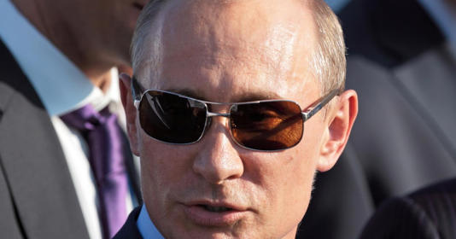](https://www.msn.com/en-in/news/world/brutal-order-by-putin-seek-shelter/ar-AA1mCSxS?ocid=msedgntp&cvid=0be9de2240c94315a269798a624e8036&ei=39&fullscreen=true#image=2)](https://www.msn.com/en-in/news/world/brutal-order-by-putin-seek-shelter/ar-AA1mCSxS?ocid=msedgntp&cvid=0be9de2240c94315a269798a624e8036&ei=39&fullscreen=true" \l "image=2" \t "_self)

Photo: Shutterstock.com© Provided by Dagens.com India (Eng)

The Russian military has launched another extensive offensive. A large-scale missile attack targeted several Ukrainian regions on Monday morning, [Reuters](https://www.reuters.com/world/europe/russia-launches-missile-attacks-across-country-say-ukrainian-officials-2024-01-08/) reports. The information comes directly from Ukrainian military officials who warn the entire country of aerial attacks. Air raid sirens are now sounding in all Ukrainian regions, including the capital.

"Kyiv, seek shelter!" urges Ukraine's Air Force on [Telegram](https://t.me/kpszsu/9573) to the city's inhabitants. According to the military, ballistic missiles are being directed at Ukraine.

**Also read**

[Finland Sends a Powerful Message to All of Europe](https://www.dagens.com/news/finland-sends-a-powerful-message-to-all-of-europe)

[Putin Issues Promise to NATO Countries](https://www.dagens.com/news/putin-issues-promise-to-nato-countries)

#### **"Massive Attack"**

Zaporizhzhia, Kharkiv, Dnipropetrovsk, and Khmelnytskyi are also under heavy attack. "Massive missile attack," military officials emphasize.

This morning's attacks continue the severe escalation of assaults ordered by Russia's dictator Vladimir Putin since the new year. Early last week, Ukrainian President Volodymyr Zelensky reported that Russia fired 500 missiles and drones at Ukraine in just five days.

The attacks against Kyiv at the beginning of the year were the first in five months. "They always try to find a better way to break our air defense systems and make their attack more effective," says Oleksandr Musiyenko at the Ukrainian Center for Military Law Research to [BBC](https://www.bbc.com/news/world-europe-67871729).

[[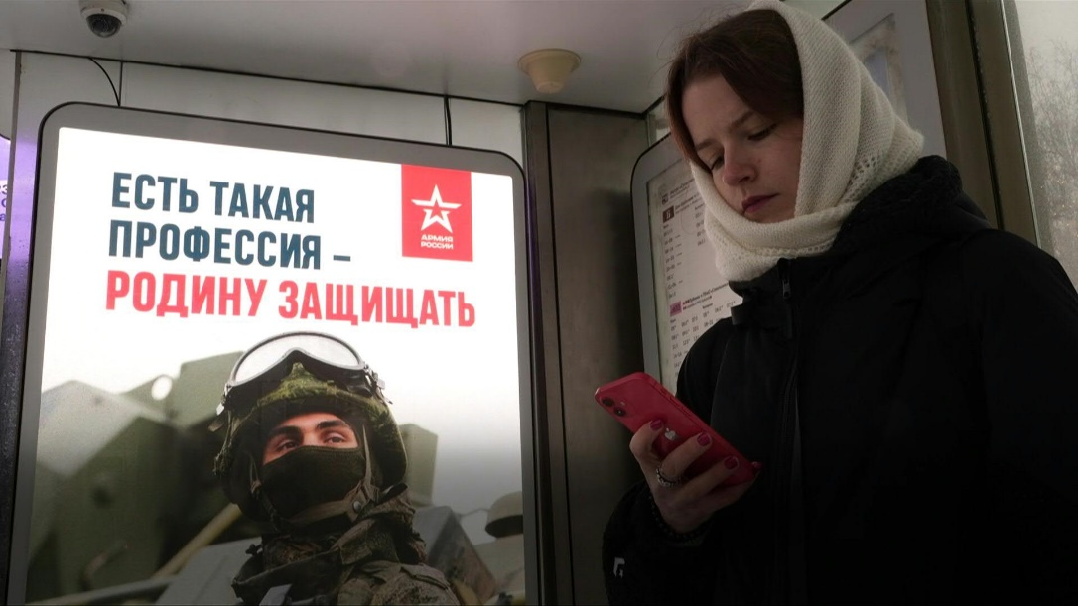](https://www.msn.com/en-in/video/news/families-of-russias-mobilised-fight-back-despite-fear/vi-AA1mDN6U?ocid=msedgntp)](https://www.msn.com/en-in/video/news/families-of-russias-mobilised-fight-back-despite-fear/vi-AA1mDN6U?ocid=msedgntp" \t "_blank)

[AFP](https://www.msn.com/en-in/video/news/families-of-russias-mobilised-fight-back-despite-fear/vi-AA1mDN6U?ocid=msedgntp" \t "_blank)**[Families of Russia's mobilised fight back despite fear](https://www.msn.com/en-in/video/news/families-of-russias-mobilised-fight-back-despite-fear/vi-AA1mDN6U?ocid=msedgntp" \t "_blank)**

[[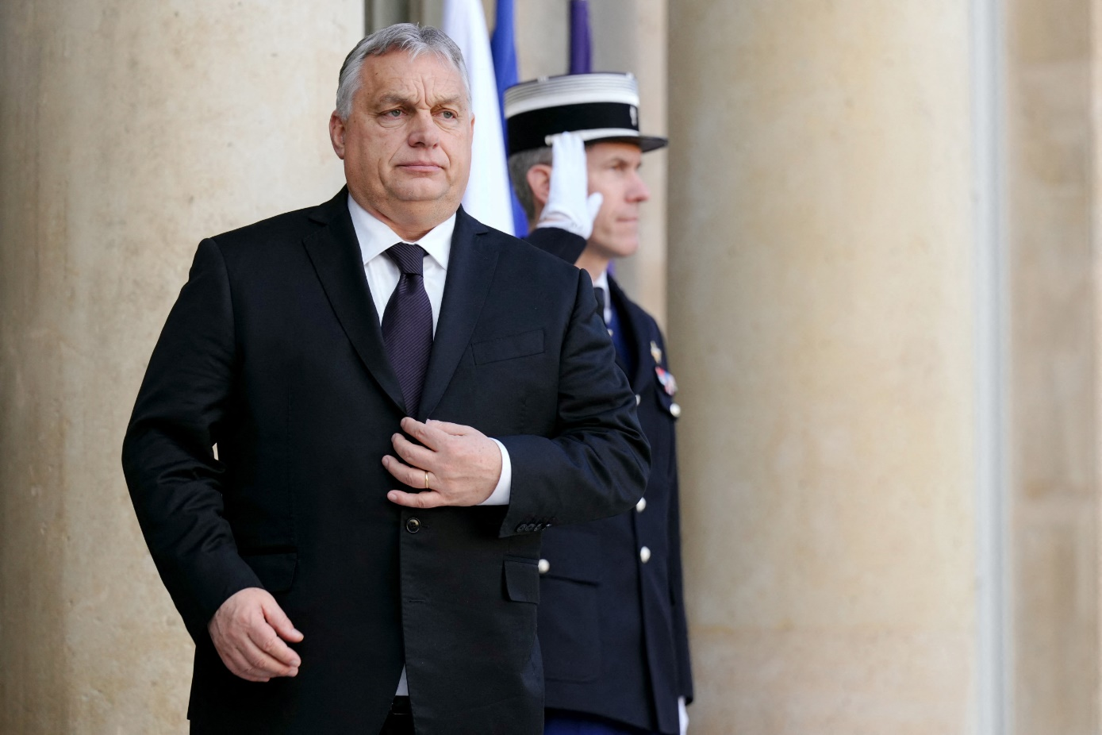](https://www.msn.com/en-in/video/news/putin-ally-could-soon-be-in-charge-of-european-council/vi-AA1mDY8G?ocid=msedgntp)](https://www.msn.com/en-in/video/news/putin-ally-could-soon-be-in-charge-of-european-council/vi-AA1mDY8G?ocid=msedgntp" \t "_blank)

#### **Using North Korean Weapons**

Last week, US officials from the intelligence service reported that Russia is using ballistic missiles from North Korea.

"North Korea is now a weapons supplier to the war. I imagine large quantities of cheap ballistic robots for the Russian military," says Jeffrey Lewis, active at the Middlebury Institute of International Studies, to Reuters.

#### **"Deeply Concerning"**

Swedish military experts also agree that North Korea's involvement is the start of a clear escalation from Russia's side. "It is a deeply worrying development," says Joakim Paasikivi, lieutenant colonel, to TV4 and adds that it gives Russia the opportunity to reach more cities than before.

The occurrence should be interpreted as a signal to the world. "It is worrying that rogue states like Iran and North Korea can continue to send weapons to Russia without it having consequences," says Joakim Paasikivi.

**JSCIAR,**

**22nd January, 2024.**

**God has chosen the foolish things of the world to put to shame the wise; God has chosen the weak things of the world to put to shame the strong.**

**1 Corinthians 1:27**

[[The Financial Express](http://www.financialexpress.com/)](http://www.financialexpress.com/" \o "The Financial Express" \t "_blank)

**[The Financial Express](http://www.financialexpress.com/" \o "The Financial Express" \t "_blank)**

th Korea stresses alignment with Russia against US and says Putin could visit at an early date

Story by Associated Press  • 13h

[[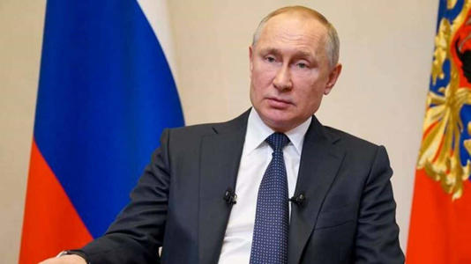](https://www.msn.com/en-in/news/world/north-korea-stresses-alignment-with-russia-against-us-and-says-putin-could-visit-at-an-early-date/ar-BB1h2veL?ocid=msedgntp&cvid=2c6f587f7f2146f28a6aab9daed1f290&ei=18&fullscreen=true#image=2)](https://www.msn.com/en-in/news/world/north-korea-stresses-alignment-with-russia-against-us-and-says-putin-could-visit-at-an-early-date/ar-BB1h2veL?ocid=msedgntp&cvid=2c6f587f7f2146f28a6aab9daed1f290&ei=18&fullscreen=true" \l "image=2" \t "_self)

Both Pyongyang and Russia have denied accusations by Washington and Seoul about North Korean arms transfers to Russia. (Image/Reuters)© Provided by The Financial Express

North Korea said Sunday that Russian President Vladimir Putin expressed his willingness to visit the North at an unspecified “early date” as the countries continue to align in the face of their separate, intensifying confrontations with the United States.The North Korean Foreign Ministry highlighted Putin’s intent for a visit following North Korean Foreign Minister Choe Son Hui’s meetings with Putin and Russian Foreign Minister Sergey Lavrov in Moscow last week.

The ministry said in a statement published by state media that the two countries agreed to further strategic and tactical cooperation with Russia to establish a “new multi-polarized international order,” a reference to their efforts to build a united front against Washington.

Putin had already confirmed his willingness to visit the capital, Pyongyang, at a convenient time during his meeting with North Korean leader Kim Jong Un in Russia’s Far East in September. One of the few world leaders openly supporting Putin’s war on Ukraine, Kim has been actively boosting the visibility of his ties with Russia in an attempt to break out of diplomatic isolation and strengthen his footing, as he navigates a deepening nuclear standoff with Washington, Seoul and Tokyo.

In a separate statement on Sunday, the North’s Foreign Ministry condemned the UN Security Council for calling an emergency meeting over the country’s latest ballistic test, which state media described as a new intermediate-range solid-fuel missile tipped with a hypersonic warhead. The ministry said the test-firing on Jan. 14 was among the country’s regular activities to improve its defense capabilities and that it didn’t pose a threat to its neighbors.

South Korea on Thursday urged the Security Council “to break the silence” over North Korea’s escalating missile tests and threats. Russia and China, both permanent members of the council, have blocked U.S.-led efforts to increase sanctions on North Korea over its recent weapons tests, underscoring a divide deepened over Russia’s war on Ukraine.

The alignment between Pyongyang and Moscow has raised international concerns about alleged arms cooperation, in which the North provides Russia with munitions to help prolong its fighting in Ukraine, possibly in exchange for badly needed economic aid and military assistance to help upgrade Kim’s forces. Both Pyongyang and Russia have denied accusations by Washington and Seoul about North Korean arms transfers to Russia.

North Korea’s Foreign Ministry, in comments published by state media, said Choe and the Russian officials in their meetings expressed a “strong will to further strengthen strategic and tactical cooperation in defending the core interests of the two countries and establishing a new multi-polarized international order.” Russia expressed “deep thanks” to North Korea for its “full support” over its war on Ukraine, the North Korean ministry said. It said Choe and the Russian officials expressed “serious concern” over the United States’ expanding military cooperation with its Asian allies that they blamed for worsening tensions in the region and threatening North Korea’s sovereignty and security interests.

Tensions on the Korean Peninsula are at their highest point in years, after Kim in recent months used Russia’s invasion of Ukraine as a distraction to ramp up his weapons tests and military demonstrations. The United States, South Korea and Japan have responded by strengthening their combined military exercises, which Kim portrays as invasion rehearsals, and sharpening their deterrence plans built around nuclear-capable U.S. assets.

In the latest tit-for-tat, North Korea on Friday said it conducted a test of a purported nuclear-capable underwater attack drone in response to a combined naval exercise by the United States, South Korea and Japan last week, as it continued to blame its rivals for tensions in the region.Choe’s visit to Moscow came as Kim continues to use domestic political events to issue provocative threats of nuclear conflict.

At Pyongyang’s rubber-stamp parliament last week, Kim declared that North Korea is abandoning its long-standing goal of a peaceful unification with war-divided rival South Korea and ordered the rewriting of the North’s constitution to cement the South as its most hostile foreign adversary. He accused South Korea of acting as “top-class stooges” of the Americans and repeated a threat that he would use his nukes to annihilate the South if provoked.Analysts say North Korea could be aiming to diminish South Korea’s voice in the regional nuclear standoff and eventually force direct dealings with Washington as it looks to cement its status as a nuclear weapons state.