JSCIAR,

24th January, 2024.

**Smt Nirmala Sitaraman**

https://www.msn.com/en-in/money/news/ahead-of-budget-2024-here-s-the-journey-of-nirmala-sitharaman/ar-BB1ha9Rk?ocid=msedgntp&pc=U531&cvid=3b97864ea84244db84e60100cf34586b&ei=17

[[Indiatimes](https://www.indiatimes.com/)](https://www.indiatimes.com/" \o "Indiatimes" \t "_blank)

**[Indiatimes](https://www.indiatimes.com/" \o "Indiatimes" \t "_blank)**

Follow

**Ahead of Budget 2024, Here’s The Journey Of Nirmala Sitharaman**

Story by Vanya Gautam  • 6h

[[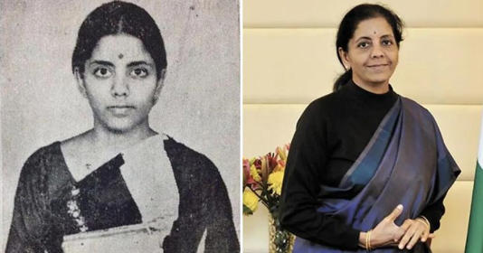](https://www.msn.com/en-in/money/news/ahead-of-budget-2024-here-s-the-journey-of-nirmala-sitharaman/ar-BB1ha9Rk?ocid=msedgntp&pc=U531&cvid=3b97864ea84244db84e60100cf34586b&ei=17&fullscreen=true#image=2)](https://www.msn.com/en-in/money/news/ahead-of-budget-2024-here-s-the-journey-of-nirmala-sitharaman/ar-BB1ha9Rk?ocid=msedgntp&pc=U531&cvid=3b97864ea84244db84e60100cf34586b&ei=17&fullscreen=true" \l "image=2" \t "_self)

Ahead of Budget 2024, Here’s The Journey Of Nirmala Sitharaman© Provided by Indiatimes

It's been nearly five years since India got its first full time female Finance Minister when **Nirmala Sitharaman**was appointed for the role in May 2019. Just two months later, she presented her first Union Budget in July 2019. And now, FM Sitharaman is **set to present India’s Union**[**Budget**](https://www.indiatimes.com/worth/news/interim-budget-2024-must-know-terms-625060.html)**for the fifth time**.

As the days get closer to February 1st, i.e. when FM [Sitharaman](https://www.indiatimes.com/worth/news/meet-niramal-sitharaman-team-behind-interim-budget-2024-625524.html)will present the interim budget, let us look back at the**journey of India’s first full time female Finance Minister**:

**Where Was Nirmala Sitharaman Born?**

[[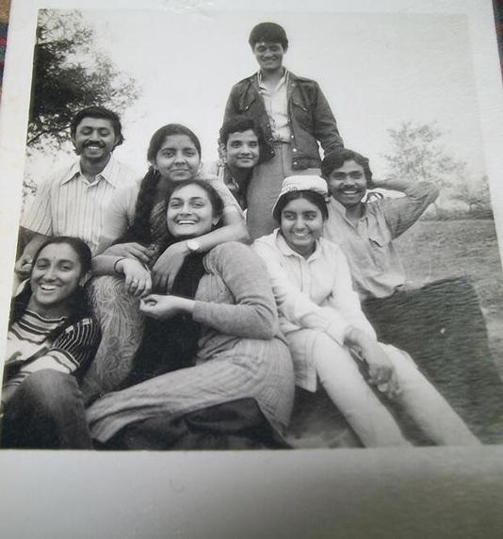](https://www.msn.com/en-in/money/news/ahead-of-budget-2024-here-s-the-journey-of-nirmala-sitharaman/ar-BB1ha9Rk?ocid=msedgntp&pc=U531&cvid=3b97864ea84244db84e60100cf34586b&ei=17&fullscreen=true#image=2)](https://www.msn.com/en-in/money/news/ahead-of-budget-2024-here-s-the-journey-of-nirmala-sitharaman/ar-BB1ha9Rk?ocid=msedgntp&pc=U531&cvid=3b97864ea84244db84e60100cf34586b&ei=17&fullscreen=true" \l "image=2" \t "_self)

nirmala sitharman jnu/twitter© Provided by Indiatimes

**Nirmala Sitharaman** was born on 18th August, 1959, in Tamil Nadu's Madurai. As far as her educational qualifications are concerned, [Sitharaman](https://www.indiatimes.com/worth/news/41-crore-indians-will-start-paying-tax-by-2047-says-nirmala-sitharaman-614211.html)completed her **graduation**from Seethalakshmi Ramasamy College, Tiruchirappalli and obtained her M.A. (Economics) from Jawaharlal Nehru University, New Delhi.

Before that, she did her **schooling**from Sacred Heart Convent Anglo Indian Higher Secondary School, Villupuram till primary level and also from Madras and Tiruchirappalli.

**When Did She Become India's First Full Time Female Finance Minister?**

[[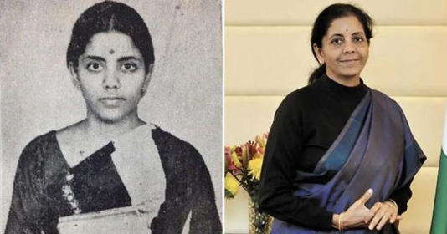](https://www.msn.com/en-in/money/news/ahead-of-budget-2024-here-s-the-journey-of-nirmala-sitharaman/ar-BB1ha9Rk?ocid=msedgntp&pc=U531&cvid=3b97864ea84244db84e60100cf34586b&ei=17&fullscreen=true#image=2)](https://www.msn.com/en-in/money/news/ahead-of-budget-2024-here-s-the-journey-of-nirmala-sitharaman/ar-BB1ha9Rk?ocid=msedgntp&pc=U531&cvid=3b97864ea84244db84e60100cf34586b&ei=17&fullscreen=true" \l "image=2" \t "_self)

nirmala sitharaman journey finance minister/indiatimes© Provided by Indiatimes

On 30 May 2019, Nirmala Sitharaman scripted history by**becoming India's first ever full time Finance Minister**. Before her, late Arun Jaitely had held the FM position.

**What About Her Non-Political Career?**

**Nirmala Sitharaman** worked as a sales representative at the Regent Street home décor store in London. She worked for the UK's Agricultural Engineers Association as an economist's assistant. She has also worked as a Senior Manager (R&D) for PWC and for a brief period of time at the BBC World Service while she has been in the UK. She was a member of the National Commission for Women as well. She was one of the original directors of Hyderabad's Pranava in 2017.

[[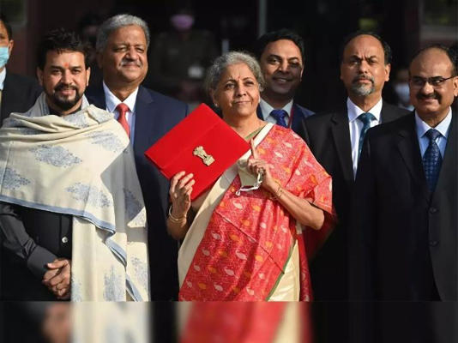](https://www.msn.com/en-in/money/news/ahead-of-budget-2024-here-s-the-journey-of-nirmala-sitharaman/ar-BB1ha9Rk?ocid=msedgntp&pc=U531&cvid=3b97864ea84244db84e60100cf34586b&ei=17&fullscreen=true#image=2)](https://www.msn.com/en-in/money/news/ahead-of-budget-2024-here-s-the-journey-of-nirmala-sitharaman/ar-BB1ha9Rk?ocid=msedgntp&pc=U531&cvid=3b97864ea84244db84e60100cf34586b&ei=17&fullscreen=true" \l "image=2" \t "_self)

nirmala sitharaman to present interim budget on 1 feb/pti© Provided by Indiatimes

**Which Other Key Positions Has She Held?**

Over the decades,[**Sitharaman**](https://www.indiatimes.com/worth/news/nirmala-sitharaman-says-money-laundering-and-terror-financing-biggest-crypto-concerns-567330.html)**has held several key positions,** including: Member, National Commission for Women,Minister of State in the Ministry of Finance Minister of State in the Ministry of Corporate Affairs, Minister of State (Independent Charge) of the Ministry of Commerce and Industry,Rajya Sabha member, Minister of Defense.

JSCIAR,

25th January, 2024.

**Go to an ant thou sluggard, consider her ways. Proverbs 6:6**

**Smt Nirmala Sitaraman – A diligent leader knowing the value of time and doing right things at the right time**

[[Jagran English](https://english.jagran.com/)](https://english.jagran.com/" \t "_blank)

**[Jagran English](https://english.jagran.com/" \t "_blank)**

Follow

# Budget 2024: Nirmala Sitharaman To Present Vote On Account On Feb 1; A Look At Longest Budget Speeches In India

Story by Jagran English • 18h

[[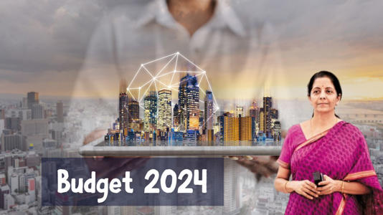](https://www.msn.com/en-in/money/news/budget-2024-nirmala-sitharaman-to-present-vote-on-account-on-feb-1-a-look-at-longest-budget-speeches-in-india/ar-BB1hbVoO?ocid=msedgntp&pc=U531&cvid=255659e68ab7444c94658eb9043b52b6&ei=25&fullscreen=true#image=2)](https://www.msn.com/en-in/money/news/budget-2024-nirmala-sitharaman-to-present-vote-on-account-on-feb-1-a-look-at-longest-budget-speeches-in-india/ar-BB1hbVoO?ocid=msedgntp&pc=U531&cvid=255659e68ab7444c94658eb9043b52b6&ei=25&fullscreen=true" \l "image=2" \t "_self)

Budget 2024: Nirmala Sitharaman To Present Vote On Account On Feb 1; A Look At Longest Budget Speeches In India© Provided by Jagran English

As the Union Budget for the financial year 2024 is just a few days ago, all eyes are on the speech of Nirmala Sitharaman, the finance minister of India. Speculations are rife about the sectors that will benefit from this year's budget. As the countdown has begun, here’s a list of the longest budget speeches delivered ever in India.

**Nirmala Sitharaman**

The longest speech to be presented was by the present finance minister, Nirmala Sitharaman, who has presented the budget five times so far. In 2020, the budget presented by her is the longest budget speech ever delivered in the history of the country. According to a report by the Deccan Herald, the second speech by her in 2020 started at 11 a.m. and continued till 1:40 p.m., which is a total of 2 hours and 42 minutes. Sh broke her 2019 record of having delivered the longest budget speech in India. In that year, Sitharaman delivered a speech that went on for 2 hours and 7 minutes, making it the second-longest speech ever.

**Jaswant Singh**

Before Sitharaman, the longest budget speech was delivered by former Finance Minister Jaswant Singh, who delivered one of the biggest speech in 2003. His speech lasted for over 2 hours, 13 minutes, making it the third budget speech ever.

**Arun Jaitley**

Bharatiya Janata Party (BJP) leader and former Finance Minister Arun Jaitley spoke for 2 hours and 20 minutes during the 2014 budget.

As the general assembly polls is just a few months away, all eyes will be on the Union Budget of this year. On Wednesday, the Confederation of Indian Industry (CII) recommended the establishment of a comprehensive Ministry of Investment on the investment front for the interim budget. Meanwhile, the education sector holds high hopes for a higher budget allocation and a significant push for digital infrastructure, pedagogy transformation, and teacher development.

Education experts also opine that a strategic fiscal approach is the need of the hour to foster a conducive learning environment that aligns with the objectives of the NEP 2020 and Industry 4.0.

The budget will be tabled by the Union Finance Minister, Nirmala Sitharaman, on February 1, 2024.

JSCIAR,

25th January, 2024.

**Then He took the five loaves and the two fish ….. Luke 9:16**

[[Indiatimes](https://www.indiatimes.com/)](https://www.indiatimes.com/" \t "_blank)

**[Indiatimes](https://www.indiatimes.com/" \t "_blank)**

Follow

# Budget 2024:Nirmala Sitharaman Takes Part In Halwa Ceremony

Story by Vanya Gautam • 10h

[[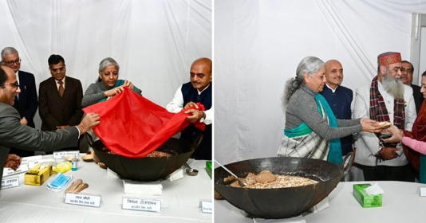](https://www.msn.com/en-in/entertainment/southcinema/budget-2024-nirmala-sitharaman-takes-part-in-halwa-ceremony/ar-BB1hdM5y?ocid=msedgntp&pc=U531&cvid=9f3d012b399647bdb406693cea1a3a2d&ei=35&fullscreen=true#image=2)](https://www.msn.com/en-in/entertainment/southcinema/budget-2024-nirmala-sitharaman-takes-part-in-halwa-ceremony/ar-BB1hdM5y?ocid=msedgntp&pc=U531&cvid=9f3d012b399647bdb406693cea1a3a2d&ei=35&fullscreen=true" \l "image=2" \t "_self)

Budget 2024:Nirmala Sitharaman Takes Part In Halwa Ceremony© Provided by Indiatimes

With just a handful of days left for**interim budget 2024**to take place on February 1st, the **Halwa ceremony** was held in the presence of Finance Minister Nirmala Sitharaman.

## When Was Halwa Ceremony Held?

[[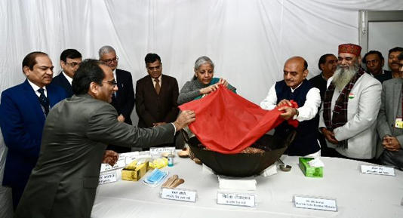](https://www.msn.com/en-in/entertainment/southcinema/budget-2024-nirmala-sitharaman-takes-part-in-halwa-ceremony/ar-BB1hdM5y?ocid=msedgntp&pc=U531&cvid=9f3d012b399647bdb406693cea1a3a2d&ei=35&fullscreen=true#image=2)](https://www.msn.com/en-in/entertainment/southcinema/budget-2024-nirmala-sitharaman-takes-part-in-halwa-ceremony/ar-BB1hdM5y?ocid=msedgntp&pc=U531&cvid=9f3d012b399647bdb406693cea1a3a2d&ei=35&fullscreen=true" \l "image=2" \t "_self)

halwa ceremony 2024/twitter© Provided by Indiatimes

The customary [**Halwa ceremony**](https://www.indiatimes.com/worth/news/what-is-halwa-ceremony-and-why-is-it-done-before-every-budget-625642.html)**was held on the evening of 24th January 2024**. It was held in Finance Ministry's HQ at North Block, in the presence of FM Sitharaman and Union Minister of State for Finance Dr. Bhagwat Kisanrao Karad. The Finance Ministry confirmed that just like the previous three budgets,[**Interim Union Budget 2024**](https://www.indiatimes.com/worth/news/interim-budget-2024-must-know-terms-625060.html) will also be delivered in paperless form.

**Also Read;**[**Meet Nirmala Sitharaman's Team Behind Interim Budget 2024**](https://www.indiatimes.com/worth/news/meet-niramal-sitharaman-team-behind-interim-budget-2024-625524.html)

### Why Does The Halwa Ceremony Take Place?

[[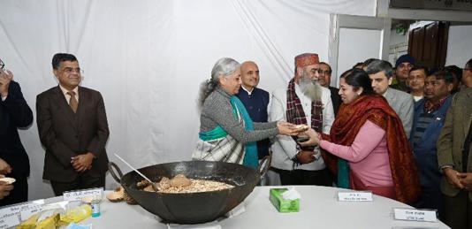](https://www.msn.com/en-in/entertainment/southcinema/budget-2024-nirmala-sitharaman-takes-part-in-halwa-ceremony/ar-BB1hdM5y?ocid=msedgntp&pc=U531&cvid=9f3d012b399647bdb406693cea1a3a2d&ei=35&fullscreen=true#image=2)](https://www.msn.com/en-in/entertainment/southcinema/budget-2024-nirmala-sitharaman-takes-part-in-halwa-ceremony/ar-BB1hdM5y?ocid=msedgntp&pc=U531&cvid=9f3d012b399647bdb406693cea1a3a2d&ei=35&fullscreen=true" \l "image=2" \t "_self)

halwa ceremony budget 2024/twitter© Provided by Indiatimes

We all know that it's customary in many parts of India to begin a big or auspicious occasions with sweets, right. Similar is the case with [**Budget**](https://www.indiatimes.com/worth/news/interim-budget-2024-must-know-terms-625060.html). Ahead of the union budget presentation, the **Halwa ceremony**takes place, in which the Finance Minister also shows gratitude to everyone who put in a great deal of efforts and hard work to prepare the Budget. The **Halwa ceremony also marks the final stage of budget preparation**process.

Once the 'halwa' is served to all the staff of **the finance ministry**, the ceremony initiates the 'lock in' and printing of budget documents.

#### What Is The 'Lock In Period' That Has Started After Halwa Ceremony?

[[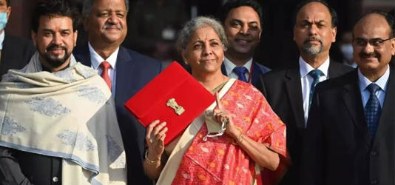](https://www.msn.com/en-in/entertainment/southcinema/budget-2024-nirmala-sitharaman-takes-part-in-halwa-ceremony/ar-BB1hdM5y?ocid=msedgntp&pc=U531&cvid=9f3d012b399647bdb406693cea1a3a2d&ei=35&fullscreen=true#image=2)](https://www.msn.com/en-in/entertainment/southcinema/budget-2024-nirmala-sitharaman-takes-part-in-halwa-ceremony/ar-BB1hdM5y?ocid=msedgntp&pc=U531&cvid=9f3d012b399647bdb406693cea1a3a2d&ei=35&fullscreen=true" \l "image=2" \t "_self)

Interim Budget 2024 halwa ceremony/pti© Provided by Indiatimes

Right after Halwa ceremony gets held, the "lock-in" period, which is a part of the Union Budget process,begins. **The lock-in period** is observed to maintain the secrecy of upcoming budget, aimed to prevent any information leakage before the Finance Minister<https://www.indiatimes.com/worth/news/ahead-of-budget-2024-heres-the-journey-of-indias-finance-minister-nirmala-sitharaman-625920.html> presents the Union budget in the Parliament on**February 1.** So, after the Halwa ceremony, not only does the Budget documents printing process begins, but the ceremony is serves as a formal ‘send-off’ for the Finance ministry officials and staff who were engaged in the budget's preparation.

These top officials have now **entered the ‘lock-in’ period, in which they will be isolating themselves**within the Finance Ministry premises to preserve the confidentiality about the budget until it gets presented by FM Sitharaman on 1st February.

#### What Is The Date & Time For Interim Budget 2024?

The **Interim Union Budget 2024 will be presented on 1st February, 2024 at 11 am** by FM Nirmala Sitharaman. You can watch the live presentation of interim budget 2024 on Sansad TV and Doordarshan, and also their YouTube channels. The PIB (Press Information Bureau) will also stream the Interim Union Budget 2024 on their online platforms.

JSCIAR,

26th January, 2024.

Righteousness exalts a nation. Proverbs 14:34

A just weight and balance are the LORD’S. Proverbs 16:11

**Smt Nirmala Sitaraman – Aiming to distribute the national resources to its people with just weight and balance**

\* Water resources

\* Agriculture sector

\* Science and technology

\* Security and defense

\* Education

\* Support to weaker sections

\* Special provision for the old and sick and disabled

\* Women empowerment and child development

\* Creation of employment opportunities to the youth (Manufacturing and infrastructure, waste management, tree plantations, places of recreations like gardens, parks, with green patches)

\* Price reductions on basic amenities of common man

[[ABP Live](https://news.abplive.com/)](https://news.abplive.com/" \o "ABP Live" \t "_blank)

**[ABP Live](https://news.abplive.com/" \o "ABP Live" \t "_blank)**

Union Budget 2024: India Inc Eagerly Awaits FM's Feb 1 Budget For Growth Boosting Measures

Story by PTI  • 16h

India Inc wants Finance Minister Nirmala Sitharaman to announce more measures in her interim Budget to boost manufacturing, earmark larger funds for infrastructure development, and accord more focus on social sector schemes, while giving relief on taxation front. Sitharaman, who has already presented five annual Budgets, will be unveiling an interim Budget for fiscal 2024-25 on February 1 in the Lok Sabha. It will be the last major economic document before the next general elections.

Industry says that it is imperative for the government to take measures to boost economic growth in the country as India marches towards becoming the third largest economy in the coming years.

Industry body CII has suggested launch of 'National Mission for Advanced Manufacturing' to enhance quality and productivity in manufacturing.

"The mission should strengthen the ecosystem for building a technologically advanced manufacturing industry and accelerate the adoption of transformative technologies in the manufacturing sector," it said.

It has also made a case for expanding PLIs to labour-intensive sectors, such as apparel, toys, footwear for boosting employment generation, and to sectors with large imports but domestic capability, like capital goods, chemicals, to reduce import dependence.

Another leading industry chamber FICCI said the capital expenditure outlay in the last Union Budget 2023-24 was increased by 37.4 per cent to Rs 10 lakh crore. Further, latest GDP release reported encouraging data on capital formation.

[[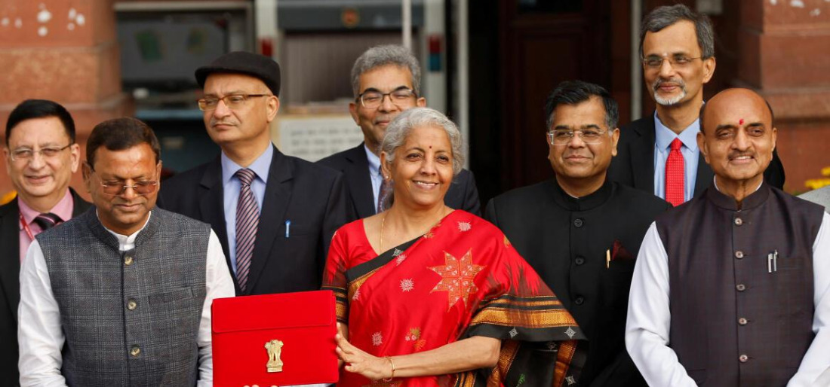](https://www.msn.com/en-in/video/money/how-halwa-keeps-the-lid-tight-on-union-budget/vi-BB1hfCLg?ocid=msedgntp)](https://www.msn.com/en-in/video/money/how-halwa-keeps-the-lid-tight-on-union-budget/vi-BB1hfCLg?ocid=msedgntp" \t "_blank)

"...India is at an important inflection point and given the current global developments and associated headwinds, the government should continue to lay major thrust on public capex (on physical, social and digital infrastructure) in the forthcoming budget," it said.

Last month, Sitharaman had indicated that the Budget to be presented on February 1 would not have any "spectacular announcement" as it would be a vote-on-account in the run-up to the general elections.

On expectations from the Budget, Pavan Choudary, Chairman of Medical Technology Association of India (MTaI) said India’s current tariff duty structure on medical device imports is very high.

He said the high customs duty regime adversely impacts the costs of medical devices which contradicts the government’s efforts to provide low-cost healthcare available to the masses through schemes like Ayushman Bharat (PMJAY).

"Therefore, we request the government that for products where the ability to import substitutes is still some time away, the customs duty rate should be reduced," Choudary said.

Akshat Khetan, Founder, AU Corporate and Legal Advisory Services Limited (AUCL) said tourism promotion, Digital India push, and housing for all are expected to receive increased allocations.

These would be balanced with more proactive fiscal deficit control measures as well as targeted reforms augmenting demand in the e-commerce space.

"Certain measures can also be expected to address India’s increasing influence with regard to key global conversations, leveraging trade and cultural legacy as a key bulwark towards enabling a more holistic discourse in terms of both economic development and social well-being," Khetan said.

A brief Budget session of Parliament, the last of the 17th Lok Sabha, will be held between January 31 and February 9.

Saurabh Rai, CEO, Arahas Technologies said as India prepares to unveil its 2024 Budget, there's an air of expectancy among the Geographic Information Systems (GIS), space, and drone industries.

"Poised at the forefront of technological evolution, these sectors are integral to the country's economic growth. The forthcoming budget is viewed as a pivotal moment, offering tailored solutions to their distinct needs and setting the stage for transformative developments and sustained advancement," he said.

Sitharaman on Wednesday participated in a traditional 'halwa' ceremony, marking the final stage for preparation of the interim Budget 2024. The ceremony is an annual ritual in which traditional dessert 'halwa' is prepared and served to officials and staff members of the finance ministry who are involved in the preparation of the Budget.

Dharmesh Shah, CEO, Hero Realty said the real estate industry's outlook for 2024 remains positive after the top seven cities saw record-breaking sales of 4.77 lakh housing units, but the upcoming general elections may impact demand and growth in residential real estate.

"To continue the buoyancy, an industry status for the housing sector, a single-window clearance for housing projects, and an increase in the tax rebate under Section 24 of the Income Tax Act to Rs 2 lakh is the necessity," he said.

On what he expects from the finance minister, Ankit Kumar, CEO, Skye Air said the drone startup community is eagerly eyeing key expectations that could revolutionise the industry.

"Foremost among these is the call for a Production-Linked Incentive (PLI) exclusively tailored for the service sector. Such a scheme would not only attract investments but also catalyze job creation, fostering a rapid integration of drones in critical domains like healthcare and agriculture," he said.

Rahul Mehrotra, Managing Director and CEO at Religare Housing Development Finance Corporation expects a comprehensive reform in capital gains tax, signalling a commitment to optimizing fiscal policies.

"The government is set to usher in a tech-driven era in agriculture, introducing innovative projects aimed at enhancing efficiency and productivity in this crucial sector, ensuring a technologically advanced and sustainable future," Mehrotra said.

Post elections, the new government will be presenting the final Budget for 2024-25, which may include major policy initiatives, and tax proposals to propel India towards a USD 5 trillion economy, and also to become the world's third largest economy.

***(This report has been published as part of an auto-generated syndicate wire feed. Apart from the headline, no editing has been done in the copy by ABP Live.)***

JSCIAR,

26th January, 2024.

**Who is like the wise? Ecclesiastes 8:1**

**Smt Nirmala Sitharama - Showing wisdom in drafting the budget focusing on people’s welfare and bringing to memory the lasting work of Dr Manmohan Singh, the 22nd Minister of Finance**

[[The Times of India](https://timesofindia.indiatimes.com/)](https://timesofindia.indiatimes.com/" \o "The Times of India" \t "_blank)

**[The Times of India](https://timesofindia.indiatimes.com/" \o "The Times of India" \t "_blank)**

Government policies to focus on 4 groups: Finance minister Nirmala Sitharaman

11h

[[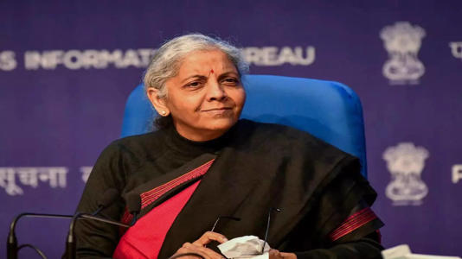](https://www.msn.com/en-in/news/other/government-policies-to-focus-on-4-groups-finance-minister-nirmala-sitharaman/ar-BB1hgjsz?ocid=msedgntp&pc=U531&cvid=d6849381fb374308af5dbcc73f0f4293&ei=38&fullscreen=true#image=2)](https://www.msn.com/en-in/news/other/government-policies-to-focus-on-4-groups-finance-minister-nirmala-sitharaman/ar-BB1hgjsz?ocid=msedgntp&pc=U531&cvid=d6849381fb374308af5dbcc73f0f4293&ei=38&fullscreen=true" \l "image=2" \t "_self)

Government policies to focus on 4 groups: Finance minister Nirmala Sitharaman© Provided by The Times of India

NEW DELHI: Finance minister Nirmala Sitharaman on Thursday said that youth, women, farmers and the poor would be the focus of government policies, in what many saw as an indication of thrust of the interim Budget due to be presented in Parliament next week.

Pointing to PM Narendra Modi's recent statement on the target groups, she said: "...yuva, women, those who give us the food security, good farmers, and then the unfortunate poor, who still need some more support for them to get uplifted. So, (focus on) just these four groups, everything will be focused towards their betterment. Then you don't really get into this whole thing about you know which caste which community which religion, everybody is covered," she said at an event at Hindu College.

She said that the government has focused on skilling, improving the tools available to farmers and making healthcare and other benefits available to the citizens, with the idea being saturation of schemes across categories. "Make sure everybody who's actually eligible to get those should get it and equally make sure that every local talent, every product that comes out should also find a market should also find local access to markets," the FM said.

She said the emphasis was on modernising post-harvest practices and pushing manufacturing in sunrise sectors, such as, renewable energy, semiconductors, material sciences, earth sciences and space industries. "High priority is being given to these sectors, and not just in the budget. We are also looking at improving R&D and bringing in top experts as advisors."

Sitharaman also said government and RBI are actively engaged in improving the central bank digital currency (CBDC) so that it can be used for cross-border payments. It helps in speeding up payments at a lower cost, she said, adding, it brings down cost for inward and outward remittance.

Observing that India is the fastest growing major economy and companies and stock market are doing very well, she said, narrative is being build that "the Indian economy is not (doing) very well. It is sick."

Contradicting the claim that the Indian economy is registering K-shaped recovery, Sitharaman said, "I want them to stand up and say on what basis are they saying it but they wouldn't be available for you to answer. They throw that idea and go away."

JSCIAR,

26th January, 2024.

**With God all things are possible. Matthew 19:26**

**Mrs Nirmala Sitharaman – Fighting against odds and setting new records while spearheading the economy of 1.4 billion people with focus on water resources and agriculture and rural upliftment**

[[The New Indian Express](https://www.newindianexpress.com/)](https://www.newindianexpress.com/" \o "The New Indian Express" \t "_blank)

**[The New Indian Express](https://www.newindianexpress.com/" \o "The New Indian Express" \t "_blank)**

FM Sitharaman to equal record of ex-PM Desai by presenting six budgets in a row

30m

[[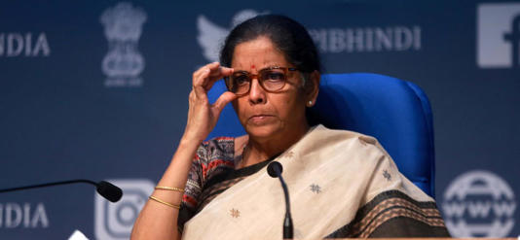](https://www.msn.com/en-in/news/India/fm-sitharaman-to-equal-record-of-ex-pm-desai-by-presenting-six-budgets-in-a-row/ar-BB1hi8lQ?ocid=msedgntp&pc=U531&cvid=a659a694bab2495f88a708291f2a95d3&ei=32&fullscreen=true#image=2)](https://www.msn.com/en-in/news/India/fm-sitharaman-to-equal-record-of-ex-pm-desai-by-presenting-six-budgets-in-a-row/ar-BB1hi8lQ?ocid=msedgntp&pc=U531&cvid=a659a694bab2495f88a708291f2a95d3&ei=32&fullscreen=true" \l "image=2" \t "_self)

Union Finance minister Nirmala Sitharaman.© Provided by The New Indian Express

NEW DELHI: Finance Minister Nirmala Sitharaman will equal the record of former Prime Minister Morarji Desai when she presents her sixth straight budget on February 1.

Sitharaman, the first full-time woman finance minister of the country, has presented five full budgets since July 2019 and will present an interim or vote-on-account budget next week.

With the presentation of interim budget on February 1, Sitharaman will surpass the records of her predecessors like Manmohan Singh, Arun Jaitley, P Chidambaram, and Yashwant Sinha, who had presented five budgets in a row.

Desai, as finance minister, had presented five annual budgets and one interim budget between 1959-1964.

The interim budget 2024-25 to be presented by Sitharaman on February 1, will be a vote-on-account that will give the government authority to spend certain sums of money till a new government comes to office after the April-May general elections.

As the Parliamentary elections are due, Sitharaman's interim budget may not contain any major policy changes.

Speaking at an industry event last month, Sitharaman had ruled out any "spectacular announcement" in the interim budget, saying it would just be a vote-on-account before the general elections.

A vote-on-account, once approved by Parliament, will authorise the government to withdraw money from the Consolidated Fund of India on pro-rata basis to meet expenditure for the April-July period.

The new government, which is likely to be formed around June, will come up with a final budget for 2024-25 sometime in July.

Usually, interim budgets do not contain major policy announcements, but nothing stops the government from taking steps which are necessary to deal with the urgent issues facing the economy.

After the Modi government came to power in 2014, Arun Jaitley took charge of the finance ministry and presented five budgets in a row from 2014-15 to 2018-19.

It was in 2017, that Jaitley departed from the colonial-era tradition of presenting budget on the last working day of February to 1st of the month.

Piyush Goyal, who was holding the additional charge of the ministry due to ill health of Jaitley, presented the interim budget for 2019-20 on February 1, 2019.

Goyal had hiked standard deduction for salaried taxpayers by Rs 10,000 to Rs 50,000.

Also, the tax rebate for taxpayers whose annual taxable income did not exceed Rs 5 lakh was increased from Rs 2,500 to Rs 12,500.

After the 2019 general elections, in the Modi 2.0 Government, Sitharaman was given the charge of the finance portfolio.

She became the second woman to have presented budget after Indira Gandhi, who had presented the budget for financial year 1970-71.

That year, Sitharaman did away with the traditional budget briefcase and instead went for a 'bahi-khata' with the National Emblem to carry the speech and other documents.

Under Sitharaman, India has weathered the Covid pandemic with an array of policy measures announced for the poor and continued its tag of the fastest growing major economy and a 'bright spot' in the world economy.

India is racing to become a USD 5 trillion economy by 2027-28 and USD 30 trillion by 2047.

Former Prime Minister Morarji Desai who holds the tag of presenting 10 budgets -- the maximum by any finance minister -- had presented six of them, including one interim, in a row.

The first budget of Independent India was presented by the first finance minister R K Shanmukham Chetty.

Sitharaman, who will be presenting her sixth budget in a row, is expected to come up with some measures, especially to boost the rural sector as the agriculture sector growth in 2023-24 is estimated to decelerate to 1.

8 per cent, from 4 per cent, in the preceding year.

Rakesh Nangia, Chairman, Nangia Andersen India said given the proximity to the elections, the budget is expected to focus on immediate fiscal needs rather than introducing broad long-term economic reforms.

In the last interim budget for FY 2019-20, while the overall tax structure remained unchanged, there were certain specific tax rebate and standard deduction concessions.

"While major announcements may be deferred until after the 2024 Lok Sabha elections, the budget is expected to address ongoing concerns and lay the foundation for future economic growth.

This strategic approach aims to balance immediate fiscal responsibilities with long-term economic objectives in a pre-election context," Nangia said.

JSCIAR,

27th January, 2024.

**Before honor is humility. 18:12**

**Smt Nirmala Sitharaman – A leader know for humility carrying cloth bags to make the ends meet**

# Why Does FM Sitharaman Use A Red Cloth To Wrap The Budget

Story by Vanya Gautam  • 1d

[[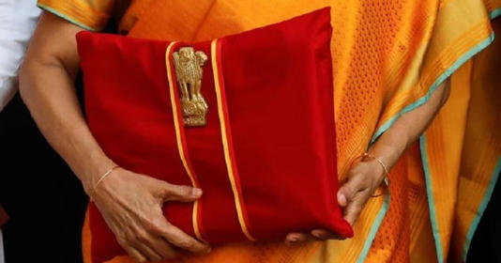](https://www.msn.com/en-in/news/India/why-does-fm-sitharaman-use-a-red-cloth-to-wrap-the-budget/ar-BB1hhL8Z?ocid=msedgntp&pc=U531&cvid=9db78c9b7b27406c9b861b78f4db59d0&ei=21&fullscreen=true#image=2)](https://www.msn.com/en-in/news/India/why-does-fm-sitharaman-use-a-red-cloth-to-wrap-the-budget/ar-BB1hhL8Z?ocid=msedgntp&pc=U531&cvid=9db78c9b7b27406c9b861b78f4db59d0&ei=21&fullscreen=true" \l "image=2" \t "_self)

Why Does FM Sitharaman Use A Red Cloth To Wrap The Budget© Provided by Indiatimes

Nearly five years ago, in her first union budget presentation itself, India’s first full time female Finance Minister**Nirmala Sitharaman** had broken an age old tradition. Instead of carrying the [**Union Budget**](https://www.indiatimes.com/worth/news/budget-2024-difference-between-interim-and-full-union-budget-625975.html) in a briefcase, FM Sitharaman had in 2019 started carrying the documents wrapped in red cloth.

## When Did FM Sitharaman Start Using The Red Cloth?

[[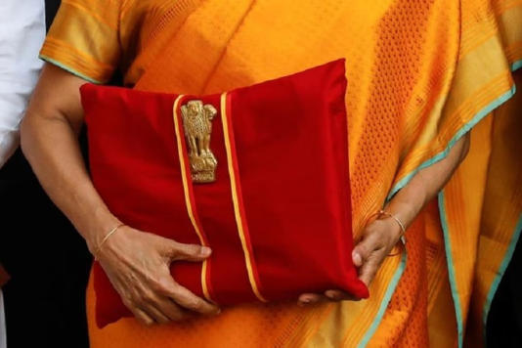](https://www.msn.com/en-in/news/India/why-does-fm-sitharaman-use-a-red-cloth-to-wrap-the-budget/ar-BB1hhL8Z?ocid=msedgntp&pc=U531&cvid=9db78c9b7b27406c9b861b78f4db59d0&ei=21&fullscreen=true#image=2)](https://www.msn.com/en-in/news/India/why-does-fm-sitharaman-use-a-red-cloth-to-wrap-the-budget/ar-BB1hhL8Z?ocid=msedgntp&pc=U531&cvid=9db78c9b7b27406c9b861b78f4db59d0&ei=21&fullscreen=true" \l "image=2" \t "_self)

union budget red cloth/reuters© Provided by Indiatimes

In July 2019, when **FM**[**Sitharman**](https://www.indiatimes.com/worth/news/ahead-of-budget-2024-heres-the-journey-of-indias-finance-minister-nirmala-sitharaman-625920.html)**presented her first ever budget**, she not only broke from the British-era tradition of carrying a briefcase by using a bahi khata (ledger), she also wrapped it in a**red cloth** tied with a string.

### Why The Red Cloth Is Being Used?

The red cloth wrapped to the bahi khata file (from 2019-2021) has the national emblem emblazoned on it. The reason for **red**is that red cloth is usually used to cover religious texts in our country.

After 2021, FM Sitharaman began presenting a paperless budget by using a tablet instead of bahi khata. **She wraps that tab with a red cloth.**

### What Is The Reason For Using A Tablet & Not Bahi Khata Or Briefcase?

From 2019, FM Sitharaman replaced the **briefcase**with a bahi khata (ledger file) and then from the year 2021, she presented the budget in a paperless form, using a tablet. Reacting on the move at that time, India’s Chief Economic Advisor Krishnamurthy Subramanian had called it a sign of**departure from slavery**of Western slavery.

[[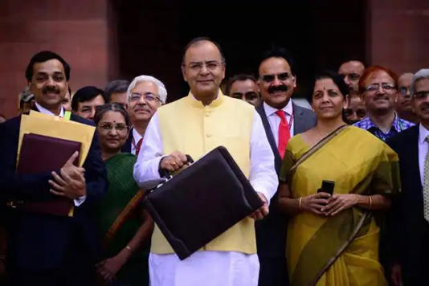](https://www.msn.com/en-in/news/India/why-does-fm-sitharaman-use-a-red-cloth-to-wrap-the-budget/ar-BB1hhL8Z?ocid=msedgntp&pc=U531&cvid=9db78c9b7b27406c9b861b78f4db59d0&ei=21&fullscreen=true#image=2)](https://www.msn.com/en-in/news/India/why-does-fm-sitharaman-use-a-red-cloth-to-wrap-the-budget/ar-BB1hhL8Z?ocid=msedgntp&pc=U531&cvid=9db78c9b7b27406c9b861b78f4db59d0&ei=21&fullscreen=true" \l "image=2" \t "_self)

arun jaitely budget/mint© Provided by Indiatimes

**Also Read:**[**Meet Nirmala Sitharaman's Team Behind Interim Budget 2024**](https://www.indiatimes.com/worth/news/meet-niramal-sitharaman-team-behind-interim-budget-2024-625524.html)

#### How Will Budget 2024 Be Presented?

India's Ministry of Finance has already mentioned that just like the previous three previous [Union Budgets](https://www.indiatimes.com/worth/news/interim-budget-2024-must-know-terms-625060.html), **interim budget 2024 will also be presented in paperless form**.

[[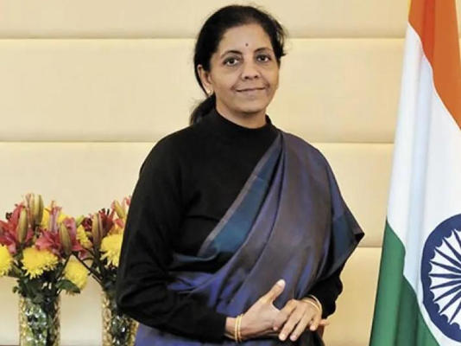](https://www.msn.com/en-in/news/India/why-does-fm-sitharaman-use-a-red-cloth-to-wrap-the-budget/ar-BB1hhL8Z?ocid=msedgntp&pc=U531&cvid=9db78c9b7b27406c9b861b78f4db59d0&ei=21&fullscreen=true#image=2)](https://www.msn.com/en-in/news/India/why-does-fm-sitharaman-use-a-red-cloth-to-wrap-the-budget/ar-BB1hhL8Z?ocid=msedgntp&pc=U531&cvid=9db78c9b7b27406c9b861b78f4db59d0&ei=21&fullscreen=true" \l "image=2" \t "_self)

nirmala sitharaman budget 2024/pti© Provided by Indiatimes

Its noteworthy that this year India will have two union budgets. February 1st will witness [**FM Sitharaman**](https://www.indiatimes.com/worth/news/nirmala-sitharaman-budget-2024-halwa-ceremony-625994.html)presenting an interim budget. And later in July 2024, after the Lok Sabha elections, the newly formed govt will present the full union budget.