JSCIAR,

12th January, 2024.

**Swami Vivekananda (12/1/1863-4/7/1902)**

**"Arise, awake, and stop not until the goal is reached,"**

[[Jagran English](https://english.jagran.com/)](https://english.jagran.com/" \o "Jagran English" \t "_blank)

**[Jagran English](https://english.jagran.com/" \o "Jagran English" \t "_blank)**

Follow

**National Youth Day 2024: Top 10 Successful And Inspiring Quotes Said By Swami Vivekananda**

Story by Jagran English  • 1d

[[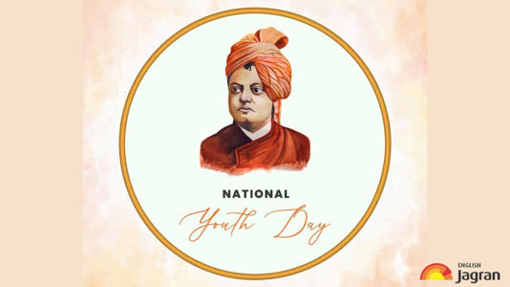](https://www.msn.com/en-in/news/India/national-youth-day-2024-top-10-successful-and-inspiring-quotes-said-by-swami-vivekananda/ar-AA1mQAbq?ocid=msedgdhp&pc=U531&cvid=026b92872b9540d9ade7070c926ac63f&ei=9&fullscreen=true#image=2)](https://www.msn.com/en-in/news/India/national-youth-day-2024-top-10-successful-and-inspiring-quotes-said-by-swami-vivekananda/ar-AA1mQAbq?ocid=msedgdhp&pc=U531&cvid=026b92872b9540d9ade7070c926ac63f&ei=9&fullscreen=true" \l "image=2" \t "_self)

National Youth Day 2024: Top 10 Successful And Inspiring Quotes Said By Swami Vivekananda© Provided by Jagran English

**National Youth Day 2024:** Today, January 12, people from all across the nation are celebrating this day. The key figure in India's spiritual and cultural history, Swami Vivekananda, left behind a legacy of inspirational quotes that are still relevant, particularly on National Youth Day. His advice to young people emphasizes self-belief, resiliency, and the quest for knowledge and serves as a beacon of hope. The well-known saying of Vivekananda, "Arise, awake, and stop not until the goal is reached," sums up his insistence on proactive participation and unwavering resolve.

Also, National Youth Day honors the date of his birth, serving as a reminder of his timeless wisdom and inspiring young people to make important contributions to society that promote both individual and societal development.

[[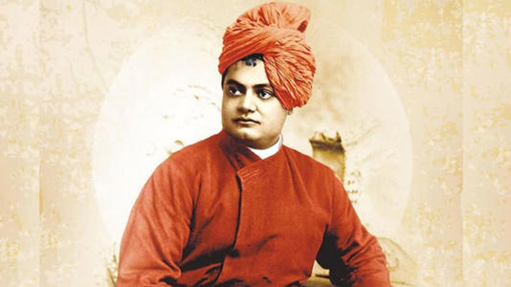](https://www.msn.com/en-in/news/India/national-youth-day-2024-top-10-successful-and-inspiring-quotes-said-by-swami-vivekananda/ar-AA1mQAbq?ocid=msedgdhp&pc=U531&cvid=026b92872b9540d9ade7070c926ac63f&ei=9&fullscreen=true#image=2)](https://www.msn.com/en-in/news/India/national-youth-day-2024-top-10-successful-and-inspiring-quotes-said-by-swami-vivekananda/ar-AA1mQAbq?ocid=msedgdhp&pc=U531&cvid=026b92872b9540d9ade7070c926ac63f&ei=9&fullscreen=true" \l "image=2" \t "_self)

National Youth Day 2024: Top 10 Successful And Inspiring Quotes Said By Swami Vivekananda© Provided by Jagran English

*National Youth Day 2024 (Image Credit: File Image)*

So here we have curated some of his most inspiring and successful quotes, which you can share on this special day with your friends, family, and close ones.

External nature is only internal nature writ large.

[**Also Read: Cervical Cancer Awareness Month 2024: Exercise And Cervical Health: How Regular Exercise Can Contribute To Overall Wellbeing**](https://english.jagran.com/lifestyle/cervical-cancer-awareness-month-2024-exercise-and-cervical-health-how-regular-exercise-can-contribute-to-overall-wellbeing-10126515)



[**Executive PG in Data Science - Limited seats. Filling up soon - NASSCOM Certified Executive PG**](https://www.bing.com/api/v1/mediation/tracking?adUnit=379960&auId=feb1e7f9-02bd-43f9-9a41-25cd731efb06&bidId=1&bidderId=4&cmExpId=LV3&oAdUnit=379960&publisherId=17160724&rId=ff4b463a-d328-46b5-b0ee-bfbef3a038ea&rlink=https%3A%2F%2Fwww.bing.com%2Faclick%3Fld%3De8P0BfeV1ameShpsOddjCwRzVUCUwCeuwL86UbkLeD8WvIpE8RNgeyULzcicFyriVV3EUE0kYX3EwXGygvgqak-csBfK_bJ3Ekag3y4yYR6CS3Z-N0gbkQ7QYUWWfjFqTrrcDjxo3btjJj19fxt9YVTdsuSZsdRUtPjZ0eFWm3AMIi532MSNrn1PzLXsOVq8sUdKUDxw%26u%%26rlid%3Dc9df4a074b8014075c082fa57853105b&rtype=targetURL&tagId=webcompar-inarticle-1&trafficGroup=zfa_ncnp&trafficSubGroup=ego)

[Ad](https://account.microsoft.com/privacy/ad-settings)

[UpGrad](https://www.bing.com/api/v1/mediation/tracking?adUnit=379960&auId=feb1e7f9-02bd-43f9-9a41-25cd731efb06&bidId=1&bidderId=4&cmExpId=LV3&oAdUnit=379960&publisherId=17160724&rId=ff4b463a-d328-46b5-b0ee-bfbef3a038ea&rlink=https%3A%2F%2Fwww.bing.com%2Faclick%3Fld%3De8P0BfeV1ameShpsOddjCwRzVUCUwCeuwL86UbkLeD8WvIpE8RNgeyULzcicFyriVV3EUE0kYX3EwXGygvgqak-csBfK_bJ3Ekag3y4yYR6CS3Z-N0gbkQ7QYUWWfjFqTrrcDjxo3btjJj19fxt9YVTdsuSZsdRUtPjZ0eFWm3AMIi532MSNrn1PzLXsOVq8sUdKUDxw%26u%%26rlid%3Dc9df4a074b8014075c082fa57853105b&rtype=targetURL&tagId=webcompar-inarticle-1&trafficGroup=zfa_ncnp&trafficSubGroup=ego)

The greatest sin is to think yourself weak.

In a day, when you don't come across any problems - you can be sure that you are travelling in a wrong path.

Condemn none: if you can stretch out a helping hand, do so. If you cannot, fold your hands, bless your brothers, and let them go their own way.

[[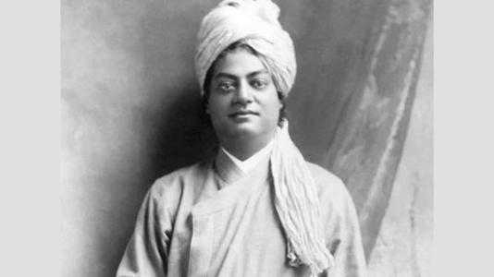](https://www.msn.com/en-in/news/India/national-youth-day-2024-top-10-successful-and-inspiring-quotes-said-by-swami-vivekananda/ar-AA1mQAbq?ocid=msedgdhp&pc=U531&cvid=026b92872b9540d9ade7070c926ac63f&ei=9&fullscreen=true#image=2)](https://www.msn.com/en-in/news/India/national-youth-day-2024-top-10-successful-and-inspiring-quotes-said-by-swami-vivekananda/ar-AA1mQAbq?ocid=msedgdhp&pc=U531&cvid=026b92872b9540d9ade7070c926ac63f&ei=9&fullscreen=true" \l "image=2" \t "_self)

National Youth Day 2024: Top 10 Successful And Inspiring Quotes Said By Swami Vivekananda© Provided by Jagran English

*National Youth Day 2024 (Image Credit: File Image)*

Dare to be free, dare to go as far as your thought leads, and dare to carry that out in your life.

Do one thing at a Time, and while doing it put your whole Soul into it to the exclusion of all else.

Arise! Awake! and stop not until the goal is reached.

[[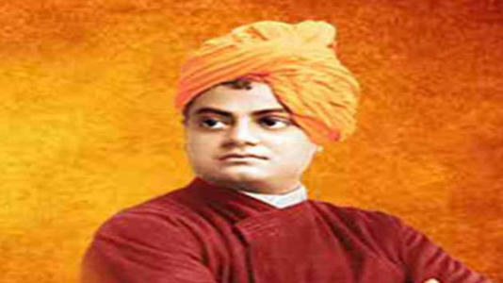](https://www.msn.com/en-in/news/India/national-youth-day-2024-top-10-successful-and-inspiring-quotes-said-by-swami-vivekananda/ar-AA1mQAbq?ocid=msedgdhp&pc=U531&cvid=026b92872b9540d9ade7070c926ac63f&ei=9&fullscreen=true#image=2)](https://www.msn.com/en-in/news/India/national-youth-day-2024-top-10-successful-and-inspiring-quotes-said-by-swami-vivekananda/ar-AA1mQAbq?ocid=msedgdhp&pc=U531&cvid=026b92872b9540d9ade7070c926ac63f&ei=9&fullscreen=true" \l "image=2" \t "_self)

National Youth Day 2024: Top 10 Successful And Inspiring Quotes Said By Swami Vivekananda© Provided by Jagran English

*National Youth Day 2024 (Image Credit: File Image)*

You cannot believe in God until you believe in yourself.

The great secret of true success, of true happiness, is this: the man or woman who asks for no return, the perfectly unselfish person, is the most successful.

[**Also Read: Happy National Youth Day 2024: Wishes, Messages, Quotes, WhatsApp And Facebook Status To Share On This Day**](https://english.jagran.com/lifestyle/national-youth-day-2024-wishes-messages-quotes-whatsapp-and-facebook-status-to-share-on-this-day-10126351)

Comfort is no test of truth. Truth is often far from being comfortable.

**JSCIAR,**

**14th January, 2024.**

**Swami Vivekananda on religion**

# 11 Facts About Swami Vivekananda You Probably Don't Know

Story by Anuj Tiwari  • 2d

https://www.msn.com/en-in/news/india/11-facts-about-swami-vivekananda-you-probably-don-t-know/ar-AA1mNXXI?ocid=msedgntp&pc=U531&cvid=93ca93bbf1f549b286f454ea64963eaa&ei=21

[[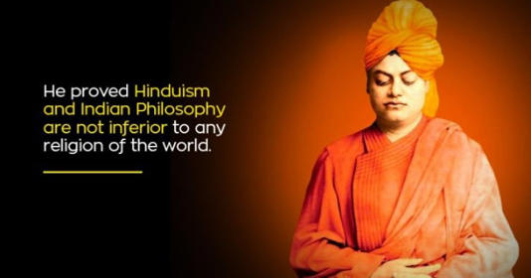](https://www.msn.com/en-in/news/india/11-facts-about-swami-vivekananda-you-probably-don-t-know/ar-AA1mNXXI?ocid=msedgntp&pc=U531&cvid=93ca93bbf1f549b286f454ea64963eaa&ei=21&fullscreen=true#image=2)](https://www.msn.com/en-in/news/india/11-facts-about-swami-vivekananda-you-probably-don-t-know/ar-AA1mNXXI?ocid=msedgntp&pc=U531&cvid=93ca93bbf1f549b286f454ea64963eaa&ei=21&fullscreen=true" \l "image=2" \t "_self)

11 Facts About Swami Vivekananda You Probably Don't Know© Provided by Indiatimes

**National Youth Day 2024:**National Youth Day is celebrated every year on the birth anniversary of Swami Vivekananda. Swami Vivekananda was arguably the most inspiring person for the younger generation and hence his birthday, January 12, is celebrated as National Youth Day. A monk and a heartened disciple of Ramakrishna, Swami Vivekanand has been an influential personality who inspired millions of people worldwide. His morals and magnetic aura are being celebrated even after a century of his demise.

[[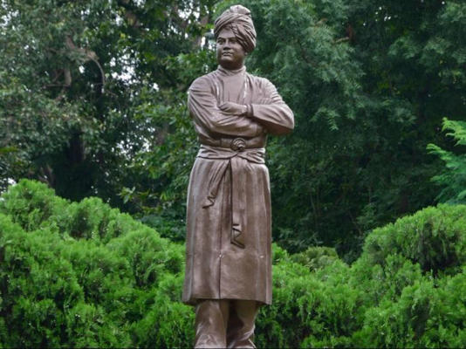](https://www.msn.com/en-in/news/india/11-facts-about-swami-vivekananda-you-probably-don-t-know/ar-AA1mNXXI?ocid=msedgntp&pc=U531&cvid=93ca93bbf1f549b286f454ea64963eaa&ei=21&fullscreen=true#image=2)](https://www.msn.com/en-in/news/india/11-facts-about-swami-vivekananda-you-probably-don-t-know/ar-AA1mNXXI?ocid=msedgntp&pc=U531&cvid=93ca93bbf1f549b286f454ea64963eaa&ei=21&fullscreen=true" \l "image=2" \t "_self)

wikimedia/ representational image© Provided by Indiatimes

Swami Vivekananda should always be remembered for his inspiration to mankind. Swami, without a doubt, is the greatest source of achievement, pride and [inspiration](https://www.indiatimes.com/news/india/swami-vivekananda-158th-birth-anniversary-inspirational-quotes-531745.html?nocache=1&preview=1).

Today, we are celebrating National Youth Day 2024, So here are some little-known facts about Swami Vivekananda you should probably don't know:

## **Interesting Facts About Facts About Swami Vivekananda**

## **1. Pre-monastic name**

Swami Vivekananda's pre-monastic name was Narendra Nath Datta. He was born with a temperament of yogis and used to meditate at a very early age.

## **2. Lived in extreme poverty**

Swami Vivekananda’s father died suddenly when he was young. This broke the financial backbone of his family and the whole family was pushed into poverty.

After his father’s death, his family was in extreme poverty. Many times Swamiji used to lie in the house where he has been invited to eat somewhere so that the rest of the people can get food properly.

## **3. Scored 56 per cent in BA exam**

Swami Vivekananda’s uncontested wisdom and eloquence as an orator and leader were made known to the world during his few years in public life. However, it is known by few that he was an average scorer all through his academic life. It is believed that he could only score 46 per cent at the university entrance level examination and around 56 per cent in his BA examinations. Moreover, he was said to be terrible at English grammar.

## **4. Iconic speech in Chicago**

Swami Vivekananda’s iconic speech at the World Religion Conference in Chicago is remembered by one and all. It is on September 11, 1893, when Swami Vivekanand gave a speech full of wisdom. For those unversed, it is in this iconic Chicago Speech that Vivekananda addressed the audience as ‘Brothers and Sisters of America’. In the speech that blew everyone’s mind, Swami Vivekananda had mentioned the basic yet most important things that one should follow in life.

[[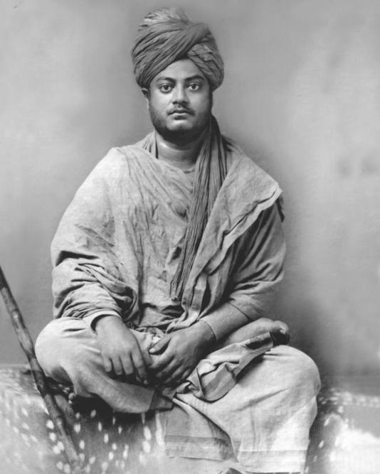](https://www.msn.com/en-in/news/india/11-facts-about-swami-vivekananda-you-probably-don-t-know/ar-AA1mNXXI?ocid=msedgntp&pc=U531&cvid=93ca93bbf1f549b286f454ea64963eaa&ei=21&fullscreen=true#image=2)](https://www.msn.com/en-in/news/india/11-facts-about-swami-vivekananda-you-probably-don-t-know/ar-AA1mNXXI?ocid=msedgntp&pc=U531&cvid=93ca93bbf1f549b286f454ea64963eaa&ei=21&fullscreen=true" \l "image=2" \t "_self)

Facts about Swami Vivekananda | Wikipedia© Provided by Indiatimes

These things included being patriotic, loving all religions, analysing religion, being acquainted with science, knowing the importance and necessity of rituals, being aware of roots of Hinduism, being aware of the goal of science, being aware of the cause of the downfall of India, and being against religious conversations.



[**Official Supplier. Order Now. - FitLine® Online Shop**](https://www.bing.com/api/v1/mediation/tracking?adUnit=379960&auId=a36e0820-eb4b-4668-b648-8d885f09e966&bidId=1&bidderId=4&cmExpId=LV3&oAdUnit=379960&publisherId=17160724&rId=6b592740-6060-4814-ac07-64694d9208c7&rlink=https%3A%2F%2Fwww.bing.com%2Faclick%3Fld%3De8F0iU0hq3DSXw_xfdrALYNDVUCUzq1Y8IOBbxYR32mv24BPc_TLj3k9Z8QusG2UvuBGf-88p8YQG5uSyR6FQ54ViXVVYoflvDWZYBrQqWKrKoDXl_Cd7AzwFWm1SnJMQJ4oJuV9UnCKiV0Nmcar9BuN0aDTy0LD1OdW1cMxH1vBaJNYqwEfxDZOXIOFxJMooxfIp9Dg%26u%3DaHR0cHMlM2ElMmYlMmZ3d3cucG0taW50ZXJuYXRpb25hbC5jb20lMmZlbiUyZiUzZlRQJTNkMzA0NTUyJTI2bXNjbGtpZCUzZGJjNmE5MTY4YjUzZjFlYmExNWE5ZjRjYmRkYWUyMjJl%26rlid%3Dbc6a9168b53f1eba15a9f4cbddae222e&rtype=targetURL&tagId=webcompar-inarticle-2&trafficGroup=zfa_ncnp&trafficSubGroup=ego)

[Ad](https://account.microsoft.com/privacy/ad-settings)

[www.pm-international.com/304552/FitLine®](https://www.bing.com/api/v1/mediation/tracking?adUnit=379960&auId=a36e0820-eb4b-4668-b648-8d885f09e966&bidId=1&bidderId=4&cmExpId=LV3&oAdUnit=379960&publisherId=17160724&rId=6b592740-6060-4814-ac07-64694d9208c7&rlink=https%3A%2F%2Fwww.bing.com%2Faclick%3Fld%3De8F0iU0hq3DSXw_xfdrALYNDVUCUzq1Y8IOBbxYR32mv24BPc_TLj3k9Z8QusG2UvuBGf-88p8YQG5uSyR6FQ54ViXVVYoflvDWZYBrQqWKrKoDXl_Cd7AzwFWm1SnJMQJ4oJuV9UnCKiV0Nmcar9BuN0aDTy0LD1OdW1cMxH1vBaJNYqwEfxDZOXIOFxJMooxfIp9Dg%26u%3DaHR0cHMlM2ElMmYlMmZ3d3cucG0taW50ZXJuYXRpb25hbC5jb20lMmZlbiUyZiUzZlRQJTNkMzA0NTUyJTI2bXNjbGtpZCUzZGJjNmE5MTY4YjUzZjFlYmExNWE5ZjRjYmRkYWUyMjJl%26rlid%3Dbc6a9168b53f1eba15a9f4cbddae222e&rtype=targetURL&tagId=webcompar-inarticle-2&trafficGroup=zfa_ncnp&trafficSubGroup=ego)

On hearing this, all the people present there stood up for him and played applause. The speech impressed the attendees so much that Swami Vivekananda went on to become India’s spiritual ambassador in America, and his teachings spread across the entire world.

## **5. Unemployed forever**

Regardless of holding a BA degree, Vivekananda never secured a job. He even went door to door for work. Swami Vivekananda’s faith in God was lost due to no employment and he started saying – “God does not exist”

## **6. Sharp memory**

[[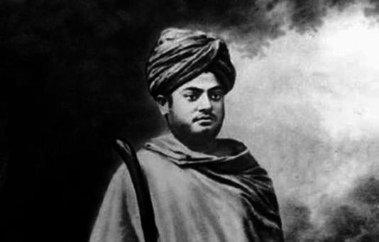](https://www.msn.com/en-in/news/india/11-facts-about-swami-vivekananda-you-probably-don-t-know/ar-AA1mNXXI?ocid=msedgntp&pc=U531&cvid=93ca93bbf1f549b286f454ea64963eaa&ei=21&fullscreen=true#image=2)](https://www.msn.com/en-in/news/india/11-facts-about-swami-vivekananda-you-probably-don-t-know/ar-AA1mNXXI?ocid=msedgntp&pc=U531&cvid=93ca93bbf1f549b286f454ea64963eaa&ei=21&fullscreen=true" \l "image=2" \t "_self)

Facts about Swami Vivekananda | Twitter© Provided by Indiatimes

Swamiji used to borrow books from the library and return it the next day. The librarian doubted whether he really read the books or not. So the librarian tested him by asking questions from a random page of the books. Swamiji answered them correctly and also quoted lines from the same page.

## **7. No entry for women inside the monastery**

Though Vivekananda used to respect and worship women, entry for them was strictly prohibited in his monastery. Once when Swamiji was ill his disciples fetched his mother. Seeing his mother he shouted, “Why did you allow a woman to come in? I was the one who made the rule and it is for me that the rule is being broken.”

## **8. Became a monk from Narendra**

When Swami Vivekananda became a monk from Narendra, his name was Swami Vividishanand, but before moving to Chicago, he changed his name to Vivekananda.

## **9. Serving humans is more than worshiping God**

[[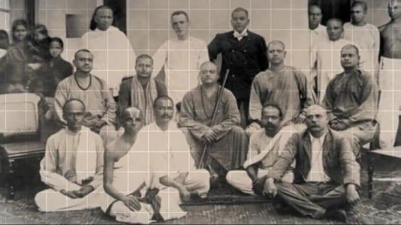](https://www.msn.com/en-in/news/india/11-facts-about-swami-vivekananda-you-probably-don-t-know/ar-AA1mNXXI?ocid=msedgntp&pc=U531&cvid=93ca93bbf1f549b286f454ea64963eaa&ei=21&fullscreen=true#image=2)](https://www.msn.com/en-in/news/india/11-facts-about-swami-vivekananda-you-probably-don-t-know/ar-AA1mNXXI?ocid=msedgntp&pc=U531&cvid=93ca93bbf1f549b286f454ea64963eaa&ei=21&fullscreen=true" \l "image=2" \t "_self)

Facts about Swami Vivekananda | YouTube© Provided by Indiatimes

After the death of his guru Ramakrishna, Swami Vivekananda sought to travel the length and breadth of India as a wandering monk. Ramakrishna taught Vivekananda that serving humans is more than worshiping God. It was during these travels that he gained extensive knowledge about the Hindu culture in India and came to understand the sufferings of the common man.

## **10. Suffered from 31 ailments and illnesses**

During the course of his life, Swami Vivekananda suffered from as many as 31 ailments and illnesses. Liver and kidney damage, insomnia, migraine, asthma, diabetes are to name a few. He was rumoured to discern and inflict intense pain on his human body and disregarded its presence throughout his life.

## **11. Predicted his own death**

Swamiji always used to say that he would not live beyond the age of 40 and he went to heaven at the age of 39 years

These little-known facts on Swami Vivekananda's life may surely made you feel that how inspiring life was this young man!