JSCIAR,

19th January, 2024.

**Blessed is the memory of the righteous. Proverbs 10:7**

**Shri Nandamuri Tharaka Ramarao**

https://www.msn.com/en-in/news/India/video-jr-ntr-kalyanram-pay-tribute-to-grandfather-ntr-on-his-death-anniversary/ar-AA1n9yEq?ocid=msedgntp&pc=U531&cvid=1eba9dd7e8af4a74b408ad8741d2fa0c&ei=77

**Video: Jr NTR, Kalyanram pay tribute to grandfather NTR on his death anniversary**

Story by Janani K  • 1d

[[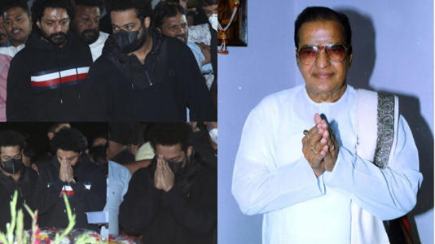](https://www.msn.com/en-in/news/India/video-jr-ntr-kalyanram-pay-tribute-to-grandfather-ntr-on-his-death-anniversary/ar-AA1n9yEq?ocid=msedgntp&pc=U531&cvid=1eba9dd7e8af4a74b408ad8741d2fa0c&ei=77&fullscreen=true#image=2)](https://www.msn.com/en-in/news/India/video-jr-ntr-kalyanram-pay-tribute-to-grandfather-ntr-on-his-death-anniversary/ar-AA1n9yEq?ocid=msedgntp&pc=U531&cvid=1eba9dd7e8af4a74b408ad8741d2fa0c&ei=77&fullscreen=true" \l "image=2" \t "_self)

Video: Jr NTR, Kalyanram pay tribute to grandfather NTR on his death anniversary© Provided by India Today

Jr NTR and Nandamuri Kalyanram, on January 18, visited NTR Gardens in Hyderabad to pay tribute to their grandfather and former Chief Minister of Andhra Pradesh, NT Rama Rao (NTR). Today, January 18, marks his 28th death anniversary. The two actors turned up in black outfits as they offered flowers at the memorial and paid their respects. Multiple videos of the actors being mobbed by their fans at the NTR ghat have surfaced online.

JR NTR, KALYANRAM PAY TRIBUTE TO NTR ON HIS DEATH ANNIVERSARY

Every year, Jr NTR and Nandamuri Kalyanram make it a point to visit the NTR Gardens to [pay their respects to their grandfather on his birth](https://www.indiatoday.in/movies/regional-cinema/story/jr-ntr-ram-charan-chiranjeevi-pay-heartfelt-tribute-to-nt-rama-rao-on-100th-birth-anniversary-1955373-2022-05-28) and death anniversaries. This year was no different.

On January 18, Jr NTR and his half-brother Nandamuri Kalyanram visited NTR's memorial in Hyderabad to pay their respects. They offered flowers and prayed with folded hands.

Here are some photos and videos:

ALL ABOUT NTR

Nandamuri Taraka Rama Rao (NTR) was a [legendary actor, filmmaker and politician](https://www.indiatoday.in/india-today-insight/story/from-the-india-today-archives-1983-nt-rama-rao-the-saffron-caesar-2366096-2023-04-29). He served as the Chief Minister of Andhra Pradesh for seven years. He also acted in 300 films and won three National Awards. He died on January 18 at his residence in Hyderabad in 1996.

NTR was conferred with Padma Shri in 1969. He founded the Telugu Desam Party (TDP) in 1982 and won the love of the people of united Andhra Pradesh.

ALSO READ | [Jr NTR gets emotional as he visits NTR ghat on late veteran actor's 100th birth anniversary](https://www.indiatoday.in/movies/regional-cinema/story/on-ntrs-100th-birth-anniversary-jr-ntr-and-kalyanram-nandamuri-remember-their-grandfather-see-tweets-2385494-2023-05-28" \t "_blank)