**JSCIAR, India,**

**27th November 2023.**

**Ebook on Fr Pope Francis**

**Fr Pope Francis – Leader with the imitation of Christ**

**https://www.msn.com/en-in/health/health-news/pope-francis-battling-lung-inflammation-but-will-attend-dubai-cop28-climate-conference-this-week/ar-AA1kzHrD?ocid=msedgntp&cvid=79e06d387f4844bab73e9992a1184451&ei=15**

**Pope Francis battling lung inflammation, but will attend Dubai COP28 climate conference this week**

Story by Sneha Swaminathan

[[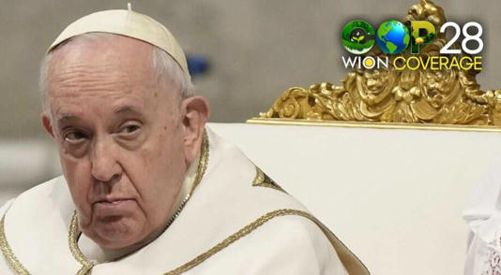](https://www.msn.com/en-in/health/health-news/pope-francis-battling-lung-inflammation-but-will-attend-dubai-cop28-climate-conference-this-week/ar-AA1kzHrD?ocid=msedgntp&cvid=79e06d387f4844bab73e9992a1184451&ei=15&fullscreen=true#image=2)](https://www.msn.com/en-in/health/health-news/pope-francis-battling-lung-inflammation-but-will-attend-dubai-cop28-climate-conference-this-week/ar-AA1kzHrD?ocid=msedgntp&cvid=79e06d387f4844bab73e9992a1184451&ei=15&fullscreen=true" \l "image=2" \t "_self)

Pope Francis battling lung inflammation, but will attend Dubai COP28 climate conference this week© Provided by WION

Pope Francis, 87, disclosed a health concern, revealing he is grappling with lung inflammation. Despite this, he expressed his determination to attend COP28, the upcoming climate change conference in Dubai later this week.

In an unusual move, Pope Francis chose to forego his weekly Sunday appearance at St Peter's Square due to his health condition.

Instead, he delivered the traditional noon blessing via a live televised broadcast from the Vatican hotel where he resides, reported the Associated Press.

Addressing the faithful, Pope Francis acknowledged his lung inflammation, preventing him from making the customary window appearance. He entrusted a priest to read his reflections for the day.

"Brothers and sisters, happy Sunday. Today I cannot appear at the window because I have this problem of inflammation of the lungs," the Pope said.

**Dubai climate change conference**

Despite his health setback, Pope Francis confirmed his participation in the COP28 gathering on climate change in the United Arab Emirates.

He reiterated his commitment to deliver his scheduled speech on Saturday, emphasizing the urgency of addressing climate change for the sake of future generations.

**Related video**: Pope Francis, inaming may lung inflammation siya | BT (Dailymotion)

Through the words read by the priest, Pope Francis highlighted climate change as a significant threat to the world, paralleling it with the dangers posed by war. He expressed gratitude to those offering prayers and urged collective efforts to safeguard the planet, referring to it as the "common house."

Video footage of the broadcast showed Pope Francis with a bandage on his right hand and what appeared to be a cannula. The Vatican did not immediately clarify whether the Pope was undergoing intravenous treatment or another form of medical intervention.

**Also watch | Pope's big initiative amid Israel-Hamas War**

A notable discrepancy emerged between Pope Francis stating he had lung inflammation and the Vatican's previous announcement that a CT scan yielded negative results for pulmonary complications. The nature of the Pope's medical treatment remains unclear.

This isn't the first time Pope Francis has faced health challenges. Earlier this year, he was hospitalised for pneumonia, characterised by the Vatican as bronchitis requiring intravenous antibiotic treatment. The current health concerns come amidst unusually windy and chilly weather in Rome.

During the broadcast, Pope Francis's voice exhibited signs of strain and breathlessness. He briefly explained his absence from the window appearance and concluded with his customary request for prayers.

**JSCIAR, India,**

**1st December, 2023.**

**Responding terror with terror is forbidden – Fr Pope Francis**

**https://www.msn.com/en-in/news/world/pope-francis-warned-israel-s-herzog-response-to-terror-with-terror-is/ar-AA1kO1yb?ocid=msedgntp&cvid=c5c2c6f0c9444e61b0749235a3fb5bb7&ei=8**

# Pope Francis warned Israel's Herzog: ‘Response to terror with terror is…’

Story by Snehashish Roy • 15h

[[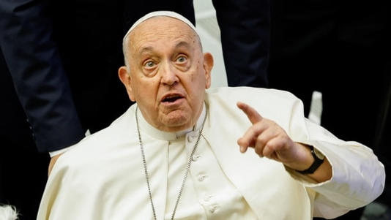](https://www.msn.com/en-in/news/world/pope-francis-warned-israel-s-herzog-response-to-terror-with-terror-is/ar-AA1kO1yb?ocid=msedgntp&cvid=c5c2c6f0c9444e61b0749235a3fb5bb7&ei=8&fullscreen=true#image=2)](https://www.msn.com/en-in/news/world/pope-francis-warned-israel-s-herzog-response-to-terror-with-terror-is/ar-AA1kO1yb?ocid=msedgntp&cvid=c5c2c6f0c9444e61b0749235a3fb5bb7&ei=8&fullscreen=true" \l "image=2" \t "_self)

Pope Francis© Provided by Hindustan Times

In a blunt rejoinder to Israeli President Isaac Herzog over a phone call amid the offensive against Hamas in Gaza in late October, Pope Francis reminded the Israeli head of state that it is “forbidden to respond to terror with terror.” *The Washington Post* reported, citing an Israeli official, how the Pope responded to Herzog's fraught call, in which the Israeli President was describing how it was important for his country to defend its citizens, by saying those responsible for the October 7 carnage should be held accountable but not at the cost of civilian lives.

The diplomatic exchange was never reported by the Israeli administration before as it was deemed “bad”. However, the Pope's response resonated with his latest statement in which he described the fighting between both sides as “terrorism", after meeting the families of Israeli hostages. “I heard how both sides suffer, and this is what wars do, but here we’ve gone beyond war." It was, however, unclear whether the Pope was referring to a specific action or the whole conflict.

Meanwhile, in a shift of tone, the US has stressed the need to comply with international law while fighting Hamas in Gaza. Top US official Antony Blinken wrote on X (formerly Twitter) that he emphasised the “need for Israel to take every possible measure to avoid civilian harm” during the meeting with Israel's Prime Minister Benjamin Netanyahu.

As the truce deal in a bid to release as many hostages as possible from Gaza enters the seventh day after a second extension from the initial agreement, the international mediators are seeking to lengthen the ceasefire beyond Thursday.

**Related video**: The Pope is reportedly evicting this long-term opponent (Dailymotion)

However, Israel has been reiterating its position on re-launching its offensive against Hamas soon after the truce is over. The White House has also extended its support to Israel's prospective operation. “When Israel decides to go after Hamas again, it will continue to find support from the US,” said National Security Council spokesperson John Kirby.

**JSCIAR, India,**

**15th December, 2023.**

**Fr Pope Francis – Abreast with advanced technologies of his times**

https://www.msn.com/en-in/news/world/pope-francis-calls-for-global-ai-treaty-for-ethical-use/ar-AA1luE3N?ocid=msedgntp&cvid=8a85a5643c854863aebc1e29e77d9e91&ei=16

[[Firstpost](https://www.firstpost.com/)](https://www.firstpost.com/" \t "_blank)

**[Firstpost](https://www.firstpost.com/" \t "_blank)**

Follow

# Pope Francis calls for global AI treaty for ethical use

Story by Shivam Verma • 18h

[[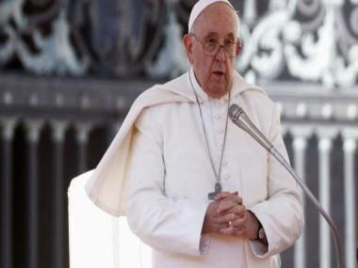](https://www.msn.com/en-in/news/world/pope-francis-calls-for-global-ai-treaty-for-ethical-use/ar-AA1luE3N?ocid=msedgntp&cvid=8a85a5643c854863aebc1e29e77d9e91&ei=16&fullscreen=true#image=2)](https://www.msn.com/en-in/news/world/pope-francis-calls-for-global-ai-treaty-for-ethical-use/ar-AA1luE3N?ocid=msedgntp&cvid=8a85a5643c854863aebc1e29e77d9e91&ei=16&fullscreen=true" \l "image=2" \t "_self)

Pope Francis calls for global AI treaty for ethical use© Provided by Firstpost

Pope Francis has urged global leaders to adopt a worldwide agreement governing the ethical use of artificial intelligence (AI).

In a comprehensive message preceding the Catholic Church’s World Day of Peace on January 1, which focuses on AI this year, the 86-year-old pontiff acknowledged the positive impact of technological advances in alleviating human suffering.

However, he cautioned against the potential risks posed by certain discoveries, emphasising the need for responsible AI application.

He highlighted the dangers of using AI, including in disinformation and interference in elections, and also to make decisions — from social security payments to where to target weapons — for which responsibility becomes blurred.

Expressing concerns about the pursuit of absolute freedom leading to a “technological dictatorship,” he emphasised the importance of an international treaty to oversee AI development and use. The goal of such a treaty would be to prevent harm and promote responsible practices.

Pope Francis underscored that the designers of algorithms and digital technologies cannot be presumed to consistently act ethically and responsibly.

Instead, he called for “binding international treaty” to regulate the development and use of AI, with the goal of preventing harm and sharing good practice. 1:30

[[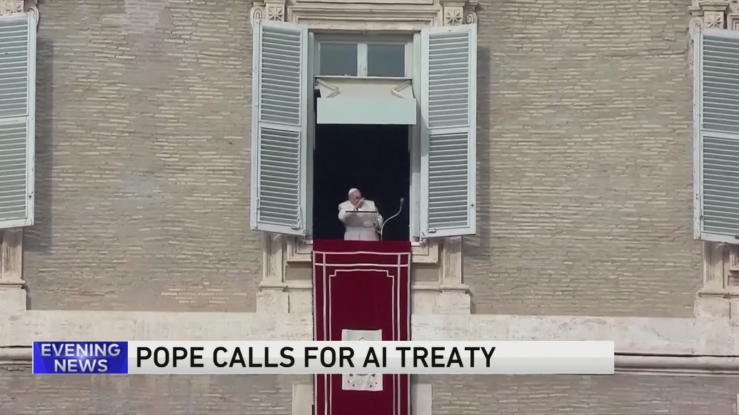](https://www.msn.com/en-in/video/news/pope-once-a-victim-of-ai-generated-imagery-calls-for-treaty-to-regulate-artificial-intelligence/vi-AA1lwdc4?ocid=msedgntp)](https://www.msn.com/en-in/video/news/pope-once-a-victim-of-ai-generated-imagery-calls-for-treaty-to-regulate-artificial-intelligence/vi-AA1lwdc4?ocid=msedgntp" \t "_blank)

**[ence](https://www.msn.com/en-in/video/news/pope-once-a-victim-of-ai-generated-imagery-calls-for-treaty-to-regulate-artificial-intelligence/vi-AA1lwdc4?ocid=msedgntp" \t "_blank)**

“Technological developments that do not lead to an improvement in the quality of life of all humanity, but on the contrary aggravate inequalities and conflicts, can never count as true progress,” he wrote.

Concerns about AI have increased since the chatbot ChatGPT, a mass-market gateway to generative AI, exploded onto the scene in late 2022.

The European Union is working on a broad law covering the sector, while Chinese legislation specifically regulating generative AI came into force in August this year.

US President Joe Biden also issued an executive order on AI safety standards in October.

Pope Francis himself has been the subject of several AI-generated images, including one that went viral, showing him wearing a huge white puffer coat with a large crucifix hanging over it.

With inputs from AFP

**JSCIAR, India**

**18th December 2023.**

**Fr Pope Francis - Compassitionate like Jesus Christ towards the weaknesses of men:**

https://www.msn.com/en-in/autos/photos/pope-francis-approves-blessings-for-same-sex-couples-says-shouldn-t-be-subject-to-moral-analysis/ar-AA1lGxdZ?ocid=msedgntp&cvid=bda3461ddd6041ba93982ec605bc9628&ei=44

[[ABP Live](https://news.abplive.com/)](https://news.abplive.com/" \o "ABP Live" \t "_blank)

**[ABP Live](https://news.abplive.com/" \o "ABP Live" \t "_blank)**

Follow

# Pope Francis Approves Blessings For Same-Sex Couples, Says Shouldn’t Be Subject To 'Moral Analysis'

Story by ABP News Bureau  • 39m

In a significant move, Pope Francis has officially endorsed the blessing of same-sex couples, marking a radical shift in Vatican policy. A new document from the Vatican's doctrine office, released on Monday, elucidates on the Pope's earlier communication to two conservative cardinals, underscoring that individuals seeking God's love and mercy should not undergo an "exhaustive moral analysis" as a prerequisite, news agency Associated Press reported.

The document reaffirms that marriage remains a sacrament between a man and a woman, emphasising that blessings should not be equated with the sacrament of marriage and should not coincide with civil unions. Furthermore, it discourages the use of wedding-related clothing and gestures during such ceremonies.

While upholding the traditional definition of marriage, the document asserts that requests for blessings for same-sex couples should not be outright denied. It offers an extensive scriptural definition of the term "blessing" to emphasise that individuals seeking a transcendent relationship with God, love, and mercy should not be burdened by exhaustive moral scrutiny.

**A**

According to the document, a blessing serves as a means for individuals to enhance their trust in God, AP's report mentioned. It contends that the request for a blessing signifies and nurtures openness to transcendence, mercy, and closeness to God in various concrete circumstances of life. The document highlights the importance of not hindering this seed of the Holy Spirit but nurturing it.

"Ultimately, a blessing offers people a means to increase their trust in God. The request for a blessing, thus, expresses and nurtures openness to the transcendence, mercy, and closeness to God in a thousand concrete circumstances of life, which is no small thing in the world in which we live," the document states, as quoted by the report.

“It is a seed of the Holy Spirit that must be nurtured, not hindered,” it adds.

The decision signals the Pope's effort to bridge a more compassionate understanding in line with the changing societal attitudes towards LGBTQ+ issues.

JSCIAR, India,

19th December 2023.

* **3**

[Ad](https://go.microsoft.com/fwlink/?LinkID=286759)

[[WION](https://www.wionews.com/)](https://www.wionews.com/" \o "WION" \t "_blank)

**[WION](https://www.wionews.com/" \o "WION" \t "_blank)**

Follow

# Landmark Vatican ruling approved by Pope Francis allows priests to bless same-sex couples

Story by Sneha Swaminathan  • 16h

https://www.msn.com/en-in/news/world/landmark-vatican-ruling-approved-by-pope-francis-allows-priests-to-bless-same-sex-couples/ar-AA1lGTPD?ocid=msedgntp&cvid=06a03f52e66d4899a015d1ba0ceb58a5&ei=9

[[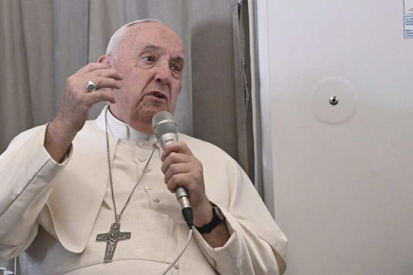](https://www.msn.com/en-in/news/world/landmark-vatican-ruling-approved-by-pope-francis-allows-priests-to-bless-same-sex-couples/ar-AA1lGTPD?ocid=msedgntp&cvid=06a03f52e66d4899a015d1ba0ceb58a5&ei=9&fullscreen=true#image=2)](https://www.msn.com/en-in/news/world/landmark-vatican-ruling-approved-by-pope-francis-allows-priests-to-bless-same-sex-couples/ar-AA1lGTPD?ocid=msedgntp&cvid=06a03f52e66d4899a015d1ba0ceb58a5&ei=9&fullscreen=true" \l "image=2" \t "_self)

Landmark Vatican ruling approved by Pope Francis allows priests to bless same-sex couples© Provided by WION

In a historic ruling approved by Pope Francis, the Vatican declared on Monday (Dec 18) that Roman Catholic priests can offer blessings to same-sex couples, provided these blessings are not incorporated into regular Church rituals or liturgies.

The pronouncement comes through a document from the Vatican's doctrinal office, gesturing a significant shift in the Church's stance.

The Vatican said that these blessings should not be confused with the sacrament of heterosexual marriage.

Priests are encouraged to make decisions on a case-by-case basis, allowing the Church's support for people seeking God's help through a simple blessing.

[Also read | Pope Francis calls for binding global treaty to regulate AI](https://www.wionews.com/world/pope-francis-calls-for-binding-global-treaty-to-regulate-ai-669704)

## ****Background and Pope's October hints****

Pope Francis hinted at potential changes in October, responding to questions raised by conservative cardinals.

While the October response was nuanced, the recent eight-page document, titled "On the Pastoral Meaning of Blessings," explicitly addresses specific scenarios, including an 11-page section on "Blessings of Couples in Irregular Situations and of Couples of the Same Sex."

The Church maintains that same-sex attraction is not sinful, but homosexual acts are. Since his papacy's beginning in 2013, Pope Francis has aimed to foster a more welcoming environment for the LGBTQ+ community within the Church without altering the moral doctrine on same-sex activity.

Father James Martin, a prominent American Jesuit priest known for his work with the LGBTQ+ community, hailed the document as "a major step forward in the church's ministry" to them. Martin expressed delight in being able to bless his friends in same-sex unions, as reported by Reuters.

## ****Cautionary measures in the document****

Titled "Fiducia Supplicans" (Supplicating Trust) in Latin, the document says that the blessing's form should avoid ritual fixations to prevent confusion with the Sacrament of Marriage. It can be applied to those not seeking legitimation but desiring enrichment, healing, and elevation of their lives by the Holy Spirit.

**Also watch | Pope celebrates 87th birthday; One of the oldest popes in Church history**

The document stipulates that these blessings should not coincide with civil marriage ceremonies and must lack the trappings of a wedding. Potential contexts include visits to shrines, meetings with priests, group prayers, or pilgrimages.

While this progressive move aligns with Pope Francis' inclusive approach, it is expected to face opposition from conservative quarters within the Church. The document, signed by Cardinal Victor Manuel Fernandez, head of the Vatican's Dicastery for the Doctrine of the Faith, was approved by the pope in a private audience on Monday morning (Dec 18).

(With inputs from agencies)

JSCIAR, India,

21st December, 2023.

Fr Pope Francis – Messanger of peace

“Terror should not be responded with terror; nor violence with violence” – Fr Pope Francis

[[Hindustan Times](https://www.hindustantimes.com/)](https://www.hindustantimes.com/" \o "Hindustan Times" \t "_blank)

**[Hindustan Times](https://www.hindustantimes.com/" \o "Hindustan Times" \t "_blank)**

https://www.msn.com/en-in/news/India/aid-worker-reveals-horror-in-gaza-hospital-no-food-injured-kids-sleeping-on-the-floor/ar-AA1lP3Jd?ocid=msedgntp&cvid=07db0825785d4dcda88ab7b6e289fb93&ei=18

Follow

# Aid worker reveals horror in Gaza hospital: ‘No food, injured kids sleeping on the floor’

Story by Sumanti Sen  • 7h

[[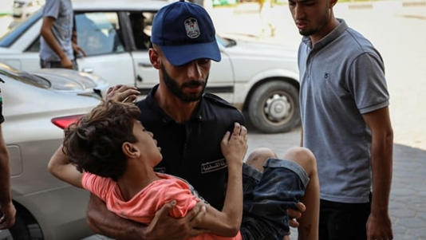](https://www.msn.com/en-in/news/India/aid-worker-reveals-horror-in-gaza-hospital-no-food-injured-kids-sleeping-on-the-floor/ar-AA1lP3Jd?ocid=msedgntp&cvid=07db0825785d4dcda88ab7b6e289fb93&ei=18&fullscreen=true#image=2)](https://www.msn.com/en-in/news/India/aid-worker-reveals-horror-in-gaza-hospital-no-food-injured-kids-sleeping-on-the-floor/ar-AA1lP3Jd?ocid=msedgntp&cvid=07db0825785d4dcda88ab7b6e289fb93&ei=18&fullscreen=true" \l "image=2" \t "_self)

A medic carries an injured Palestinian child into the Al-Aqsa Martyrs Hospital following Israeli airstrikes in Deir Al-Balah, central Gaza, on Wednesday, Oct. 25, 2023 (Photographer: Ahmad Salem/Bloomberg)© Provided by Hindustan Times

An aid worker has claimed that he saw “injured kids sleeping on the hospital floor” at a medical facility in Deir al-Balah in central Gaza. There were “injured people everywhere” at Al-Aqsa Martyrs Hospital, Abu Fares, 53, a volunteer with the Palestinian Children’s Relief Fund, told NBC News.

“I saw injured kids sleeping on the hospital floor," he said. He also claimed there is no food in the facility. "Even if you have money, it doesn't matter," he said.

Flour that may be available in some markets could be 100 times more expensive than usual. "We are not on the verge of a humanitarian crisis. We are in a crisis," Fares said.

## ‘Toxic mix of disease, hunger and lack of hygiene and sanitation’

The World Health Organization’s head has claimed that there is a "toxic mix of disease, hunger and lack of hygiene and sanitation" faced by people in the Gaza Strip. “Hunger weakens the body’s defenses and opens the door to disease,” Tedros Adhanom Ghebreyesus wrote on X.

He added, “Gaza is already experiencing soaring rates of infectious disease outbreaks. Diarrhoea cases among children aged under 5 are 25 times what they were before the conflict. Such illnesses can be lethal for malnourished children, more so in the absence of functioning health services. We need a ceasefire now.”

## 66% of employment lost in Gaza and the West Bank

At least 66% of employment has been lost in Gaza and the West Bank following the October 7 Hamas attack on Israel, the U.N. agency the International Labour Organization has said. “The repercussions on the lives and livelihoods of affected communities are beyond anything seen in the Occupied Palestinian Territory before," ILO regional director for Arab states Ruba Jaradat said in a statement, as per NBC News. Jaradat added that the impact has “grave cascading implications” on the West Bank too.

Meanwhile, it has been reported by Hamas' government media office that an estimated 20,000 people have been killed in Gaza since the Hamas-Israel conflict began after the October 7 attack. Among them are 8,000 children and more than 6,000 women. About 6,700 people reportedly remain missing.

Read more news like this on [HindustanTimes.com](https://www.hindustantimes.com/?utm_source=microsoft_homepagelink)

**JSCIAR, India,**

**26th December 2023.**

**Fr Pope Francis on what should be our response to violent and terror and massacre:**

[[India Today](https://www.indiatoday.in/)](https://www.indiatoday.in/" \o "India Today" \t "_blank)

**[India Today](https://www.indiatoday.in/" \o "India Today" \t "_blank)**

Follow

# 'Children dying in wars are little Jesuses of today': Pope Francis in Christmas message

Story by Reuters  • 1h

[[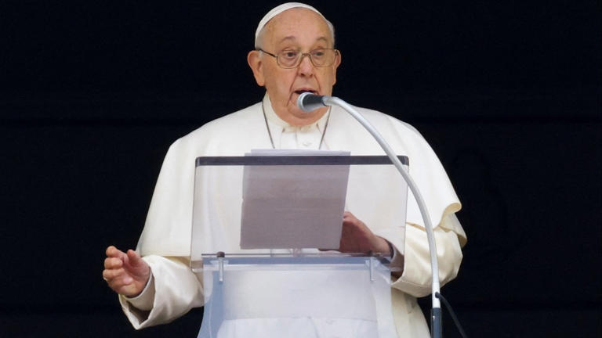](https://www.msn.com/en-in/news/world/children-dying-in-wars-are-little-jesuses-of-today-pope-francis-in-christmas-message/ar-AA1m1TSd?fullscreen=true#image=2)](https://www.msn.com/en-in/news/world/children-dying-in-wars-are-little-jesuses-of-today-pope-francis-in-christmas-message/ar-AA1m1TSd?fullscreen=true" \l "image=2" \t "_self)

'Children dying in wars are little Jesuses of today': Pope Francis in Christmas message© Provided by India Today

Pope Francis said in his Christmas message on Monday that children dying in wars, including in Gaza, are the "little Jesuses of today" and that Israeli strikes there were reaping an "appalling harvest" of innocent civilians.

In his Christmas Day "Urbi et Orbi" (to the city and world) address, Francis also called the October 7 attack on Israel by Hamas militants "abominable" and again appealed for the release of around 100 hostages still being held in Gaza.

Speaking from the central balcony of St Peter's Basilica to thousands of people in the square below, he took another swipe at the armaments industry, saying it ultimately controlled the "puppet-strings of war".

The 87-year-old Pope, celebrating the 11th Christmas of his pontificate, called for an end to conflicts, political, social or military, in places including Ukraine, Syria, Yemen, Lebanon, Armenia and Azerbaijan, and he defended the rights of migrants around the world.

"How many innocents are being slaughtered in our world! In their mothers' wombs, in odysseys undertaken in desperation and in search of hope, in the lives of all those little ones whose childhood has been devastated by war. They are the little Jesuses of today," he said.

He gave particular attention to the Holy Land, including Gaza, where, according to Palestinian health officials, [Israeli air strikes killed at least 78 people](https://www.indiatoday.in/world/story/israeli-air-strike-on-al-maghazi-refugee-camp-in-central-gaza-death-toll-injured-2480052-2023-12-25) in one of the besieged enclave's deadliest nights of Israel's 11-week-old battle with Hamas.

  ALSO READ | [Pope Francis allows priests to bless same-sex couples in landmark ruling](https://www.indiatoday.in/world/story/pope-francis-vatican-approves-blessings-same-sex-couples-landmark-ruling-2477567-2023-12-18)

[[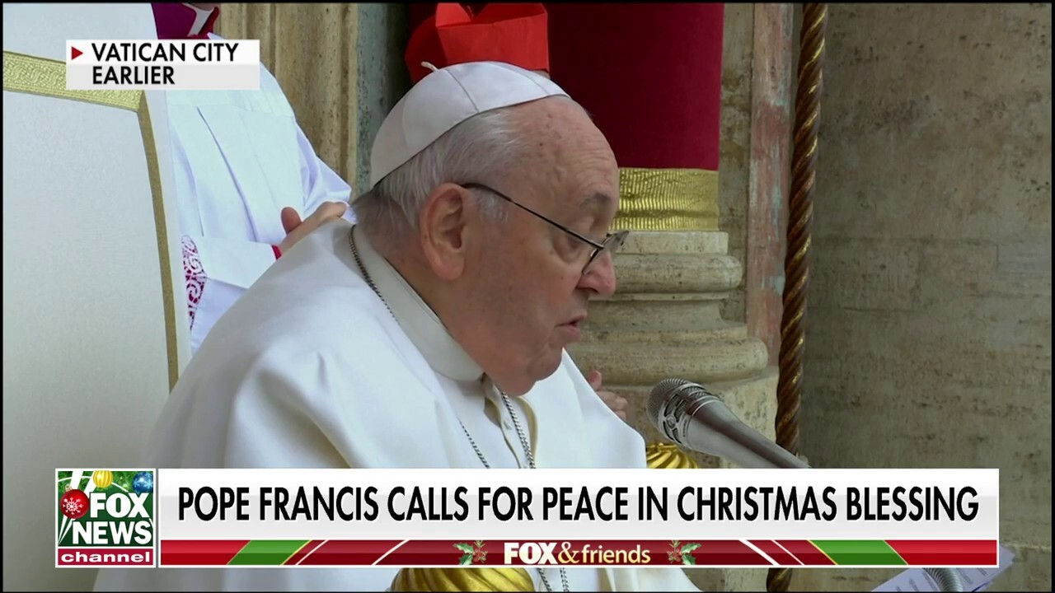](https://www.msn.com/en-in/video/news/pope-francis-says-children-suffering-from-war-are-the-%E2%80%98jesuses-of-today%E2%80%99-in-christmas-blessing/vi-AA1m1agp)](https://www.msn.com/en-in/video/news/pope-francis-says-children-suffering-from-war-are-the-%E2%80%98jesuses-of-today%E2%80%99-in-christmas-blessing/vi-AA1m1agp" \t "_blank)

[FOX News/FOX News](https://www.msn.com/en-in/video/news/pope-francis-says-children-suffering-from-war-are-the-%E2%80%98jesuses-of-today%E2%80%99-in-christmas-blessing/vi-AA1m1agp" \t "_blank)**[Pope Francis says children suffering from war are the ‘Jesuses of today’ in Christmas blessing](https://www.msn.com/en-in/video/news/pope-francis-says-children-suffering-from-war-are-the-%E2%80%98jesuses-of-today%E2%80%99-in-christmas-blessing/vi-AA1m1agp" \t "_blank)**

**[4:33](https://www.msn.com/en-in/video/news/pope-francis-says-children-suffering-from-war-are-the-%E2%80%98jesuses-of-today%E2%80%99-in-christmas-blessing/vi-AA1m1agp" \t "_blank)**

[[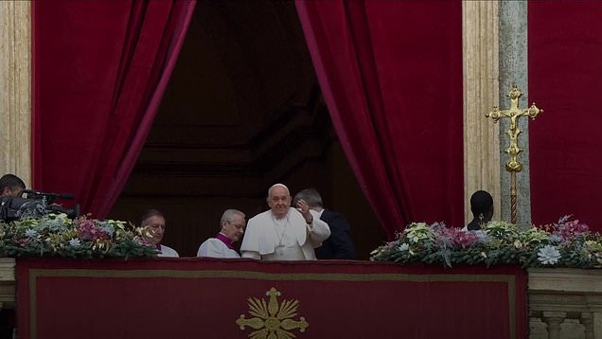](https://www.msn.com/en-in/video/news/pope-blasts-weapons-industry-as-he-makes-christmas-appeal-for-world-peace/vi-AA1m1ivk)](https://www.msn.com/en-in/video/news/pope-blasts-weapons-industry-as-he-makes-christmas-appeal-for-world-peace/vi-AA1m1ivk" \t "_blank)

[Daily Mail](https://www.msn.com/en-in/video/news/pope-blasts-weapons-industry-as-he-makes-christmas-appeal-for-world-peace/vi-AA1m1ivk" \t "_blank)**[Pope blasts weapons industry as he makes Christmas appeal for world peace](https://www.msn.com/en-in/video/news/pope-blasts-weapons-industry-as-he-makes-christmas-appeal-for-world-peace/vi-AA1m1ivk" \t "_blank)**

**[1:33](https://www.msn.com/en-in/video/news/pope-blasts-weapons-industry-as-he-makes-christmas-appeal-for-world-peace/vi-AA1m1ivk" \t "_blank)**

JSCIAR,

18th January, 2024.

Fr Pope Fracis – Wise counselling on private issues like sex

[Ad](https://go.microsoft.com/fwlink/?LinkID=286759)

[[Hindustan Times](https://www.hindustantimes.com/)](https://www.hindustantimes.com/" \o "Hindustan Times" \t "_blank)

**[Hindustan Times](https://www.hindustantimes.com/" \o "Hindustan Times" \t "_blank)**

Follow

# Pope Francis condemns porn, advises to embrace physical intimacy: ‘Sexual pleasure is a gift from God’

Story by Tuhin Das Mahapatra  • 1h

[[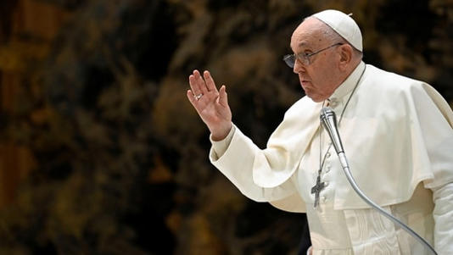](https://www.msn.com/en-in/news/world/pope-francis-condemns-porn-advises-to-embrace-physical-intimacy-sexual-pleasure-is-a-gift-from-god/ar-AA1n9y49?ocid=msedgntp&pc=U531&cvid=d5a0d00b0d974873ba725684510ebe7f&ei=15&fullscreen=true#image=2)](https://www.msn.com/en-in/news/world/pope-francis-condemns-porn-advises-to-embrace-physical-intimacy-sexual-pleasure-is-a-gift-from-god/ar-AA1n9y49?ocid=msedgntp&pc=U531&cvid=d5a0d00b0d974873ba725684510ebe7f&ei=15&fullscreen=true" \l "image=2" \t "_self)

Pope Francis holds a weekly general audience at the Vatican, January 17, 2024. Vatican Media/­Handout via REUTERS© Provided by Hindustan Times

The pope has spoken out about the importance of sexual pleasure and the dangers of pornography in a recent address to the faithful.

[Pope Francis](https://www.hindustantimes.com/topic/pope-francis), 87, said that “sexual pleasure is a gift from God” and should be valued, but it is being corrupted by the influence of porn.

“We must defend love,” he said, according to *The Guardian*. “Winning against the battle of lust can be a lifelong undertaking.”

The pope, who was born in Argentina, said that porn can create addictive behaviours and lead to a “dangerous vice.”

He continued, “Lust plunders, it robs, it consumes in haste, it does not want to listen to the other but only to its own need and pleasure; lust judges every courtship a bore, it does not seek that synthesis between reason, drive and feeling that would help us to conduct existence wisely,” according to the *Telegraph*.

He also warned that lust can cause one to treat the other as an object and try to “possess” them.

## Not the first time the pope has addressed the issue of porn

In Oct. 2022, he confessed that he was aware of priests and nuns who watched porn and cautioned them and the laity that the “devil enters from there.”

He advised them, “If you can cancel it from your phone, then cancel it, then you won’t have temptation in your hand.”

The pope’s latest comments came after the revelation that Cardinal Victor Manuel Fernandez, the head of the Dicastery for the Doctrine of Faith, had authored a book in 1998 that detailed male and female orgasm.

The book, which is no longer in print, was criticized as “scandalous” by some conservative Catholics who called for his removal, the Telegraph reported.

The pope also defended the church’s recent decision to allow blessings for same-sex couples on Sunday.

He responded to the criticism and resistance from some priests who refused to follow the new rules, saying, “Sometimes decisions are not accepted, but in most cases when decisions are not accepted, it is because they are not understood.”