JSCIAR,

9th January, 2024.

**Righteousness exalts a nation. Proverbs 14:34**

**Begam Sheikh Hasina – People’s leader with the imitation of Christ**

**https://www.msn.com/en-in/news/world/why-sheikh-hasina-s-record-win-in-bangladesh-matters-to-india/ar-AA1mC6Js?ocid=msedgntp&cvid=7bce8be7afd1430c98ec27045b400cd2&ei=1834**

**Why Sheikh Hasina’s record win in Bangladesh matters to India**

Story by Roshneesh Kmaneck  • 1d

The results were more or less known even before the first ballot was cast, but now it’s official. Bangladesh’s prime minister Sheikh Hasina has won the re-election for a fifth term, after the Opposition boycotted the polls.

Television journalists on Sunday announced that the Hasina-led Awami League won 224 seats of the 299, while Independent candidates won 62. The Jatiya Party, the third largest in the country, took 11 seats and Kallyan Party got one.

This election – the 12th general poll – in the country was closely watched by neighbours India and China, with both of them having stakes in the results.

But why does Sheikh Hasina’s win matter for India? We get you the answers.

**Hasina retains power… again**

An Election Commission spokesman told *AFP* on Monday morning (8 January) that Hasina’s ruling Awami League “has [won the election](https://www.firstpost.com/world/bangladesh-sheikh-hasina-has-been-re-elected-for-fifth-time-after-polls-without-opposition-13587262.html)”, after a vote that initial reports suggested had a [meagre turnout](https://www.firstpost.com/explainers/sham-no-fair-elections-why-bangladeshs-opposition-is-boycotting-polls-13583362.html) of some 40 per cent.

With this win, Hasina will serve as Bangladesh prime minister for another five years, who first became prime minister in 1996 and was re-elected in 2009, remaining in power since.

[[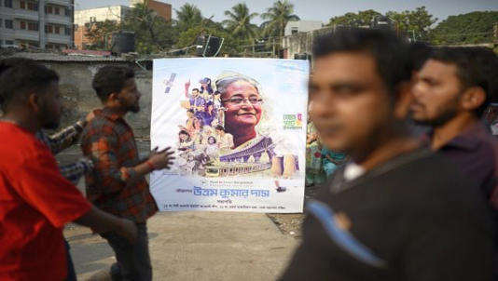](https://www.msn.com/en-in/news/world/why-sheikh-hasina-s-record-win-in-bangladesh-matters-to-india/ar-AA1mC6Js?ocid=msedgntp&cvid=7bce8be7afd1430c98ec27045b400cd2&ei=1834&fullscreen=true#image=2)](https://www.msn.com/en-in/news/world/why-sheikh-hasina-s-record-win-in-bangladesh-matters-to-india/ar-AA1mC6Js?ocid=msedgntp&cvid=7bce8be7afd1430c98ec27045b400cd2&ei=1834&fullscreen=true" \l "image=2" \t "_self)

People stand next to a campaign poster of the ruling party during parliamentary election in Dhaka, Bangladesh. AP© Provided by Firstpost

While her critics and the Opposition have slammed Hasina for cracking down on dissent, her supporters insist she has provided much-needed political stability for Bangladesh. “We have continued the democratic process which has given this political stability. I think the world should credit Sheikh Hasina for that,” Law Minister Anisul Huq told the *BBC*.

Hasina’s single biggest achievement in the past 15 years “is the confidence that she has ushered in in the minds of the people of Bangladesh. They have come to believe in themselves,” he added.

**Sheikh Hasina’s win significant for India**

For India, the polls in Bangladesh held significance as the two countries share a 4,100-km border and deep historical, cultural, and economic ties. Moreover, Hasina’s win is particularly beneficial to India in almost all aspects – national security, economically as well as culturally.

Let’s examine each aspect separately. When it comes to India’s national security, Sheikh Hasina has been extremely cooperative. Earlier, Bangladesh was known to house several anti-India elements, and Islamist jihadist groups. However, Hasina’s administration has come down heavily on such terrorist and militant groups.

New Delhi’s security agencies have received a lot of help and cooperation from its Bangladeshi counterparts to curb anti-India activity in the neighbouring country. Moreover, it was under Hasina’s tenure that Dhaka signed the historical 1974 Land Boundary Agreement (LBA), which settled the 4,096-kilometre-long border dispute between the two countries.

For India, a return of the Bangladesh Nationalist Party (BNP), led by Khaleda Zia, who is under house arrest as a convict of graft charges, would spell trouble. This is because Zia, the former prime minister of Bangladesh, is seen as hostile to New Delhi, with some even going as far as calling her a proxy of Pakistan.

And in light of the deteriorating situation in Myanmar, Bangladesh plays an even more important role in maintaining peace in the region.

Former Indian Ambassador Ashok Kantha was quoted as telling the *Hindustan Times*, “Dhaka is sensitive to India’s security concerns. It realises that as long as New Delhi’s security is not compromised, they can go ahead and do business with China. It is important to keep this in mind.”

[[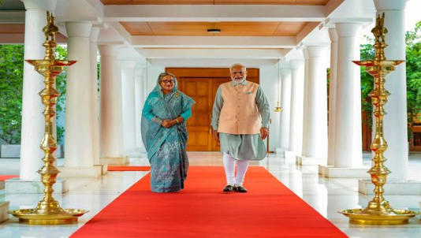](https://www.msn.com/en-in/news/world/why-sheikh-hasina-s-record-win-in-bangladesh-matters-to-india/ar-AA1mC6Js?ocid=msedgntp&cvid=7bce8be7afd1430c98ec27045b400cd2&ei=1834&fullscreen=true#image=2)](https://www.msn.com/en-in/news/world/why-sheikh-hasina-s-record-win-in-bangladesh-matters-to-india/ar-AA1mC6Js?ocid=msedgntp&cvid=7bce8be7afd1430c98ec27045b400cd2&ei=1834&fullscreen=true" \l "image=2" \t "_self)

Prime Minister Narendra Modi with Prime Minister of Bangladesh Sheikh Hasina, in New Delhi. The two world leaders share a good relationship, which has translated to better ties between the two nations. File image/PTI© Provided by Firstpost

From an economic standpoint too, Hasina’s win is important. Importantly, Bangladesh has risen to be the second-largest economy in the region – the GDP of Bangladesh was $460 billion in 2022, more than Pakistan’s $375 billion.

India and Bangladesh share close economic ties, which have been fostered in recent times. The two countries’ bilateral trade has been $14.2 billion in 2022-23 and $8.13 billion in 2021-22. In fact, Bangladesh has been the fifth largest market for Indian goods, as per the Indian Express, only behind the United States, the UAE, the Netherlands, and China.

Additionally, under Hasina, connectivity is being improved between India’s northeast and Dhaka. India has also offered more than $7 billion in Line of Credit to Bangladesh since 2010 for infrastructure and development projects.

Bangladesh also allows India to use four of its ports to transport goods from one Indian state to another.

Hasina also maintains a supportive stance towards the Narendra Modi administration.

[[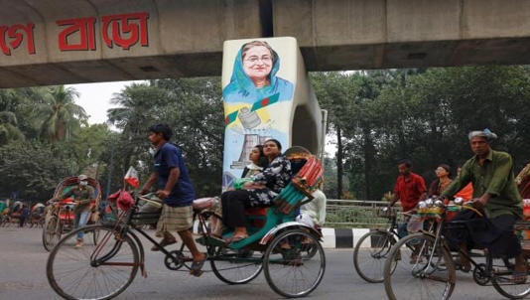](https://www.msn.com/en-in/news/world/why-sheikh-hasina-s-record-win-in-bangladesh-matters-to-india/ar-AA1mC6Js?ocid=msedgntp&cvid=7bce8be7afd1430c98ec27045b400cd2&ei=1834&fullscreen=true#image=2)](https://www.msn.com/en-in/news/world/why-sheikh-hasina-s-record-win-in-bangladesh-matters-to-india/ar-AA1mC6Js?ocid=msedgntp&cvid=7bce8be7afd1430c98ec27045b400cd2&ei=1834&fullscreen=true" \l "image=2" \t "_self)

Rickshaws drive past a graffiti of Sheikh Hasina, prime minister of Bangladesh, on the pillar of metro rail, at TSC of the University of Dhaka, ahead of the general election, in Dhaka, Bangladesh. File image/Reuters© Provided by Firstpost

**Hasina’s old ties with India**

Hasina’s ties to India run long and deep, as *Times of India* said, ‘deeper than the usual neighbourly ones who share a common history’.

For Hasina, Delhi is more than just the capital of India. It is the land, which gave her refuge for six years following the 1975 massacre of her family, in which her father was assassinated. For those who don’t remember, on 15 August 1975, as many as 18 members of her family, were assassinated. She escaped the assassination as she was in West Germany at the time.

Following the killings, she realised that there was no question of her returning home and that was how she came to Delhi in late-1975 with her husband and two children. She briefly stayed at 56 Ring Road, Lajpat Nagar-3, and later at Pandara Road near Pandara Market.

It was only in May 1981 that Hasina ended her exile in Delhi and returned to Bangladesh.