JSCIAR, India,

19th November 2023.

**https://www.msn.com/en-in/news/India/remembering-indira-gandhi-a-formidable-political-force/ar-AA1k8AaH?ocid=msedgntp&cvid=4902db900abe411db3f71afbe2c456fd&ei=32**

**Mrs Indira Priyadarshini – 19th November 1917 – 31st October 1984**

**Remembering Indira Gandhi: A formidable political force**

[[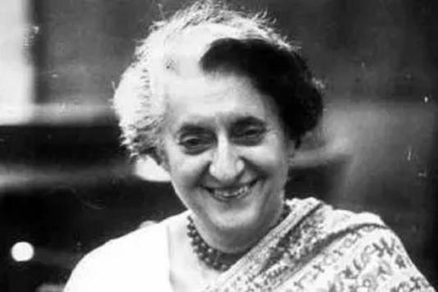](https://www.msn.com/en-in/news/India/remembering-indira-gandhi-a-formidable-political-force/ar-AA1k8AaH?ocid=msedgntp&cvid=4902db900abe411db3f71afbe2c456fd&ei=32&fullscreen=true#image=2)](https://www.msn.com/en-in/news/India/remembering-indira-gandhi-a-formidable-political-force/ar-AA1k8AaH?ocid=msedgntp&cvid=4902db900abe411db3f71afbe2c456fd&ei=32&fullscreen=true" \l "image=2" \t "_self)

Remembering Indira Gandhi: A formidable political force© Provided by Mid-Day

In the history of Indian politics, Indira Gandhi is still regarded as a key figure because of her strong leadership and the revolutionary path she set for the country. The socio-political landscape of India was profoundly impacted by her stint as Prime Minister from 1966 to 1977 and then again from 1980 until her untimely death in 1984.

Ahead of her death anniversary, November 19, commemorating the formidable force that Gandhi was, people around the world reflect on her enduring legacy and the indelible mark she left on the realms of politics, leadership, and social change.

Indira Gandhi`s entry into politics seemed inevitable, given her birth into the distinguished Nehru-Gandhi family. Her politics were defined by her leadership style, which was a combination of boldness and pragmatism. Gandhi played a leading role in defining India`s international character during his term and was ardently committed to socioeconomic changes.

The 1975 declaration of a state of emergency, which many saw as an authoritarian ploy to consolidate control, was one of the most contentious periods of her presidency. During this time, media censorship was implemented, political opponents were imprisoned, and civil freedoms were restricted. It is crucial to remember that throughout this time, policy changes and infrastructure advancements were also implemented, which had a substantial impact on India`s development, in spite of the criticisms.

**More videos**

The care of the marginalised and the uplift of the oppressed were central to Gandhi`s political thought. She promoted rural people`s rights and started a number of programmes to reduce poverty and land change that would strengthen the agricultural industry.

To lessen economic inequality and encourage equitable growth, she placed a strong focus on nationalisation, especially in the banking industry and other important industries.

During the Cold War, Indira Gandhi also promoted India as a leader in non-alignment on the international front by supporting its independence and sovereignty over major powers. India gained more credibility in international affairs and a stronger voice on international forums because of her adept diplomacy and statesmanship.

Beyond her political astuteness, Indira Gandhi left a lasting impact. Her ability to withstand hardships and political upheavals with steadfast strength made her a symbol of resilience. Tensions resulting from Sikh separatists led to her tragic killing in 1984, which rocked the country and irrevocably altered Indian politics.

Her legacy and principles are still felt in the Indian National Congress, the party she led for a considerable amount of time. Leaders negotiating the complex world of Indian politics can allude to her persona and political skills.

Indira Gandhi is remembered in Indian history as a key figure in shaping the country`s future due to her unwavering spirit, forward-thinking policies, and forceful leadership. Though perspectives on her reign may differ, her influence on the political landscape of India continues to be an indisputable aspect of the nation`s history.

[‘A people’s leader’: Congress leaders, PM Modi pay tribute on Indira Gandhi’s 106th birth anniversary (msn.com)](https://www.msn.com/en-in/news/India/a-people-s-leader-congress-leaders-pm-modi-pay-tribute-on-indira-gandhi-s-106th-birth-anniversary/ar-AA1karhJ?ocid=msedgntp&cvid=3845d89993564575a2c9f262039a7409&ei=114)

https://www.msn.com/en-in/news/India/a-people-s-leader-congress-leaders-pm-modi-pay-tribute-on-indira-gandhi-s-106th-birth-anniversary/ar-AA1karhJ?ocid=msedgntp&cvid=3845d89993564575a2c9f262039a7409&ei=114

**[The Indian Express](http://indianexpress.com/" \o "The Indian Express" \t "_blank)**

‘A people’s leader’: Congress leaders, PM Modi pay tribute on Indira Gandhi’s 106th birth anniversary

[[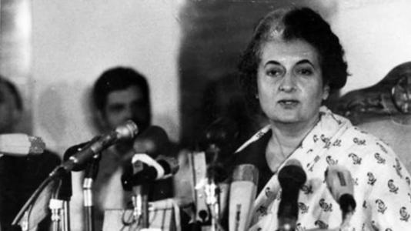](https://www.msn.com/en-in/news/India/a-people-s-leader-congress-leaders-pm-modi-pay-tribute-on-indira-gandhi-s-106th-birth-anniversary/ar-AA1karhJ?ocid=msedgntp&cvid=3845d89993564575a2c9f262039a7409&ei=114&fullscreen=true#image=2)](https://www.msn.com/en-in/news/India/a-people-s-leader-congress-leaders-pm-modi-pay-tribute-on-indira-gandhi-s-106th-birth-anniversary/ar-AA1karhJ?ocid=msedgntp&cvid=3845d89993564575a2c9f262039a7409&ei=114&fullscreen=true" \l "image=2" \t "_self)

‘A people’s leader’: Congress leaders, PM Modi pay tribute on Indira Gandhi’s 106th birth anniversary© Provided by The Indian Express

On the 106th birth anniversary of former prime minister Indira Gandhi, Congress leader Rahul Gandhi remembered his grandmother calling her a "people's leader" for India and a teacher for him. Tributes for the 'Iron Lady of India' also poured in from Prime Minister Narendra Modi and several other Congress leaders.

In a post on X in Hindi, Rahul Gandhi said, "The values of dedication taught by her to the country and the people are the strength behind every step and the strength of my thinking." He also shared a black-and-white picture from his childhood with Indira Gandhi.

Further, Rahul Gandhi, along with Congress national president Mallikarjun Kharge, Congress Parliamentary Party chairperson Sonia Gandhi and Congress general secretary KC Venugopal visited Shakti Sthal in New Delhi to pay their respects.

Born on 19 November, 1917, Indira Gandhi served as Prime Minister from 1966 to 1977 and then again from 1980 until her assassination in 1984.

"On her birth anniversary, tributes to Smt. Indira Gandhi, India’s former Prime Minister," said PM Modi paying tribute to his predecessor.

Calling her the "most courageous, compelling and consequential leader", senior Congress leader Jairam Ramesh in his tribute detailed her work as the prime minister. He mentioned the Green Revolution, "geography of South Asia" ,and space, nuclear and missile programmes among others.

"She was a most courageous, compelling and consequential leader who provided the political direction to the Green Revolution, decisively shaped our space, nuclear and missile programmes, profoundly reshaped the geography of South Asia, showed great resilience in the face of electoral adversity and returned to impart a new direction to our economy and always placed environmental and social concerns at the core of her governance," he said on X.

Referring to her "remarkable personality," he said: "I have made an effort to bring out the different dimensions of this remarkable personality in two books that were published in 2017 and 2018. So much more needs to be written about her. She is indeed for the ages."

Odisha Congress president Sarat Patnaik paid tribute to former PM Indira Gandhi in Bhubaneswar on Sunday morning.

The All India Mahil Congress also paid their homage to to Indira Gandhi calling her courage and determination "ever inspiring."

[‘A people’s leader’: Congress leaders, PM Modi pay tribute on Indira Gandhi’s 106th birth anniversary (msn.com)](https://www.msn.com/en-in/news/India/a-people-s-leader-congress-leaders-pm-modi-pay-tribute-on-indira-gandhi-s-106th-birth-anniversary/ar-AA1karhJ?ocid=msedgntp&cvid=3845d89993564575a2c9f262039a7409&ei=114)

https://www.msn.com/en-in/news/India/a-people-s-leader-congress-leaders-pm-modi-pay-tribute-on-indira-gandhi-s-106th-birth-anniversary/ar-AA1karhJ?ocid=msedgntp&cvid=3845d89993564575a2c9f262039a7409&ei=114

# Elusive character of Indira Gandhi

***Opinion by Karan Thapar***

[[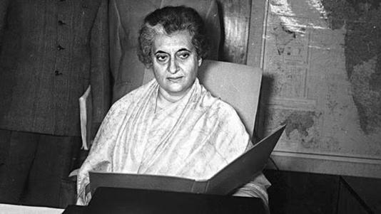](https://www.msn.com/en-in/news/opinion/elusive-character-of-indira-gandhi/ar-AA1k9dVl?ocid=msedgntp&cvid=822a721334254bc6b756dda0a719509a&ei=78&fullscreen=true#image=2)](https://www.msn.com/en-in/news/opinion/elusive-character-of-indira-gandhi/ar-AA1k9dVl?ocid=msedgntp&cvid=822a721334254bc6b756dda0a719509a&ei=78&fullscreen=true#image=2)

Like Caesar, it’s true of Indira Gandhi as well, the good has been interred with her bones and we only remember the worst.© Provided by Hindustan Times

If she were alive today she would be 106 years old. It’s odd I should recall Indira Gandhi because the truth is over the four decades since her assassination, she’s faded from memory. Of course, that’s not true of the enormous crowds that visit her memorial in Safdarjung Road. For them, it’s become a tourist attraction. For the rest of us, however, she’s part of a past that’s receded and, except for the Emergency, is hardly remembered.

I was in awe of her when I first met her. It was 1975 and the height of the Emergency. I expected to see a domineering virago of a woman. Instead, she was petite, even fragile. What I remember most clearly are her hands. They were slender and delicately shaped. They were not what I expected in a dictator. But four years earlier The Economist had dubbed her the Empress of India. Despite the manly watch on her wrist, she had a regal quality.

Yet she was a very down-to-earth person. On a Sunday during the Emergency, my sisters and I were breakfasting with the Gandhis before accompanying them to see The Pink Panther at Rashtrapati Bhavan. Lost in conversation, all of us lost track of time till Mrs Gandhi gasped. “Hurry, hurry”, she said. “We’re late. If anyone wants to spend a penny, do it now.”

Premila, my eldest sister, asked her what she did when she was campaigning. “I have all the water I want last thing at night,” Mrs Gandhi replied, “and hope it’s out of my system by the morning. After all, unlike boys, I can’t go behind a tree!”

Like Caesar, it’s true of Indira Gandhi as well, the good has been interred with her bones and we only remember the worst. Yet I vividly recall the exultation on December 16, 1971, when she announced the defeat of Pakistan and the birth of Bangladesh. A day or two later, when she wrote to President Nixon rebuffing PL 480 aid, my 16-year old mind considered this a fitting response to America’s prejudiced behaviour. Today, we correctly give credit to Sam Manekshaw for that victory but unjustly deny it to her.

Mine was a generation that took pride in the image Indira Gandhi presented abroad. In the mid-60s, standing beside Lyndon Johnson, her immaculately coiffed presence was a photographer’s dream. Those pictures from the lawns of the White House are impossible to surpass.

That is until I saw her in London in 1982 at the inaugural concert of the Festival of India. She walked in with Margaret Thatcher but it was what Indira Gandhi wore that made the audience applaud with delight. It was a stunning coat made out of a *jamawar* shawl. My mind flashed back to school and Enobarbus’s praise of Cleopatra: “Age cannot wither her, nor custom stale her infinite variety.”

Perhaps it’s fitting there’s a mystery about Indira Gandhi that may never be resolved. What made her call the elections of 1977? They weren’t due for another year and she was powerful enough to postpone them. There were no external factors that coerced her. So was it her own conscience?

Had she come to regret the Emergency? Or, at least, accept it had gone on for too long? Different people have answered these questions differently. But none convincingly.

There is, actually, an even deeper question. Did she think she could win or was she aware she was heading towards a terrible defeat? And if she knew her fate, did she welcome it? Was this penance? Her way of atoning for the Emergency?

After Indira Gandhi, we’ve had other strong rulers. We’ve had many impressively attired prime ministers. So why does Indira Gandhi remain special? Could it be because memories from adolescence acquire an inexplicable nostalgic resonance? Psychologists or philosophers would be better placed to explain. All I can say — and I don’t mean it facetiously — for me she’s become the*sine qua non* of the *je nais se quois*!

*Karan Thapar is the author of Devil’s Advocate: The Untold Story. The views expressed are personal*

Read more news like this on [HindustanTimes.com](https://www.hindustantimes.com/?utm_source=microsoft_homepagelink)

JSCIAR, India,

22nd December 2023.

[[Times Now](https://www.timesnownews.com/)](https://www.timesnownews.com/" \o "Times Now" \t "_blank)

**[Times Now](https://www.timesnownews.com/" \o "Times Now" \t "_blank)**

https://www.msn.com/en-in/news/India/indira-gandhi-s-1971-letter-to-sam-manekshaw-goes-viral-your-brilliant-leadership/ar-AA1lU53V?ocid=msedgntp&cvid=d83ddf4029144aa893a3267b9637c76a&ei=55

Follow

# Indira Gandhi’s 1971 Letter To Sam Manekshaw Goes Viral: ‘Your Brilliant Leadership…’

Story by Times Now Digital  • 4h

[[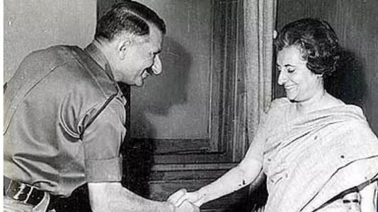](https://www.msn.com/en-in/news/India/indira-gandhi-s-1971-letter-to-sam-manekshaw-goes-viral-your-brilliant-leadership/ar-AA1lU53V?ocid=msedgntp&cvid=d83ddf4029144aa893a3267b9637c76a&ei=55&fullscreen=true#image=2)](https://www.msn.com/en-in/news/India/indira-gandhi-s-1971-letter-to-sam-manekshaw-goes-viral-your-brilliant-leadership/ar-AA1lU53V?ocid=msedgntp&cvid=d83ddf4029144aa893a3267b9637c76a&ei=55&fullscreen=true" \l "image=2" \t "_self)

indira gandhi 1971 letter to sam manekshaw goes viral: ‘your brilliant leadership…’© Provided by Times Now

Aletter written by Indira Gandhi to Sam Manekshaw is going viral on social media after it was shared on X by Bharatiya Janata Party (BJP) MP Varun Gandhi. The letter, dated December 22, 1971, has the then-Indian Prime Minister congratulate the erstwhile Chief Of Army Staff in safeguarding India’s territorial integrity and upholding national values.

“I know how heavy has been your burden and how constant have been the pressures upon you, as Chief of Army Staff and also as Chairman of the Chiefs of Staff Committee. The coordination between the three Services, so impressively demonstrated during the campaign, owes much to your brilliant leadership,” Gandhi wrote in her letter to Manekshaw.

“I particularly valued your cooperation, your clear-headed counsel, and unfailing good cheer throughout the crisis. I should like to express the gratitude of the government and the people of India to you and to your officers as men,” she wrote in the letter.

Sharing the letter, BJP MP and Indira Gandhi’s grandson Varun Gandhi wrote: “PM Smt Indira Gandhi’s letter to the then Army Chief General Sam Manekshaw, after the historic victory in the 1971 War.”

“A true leader knows that it is the entire team that wins, and knows when to be large hearted and not take sole credit. On this day all of India salutes both these great Indian treasures,” he wrote.

0

At the time of writing, the X post had been viewed more than 800,000 times.

Sam Manekshaw, India's first Field Marshal, had a storied career in the Armed Forces. It was he who led India in the India-Pakistan war of 1971 that would eventually lead to the creation of Bangladesh.