JSCIAR, India,

28th December, 2023.

**Indian Union - Centre state relationship**

https://www.msn.com/en-in/news/world/israel-reports-three-more-soldiers-killed-in-northern-gaza/vi-AA1m5Ma9?ocid=msedgntp&cvid=1f640c99339f4ec3baf6e031cbeb74fa&ei=34

Help if you can? Do not accuse.

* 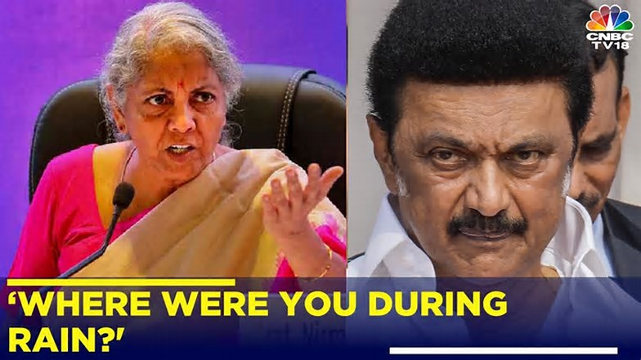

placeholderCNBCTV18

5d

Tamil Nadu Floods: Nirmala Sitharaman Hits Out At CM MK Stalin, Asks 'Where Were You During Rain?'

Union minister Nirmala Sitharaman hits out at MK Stalin after Tamil Nadu government sought to blame IMD for Heavy Rains, calls out 'excuses'Union Minister Nirmala Sitharaman on Friday said the Centre has released Rs 900 crore in two instalments to Tamil Nadu in the current financial year, to deal with the havoc caused by the unprecedented rainfall and flooding.A total of 31 people died in four southern districts owing to the heavy rainfall that occurred early this week, the Finance and Corporate Affairs Minister said.Briefing reporters here, the natural calamity has claimed human lives and caused damage to infrastructure and communication systems. Extending her condolences to the bereaved family members, Sitharaman, who spoke in Tamil, said, “The amount of rainfall that should have occurred for the whole year has been received in a single day. For example, if the total amount of rainfall is 50 cm in a place like Tuticorin, it has received the entire amount of rainfall in one single day.”#nirmalasitharaman #mkstalin #tamilnadu #cyclonemichaung #rain #cyclone #flood

Shri Udayanidhi – with the people affected with floods?

Madam, all sailing in the same boat. Help if you can. Do not accuse.

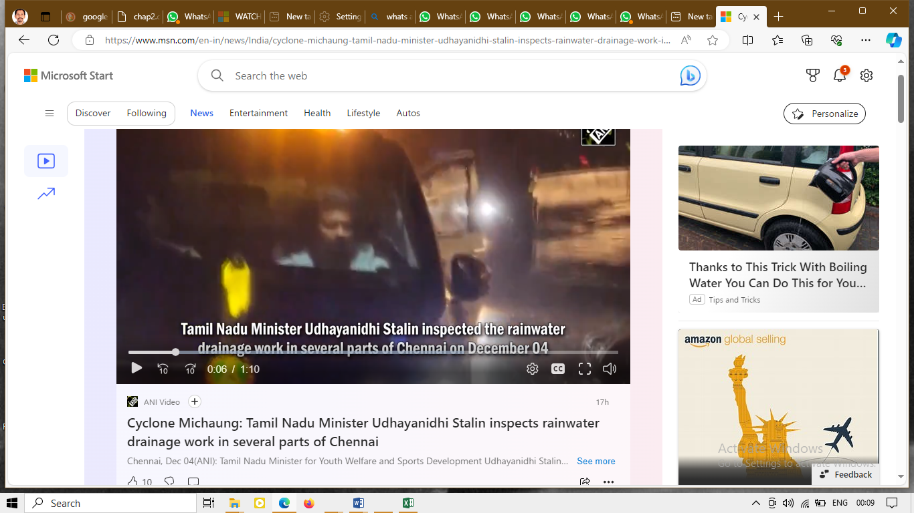

Shri Udhayanidh Stalin \_ Persistent leader in seeking good for the victims

https://www.msn.com/en-in/news/India/udhayanidhi-stalin-urges-centre-to-release-necessary-funds-for-flood-relief-in-tamil-nadu/ar-AA1m0Zwn

[[The Times of India](https://timesofindia.indiatimes.com/)](https://timesofindia.indiatimes.com/" \o "The Times of India" \t "_blank)

**[The Times of India](https://timesofindia.indiatimes.com/" \o "The Times of India" \t "_blank)**

https://www.msn.com/en-in/news/India/udhayanidhi-stalin-urges-centre-to-release-necessary-funds-for-flood-relief-in-tamil-nadu/ar-AA1m0Zwn

Follow

# Udhayanidhi Stalin urges Centre to release 'necessary' funds for flood relief in Tamil Nadu

10h

[[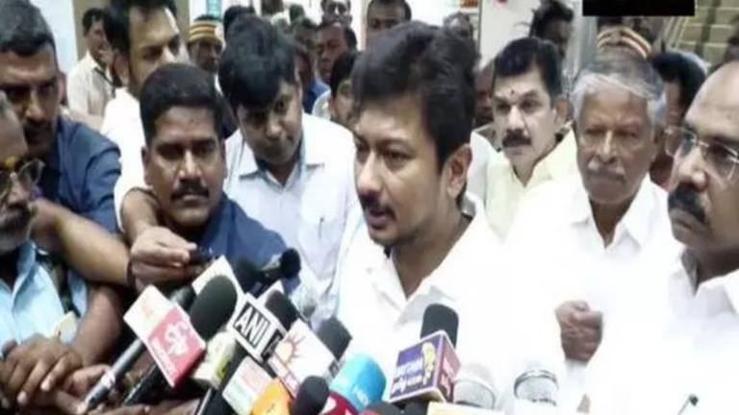](https://www.msn.com/en-in/news/India/udhayanidhi-stalin-urges-centre-to-release-necessary-funds-for-flood-relief-in-tamil-nadu/ar-AA1m0Zwn?fullscreen=true#image=2)](https://www.msn.com/en-in/news/India/udhayanidhi-stalin-urges-centre-to-release-necessary-funds-for-flood-relief-in-tamil-nadu/ar-AA1m0Zwn?fullscreen=true" \l "image=2" \t "_self)

Udhayanidhi Stalin urges Centre to release 'necessary' funds for flood relief in Tamil Nadu© Provided by The Times of India

THOOTHUKUDI: Tamil Nadu minister Udhayanidhi Stalin expressed hope on Monday that after the inspection of Union Finance Minister Nirmala Sitharaman in the flood-affected areas of the state, the Centre will allocate the required funds to the state.

"We are hopeful that after the inspection, Finance Minister Nirmala Sitharaman will allocate the required funds to the state," Udhayanidhi Stalin said here after reviewing the post-flood reconstruction and rehabilitation activities in the district.

Notably, Tamil Nadu is grappling with the aftermath of the cyclone and flooding, the state government and the Centre have jointly mobilised a massive rescue and relief operation to help the affected people.

As many as 35 deaths have been reported so far in the ongoing flooding, with Thoothukudi district accounting for 22 fatalities and Tirunelveli for 13.

"The Union Minister (Nirmala Sitharaman) said there is no big disaster. Now she is coming here tomorrow for an inspection. Prime Minister Narendra Modi has also spoken with the Tamil Nadu Chief Minister. The CM has also told the PM about the loss and has also asked for the necessary funds," he added.

Meanwhile, Tamil Nadu Bharatiya Janata Party (BJP) Chief K Annamalai on Monday hailed Prime Minister Narendra Modi for assuring support to the flood-affected state and deputing Union Finance Minister Nirmala Sitharaman to assess the flood situation, saying that the PM has always had the best interests of the people of the state in mind.

In a response to Chief Minister MK Stalin's post on X, wherein he confirmed the assistance from the union government for flood-affected regions, the BJP state chief listed earlier assistance provided to the state by the central government.

"Our Hon PM Thiru @narendramodi avl has always had the best interests of the people of TN in mind & his actions in the last 9 years exemplify that," Annamalai said.

He further said that CM Stalin should remind his party workers and his ministers, who've been "vile and exaggerative, spreading half-truths to divert people's anger for the unpreparedness of the State Government" despite receiving warnings of heavy rainfall.

Earlier on Sunday, in a post on X, Chief Minister MK Stalin expressed gratitude for the Prime Minister's prompt attention to the dire situation.

"Prime Minister @narendramodi called me to inquire about the unprecedented floods in Southern Tamil Nadu, immediately after #CycloneMichaung," CM Stalin said in the post.

The Chief Minister apprised the Prime Minister of the urgent need for financial support from the Union government to address the mounting challenges faced by the state.

"I have explained to him the massive rescue and relief efforts undertaken by the state government, despite resource constraints, and sought immediate financial support from the Union government," he added.

In response to the Chief Minister's plea, PM Modi assured full support from the Union government to help Tamil Nadu overcome these twin calamities.

Furthermore, the Prime Minister conveyed that Union Finance Minister Nirmala Sitharaman has been deputed to assess the flood situation on the ground.

"Prime Minister has assured the support of the Union government to overcome these twin calamities and conveyed that he has deputed Union Finance Minister @nsitharaman to assess the flood situation," Stalin said.

For more news like this visit [TOI](https://timesofindia.indiatimes.com/). Get all the [Latest News](https://timesofindia.indiatimes.com/), [City News](https://timesofindia.indiatimes.com/city), [India News](https://timesofindia.indiatimes.com/india), [Business News](https://timesofindia.indiatimes.com/business), and [Sports News](https://timesofindia.indiatimes.com/sports). For [Entertainment News](https://timesofindia.indiatimes.com/entertainment), [TV News](https://timesofindia.indiatimes.com/tv/hindi), and [Lifestyle Tips](https://timesofindia.indiatimes.com/life-style) visit [Etimes](https://timesofindia.indiatimes.com/etimes" \t "_blank)