JSCIAR, India,

6th December, 2023.

People with History

Dr B R Ambedkar

https://www.msn.com/en-in/news/India/pm-modi-pays-tribute-to-br-ambedkar-on-his-death-anniversary/ar-AA1l3XaM?ocid=msedgntp&cvid=96f81b3a9dd649adbac1e1cfb347c6d5&ei=52

**PM Modi pays tribute to BR Ambedkar on his death anniversary**

Story by mid-day online correspondent  • 22h

[[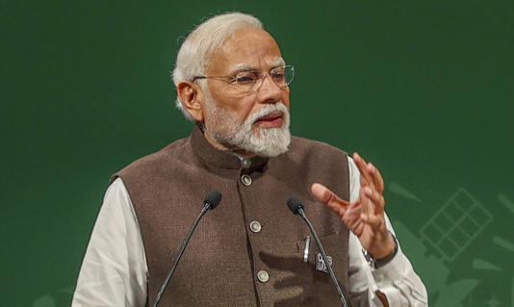](https://www.msn.com/en-in/news/India/pm-modi-pays-tribute-to-br-ambedkar-on-his-death-anniversary/ar-AA1l3XaM?ocid=msedgntp&cvid=96f81b3a9dd649adbac1e1cfb347c6d5&ei=52&fullscreen=true#image=2)](https://www.msn.com/en-in/news/India/pm-modi-pays-tribute-to-br-ambedkar-on-his-death-anniversary/ar-AA1l3XaM?ocid=msedgntp&cvid=96f81b3a9dd649adbac1e1cfb347c6d5&ei=52&fullscreen=true" \l "image=2" \t "_self)

PM Modi pays tribute to BR Ambedkar on his death anniversary© Provided by Mid-Day

As the nation observes Mahaparinirvan Divas on December 6 in memory of [Dr Bhimrao Ramji Ambedkar](https://www.mid-day.com/mumbai/mumbai-news/article/mumbai-35-per-cent-of-ambedkar-memorial-work-completed-says-mmrda-23323504), Prime Minister Narendra Modi remembered Babasaheb Ambedkar and paid his obeisance to him.

PM Modi paid tributes to [BR Ambedkar](https://www.mid-day.com/mumbai/mumbai-news/article/mahaparinirvan-diwas-public-holiday-on-dec-6-in-mumbai-maha-govt-announces-23323451) on his death anniversary, saying he dedicated his life to the welfare of the exploited and deprived.

Taking to his social media account, `X`, PM Modi wrote, "Pujya Baba Saheb, along with being the architect of the Indian Constitution, was an immortal champion of social harmony, who dedicated his life for the welfare of the exploited and the deprived. My respectful obeisance to him today on his Mahaparinirvana day."

Lok Sabha Speaker Om Birla also paid tributes to Baba Saheb Ambedkar, "Baba Saheb Dr. BR Amdebkar had dedicated his entire life to towards the establishment of an equal and just society, the progress of the nation , human rights and social justice for all. On his death anniversary I pay sincere homage to him."

Defence Minister Rajnath Singh in his message said, "On `Mahaparinirvan Diwas`, I bow to Babasaheb Ambedkar and his remarkable contributions to our nation. His thoughts inspired millions, and our coming generations will never forget his role in creating India`s Constitution."

MoS PMO Dr Jitendra Singh remembered Babasaheb saying, "Today, we remember Babasaheb Dr Bhim Rao Ambedkar on Mahaparinirvan Diwas. The chief architect of our Constitution, Babasaheb worked tirelessly throughout his life for creating an equitable and a strong India."

JSCIAR, India,

7th December, 2023.