JSCIAR, India

18th November 2023.

[Lise Meitner, the ‘Atomic Pioneer’ Who Never Won a Nobel Prize - The New York Times (nytimes.com)](https://www.nytimes.com/2023/10/02/science/lise-meitner-fission-nobel.html)

<https://www.nytimes.com/2023/10/02/science/lise-meitner-fission-nobel.html>

Lise Meitner, the Austrian-born physicist, was a longtime collaborator of Otto Hahn, who won the Nobel Prize in 1944. She did not share in the award with him.Credit...Bettmann, via Getty Images

Top of Form

Bottom of Form

[](https://www.nytimes.com/by/katrina-miller)

**By**[**Katrina Miller**](https://www.nytimes.com/by/katrina-miller)

Katrina Miller, a science reporter, recently earned a Ph.D. in particle physics from the University of Chicago. She is the third Black woman from her university to have done so.

* Published Oct. 2, 2023Updated Nov. 8, 2023

There is a memorable scene in “Oppenheimer,” the blockbuster film about the building of the atomic bomb, in which Luis Alvarez, a physicist at the University of California, Berkeley, is reading a newspaper while getting a haircut. Suddenly, Alvarez leaps from his seat and sprints down the road to find his colleague, the theoretical physicist J. Robert Oppenheimer.

“Oppie! Oppie!” he shouts. “They’ve done it. Hahn and Strassmann in Germany. They split the uranium nucleus. They split the atom.”

The reference is to two German chemists, Otto Hahn and Fritz Strassmann, who in 1939 unknowingly [reported](https://history.aip.org/exhibits/mod/fission/fission2/09a60.html) a demonstration of nuclear fission, the splintering of an atom into lighter elements. The discovery was key to the [Manhattan Project](https://www.nytimes.com/2023/07/20/science/trinity-nuclear-test-atomic-bomb-oppenheimer.html), the top-secret American effort to develop the first nuclear weapons; Oppenheimer became director of the laboratory in Los Alamos, N.M., where the atomic bomb was designed and tested.

Except the scene is not entirely accurate, [to the chagrin of some scientists](https://theconversation.com/female-physicists-arent-represented-in-the-media-and-this-lack-of-representation-hurts-the-physics-field-207697). A major player is missing from the portrayal: Lise Meitner, a physicist who worked closely with Hahn and developed the theory of nuclear fission.

Meitner was a giant in her own right, a contemporary of Nobel laureates like Albert Einstein, Niels Bohr and Max Planck. After the second atomic device was dropped on Nagasaki, the American press dubbed her the “mother of the atomic bomb,” an association she vehemently rejected.

Only Hahn [won the Nobel Prize](https://www.nobelprize.org/prizes/chemistry/1944/summary/) for nuclear fission. In his acceptance speech, he referred to Meitner with a German term that means assistant or employee, according to Marissa Moss, the author of [a recent book about Meitner](https://www.marissamoss.com/book/the-woman-who-split-the-atom/). “Or a co-worker at best,” she said.

In 2022, Ms. Moss sifted through Meitner’s archive at the University of Cambridge. Since then, she has translated hundreds of letters between Meitner and Hahn, written in German, which she says offer a more nuanced perspective of their relationship’s demise. That insight also challenges a common perception that Meitner accepted the outcome of the Nobel Prize without resentment.

The snub was about more than just gender, according to Ms. Moss. “It’s easy to say she didn’t get it because she was a woman,” Ms. Moss said. “One doesn’t think a woman is going to make noise about things.” Ms. Moss also believes Meitner’s heritage was at play: “This is a case where it was because she was a Jew.”

**Editors’ Picks**

Image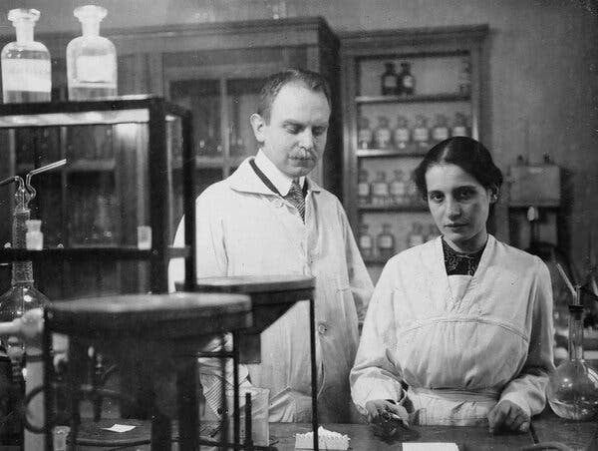

Dr. Meitner and Otto Hahn in a Berlin laboratory in the early 20th century.

In 1947, Meitner wrote to her nephew Otto Robert Frisch, a Jewish physicist who also contributed to the discovery of nuclear fission: “I know that his attitude contributed to the Nobel committee deciding against us,” she said of Hahn, in a letter translated by Ms. Moss. “But that is purely private stuff that we don’t want to make public.”

[Nobel Week](https://www.nytimes.com/article/nobel-prizes-2023.html) is a moment when the scientific community celebrates its greatest achievements but also, increasingly, examines oversights and injustices. Lise Meitner is one of many women in science [who failed to receive due credit for their work](https://www.nytimes.com/2023/04/22/obituaries/elizabeth-wagner-reed-overlooked.html), including, perhaps most notably, Rosalind Franklin, the chemist [who contributed to the discovery of the double helix structure of DNA](https://www.nytimes.com/2023/04/25/science/rosalind-franklin-dna.html) in 1953.

“There are hundreds, if not thousands, of women who achieve something great in science that just didn’t get recognized in their lifetime,” said Katie Hafner, the host of the podcast “[Lost Women of Science](https://www.lostwomenofscience.org/).” Ms. Hafner recently completed a [two-part](https://www.lostwomenofscience.org/season-6-episodes/lise-meitner) [episode](https://www.lostwomenofscience.org/season-6-episodes/why-did-lise-meitner-never-receive-the-nobel-prize-for-splitting-the-atom-part-2) about Meitner, the second half of which opens with the fateful Oppenheimer scene. Unlike other figures on her podcast, Ms. Hafner said, “Lise Meitner is not lost.”

But, she added, “she is misunderstood.”

A Radioactive Trailblazer

From the beginning, Meitner was breaking glass ceilings. Born in 1878 in Vienna, she began studying physics privately, as women in Austria were not allowed to attend college until 1897. In 1901, she enrolled in graduate school at the University of Vienna; five years later she earned a doctorate in physics, only the second woman from her university to do so.

Meitner spent the rest of her career working among the greats. She moved to the University of Berlin and began auditing classes taught by Max Planck, who won the [1918 Nobel Prize in Physics](https://www.nobelprize.org/prizes/physics/1918/summary/) — and who generally did not allow women to attend his lectures.

In Berlin, Meitner also met Otto Hahn, a chemist who was around her age and had a more progressive attitude about working with women. Hahn was also eager to collaborate with Meitner, as physicists tended to have a better grasp on radioactivity, the energy emitted by unstable atomic nuclei, than chemists. But, as a woman, Meitner was not allowed upstairs in Hahn’s lab. So she worked — without pay — in the basement. (When she needed to use the restroom, Ms. Moss said, Meitner had to dash across the street.)

In 1912, Meitner and Hahn moved to the Kaiser Wilhelm Institute for Chemistry. Together, they discovered a new element named protactinium. When the men at the Institute were drafted during World War I, Meitner was given her own physics lab and the title of professor, a position that granted her recognition and the independence to pursue her own research.

But outside the realm of science, the walls were closing in. Antisemitism was on the rise, and in 1933 Adolf Hitler was appointed chancellor of Germany. Many Jewish scientists left the country, but Meitner stayed, thinly protected by her Austrian citizenship and keen to hang on to the rare opportunity for a woman to conduct scientific research.

“I love physics with all my heart,” she wrote in a letter to a friend. “I can hardly imagine it not being part of my life.”

In 1938, Germany annexed Austria, leaving Meitner subject to the full extent of the Nazi regime. She opted to flee. The Nobel physics laureate [Niels Bohr](https://www.nobelprize.org/prizes/physics/1922/summary/" \o "" \t "_blank) arranged for her to escape by train.

Meitner eventually made her way to Sweden, devastated at having had to leave behind her life’s work and concerned about the safety of her family.

She continued collaborating with Hahn by mail. He ran experiments, and she interpreted findings he did not understand. One result stumped them both: When uranium atoms were bombarded with neutrons, the neutron should have been absorbed and an electron released, creating a heavier element. Instead, Hahn found barium, a much lighter element. They were baffled.

The finding was outside of Hahn’s expertise as a chemist. “Perhaps you can come up with some sort of fantastic explanation,” he wrote in a letter to Meitner translated by Ruth Lewin Sime, a chemist at Sacramento City College who published a [biography of Meitner](https://www.ucpress.edu/book/9780520208605/lise-meitner) in 1996. “If there is anything you could propose that you could publish, then it would still in a way be work by the three of us!”

Hahn and his colleague Fritz Strassmann submitted the results for publication in December of 1938. Their tone was uncertain. “There could perhaps be a series of unusual coincidences which has given us false indications,” [they wrote in German](https://history.aip.org/exhibits/mod/fission/fission2/09a63.html).

Meitner was not included as an author, nor was there any mention of her contribution to the work.

A Theory Is Born

Image

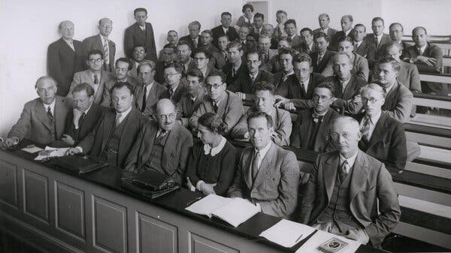

A lecture in 1937 attended by, from left in front row, Niels Bohr, Werner Heisenberg, Wolfgang Pauli, Otto Stern and Lise Meitner.Credit...CBW/Alamy

In Sweden, Meitner mulled over the results with Frisch, her physicist-nephew. One snowy day, Frisch recalled in a memoir, they took a walk, eventually stopping to sit on a tree trunk and scribble calculations on scraps of paper.

Uranium was extremely unstable, they realized, and likely to fracture on impact with, say, a neutron. Those fragments would be violently blasted apart. If one of those pieces were barium, Meitner mused, the other would have to be another light element called krypton. She computed the energy driving the blast using Einstein’s famous equation, E = mc².

Hahn and Strassmann had split the atom.

“We have read and considered your paper very carefully,” Meitner wrote to Hahn in January 1939. “Perhaps it is energetically possible for such a heavy nucleus to break up.” In a later letter, she expressed disappointment at being absent: “Even though I stand here with very empty hands, I am nevertheless happy for these wonderful findings.”

Meitner and Frisch [published](https://www.nature.com/articles/143239a0#:~:text=The%20answer%20came%20in%201939,the%20splitting%20of%20living%20cells.) their theoretical interpretation of Hahn and Strassmann’s results in the February 1939 edition of the journal Nature. Frisch and Meitner devised experiments to test their hypothesis. In the following weeks, they published [two more](https://www.nature.com/articles/143276a0) [papers](https://www.nature.com/articles/143471a0) with the results, which became the first physical confirmation of what Frisch coined “nuclear fission.”

Behind the scenes, Meitner and Hahn’s correspondence spiraled into misunderstanding. Hahn thought that she was angry that he had published without her. “What else could I have done?” he wrote to Meitner. “Believe me, it would have been preferable for me if we could still work together and discuss things as we did before!”

ADVERTISEMENT

[SKIP ADVERTISEMENT](https://www.nytimes.com/2023/10/02/science/lise-meitner-fission-nobel.html#after-story-ad-6)

Hahn was also receiving pushback for working with a Jewish scientist. “I don’t give these things much weight, of course, but didn’t want to confess to the gentlemen that you were the only one who found out everything immediately,” he wrote Meitner in 1939.

Later that year, Germany invaded Poland. World War II had begun. And the race was on to build an atomic bomb.

Word spread about nuclear fission. Though a single split atom did not generate enough energy for potential use in a weapon, some speculated that a chain reaction could do the trick. Bombarding uranium with neutrons not only produced lighter elements; it also created more neutrons. If those neutrons collided with more uranium, the reaction might sustain itself.

The American government assembled the Manhattan Project to develop such a weapon. Many of Meitner’s peers, including Frisch and Bohr, became involved. Einstein did not, although he had written a [letter](https://www.osti.gov/opennet/manhattan-project-history/Resources/einstein_letter_photograph.htm) to President Franklin D. Roosevelt urging him to secure uranium and fund chain reaction experiments.

Meitner, though she had been invited, refused to join. (“I will have nothing to do with a bomb!” [she famously said](https://ahf.nuclearmuseum.org/ahf/profile/lise-meitner/).) In 1945, after atomic bombs were dropped on Hiroshima and Nagasaki, leading to the end of the war, some newspaper stories claimed that Meitner had smuggled the recipe for the weapon out of Nazi Germany in her purse. She dismissed them. “You know so much more in America about the atomic bomb than I,” she told The New York Times in 1946.

In 1945, Hahn was nominated for the 1944 Nobel Prize in Chemistry, [one year late](https://www.nobelprize.org/prizes/chemistry/1944/summary/), for the discovery of nuclear fission. Meitner and Frisch were also [nominated for the physics prize](https://www.nobelprize.org/nomination/archive/list.php?prize=1&year=1945) that year. But only Hahn won.

A ‘Firm Tradition’

Image

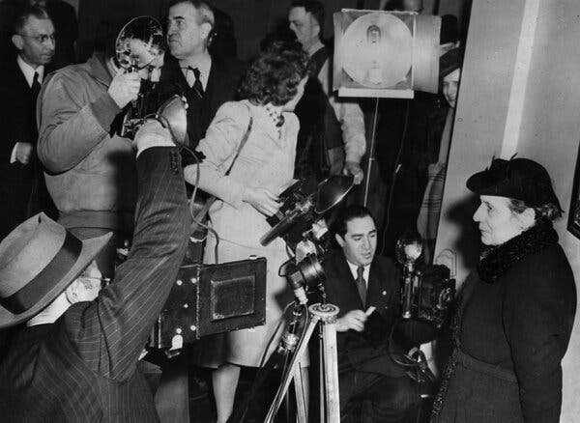

Meitner arriving in New York for a U.S. visit in January 1946. “You know so much more in America about the atomic bomb than I,” she told The New York Times that year.Credit...Associated Press

Details of Nobel Prize deliberations remain secret for 50 years after an award is given. After the documents surrounding Hahn’s win were released, science historians published [an analysis of the deliberations](https://pubs.aip.org/physicstoday/article-abstract/50/9/26/410081/A-Nobel-Tale-of-Postwar-InjusticeRecently-released?redirectedFrom=fulltext) in Physics Today in 1997. “None of this embittered Meitner,” they wrote. “She complained very little, and forgave a great deal.”

Ms. Hafner takes issue with that stance. “Who is going to say, ‘Hey, I’m bitter’?” she said. “What are the optics of that?”

Ms. Moss thinks bitter is the wrong word. “She was very, very hurt,” she said of Meitner, at both the lack of credit and the passive loyalty she felt Hahn had to Germany.

ADVERTISEMENT

[SKIP ADVERTISEMENT](https://www.nytimes.com/2023/10/02/science/lise-meitner-fission-nobel.html#after-story-ad-8)

“It was quite clear to me that Hahn was completely unaware of his unfriendly behavior,” Meitner wrote to a friend in 1946. “Naturally, the time together with him was somewhat painful, but I was prepared for it and held myself firm, bringing up no personal debates.”

Meitner was nominated again — [five times](https://www.nobelprize.org/nomination/archive/list.php?prize=1&year=1946) — for the 1946 Nobel Prize in Physics. According to the authors of the Physics Today article, the Nobel committee argued that it was “firm tradition” to award the prize for experimental, rather than theoretical, discoveries.

But Demetrios Matsakis, a retired physicist of the U.S. Naval Observatory, said it is impossible to separate the “interplay between experimentalists and theorists. They need each other.” (Dr. Matsakis learned of Meitner in 2018, and was inspired to [petition to rename another radioactive process](https://pubs.aip.org/physicstoday/article/72/9/10/924929/A-renaming-proposal-The-Auger-Meitner-effect), to recognize Meitner’s role in that discovery.)

Hahn deserved the award, but Meitner did, too, Dr. Matsakis said: “She should have gotten the Nobel Prize. There’s really no question about that.”

As an inverse comparison, scientists note the case of Chien-Shiung Wu, a Chinese American physicist who ran experiments showing that some particle interactions do not obey mirror symmetry. In 1957, two of Wu’s male colleagues [won the Nobel Prize in Physics](https://www.nobelprize.org/prizes/physics/1957/summary/) for building the theory confirmed by her results.

ADVERTISEMENT

[SKIP ADVERTISEMENT](https://www.nytimes.com/2023/10/02/science/lise-meitner-fission-nobel.html#after-story-ad-9)

The award recipient — the experimentalist or the theorist — “seems like it was reversed in these two cases,” said Harry Saal, a physicist who studied under Wu at Columbia University. “And in both cases the woman got screwed.”

Memorializing Meitner

Image

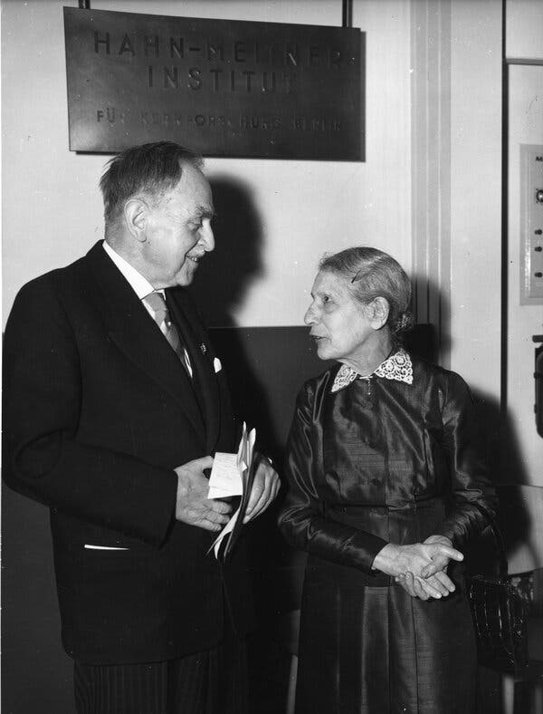

Meitner with Otto Hahn in 1959, to inaugurate the Hahn-Meitner-Institut Berlin, now the Helmholtz-Zentrum Berlin.Credit...Heinrich Sanden Sr./Associated Press

In his later years, Hahn seemed to try to make amends. He and Meitner remained friends, and he offered her a head position at the Max Planck Institute in Germany, which she declined. In 1948, [he nominated her](https://www.nobelprize.org/nomination/archive/list.php?prize=1&year=1948) for the Nobel Prize in Physics.

Meitner went on to be nominated 46 times for the Nobel in both physics and chemistry, but she never won. (To date, only four women have won in physics, [most recently in 2020](https://www.nytimes.com/2020/10/06/science/nobel-prize-physics.html), and [only eight have won in chemistry](https://www.nobelprize.org/prizes/lists/nobel-prize-awarded-women/).)

In 1968, Meitner, then 89, died in England. An [obituary](https://www.nytimes.com/1968/10/28/archives/lise-meitner-dies-atomic-pioneer-89-lise-meitner-physicist-is-dead.html) that ran in The Times referred to her as an “atomic pioneer” and the “scientific partner of Otto Hahn, the Nobel Prize-winning nuclear chemist and the discoverer of nuclear fission.”

ADVERTISEMENT

[SKIP ADVERTISEMENT](https://www.nytimes.com/2023/10/02/science/lise-meitner-fission-nobel.html#after-story-ad-10)

In 2020, the official Nobel Prize account on X, formerly known as Twitter, acknowledged that both Hahn and Meitner discovered nuclear fission. The [post](https://twitter.com/NobelPrize/status/1213009105457221632) was accompanied by artwork showing Meitner standing behind Hahn, to the outrage of many people.

Any effort to award a Nobel to Meitner posthumously would be in vain. “Once a Nobel is given, there is no going back,” Dr. Sime said. The best that can be done is to acknowledge Meitner in the present, she added — and her omission from the new Oppenheimer film “was not excusable.”

Ms. Moss is still translating Meitner’s letters; so far, she has worked through more than 700 pages. “Now I’m just doing it because I fell in love with her,” she said. “She’s an incredible person.” She plans to write another book about Meitner with all the material that did not make it into the first one.

Earlier this year, Ms. Hafner and a friend visited Meitner’s grave, located in a tiny English churchyard “in the middle of nowhere,” she said. It took them half an hour to find the faded tombstone, which was overgrown with weeds.

Ms. Hafner was surprised at how unremarkable the grave was for such “a giant in science,” she said. Still, she was comforted to find a stone perched atop the marker, a Jewish practice to honor the dead. Ms. Hafner added visitation stones for herself, Ms. Moss, Bohr, Einstein, Frisch and even Hahn.

This is how people are remembered, Ms. Hafner said. “Until we chip away at this and continue to remind people of the important work she did, it just won’t get recognized,” she added. So “we do everything we can to set the record straight.”

***A correction was made on***

***Oct. 10, 2023***

*:*

*An earlier version of this article misstated the wartime role of theoretical physicist Robert J. Oppenheimer. He was director of the laboratory in Los Alamos, N.M., where the atomic bomb was developed, not the director of the entire Manhattan Project. The article also misstated Germany’s actions toward Austria at the time; Germany annexed Austria, it did not invade it.*

When we learn of a mistake, we acknowledge it with a correction. If you spot an error, please let us know at [nytnews@nytimes.com](mailto:nytnews@nytimes.com).[Learn more](https://www.nytimes.com/explain/2022/new-york-times-journalism)

[**Katrina Miller**](https://www.nytimes.com/by/katrina-miller) is a science [reporting fellow](https://www.nytco.com/careers/newsroom/newsroom-fellowship/) for The Times. She recently earned her Ph.D. in particle physics from the University of Chicago. [More about Katrina Miller](https://www.nytimes.com/by/katrina-miller)

A version of this article appears in print on Oct. 3, 2023, Section D, Page 1 of the New York edition with the headline: An Atomic Pioneer Too Often Overlooked. [Order Reprints](https://www.parsintl.com/publication/the-new-york-times/) | [Today’s Paper](https://www.nytimes.com/section/todayspaper) | [Subscribe](https://www.nytimes.com/subscriptions/Multiproduct/lp8HYKU.html?campaignId=48JQY)