JSCIAR, India,

23rd November, 2023.

**First female judge of Supreme Court Fathima Beevi passes away at 96**

Story by Bobins Abraham

[[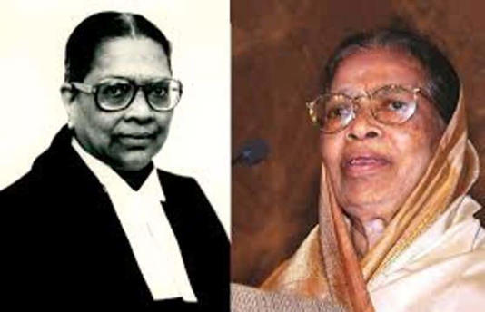](https://www.msn.com/en-in/news/India/first-female-judge-of-supreme-court-fathima-beevi-passes-away-at-96/ar-AA1koNZh?ocid=msedgntp&cvid=cb8798afbcf84c7986634f51501de8a5&ei=35&fullscreen=true#image=2)](https://www.msn.com/en-in/news/India/first-female-judge-of-supreme-court-fathima-beevi-passes-away-at-96/ar-AA1koNZh?ocid=msedgntp&cvid=cb8798afbcf84c7986634f51501de8a5&ei=35&fullscreen=true" \l "image=2" \t "_self)

First female judge of Supreme Court Fathima Beevi passes away at 96© Provided by Newsable Asianet News

Kollam: The first female judge of the Supreme Court Fathima Beevi passed away on Thursday (Nov 23). She was 96. She was undergoing treatment at a private hospital in Kollam.

As the first female judge of the Indian Supreme Court, Beevi created history in 1989. She was also the country's first Muslim woman appointed to any higher court position. In 1992, she retired from the Supreme Court. When Beevi was named governor of Tamil Nadu in 1997, she was the first woman of Muslim descent to hold the position. She held that role until 2001. In addition, she was a member of the National Human Rights Commission and the Chairman of the Kerala Commission for Backward Classes. She was a candidate for several prominent roles, including President of India.

Fathima Beevi was the daughter of Annaveettil Meer Sahib and Khadeeja Beevi of the Rowther Family in Pathanamthitta. She was born in 1927.

[[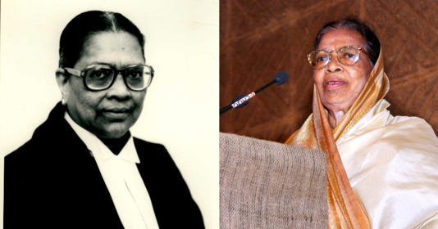](https://www.msn.com/en-in/news/India/justice-fathima-beevi-india-s-first-female-supreme-court-judge-passes-away/ar-AA1koU1c?ocid=msedgntp&cvid=5ab78efa837347f6a4364bf293053521&ei=2&fullscreen=true#image=2)](https://www.msn.com/en-in/news/India/justice-fathima-beevi-india-s-first-female-supreme-court-judge-passes-away/ar-AA1koU1c?ocid=msedgntp&cvid=5ab78efa837347f6a4364bf293053521&ei=2&fullscreen=true#image=2)

Justice Fathima Beevi, India’s First Female Supreme Court Judge, Passes Away© Provided by Indiatimes

Justice Fathima Beevi, the first woman to be appointed as judge of the [Supreme Court of India](https://www.indiatimes.com/news/india/all-women-have-right-to-safe-and-legal-abortion-supreme-court-of-india-580822.html), has passed away. She was 96.

Born in the Pathanamthitta District of Kerala, Justice Fathima Beevi made history in 1989 when she was appointed the first female judge of the Supreme Court of India.

[[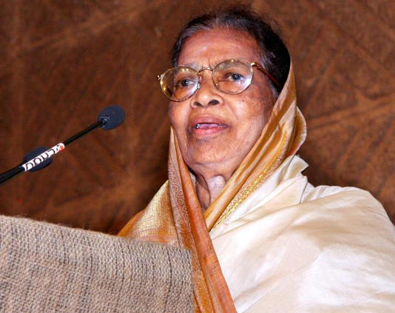](https://www.msn.com/en-in/news/India/justice-fathima-beevi-india-s-first-female-supreme-court-judge-passes-away/ar-AA1koU1c?ocid=msedgntp&cvid=5ab78efa837347f6a4364bf293053521&ei=2&fullscreen=true#image=2)](https://www.msn.com/en-in/news/India/justice-fathima-beevi-india-s-first-female-supreme-court-judge-passes-away/ar-AA1koU1c?ocid=msedgntp&cvid=5ab78efa837347f6a4364bf293053521&ei=2&fullscreen=true" \l "image=2" \t "_self)

BCCL/FILE© Provided by Indiatimes

## **Who was Justice Fathima Beevi?**

She was also the first Muslim woman to be appointed to any of the higher judiciaries in the country. She retired from the apex court in 1992.

After she retired from judicial service, she was appointed the Governor of Tamil Nadu in 1997, making her the first Muslim woman to hold the post. She served in the position till 2001.

A B.Sc and law graduate, Justice Beevi enrolled as an Advocate in 1950.

She started her judicial career as the Munsiff in the Kerala Subordinate Judicial Services.

She became a High Court Judge in 1983 and a Supreme Court Judge in 1989.

[[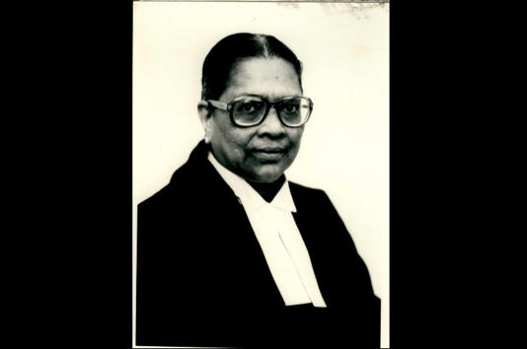](https://www.msn.com/en-in/news/India/justice-fathima-beevi-india-s-first-female-supreme-court-judge-passes-away/ar-AA1koU1c?ocid=msedgntp&cvid=5ab78efa837347f6a4364bf293053521&ei=2&fullscreen=true#image=2)](https://www.msn.com/en-in/news/India/justice-fathima-beevi-india-s-first-female-supreme-court-judge-passes-away/ar-AA1koU1c?ocid=msedgntp&cvid=5ab78efa837347f6a4364bf293053521&ei=2&fullscreen=true" \l "image=2" \t "_self)

PIB© Provided by Indiatimes

## **How Justice Fathima Beevi became a pioneer**

As a Supreme Court judge, she became the first Muslim woman in the higher judiciary and the first woman to become a Supreme Court Justice in an Asian country.

She also served as the Chairman of the Kerala Commission for Backward Classes. She was a member of the National Human Rights Commission before being appointed as the Governor of Tamil Nadu.

## **Her career as Tamil Nadu Governor**

As the Governor of Tamil Nadu, Justice Beevi had rejected the mercy petitions filed by the death-row convicts in the Rajiv Gandhi assassination case.

She resigned from the post in 2001 following her controversial decision to invite Jayalalitha to form the government.

Justice Beevi submitted her resignation after the Union Cabinet recommended that the President recall the Governor for failing to discharge her constitutional obligation.

[Justice Fathima Beevi, India's first woman judge of SC dies at 96. Five things to know about her (msn.com)](https://www.msn.com/en-in/news/India/justice-fathima-beevi-india-s-first-woman-judge-of-sc-dies-at-96-five-things-to-know-about-her/ar-AA1kp6Zn)

<https://www.msn.com/en-in/news/India/justice-fathima-beevi-india-s-first-woman-judge-of-sc-dies-at-96-five-things-to-know-about-her/ar-AA1kp6Zn>

# Justice Fathima Beevi, India's first woman judge of SC dies at 96. Five things to know about her

Story by HT News Desk  • 3h

[[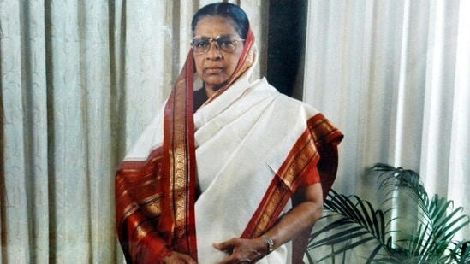](https://www.msn.com/en-in/news/India/justice-fathima-beevi-india-s-first-woman-judge-of-sc-dies-at-96-five-things-to-know-about-her/ar-AA1kp6Zn?fullscreen=true#image=2)](https://www.msn.com/en-in/news/India/justice-fathima-beevi-india-s-first-woman-judge-of-sc-dies-at-96-five-things-to-know-about-her/ar-AA1kp6Zn?fullscreen=true" \l "image=2" \t "_self)

Justice Fathima Beevi.© Provided by Hindustan Times

Justice Fathima Beevi, India's first woman judge of the Supreme Court, died on Thursday at a private hospital in Kerala's Kollam. She was 96.

Tamil Nadu Governor R N Ravi said that he was deeply saddened at the passing away of Justice Beevi.

“Her contributions to public service will always be remembered. My thoughts are with her family members in this sorrowful hour. May she rest in peace,” the governor said.

Kerala Chief Minister Pinarayi Vijayan expressed condolences over the death of Justice Beevi.

He further said that Justice Beevi was the first woman from the Muslim community to be a part of the higher judiciary, as she was able to overcome the negative aspects of social situations by seeing them as challenges, according to PTI.

“Her life is an inspiration to everyone, especially women,” the chief minister said, adding that as a tribute to her, she has been chosen for the Kerala Prabha Award.

Kerala Health Minister Veena George also condoled her death by saying that the demise of Justice Beevi was extremely painful.

"She was a brave woman who had many records to her name. She was a personality who through her own life showed that willpower and a sense of purpose can overcome any adversity," George said in a statement.

## **Here's what more we know about Justice Beevi:**

* Justice Beevi was born in Kerala's Pathanamthitta in April 1927. She graduated from the University College, Trivandrum and studied law at the Law College in Trivandrum.
* She enrolled as an advocate in November 1950 and worked her way up to become a district and sessions judge in 1974.

In 1983, she was elevated to the High Court and became a permanent judge a year later.

* She made history after she was elevated to the Supreme Court as a judge in 1989. She retired in 1992.
* After retiring, she served as a member of the National Human Rights Commission from 1993 to 1997, before becoming the Governor of Tamil Nadu till 2001.

JSCIAR, India,

25th November 2023.

[Justice M Fathima Beevi, a woman of many firsts who broke convention (msn.com)](https://www.msn.com/en-in/news/India/justice-m-fathima-beevi-a-woman-of-many-firsts-who-broke-convention/ar-AA1kruCT?ocid=msedgntp&cvid=959cac4edba54ed69555f6e58f2f1ce4&ei=28)

<https://www.msn.com/en-in/news/India/justice-m-fathima-beevi-a-woman-of-many-firsts-who-broke-convention/ar> AA1kruCT?ocid=msedgntp&cvid=959cac4edba54ed69555f6e58f2f1ce4&ei=28

# Justice M Fathima Beevi, a woman of many firsts who broke convention

Fathima Beevi, first woman judge of SC and former governor of Tamil Nadu, passes away

KOLLAM/CHENNAI:   Justice M Fathima Beevi, a pioneering figure in the country’s judicial history and the first woman judge of the Supreme Court, passed away in Kollam on Thursday. She was 96. She was admitted to the Travancore Medicity Hospital in Kollam following pulmonary issues.

She was later diagnosed with pneumonia and breathed her last on Thursday at 11.45am, the hospital authorities said. Born in Pathanamthitta in 1927, Justice Beevi embarked on her educational journey at St Joseph’s Convent School.

She earned a BSc degree in chemistry from the University of Kerala and pursued law at the Government Law College in Thiruvananthapuram, with the encouragement of her father, Annaveettil Meera Sahib. In 1950, she made history by becoming the first woman in Kerala to earn a law degree.

Her illustrious legal career began with her topping the bar council exam in 1950, followed by her enrolment as a lawyer on November 14, 1950. Starting in the lower judiciary, she ascended the ranks, serving as a munsiff in the Kerala Subordinate Judicial Services in May 1958, subordinate judge in 1968, chief judicial magistrate in 1972, and the district and sessions judge in 1974.

In January 1980, she assumed the role of judicial member of the Income Tax Appellate Tribunal, paving the way for her elevation to the High Court as a judge on August 4, 1983. She became a permanent judge of the High Court on May 14, 1984, and retired on April 29, 1989. She was appointed as a judge in the Supreme Court on October 6, 1989, under the Rajiv Gandhi government, becoming the first Muslim woman judge in any higher judiciary. She retired from the apex court on April 29, 1992.

In 1997, Justice Beevi took charge as the Governor of Tamil Nadu, becoming the first woman from the Muslim community to hold the position. Though Beevi had many accomplishments in her legal arena, her term as governor of Tamil Nadu between 1997- 2001 ended in controversy, especially her decision to allow the swearing-in of AIADMK leader J Jayalalithaa as the chief minister of the state in May 2001 after the Assembly elections the AIAD MK leader was convicted in the TAN SI land case in October 2000.

Normally, people convicted of such crimes are barred from contesting elections for six years. But Fathima Beevi allowed Jayalalithaa to become the chief minister within eight months of her conviction in the case. This drew a lot of criticism from almost all quarters, particularly from the DMK. In 2001, Beevi stepped down as the governor of Tamil Nadu after the union cabinet decided to recall her for failing to send an objective report on what had happened during the arrest of DMK president M Karunanidhi on June 30, 2001. She gave a clean chit to the police in this incident and the then NDA government found the report as a mere reflection of the AIAD MK government.

Following this, Fathima Beevi stepped down as the governor of Tamil Nadu on July 2, 2001. Justice Beevi’s contributions extended beyond the judiciary; she served as the chairperson of the Kerala Commission for Backward Classes and was a member of the National Human Rights Commission. The mortal remains of Justice M Fathima Beevi will be shifted to Pathanamthitta, with the funeral slated to take place on Friday at 2pm at the Town Juma Mas j id i n Pathanamthitta.

[[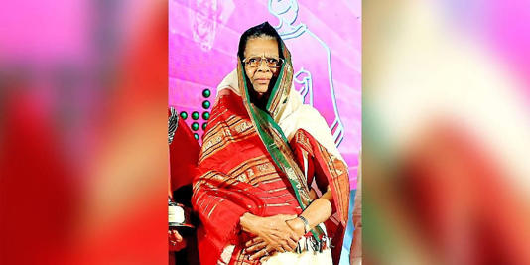](https://www.msn.com/en-in/news/India/justice-m-fathima-beevi-a-woman-of-many-firsts-who-broke-convention/ar-AA1kruCT?ocid=msedgntp&cvid=959cac4edba54ed69555f6e58f2f1ce4&ei=28&fullscreen=true#image=2)](https://www.msn.com/en-in/news/India/justice-m-fathima-beevi-a-woman-of-many-firsts-who-broke-convention/ar-AA1kruCT?ocid=msedgntp&cvid=959cac4edba54ed69555f6e58f2f1ce4&ei=28&fullscreen=true" \l "image=2" \t "_self)

Justice M Fathima Beevi, a woman of many firsts who broke convention© Provided by The New Indian Express